Introduction to Special Census

Special Census Overview

What is the Special Census (SC) Program?
The purpose of the Special Census program is to enumerate the population and housing units at the request of your local government. Many states use special census population statistics to determine the distribution of state funds to local jurisdictions. Local jurisdictions may use the data to plan new schools, transportation systems, housing programs, or water treatment facilities.
A Special Census is a basic enumeration of population, housing units (HUs), group quarters (GQ), and transitory locations (TL) conducted by the U.S. Census Bureau in the years between Decennial censuses; every 10 years, the national census, known as the Decennial Census. Local residents are hired and trained to conduct the Special Census. They are conducted on a cost-reimbursable basis.
For Special Census purposes, a governmental unit is defined as the government of any state, county, city, or other political subdivision within a state, or the government of the District of Columbia or the government of any possession or area including political subdivisions, American Indian Reservations, or Alaskan Native villages.
During a Special Census, Field Representatives (FRs) visit assigned areas and canvass, that is, travel systematically all streets, roads, and paths in the assigned area, to find all living quarters. While canvassing, they verify or update the Census Bureau’s address lists, based on what they observe on the ground and through interviews with respondents. At each address identified as a housing unit, FRs interview an occupant and complete a Special Census questionnaire for the household.
To measure the quality of the work performed, the Special Census program includes several quality control (QC) checks. Field Supervisors (FSs) review FR work progress. A separate team of FSs and FRs performs QC checks on completed assignments, which includes dependent quality checks and reinterviews.

Why is the Special Census Program Conducted?
The purpose of the Special Census program is to give governmental units an opportunity to conduct a census for their community in the years between Decennial Censuses.
Receiving up-to-date census information about their communities helps local and tribal governments to:
- Become eligible for receiving increased state funds and grants for schools, hospitals, roads, public works, and other vital programs.
- Improve the ability to plan for schools and better transportation.
- Improve public safety and emergency preparedness.

Where is the Special Census Program Conducted?
A Special Census may be taken wherever a governmental unit determines it is beneficial: in counties, neighborhoods, governmental units, or other geographic areas in the United States and Puerto Rico.

What is the Special Census Date?
The U.S. Census Bureau and the local government will determine a reference date for collecting the data. This date is called the Special Census Day.
It is critical that all data collected are based on the status of the address on the Special Census Day.

The U.S. Census Bureau

The Role of the U.S. Census Bureau
The Special Census program is conducted by the U.S. Census Bureau - the federal government’s largest statistical agency.
As the leading source of quality data about the nation’s people and economy, the Census Bureau honors privacy, protects confidentiality, shares our expertise globally, and conducts our work openly. The Census Bureau is guided on this mission by our strong and capable workforce, our readiness to innovate, and our abiding commitment to our customers.
The primary function of the Census Bureau is to conduct, every 10 years, the national census, known as the Decennial Census. The primary reason for conducting the Decennial Census is to determine the number of seats in the U.S. House of Representatives each state will have, based on its population. But there are many other reasons why the Decennial Census and other censuses, including Special Censuses, are important.
- Responses to the 2020 Census shape how more than $675 billion in federal funding is distributed annually to local communities.
- Responses determines further political representation in Congress.
- Population totals and breakdowns by sex, age, race, and other factors inform decisions about distribution of Federal funds, grants and support to states, counties, and communities.
- Governments and businesses use Census results to plan new investments, services, and jobs.
- Developers use census data to build new homes and revitalize old neighborhoods.
- Local governments use census data for public safety and emergency preparedness.
- Residents use census data to support community initiatives involving legislation, quality-of-life, and consumer advocacy.
- The census has always been a record of our history. The 2020 Census will shape a roadmap for our future.
Refer to Appendix A to learn about other surveys the Census Bureau may be conducting at regular or irregular intervals in the Special Census enumeration areas.

Who’s Who in the Special Census

Overview
A Special Census has positions at the Special Census Office (SCO) and in the field. The following sections provide a concise summary of various job positions and their respective responsibilities
Your role in the office is crucial for the success of the Special Census and it ensures the collection of high-quality data.

Structure of the Census Bureau Staff
Conducting a Special Census is an involved process that takes many people to maintain.

Census Bureau Headquarters
The U.S. Census Bureau Headquarters in Suitland, MD developed the Special Census program, including training materials and procedures used by Regional Offices (RO), Special Census Office (SCO), and field staff. Census Bureau Headquarters oversees the ROs.

Regional Office (RO)
ROs are permanent offices that coordinate and carry out survey and census field data collection operations for the Census Bureau and its customers. ROs oversee the SCOs. The ROs are:
New York (RO# 2200). Located in New York, NY, the NYRO serves Connecticut, Maine, Massachusetts, New Hampshire, New Jersey, New York, Puerto Rico, Rhode Island, and Vermont.
Philadelphia (RO# 2300). Located in Philadelphia, PA, the PHRO serves Delaware, District of Columbia, Kentucky, Maryland, Ohio, Pennsylvania, Tennessee, Virginia, and West Virginia.
Chicago (RO# 2500). Located in Chicago, IL, the CHRO serves Arkansas, Illinois, Indiana, Iowa, Michigan, Minnesota, Missouri, and Wisconsin.
Atlanta (RO# 2900). Located in Atlanta, GA, the ATRO serves Alabama, Florida, Georgia, Louisiana, Mississippi, North Carolina, and South Carolina.
Denver (RO# 3100). Located in Lakewood, CO, the DNRO serves Arizona, Colorado, Kansas, Montana, Nebraska, New Mexico, North Dakota, South Dakota, Oklahoma, Texas, Utah, and Wyoming.
Los Angeles (RO# 3200). Located in Burbank, CA the LARO serves Alaska, California, Hawaii, Idaho, Nevada, Oregon, and Washington.

Special Census Office (SCO)
SCOs are temporary offices established to conduct the Special Census program.

Special Census Supervisor
The Special Census Supervisor (SCS) works under the supervision of the RO Coordinator and manages all activities of the Special Census Office. The Special Census Supervisor performs the duties of the Field Manager (FM) when the Special Census does not hire a FM. The Special Census Office Supervisor:
- Reviews and certifies FR and FS payrolls in GovTA
- Assists with recruiting, at the discretion of the RO, if the governmental unit has not recruited enough applicants to work on the Special Census.
- Oversees clerical operations in the office, including the review of questionnaires and address registers as well as all Quality Control (QC) operations.
- Communicates with the Special Census Manager.
- Promptly responds to messages.
- Directs duties of SCO staff.
- Make final decision on reinterview questionnaire when there is a discrepancy with the original questionnaire.
- Monitors daily progress and performance reports.
- Meets with governmental units to discuss special census operations, office space, timing, publicity, and the status of local-recruiting efforts, when directed by the RO.
- Oversees the use of MOJO to track the flow of work to and from the field. MOJO activities include the check-out/check-in of address registers, the check-in of questionnaires and address registers and the keying of selected data.
- Takes corrective actions, as appropriate, to keep the operation on schedule.
- Transmits completed materials on a timely basis.
- Completes all special census final reports and transmitting them to the RO, HQ, and to governmental units, as appropriate.
- Manages the Special Census Field Managers (FMs).
- Is available for discussions with the FM.
- Performs the duties listed below under FM when the SCO does not hire a FM.

Special Census Office Clerks
Special Census clerks perform a variety of tasks in the Special Census Office. The office clerks:
- Prepare address registers (AR) for assignment.
- Checkout work to the Field Supervisors.
- Reassign work to Field Representatives after the FS makes assignments or reassignments.
- Check in completed assignments as work is returned to the SCO.
- Review completed work as it is returned to the SCO.
- Document errors on completed work that is returned to the SCO and return to the FS.
- Prepare Form SC-RQ, Special Census Reinterview Questionnaire, as production questionnaires are selected for Reinterview.
- Conduct telephone Reinterview, as assigned.
- Run daily reports and provide to the SCS and the FM.
- Assist with SCO closeout activities.
- Audit, enter time and validate timesheets for FRs and FSs.

Special Census Field Manager (FM)
FMs directly manage Field Supervisors (FS). Each FM oversees approximately 6-8 FSs. FMs train FSs and monitor work assignments and work progress for each FS team. FMs also certify submitted FS payroll records and advise and assist FSs on personnel and performance issues. The FM is the main point of contact for all field activities. The Field Manager:
- Promptly responds to messages.
- Meets with FSs daily to discuss progress of the team’s work, discuss performance, or conduct issues, provide guidance on difficult of unusual situations.
- Is available for phone calls from the Field Supervisor.

Special Census Field Supervisor (FS)
FSs directly supervise Field Representatives (FRs). Each FS oversees a team of approximately 6-8 FRs. FSs train FRs, provide assignments, and monitor FR progress and performance as they conduct their work. FSs discuss FR conduct and performance issues with the FM. FSs also provides feedback on job performance and answer work-related questions.

Special Census Field Representative (FR)
FRs are responsible for working the Special Census assignments. This work includes traveling to the assigned area, verifying or updating the provided address list, and conducting interviews with respondents to collect data as required for the Special Census.

Employee Responsibilities

Become Familiar with Special Census Materials and Procedures
The SC-1202, Special Census Field Representative (FR) Manual contains specific FR instructions for conducting the Special Census field operation. The SC-1130, Special Census Field Supervisor (FS) Manual contains the specific instructions for supervising FRs in the field and the procedures for the quality assurance activities. The Special Census Supervisor (SCS) must be familiar with these documents to understand the Special Census operation. This manual, the SC-50, Special Census Office Manual, contains specific instructions for office staff.
Depending on the Special Census Office (SCO), Group Quarters (GQ) or Transitory Locations (TL) operations may be implemented in your Special Census area. The SC-569.12, Group Quarters Field Representative Manual and SC-569.30, Transitory Locations Field Representative Manual contain the specific instructions and procedures to conduct these operations in the field. The Special Census Supervisor may need to also be familiar with these documents to understand these operations and its implementation in the field.

Title 13
Protection under Title 13 of the U.S. Code guarantees confidentiality of census information and establishes penalties for disclosing this information.
This means that only people sworn to protect Title 13 data may see information the Census Bureau collects. Protected information cannot be shared with anyone who is not sworn to maintain the confidentiality of Title 13 protected data – including the Federal Bureau of Investigation, Internal Revenue Service, or a court of law.
Unauthorized disclosure of confidential information by a sworn Census Bureau employee is punishable by a fine of up to $250,000, imprisonment of up to 5 years, or both. You must never reveal census information to anyone who is not a sworn Census Bureau employee.

Data Stewardship
The Census Bureau workforce is bound to protect confidential information by an ironclad commitment backed by Federal law. Data Stewardship means providing quality data for public good while protecting individual privacy and confidentiality. This is the Census Bureau’s core responsibility. We may not release personally identifiable information.
Data Stewardship assures the Census Bureau can effectively collect high quality data to be used by its customers while meeting the legal and reporting obligations of Title 13, the Privacy Act, and other applicable statutes. Keeping the public’s trust is critical to our ability to carry out our mission as the leading source of quality data about the nation’s people and economy.

Ways to Maintain Confidentiality as a Data Steward
Here are ways you can maintain the confidentiality of all census information:
- When not working, always lock your vehicle whenever Special Census materials are in it. Store Special Census materials out of view.
- Do not show the address lists, maps, or completed questionnaires to anyone.
- Be sure no one else can hear you if discussing Title 13 protected data with your manager in public places.
- Do not share personally identifiable information (PII) with another sworn Census Bureau employee who does not have a need to know.
- Always ask your manager if you are not sure whether something is considered personally identifiable information (PII).
Remember that when you took the confidentiality oath, you were sworn for life.

The Privacy Act of 1974
The Privacy Act of 1974 requires that each Federal agency advise people of their rights when collecting information from them. Specifically, a person must know under what law the information is being collected, how the information will be used and whether they must answer.
The SC-CN(E/S), Confidentiality Notice, contains the information required by the Privacy Act of 1974. Special Census staff must give a Confidentiality Notice to each person from whom they request census-related information. Never leave this notice at an address where no one is home or that is vacant. It must always be handed to a person.

Data Falsification
There may be times when work is not progressing well. Even though you want to do a good job and keep on schedule, you may encounter problems. However, no matter what the circumstances, work must never be falsified. All data collected must be obtained from an occupant, knowledgeable person, or through observation. Never search for information from public records or on the Internet.
Your manager and other office personnel are trained to recognize bogus materials. A percentage of all work is verified for accuracy. The chances of catching falsified data are very high. If it is discovered that someone submitted falsified data, they will be dismissed immediately.
Anyone willfully falsify information collected under Title 13, United States Code, Section 213, can be found guilty of perjury (fabrication) and may be fined up to $250,000 and/or imprisoned up to five years. If it is determined that the falsification was intentional, they will be removed from federal service.

Media Contacts While You Are Working
As you go about your work, reporters from local newspapers, radio, or TV stations may approach you seeking an interview. They may even want to accompany you while you work. If this happens:
- Stop work immediately. Walk away from the location where you are working to make sure the address is not identified.
- Do not:
- Allow the reporter(s) to see any of your work materials.
- Let the reporter(s) overhear or observe any meetings or interviews you are conducting.
- Divulge any information that could lead the reporter(s) to identify a person, such as an address or phone number. Title 13 guarantees respondents that all information the Census Bureau collects will be kept confidential.
- Call your manager.

Restrictions on the Political Activities of Federal Employees
While you are working for the Census Bureau, you are covered by the Hatch Act, which restricts certain political activities of Federal employees. The following are examples of activities allowed and prohibited under the Hatch Act.

Activities Allowed by the Hatch Act
Census Bureau employees may participate in the following activities during non-duty hours:
- Register and vote as they choose
- Contribute money to political organizations
- Attend political fund-raising functions
- Attend and be active at political rallies and meetings

Activities Prohibited by the Hatch Act
Census Bureau employees are prohibited from:
- Engaging in political activity while on duty
- Engaging in political activity in a government office
- Engaging in political activity while wearing an official ID badge
- Engaging in political activity while using a government vehicle
- Wearing political buttons or other political items while on duty
- Soliciting or receiving political contributions

Partisan Political Signs or Stickers
Census Bureau employees may display a partisan political sign or sticker (such as a bumper sticker) on a privately-owned (or borrowed) vehicle if the vehicle is not used for official government work. The employee must remove or cover up any such sign or sticker on the vehicle during the period in which the vehicle is used for official government work (for example, while the employee is on duty). Employees may display a partisan political sign or sticker from a past partisan political campaign after the election, so long as the person is not currently running in a partisan political campaign.

How Does the Hatch Act Affect You?
Please remember that it is your responsibility to raise any questions or concerns about permissible political activities to your manager. Federal employees should be aware that certain political activities might also constitute criminal offenses under Title 18 of the U.S. Code.
For more information on the Hatch Act, please refer to the SC-590, Census Employee Handbook for Field Representatives.

Lost, Missing, or Stolen Materials
As a census employee, you are responsible for protecting all materials assigned to you, including your Census Bureau-issued ID badge. You must take special care to protect Address Registers, labeled questionnaires, completed questionnaires, and other materials containing Title 13 data that are in your possession. These materials must be always accounted for.
You are responsible for:
- Using census-owned property for the sole purpose of conducting official government-related work
- Properly caring for, handling, and protecting the Address Registers, questionnaires, your Census Bureau-issued ID badge, and other materials containing Title 13 data in your possession
- Properly reporting materials that are lost, missing, or stolen within one hour of the discovery
- Immediately returning all census-owned materials to your manager before transfer, reassignment, or separation from the Census Bureau
Employees may be held financially liable for equipment that is lost, missing, stolen, or damaged due to negligence. The criminal code of the United States also provides penalties for theft, embezzlement, conversion of, or willful damage to government property. Title 18, U.S. Code 641, provides penalties of up to $250,000 and/or 10 years of imprisonment. The Census Bureau is committed to using any lawful and reasonable means necessary to recover property owned by the Federal government and to ensuring the security of all Title 13 data in an employee’s possession.
If You Experiences Lost, Missing, or Stolen Materials Containing Title 13 Data
If the materials are found or recovered, you must notify the Census Service Center at 1-877-343-2010, Option #1, to update them on the status.
If you experience lost, missing, or stolen materials, including your Census Bureau-issued ID badge, you must do all the following:
- If the materials were stolen, call the police, making sure to obtain a police report number.
- Call the Census Service Center (CSC) at 1-877-343-2010 and select Option #1 for Cyber Security, Physical Security, and PII Breach Incident Reporting, to report the incident.
- This must be done within one (1) hour of the discovery of the lost, missing, or stolen materials.
- Provide the police report number (if the materials were stolen).
- Obtain a case number from the Census Service Center operator.
- Notify your manager, inform them of the incident, and provide the police report number (if the materials were stolen).

This page intentionally left blank.

Arranging for a Special Census
This chapter provides a general overview of Special Census (SC) preparatory activities. The responsibilities of the governmental unit (GU), Census Bureau Headquarters (HQ) and Regional Office (RO) staff, including the designated Special Census Supervisor (SCS), are discussed below.

Overview of Responsibilities

Introduction
There is a substantial amount of preparatory work completed by HQ and RO staff before Special Census field work starts. The Special Census Supervisor should be familiar with these activities.

Special Census Request Overview
The governmental unit seeking a Special Census submits completed a Form SC-900, Special Census Cost Estimate (CE) Request, to HQ. This form is available on the Census Bureau’s Special Census website at: http://www.census.gov/programs-surveys/specialcensus.html
Direct link to the form: https://www2.census.gov/programs-surveys/special-census/sc-900.pdf
The governmental unit completes the Form SC-900, Special Census Cost Estimate Request, and provides specific information about the area being considered for the Special Census. The governmental unit must also send a letter from the highest elected official for the cost estimate preparation.
Information from the completed Form SC-900, Special Census Cost Estimate Request, along with suggested pay rates, housing unit (HU) and population count estimates, and other pertinent information are forwarded to the RO by HQ staff. The RO:
- Assesses the information.
- Determines the regional office resources needed to conduct the Special Census for the governmental unit.
- Provides any additional information that would be helpful to the HQ staff in the cost estimate preparation.
HQ staff use the information submitted by the governmental unit and the input from the RO to prepare a cost estimate. HQ staff sends the governmental unit a cover letter, the Special Census (SC) cost estimate, and two copies of a Memorandum of Agreement (MOA) outlining the Special Census requirements.
If the cost estimate is acceptable to the governmental unit, the appropriate government local official signs and sends the Memorandum of Agreement back to HQ. Once the governmental unit transfers the necessary funds to the Census Bureau as outlined in the Memorandum of Agreement, the activities to conduct the Special Census for the governmental unit begin.

Governmental Unit Responsibilities
GU are responsible for:
- Requesting a Special Census Cost Estimate in writing.
- Signing the MOA and transferring the necessary funds to the Census Bureau (if the terms and cost are acceptable).
- Reviewing and updating census maps of their SC area, including the Boundary and Annexation Survey (BAS) Map and the Special Census Verification Map.
- Supplying office space and equipment for use by Census Bureau staff for the duration of the SC.
- Recruiting local applicants to work on the SC.
- Conducting outreach activities to educate residents and promote cooperation with the SC Field Representatives (FRs).

Headquarters Special Census Staff Responsibilities
There are several divisions in the Census Bureau that work together planning and implementing a SC for a GU. HQ will:
- Coordinate the development of the cost estimate for the GU.
- Prepare a CE letter and sending it to the GU.
- Ensure that the initial payment from the GU is received.
- Prepare fund allocation memos and budget documentation for the distribution of funds to participating divisions for preparatory work, geographic support, processing, and field supervision once full payment is received from the GU.
- Prepare project descriptions and operating plans for each SC.
- Monitor the charges to the SC program.
- Prepare and send out a MOA for signature to the requesting local government. The MOA includes the terms that the GU and the Census Bureau agrees to for conducting the SC.
- Prepare the MOA and handle all communication with the governmental unit relative to the MOA, including:
- Reasons a GU may want to conduct a SC
- SC schedule and timing
- Data collection activities
- Special data requirements
- CE procedures
- Develop procedural and training materials.
- Coordinate, approve, and disseminate any changes to procedures.
- Provide technical and procedural support to the RO.
- Coordinate and oversee the work for the data processing and tabulation activities performed in HQ.
- Prepare and send the SC results letter to the GU, state officials, and the RO.

Regional Office Responsibilities
The RO is responsible for implementing and monitoring field data collection activities. The RO also ensures that quality and schedule expectations are met. The RO is involved in all aspects of the SC program, from fielding initial questions about the program before a GU embarks on a SC to answering questions about the final counts after a SC is completed. The staff from the RO are extremely important in maintaining a cooperative and productive relationship with the GU throughout the SC. The RO supports the GU from the initial request for a cost estimate until after field operations end.
Additional information about the support provided during each of the phases is provided below.

Prior to Receiving a Signed MOA/Cost Estimate
GU may contact the RO for information and guidance regarding a SC. RO staff should refer the GU to HQ to provide this information and guidance at any point before the MOA is signed.
If a GU requests a CE, the RO provides information to the HQ staff for completing the CE. This information includes the feasibility of conducting the SC during the requested time frame, the staffing requirements, and other regional cost factors.

After a MOA Is Signed but Prior to Field Operations
Once the MOA has been signed, the RO will:
- Explain the SC BAS Map.
- Explain the Special Census Verification Map.
- Prepare a letter to the GU from the Regional Director (RD)outlining the SC requirements and needs. See Appendix E for an example template of this letter.
The letter usually includes information on:
- Requirements for secure office space, equipment, telephone lines, and other requirements.
- SC publicity.
- Staffing requirements.
- Scheduling.
- Designating the Special Census Supervisor (SCS).

During Field Operations
The RO support responsibilities during the field operation include:
- Ordering SC supplies from the National Processing Center (NPC).
- Providing technical and procedural support to the SCS.
- Responding to inquiries from HQ staff.
- Monitoring the progress of the SC and reporting ongoing status to SC HQ staff.
- Ensuring all quality assurance procedures are fully and correctly implemented.

Post Field Operations
After field operations are over, the RO responsibilities include:
- Ensuring all materials used in the SC are sent to the appropriate destinations. Some materials go to NPC, the RO or HQ. See Chapter 18: Closing Out the Special Census for more information about SC materials disposition.
- Closing the Special Census Office (SCO).

Working with Governmental Units

Introduction
It is important that the RO, as well as the Special Census Supervisor, know who the key contact people are in the GUs. The RO and the Special Census Supervisor need to establish and maintain communications with the GUs. The RO has the flexibility to determine the contact frequency and communication method with the GU prior, during, and after the SC.
The communication methods and frequency may vary from RO to RO or from Special Census to Special Census. This section provides some suggestions and guidance for effective interactions and communications with the GUs. The RO will provide the Special Census Supervisor guidance on how to communicate with the GUs.

Initial Contact with Local Officials
The RO is responsible for contacting the GU after the MOA has been signed and the required funds for the SC have been transmitted to the Census Bureau. Depending on the location of the SC, the contact may be made via telephone or personal visit. It is suggested that this initial contact should occur to notify the governmental that the Census Bureau received the signed MOA and to confirm the funds were received by the Census Bureau.
The RO should also inform the GU they will receive a letter with information about the requirements and responsibilities of the GU to conduct the SC, and other materials, such as the SC Program, Guidebook for Sponsors.

Regional Director’s Letter of Governmental Unit Responsibilities
Shortly after a SC MOA has been signed and the required funds are transferred to the Census Bureau, HQ staff notifies the RO that it may start working with the GU.
The RO prepares an initial letter outlining the GUs responsibilities for conducting the SC in their jurisdiction within two weeks of receiving notice from HQ to start working with the GU.
Among the GUs responsibilities are:
- Provisioning of the office space and equipment, such as laptops and printers.
- Recruiting the required number of job applicants.
- Recommending outreach activities to promote resident cooperation and participation.
The letter specifically states:
- The amount of required office space square footage.
- The number of chairs and tables.
- The telephone and internet equipment requirements.
- The number of applicants that must be recruited.
- Other pertinent requirements for conducting a SC.
At least one copy of the SC Program, Guidebook for Sponsors, should be included with the initial Regional Director’s letter. This allows the GU time to review the guidebook and formulate questions for the initial conversations and/or meetings.
The RDs letter is sent to the highest elected official of the GU. Information contained in this letter may be discussed with the GU at an appropriate or agreed upon time between the RO and the GU.
This discussion may occur when either of the map sets are delivered to the governmental unit for their review, or at the request of the GU. The RO has the discretion to determine at when this discussion should take place.
A letter template is shown in Appendix E.

Suggested Agenda when Meeting with the Governmental Unit for the First Time
The GU is likely to have questions after local officials review the SC Program, Guidebook for Sponsors. During the initial contact or visit to the GU, at a minimum, the RO should discuss the following topics with the GU:
- The Census Bureau’s point of contact for the GU.
- The purpose for conducting a SC (recent annexations, new housing units, more occupied units, or other reasons).
- The proposed SC schedule, including the SC Date.
- The SC boundaries and the purpose of the Boundary and Annexation Survey Map.
- The purpose of the Verification Map.
- The GU responsibilities, including:
- Supplying office space and equipment, such as laptops and printers.
- Recruiting an adequate number of people for field positions.
- Planning for outreach to residents.
- Planning for publicity to help ensure cooperation.
- Provide and review the SC Program, Guidebook for Sponsors.
- SC operational workflow.
- Conducting quality assurance activities.
- Conducting the SC closeout activities.
Additional information about the discussion topics is provided below.

Governmental Unit Point of Contact
It is important to document the GUs designated point of contact to ensure effective lines of communication between the local officials and Census staff. Once the GU identifies the designated point of contact person (POC), this is the person through whom all communications regarding the SC should occur.

Purpose for Conducting the Special Census
The RO staff previously discussed with governmental unit their reasons for requesting a SC. The RO staff (or other designee, which may be the Special Census Supervisor) should also discuss the reasons for the projected increase/decrease of population. This discussion helps ensure that GUs expectations are reasonable. This discussion also provides an opportunity for Census Bureau staff to ask where areas of new housing are located or whether there are other areas within the community that may impact the enumeration process.

Proposed Special Census Schedule including the Special Census Date
The RO probes the GU to determine if there are any dates of significance that may impact the results of the SC (e.g., University semester breaks, or migrant populations). The RO must have a general idea of when the GU wants the SC conducted and use the information to accurately schedule the SC.
The Special Census Date is the reference date for all data collection. This includes housing unit status (occupied or vacant) and enumeration status. It is important that the GU be informed of the Special Census Date.

Special Census Boundaries and the Boundary and Annexation Survey Map
Depending on the RO’s preferences, the first meeting after the MOA has been signed may also be used to deliver and discuss the SC Boundary and Annexation Survey (BAS) Map. The BAS is a Census Bureau program where GUs provide the Census Bureau with updates related to the jurisdiction boundaries and/or annexations. The SC BAS Map contains the most recent jurisdiction boundaries the Census Bureau has for the governmental unit and is used to collect information about the legally defined geographic area to be included in the SC.
A full special census is a basic enumeration of population, HUs, GQs, and at TLs for an area entirely within the jurisdiction of a GU requesting the special census. A partial special census is conducted using the same methodologies and procedures as a full special census, but it is for a subset of areas within the jurisdiction of the GU. The minimum statistical area for which any partial special census can be conducted is a 2020 Census tract.
An explanation of what is depicted on the BAS map, including what the various map symbols represent, should be provided. It is especially important to review the GUs boundaries at this meeting. An explanation of census tracts and boundaries is crucial, especially if the sponsor is conducting a partial Special Census.
In addition to updating the GU boundaries, including any annexations and/or detachments, the sponsor is also encouraged to add any street features and names missing from the BAS map during this review. This is especially important for areas of where there are newly built housing units and where the streets and their names may be missing from the census maps.
These updates made to the BAS maps are reflected on subsequent SC mapping products, including mapping products produced for data collection. Accurate field maps contribute to more efficient and accurate data collection.
The process for updating boundaries, the BAS forms, and the boundary certification process are included in the BAS how to guides. This guide is available online at: https://www.census.gov/programs-surveys/bas.html.
It is crucial that the GU reviews the maps carefully because the updates from this map are used to generate the governmental unit’s Special Census Verification Map. Errors on the Special Census Verification map that require correction may delay the start of the SC.

Special Census Verification Map
The Special Census Verification Map is produced from the information submitted by the sponsor on the Special Census Boundary and Annexation Survey Map. The Verification Map shows the Special Census Area (SCA) that will be included in the SC. The Special Census Verification Map shows updates the GU made to the BAS map.
It is crucial that the GU very carefully reviews the boundaries and all other updates that were submitted through the BAS to ensure the map properly reflects the SCA and the updates. All SC data collection products, i.e., the maps and address lists, are generated from a database benchmark based on the Special Census Verification Map.
Any errors on the Verification Map, once it has been certified as correct and returned to the Census Bureau, may result in an extended delay of the SC if anything must be changed or corrected.
Note: The Special Census Verification map is not an opportunity for the governmental unit to include additional areas in the SC. If the GU wishes to revise the SC area, additional costs and an extended timeline may be introduced into the SC process. Notify the RO Special Census manager immediately if the sponsor indicates there are errors or changes required to the Verification Map.

Governmental Unit Responsibilities Discussion
During the initial contact with the GU, the RO (or designee) discusses the GUs responsibilities outlined in the Regional Director’s letter. The GUs responsibilities include:
- Supplying office space.
- Supplying equipment, such as laptops and printers
- Recruiting.
- Planning for outreach.
- Planning for publicity.
Additional information about each of the governmental unit’s responsibilities is provided below.

Governmental Unit Responsibilities: Supplying Office Space
Ensure that the GU understands that they must provide the required office space to open a Special Census Office (SCO) and that whatever space is provided for the SCO must be compliant with the Americans with Disabilities Act (ADA) and the requirements of the National Institute for Occupational Safety and Health.
If the space to house the SCO has been identified by the time of one of the initial meetings, the RO staff should inspect it, if possible.
SCO space requirements include:
- The office space should have a large open room for the field staff to meet with their supervisor and to receive supplies as necessary.
- Adequate parking should be available for the number of SCO staff and visiting field staff.
- The space must not be accessible by anyone other than the SC staff. It must contain enough locking file cabinets to secure confidential Title 13 and Personally Identifiable Information.
- An adequate number of tables and chairs must be provided, as outlined in the letter. Waste receptacles should also be provided.
- The GU is responsible for office maintenance, including trash removal. The sponsor must provide toilet paper and paper towels (if no hand dryer) for the restrooms.
Anyone providing maintenance services in the SCO must complete the Form BC-1759(SC), Special Sworn Status (SSS). This means, it is preferable that the same person (or persons) performs the maintenance services for the duration that the SCO is opened. See Topic 7 in Chapter 7 for more information about the Form BC-1759(SC), SSS.

Governmental Unit Responsibilities: Supplying Equipment
Ensure that the GU understands the equipment requirements. The requirements for phone and Internet connections are important since installation of these telecommunications may require a significant lead team to install. Delay in the equipment installation can result in a delay of the SC.
The number of telephones required for the special census office depends on the size of the special census and the number of authorized office and field staff. Telephones must be non-cellular and connected to direct lines.
Because of the Census Bureau’s privacy and confidentiality requirements, the lines cannot be routed through a switchboard or be part of the governmental unit’s telephone network. If telephone lines must be installed, please check with the local telephone company regarding their installation timeline(s). Be aware that there can be a significant time from the request date until installation.
The Census Bureau attempts to minimize the amount of time and money a jurisdiction must spend to equip a special census office. Office furniture requirements are based on the need for simple work surfaces and the need to secure personally identifiable information protected under Title 13 of the U.S. Code.
At a minimum, each workstation should consist of a table and a chair. Desks are not necessary but can be provided for the special census supervisor and office clerks if they are available. Sufficient electrical outlets near each workstation are also required to support computers and a printer. Field staff will come into the special census office to meet with their supervisors and drop off work. Tables and chairs to use while reviewing materials are sufficient for these staff.
Locking vertical or lateral file cabinets are required to secure the Title 13 and personally identifiable information materials. Legal size cabinets are required to accommodate the oversized address registers and maps. The number of cabinets required is specified in the initial letter from the Census Bureau’s regional director.
For this decade, the Census Bureau is requiring that GUs provide their own equipment and support. This allows for the GUs to use equipment they already possess as opposed to procuring it from the Census Bureau. This will decrease the overall cost to the GU. GUs should provide, at a minimum, computers (laptops or desktops), monitors if appropriate, printers, and barcode scanners. Detailed IT requirements will be provided to the GU through the Memorandum of Agreement process.

Governmental Unit Responsibilities: Recruiting
In the initial visit with GU officials, recruiting needs should be discussed, including the number of applicants required and methods the governmental unit plans to use to attract applicants.
Generally, applicants are recruited at a rate of approximately three (3) to four (4) times the number of positions that are budgeted. The GU should recruit more applicants than the number of people who will be invited to training because experience has shown that (1) applicants may change their mind about working, (2) accept the job offer but do not show up for training, (3) complete the training but do not accept an assignment, or (4) drop their assignment before completing it. If there are any concerns by the GU or the Census Bureau that there may not be enough applicants for testing, this should be discussed, and a plan should be created to resolve the issue.
The discussion should include the GUs wishes regarding hiring from within the community. If not limited to those within the community, establish an acceptable distance (usually in miles) from a designated point for hiring staff. The GU should understand that field staff are paid time and mileage from their home to their assignments and any hiring of staff who live outside the acceptable distance may result in increased costs to the governmental for which they will be billed as indicated in the MOA.
The GU is also expected to provide ADA-compliant training space. In relatively small SCs, the SCO may suffice for this purpose. In larger SCs, where multiple, concurrent training sessions may be required, the GU may be asked to assist in securing additional space.
If there is a shortage of applicants in the local area and the local officials are unable to devise a plan to resolve the problem, contact the RO for guidance. The Census Bureau and perhaps the Special Census Supervisor specifically, may be asked to assist with recruiting.

Governmental Unit Responsibilities: Planning for Outreach
Outreach, education, and active promotion by the GU help to ensure a successful SC. Outreach:
- Helps in recruiting workers for the SC.
- Helps to educate residents about the importance of the SC to their community.
- Encourages residents to cooperate with Census workers.
The Special Census Program, Guidebook for Sponsors, provides a wealth of information on outreach. During the initial contact with the GU, the content of this handbook on outreach should be reviewed. In particular, the RO should suggest that the Special Census sponsor establish an Outreach Committee. This committee establishes partnerships within the GU and involves the residents.
This Outreach Committee is charged with developing announcements for SC jobs, publicizes the SC, especially in terms of benefits to the community, and encourages residents to cooperate with FRs when they visit households.
The Census Bureau provides several outreach materials to the GU. Most of the materials can be customized to the GUs needs. The GU is not required to use these materials and may wish to develop their own.
The data products are available from the Data Products tab on the Special Census Website at: https://www.census.gov/programs-surveys/specialcensus/data_products.html
Materials include:
- Articles for Newsletters & Church Bulletins
- Articles & Announcements for local media outlets
- Talking points for meetings
- Flyers & Posters for distribution to local businesses
- Flyers & posters that can distributed by businesses to their patrons (for example, taped on pizza boxes)
- SC messages that can be placed on telephones, electronic bulletin boards, marquees, and websites
- SC messages that can be placed on utility/water bills
- Letter from the Highest Elected Official (HEO) about the SC

Governmental Unit Responsibilities: Planning for Publicity
Publicity is important because it both generates applicants for census jobs and helps to motivate the community to respond to the SC.
The publicity effort should consist of articles and advertisements in the local newspaper(s) and other media outlets, including websites and social media. GUs are responsible for publicity with guidance from the RO.
The RO and GUs should arrange for publicity before the Special Census Date. The Special Census Date is the reference date for collecting the population and housing data.
The publicity should:
- Request cooperation from all residents of the community.
- Explain the value of the SC to the community.
Additional publicity, as required, should be planned during the SC.
GUs should have already run advertisements about the need for FRs, their pay rate, and the number of applicants needed, and how to apply. The GUs are responsible for all publicity-related costs.
For large SCs, the RO and the GU may consider enlisting local radio and TV stations to publicize the SC in public service announcements and in news coverage.

This page intentionally left blank.

Recruiting, Assessing, and Selecting Your Staff
This chapter provides instructions for recruiting and selecting staff for the Special Census.
In a Special Census, is responsible for recruiting staff and ensuring that an adequate number of applicants are recruited. The Special Census Supervisor (or designee) is responsible for conducting applicant assessing.
Although recruiting is the responsibility of Special Census, the entire hiring process, including recruiting, application review, interviewing, and selecting, must comply with all federal employment rules and regulations. The Regional Office and Special Census Office are responsible for ensuring that Special Census employment processes follow all Census Bureau hiring procedures completely and are consistent with Equal Employment Opportunity (EEO) principles. All qualified Special Census applicants will be considered without regard to non-merit factors such as race, gender, sexual orientation, national origin, color, religion, age, or disability. It is the responsibility of the Special Census Office (SCO) staff to monitor recruiting and adherence to EEO standards.

Recruiting Special Census Office and Field Staff

Recruiting Overview
The overall success of the Special Census ultimately depends on the field and office staff of the SCO. It is critical that the SCO management team understand the staffing requirements as outlined by the RO for each Special Census. The SCO management team is responsible for seeing that the pre- established staffing levels are met and maintained with qualified, temporary employees. The RO will provide the governmental unit in the initial letter the number of candidates to recruit for Special Census positions. A sample of this letter is included in Appendix E.

Recruiting Goals
Recruiting is vital to the success of the Special Census. Successful recruiting will greatly increase the chances of a smooth and successful Special Census count.
It all starts with recruiting the right number of people, at the right time, in the right geographic areas. Pre-identified recruiting goals will be associated with each Special Census. These goals will be used to tell the governmental unit how many applicants must be recruited for that Special Census.

Recruiting the right number of people
Recruiting the right number of people means meeting recruiting goals. Recruiting goals are aimed at getting the correct number of qualified applicants. A qualified applicant is one that meets the Census Bureau criteria for employment with the Special Census. It is important to keep in mind that all the people who go through application will not automatically become qualified applicants.
The recruiting goals are set based on many factors, including workload, anticipated staff turnover, expected numbers of unqualified applicants who will apply, and many other factors. Even though the goals may seem high, they are not!
A lot of historical information and experience has gone into setting those goals, and they are realistic. Check with the RO for more information about the recruiting plan and goals for the Special Census area.

Recruiting at the right time
Recruiting at the right time means meeting the recruiting goals by the stated deadlines. The Special Census consists of a series of carefully planned data collection activities that must be conducted on schedule. We must have a large enough pool of applicants before selection and hiring begins. This ensures hiring can be completed on time to begin and complete the Special Census on schedule.

Recruiting from the right geographic area
Recruiting from the right geographic areas means making sure we have recruited from the right communities and neighborhoods. We want our workforce to be representative of the Special Census area. Having a diverse applicant pool representative of all the neighborhoods within the Special Census Area is important for many reasons.
The work that we hire people to do is done in all neighborhoods included in the Special Census Area. This work involves getting people in each Special Census Area neighborhood to cooperate and to answer questions about their address and household.
When we recruit and hire people from a neighborhood to work in that neighborhood, we have more success in gaining cooperation from the public. People are more willing to respond to someone they recognize as a neighbor or fellow member of the community.
Additionally, hiring people who live in the neighborhoods that they will work in saves money because field staff are paid time and mileage from the time they leave their homes to go out to work until the time they return home. Efficient work assignments with minimal travel required results in lower operational costs.

Recruiting Job Applicants
One of the Special Census Supervisor’s first responsibility when assigned to a Special Census will be to talk with the governmental unit about its recruiting strategy and to monitor the governmental unit’s success at its recruiting activities. As needed, the Special Census Supervisor and the RO will assist in the recruiting efforts to secure the required number of job applicants. The governmental unit, however, should be made to understand that if the Special Census Supervisor must become involved with assisting in recruiting enough job applicants, this may increase the cost of the Special Census for the governmental unit.

Recruitment Publicity Strategies
The governmental unit handbook that is provided by the Census Bureau to each governmental unit contains many suggestions of recruiting strategies that have proven effective for the Census Bureau.
Getting the word out for Special Census job opportunities in various locations is important. Sometimes people need to get the message that the Census Bureau is recruiting applicants for the Special Census Area from more than one source before they call to apply.
Distributing the recruiting message in more than one type of medium is also important. It may be useful to place advertisements in the local newspaper, have local radio stations make public service announcements, or post a notice on the local government’s sponsor website about the need for Special Census workers.
In addition, the SCO and the governmental unit can publicize the need for applicants using two possible strategies:
- One strategy is to approach the general population. For example, the governmental unit might pay and place an ad in the local newspaper announcing the Special Census job opportunities to get the message about Special Census jobs out to as many people as possible.
- The other strategy is to target specific groups. This might include the unemployed, retirees, people who work part- time or full-time, contingent workforce (including those who are self-employed or who change jobs frequently, moving in and out of the workforce), people who work at home, and volunteers.
Applicants interested in applying for Special Census positions will be directed to the online application web site. There will be no paper applications accepted for Special Census unless a reasonable accommodation is required. The RO will monitor the application process and work with the SCO so that recruitment goals are met.
If enough applicants are not available, the Special Census staff must expedite the recruiting process immediately. The governmental unit must be informed that additional recruiting efforts are needed and may result in additional costs. The Special Census Supervisor should consult regularly with the governmental unit regarding their recruiting efforts to date.

Potential Applicant Sources
As needed, the following places may be useful as recruiting sources:
- State employment office.
- Student employment office at any local college or university.
- Fraternal and veteran organizations.
- Local chamber of commerce.
- Community-based organizations such as the Urban League, NAACP, Sons of Italy, B’nai B’rith, and so on.
- Churches.
- Interested people identified by other SC employees or managers.

Monitoring the GU’s Progress in Meeting Recruiting Goals
Because the Census Bureau does not have direct responsibility for recruiting applicants, there may be some unique challenges to ensuring that the three recruiting goals: (1) the right number, (2) at the right time, and (3) in the right neighborhoods are met.
It is the responsibility of the Special Census Supervisor to closely monitor the governmental unit’s progress in meeting the pre-identified recruiting goals and to provide suggestions and assistance as needed. Some of the governmental unit’s recruiting strategies that should monitored include:
- Making sure the governmental unit understands the volume of applicants needed.
- Making sure the governmental unit is getting enough people interested in applying for short-term, temporary jobs. This can only be accomplished through repeated, widespread exposure to compelling messages about census jobs.
- Helping the governmental unit determine where and when to place recruiting message. Placing these messages is key and the governmental unit handbook provides a wealth of suggestions on how to do this successfully.

Special Census Personnel

Overview
The staff for a Special Census may include a Supervisor, Field Managers (FM), Field Supervisors (FS), Field Representatives (FRs), clerks. Except for the Special Census Supervisor, all staff positions for a Special Census are generally recruited and hired locally.
Staffing levels for a Special Census are based on several factors including the size and estimated workload of the Special Census area. Headquarters (HQ) issues guidelines for staffing which includes the number of persons needed for each position and the number of hours and days budgeted for the position. All the positions listed above may not be necessary. Additionally, the time frame needed to conduct the Special Census may both affect and change staffing needs accordingly. For example, for a Special Census with an estimated population greater than 50,000, the SCO may be authorized additional positions.

Field Representatives
FRs are responsible for the following types of activities:
- Assembling and packing the Census Bureau carrying bag with the materials needed for the day, such as the Lenel Badge, SC-1202, Special Census Field Representative Manual, SC-1(F), Information Sheet, etc.
- Locating and traveling to their Assignment Area (AA).
- Canvassing each block in their AAs to identify places where people can live.
- Conducting an interview at each structure to determine if it contains housing units.
- Verifying the Special Census Date status of each housing unit in their AA.
- Updating the SC-920, Address Listing Page, in the Address Register.
- Conducting an interview at each designated address using the SC-1, Field Representative Questionnaire.
- Completing a BC-27, Time, Attendance, and Cost Report and a BC-27A, Field Employee’s Reimbursement Expenses for each day census work is performed.
FRs may also receive additional training to conduct the enumeration at Group Quarters (GQ) and Transitory Locations (TL), if these types of places exist in the Special Census area.
Refer to Chapters 14 and 15 for more information about GQs and TLs. The Field Representatives responsibilities are described in detail in the SC-1202, Special Census Field Representative Manual.

Field Supervisors
FSs lead and direct a team of FRs. Generally, if a Special Census requires fewer than 10 FRs, the Special Census Supervisor may assume the duties of the Field Supervisor. However, regardless of the number of FRs, there will always be at least one FS.
The FSs are responsible for:
- Inventorying Special Census FR assignment packages and other forms and materials to ensure they have an ample supply.
- Becoming familiar with their Field Supervisor Area (FSA). Looking for areas with potential enumeration challenges, such as high growth areas or anything else that may impact the Special Census enumeration.
- Training FRs if instructed to do so by the Special Census Field Manager.
- Distributing assignments to each FR on their team.
- Conducting an initial observation with each FR on their team.
- Meeting daily with FRs to:
- Review completed SC-1s, Field Representative Questionnaires, Address Registers, and maps.
- May review the BC-27, Time, Attendance, and Cost Report and a BC-27A, Field Employee’s Reimbursement Expenses for completeness and accuracy.
- Answer questions and provide feedback.
- Update the SC-20, Field Supervisor’s Management Record by entering the housing unit count, person count, and hours and miles for each Field Representative on the team.
- Meeting with the supervisor daily to turn in completed work and to report progress of the Special Census.
- Providing on-the-job training (OJT) and other assistance to the FRs, if time permits.
- Conducting quality assurance activities:
- Dependent Quality Check (DQC).
- Repair address registers and maps, as needed.
- Reinterview.
- Recanvass Assignment Areas (AAs) that do not contain any housing units.
- Visiting and enumerating households that refuse to cooperate with the FRs.
- Reassigning or assisting with AAs that FRs were unable to complete because of difficult or unusual circumstances.
- Monitoring FRs performance to ensure the Special Census is completed on time and within budget.
- Providing procedures for safety, accidents, and injuries (if required).
The FSs responsibilities are described in detail in the SC-1130, Special Census Field Supervisor’s Manual.

Clerks
Clerks may perform a variety of office operations including:
- Assembling training materials.
- Preparing questionnaires and address registers for assignment.
- Preparing work assignments for Field Representatives, Field Supervisors, and Field operations supervisors.
- Checking work out to the field in MOJO.
- Reviewing incoming address registers, questionnaires, and payroll forms for completeness, consistency, and legibility.
- Performing a QA review of address registers and/or SC-1, Field Representative Questionnaires, and identifying cases that require a field check.
- Keying BC-27 and BC-27A data into the GovTA system.
- Shipping materials to the RO and/or the National Processing Center.

Special Census Office and Field Staff Candidates

Overview
FR job applicants for Field Representative position must apply online through USA Jobs before they can be considered for employment. Applicants for the position of Field Supervisor or Clerk, if authorized for the Special Census, must meet the qualification requirements posted on the Job vacancy announcement.
The Special Census Supervisor and his or her staff must:
- Ensure online sites are identified.
- Ensure an adequate number of applicants are aware of the vacancy.
- Ensure all EEO principals are followed and that applicants with disabilities receive proper and equal consideration.

Hiring Waivers
The Special Census Program does not have a waiver to hire federal retirees, including postal retirees, without offsetting their annuity. The only exception is for military retirees, who are eligible to be hired.

Federal Employment Requirements and Policies

Citizenship
Only United States Citizens will be considered for census jobs.

Age
To be eligible to work for the Census Bureau, applicants must be at least 18 years old at the time they enter on duty.

Nepotism
Nepotism (favoritism shown based on family relationships) is prohibited. The Census Bureau will monitor restrictions on the employment of relatives to ensure that Census officials do not advocate one of their relatives for employment, promotion, or advancement. In addition, no relative of an employee may be employed or assigned to any position in which the employee may be able to directly or indirectly supervise, control, or influence the work or employment status of the relative or the affairs of the organizational unit to which the relative is to be assigned. This includes promotions from a FR to FS that would result in any supervision of a relative.
A relative is defined as: father, mother, son, daughter, brother, sister, uncle, aunt, first cousin, nephew, niece, husband, wife, father-in law, mother-in-law, son-in-law, daughter-in-law, brother-in-law, sister-in-law, stepfather, stepmother, stepson, stepdaughter, stepbrother, stepsister, half-brother, or half-sister.
Nepotism is reviewed by the NPC HR Speciallists during the onboarding process.

Dual Federal Employment
The Dual Compensation Act (PL-88-448) prohibits federal employees from working more than 40 regular hours per week for more than one federal agency; therefore, you may not hire an applicant who already has a full-time federal job under any circumstances. Although the law allows more than one part-time federal position, you must refer all dual employment applications to the RO for approval before an offer of employment can be made.
Issues with Dual Federal Employment for field staff will be handled by your NPC HR Specialist.

Retired Federal Annuitants
If the applicate is a Retired Federal Annuitants, the salary would need to be offset to determine eligibility.

Retired Federal Annuitants for field staff will be handled by your NPC HR Specialist.

Retired Railroad Employees
Current or retired railroad workers are not federal employees. Thus, they are not affected by the Dual Compensation Act and should be treated as any other applicant for a Census Bureau position.

Former/Current Tax Collectors or Law Enforcement Workers
All incompatible employment must be reviewed on a case-by-case basis for compatibility with Census Bureau employment. This policy in no way implies a negative assessment of these occupations, or the trustworthiness of applicants; rather it reflects our sensitivity toward public perception and the critical need for public cooperation. Some examples of incompatible employment could include law enforcement, tax collection, immigration, etc.

Incompatible employment situations will be handled by your NPC HR Specialist.

Military Annuitants
Under the provisions of the National Defense Authorization Act for Fiscal Year 2000 (P.L. 106-65), reductions in retired or retainer pay are no longer required for retired members of a uniformed service who are employed in a civilian office or position of the U.S. Government.

Debarment of Applicants Not Registered with the Selective Service System
An applicant’s Selective Service registration can be verified on the Internet at https://www.sss.gov/verify/.
If a male applicant is between 18 and 25 and is required to register, but has not done so, he is eligible for appointment only after registering. If he states that he is not registered but has proof of military service as a veteran, or part-time National Guard or Reservist he is eligible for appointment. If the applicant is required to register, but refuses to do so, or has not registered as of his 26th birthday, inform him that a decision on his eligibility will have to be made by the Regional Director. If male applicants who otherwise meet the criteria for registration are not registered, do not hire them unless a favorable determination is made by your NPC HR Specialist..
These situations will be resolved by your NPC HR Specialist.

Restrictions on the Political Activities of Employees
Under the 1939 Hatch Act, federal employees, among others, faced significant restrictions on their ability to participate in political activities. Congress amended the Hatch Act in 1993 to permit political activity by federal employees.
With the 1993 amendments, many federal employees now are permitted to take an active part in political management or in political campaigns. The Department of Commerce (DOC), of which the Census Bureau is part, is covered by the 1993 amendments; thereby, enabling Bureau employees to participate more freely in political activities.
The following Do’s and Don’ts provide a summary of political activities:

Federal Hatch Act Do’s
Census employees covered by the 1993 amendments may:
- Be candidates for public office in nonpartisan (not affiliated with political parties) elections. However, if elected, employees must resign Census Bureau appointment or decline the elected position.
- Register and vote as they choose.
- Assist in voter registration drives.
- Express opinions about candidates and issues.
- Contribute money to political organizations, candidate, or party.
- Attend political fund-raising functions.
- Attend and be active at political rallies and meetings.
- Join and be an active member of a political party or club.
- Sign nominating petitions.
- Campaign for or against referendum questions, constitutional amendments, municipal ordinances.
- Campaign for or against candidates in partisan elections.
- Make campaign speeches for candidates in partisan elections.
- Distribute campaign literature in partisan elections.
- Hold office in political clubs or parties.

Federal Hatch Act Don’ts
Census employees covered by 1993 amendments may not:
- Use official authority or influence to interfere with an election.
- Solicit or discourage political activity of anyone with business before their agency.
- Solicit or receive political contributions. (You may solicit or accept political contributions if you are a member of a union, and the solicitation are to another member of the union who is not a subordinate employee.)
- Be candidates for public office in partisan elections.
- Wear political buttons on duty.
- Solicit or accept volunteer services from a subordinate.
- Engage in political activity while:
- on duty.
- in a government office.
- wearing an official uniform.
- using a government vehicle.

Federal Hatch Act Summary
The Do’s and Don’ts listed above are intended to provide an overview of permissible activities and restrictions; the listing is not intended as comprehensive reference of the Department of Commerce; hence, Census Bureau’s, policies relating to employee participation in political activities. While the primary responsibility in the Federal Government for provision of advisory opinion and enforcement functions relating to the Hatch Act rests with the U. S. Office of Special Counsel (OSC), your first contact for questions should be with the Census Bureau’s Employee Relations Branch, phone 301-763-3701.

Other Conditions of Employment
In addition, eligibility requirements, all applicants must meet the following criteria:
- Field staff (such as, Field Representative, Field Supervisor) must reside in the area where a major part of the work assignment is located.
- Have a valid driver’s license.
- Be able to hear responses and to read questionnaires, given reasonable accommodation.
- Be able to attend occasional training sessions away from home.
- Be able to work several hours per day which often includes a lot of walking and climbing stairs.
- Be available for day, evening, and weekend work, as needed.

Selective Factors
Selective factors are skills, abilities, or knowledge that are essential for the performance of the duties and responsibilities of the position. The selective factor must be listed on the recruitment bulletin to be used when making a selection. Applicants who do not meet a selective factor are ineligible for further consideration for that opening.

For field positions, the only applicable selective factor is language.

Employment Suitability Issues
Do not delay your preparation of a Selection Certificate if doing so will interfere with the timely completion of Special Census work. You may issue the certificate pending suitability review of CIS. However, you must hold a position available for any preference eligible pending suitability review.
Suitability issues involve the applicant or employee’s character, reputation, trustworthiness, and fitness as related to the efficiency of the federal service. General factors that must be considered are: (1) whether the conduct of the individual may reasonably be expected to interfere or prevent effective performance in the position applied for or employed in, and (2) whether the conduct of the individual may reasonably be expected to interfere with or prevent effective performance of the duties and responsibilities of the SCO.
Suitability issues with be determined by Census Investigative Services and/or the Employee Relations Branch. ERB will notify the RO of any issues.

Outside Employment Issues
The Code of Federal Regulations (CFR) prohibits outside activities that are incompatible with fulfilling a federal employee’s duties and responsibilities. Two major considerations are:
- Outside activities must not involve, or appear to involve, a conflict of interest.
- Outside activities must not interfere with or be detrimental to the efficient completion of official duties during the hours an employee is expected to be available for census work. An employee’s involvement in outside activities must not in any way affect the public trust or effective performance of official business.
Generally, the Census Bureau does not hire individuals currently employed in the law or regulatory enforcement professions (for example, police officers, tax collectors, or tax assessors) or other applicants whose primary employment may be perceived by the public as potentially being incompatible with the Census Bureau’s legal mandate to maintain the confidentiality of census data.
However, all non-Census employment, including law and regulatory enforcement jobs will be reviewed on a case-by-case basis for compatibility with Census Bureau employment policy.
This policy in no way implies a negative assessment of these occupations, or the trustworthiness of such applicants; rather, it reflects our sensitivity toward public perception and the critical need for public cooperation.
Employees are not required to seek agency approval for outside employment or activities. However, employees are responsible for ensuring that their outside employment and other outside activities comply with the provisions set forth in the Standards of Ethical Conduct for Employees of the Executive Branch (title 5, Code of Federal Regulation, Part 2635), Subpart H- Outside Activities.
Employees who wish to engage in outside employment or other outside activities must comply with all relevant statutes, regulations, and provisions including, when applicable:
- The prohibition on outside employment, or other outside activity that conflicts with the employee’s official duties.
- The restriction that employees shall not serve, other than on behalf of the United States as an expert witness with or without compensation, in any proceeding before a court or agency of the United States in which the United States is a party or has a direct and substantial interest, unless the employee’s participation is authorized by the agency.
- The limitations on receipt of outside earned income by certain Presidential appointees and other non-career employees.
- The limitations on participation in professional organizations.
- The limitations on paid and unpaid teaching, speaking, and writing.
- The limitations on fund-raising activities.
Advise all employees to consult with their supervisor on any outside employment or other activity to ensure that their participation in such activity does not raise a question of conflict of interest, or conflicts with the Standards of Ethical Conduct for Employees of the Executive Service.

Selecting Job Applicants
All selections will be made in USA Staffing. Refer to ROAM 2024-07 for guidance on selecting and hiring Special Census staff.

Training and Appointing Your Staff
Applicants selected for employment need to attend two different sessions scheduled by the Special Census Office (SCO). Selected trainees will first attend a one-day session to be photographed and badged. Those trainees that pass the background check will be invited to attend an operational training, also referred as job-specific training. This chapter provides instructions for training staff for the Special Census.

Admin Training and Operational Training
Training is divided into two types of training—Admin training and operational, or job-specific, training.
Field staff selected for employment will be invited first to Admin training. Admin training is where trainees will complete badging operations. Field Supervisors (FS) and Field Representative (FR) staff will receive Lenel Badges, and Office Staff will receive Homeland Security Presidential Directive (HSPD-12) Badges.
Operational training is the job specific training the trainee will receive to conduct the enumeration during the Special Census. They will also:
- Be trained on how to complete payroll forms.
- Be trained on personal safety.
- Complete the No Fear Act training.
The Special Census Supervisor or Field Manager trains the Field Supervisor, first presenting the Field Supervisor with the Field Representative training then the Field Supervisor training.
The Field Supervisor in turn trains the Field Representatives in their crew.

Preparing for Training Sessions

Find and Inspect a Training Site
The RO will provide guidance for securing training space. Training space requirements depend on the size of the workload for the Special Census area. For example, training might be given at the SCO if the space can accommodate the number of trainees invited for training. In some situations, the RO might have already arranged with the governmental unit to use local government space.
In other situations, the Special Census Supervisor might need to locate training space if no previous arrangements were made. The Special Census Supervisor can ask the governmental unit for assistance in locating training space or refer to Suggestions for Potential Training Sites.
The training space must be rent-free. If a rent-free facility requires a signed agreement, contact the RO immediately. The Special Census Supervisor does not have the authority to sign any agreements to rent space. Many facilities use agreements that may contain an indemnity clause, and no one, not even a Regional Director, is authorized to indemnify the federal government.
In some cases, especially when a cascaded training approach is utilized, Field Supervisors may need to locate their own training space. Field Supervisors will be trained to locate training space if needed.
The Special Census Supervisor needs to remind Field Supervisors to not sign any agreements with facilities, even if the facility is rent free.

Requirements That a Training Site Must Meet
The training site must:
- Be rent-free. If free space is not available, do not make a commitment to rent the training site.
- Be available for the days when training is scheduled.
- Be quiet and free of distractions.
- Be large enough to accommodate all the trainees.
- Be handicapped accessible.
- Have sufficient desks or table space.
- Be heated, cooled, or well ventilated, as weather requires.
- Have available restrooms.
- Have adequate parking if trainees are driving to the session.
- Have eating facilities nearby. If unable to locate a site that meets this requirement, the SCO needs to ensure to tell the trainees to bring their lunches when they are notified about the training session.
- Be as centrally located as possible in the SCOs for group training. This minimizes travel time by all trainees.

Suggestions for Potential Training Sites
Use the following suggestions as potential sites:
- City halls or municipal buildings
- City, county, or federal courthouses
- Post offices
- Military reserve centers, National Guard armories, or military bases
- Other government offices if these are not law enforcement agencies
- Veteran’s organization halls
- Club or lodge meeting halls
- Churches, synagogues, or mosques
- Community or recreation centers
- Firehouses
- Libraries
- Schools, including colleges or technical institutes
If the SCO schedules more than one training course session for Field Representatives, the clerks will create a Field Representative training session for each scheduled session. The clerks, while creating the operational training session, will also create the Admin Day training session for that specific training session.
The facility and course session information will be provided to the clerks.

Inviting Applicants to Admin Day Training
Do not invite anyone that has not completed their onboarding documents in USA Staffing and have cleared.
Applicants will be selected for employment following the guidelines indicated in Selecting Job Applicants – Applicants are invited to their training when they have:
- Been selected.
- Completed their onboarding documents.
- Cleared their background investigation.

Badging Personnel
With the introduction of the new USA Staffing hiring procedures, the badging process is quick. Once the new hire completes various paperwork, the Regional Office (RO) will prepare the badges.
The RO Administrative department delivers the Field Supervisor and Field Representative LENEL badges, along with a letter to be signed by employee, to the Special Census Office. After collecting the signed letters, the SCO returns them to the RO and the badging is complete.

Training Field Staff
Trainees that pass the background check will be invited to a job- specific (operational) training. The type of training conducted, either group or cascaded training, will usually determines who notifies the trainees of the place, date, and time to attend the job-specific training.
The trainer will verify and confirm that the training space is available for the scheduled training days. The trainer will also take and record attendance on the for each day of training. At the end of training, the trainer will forward the completed list to the SCO.

Training Packages
Both Field Supervisors and Field Representative trainees receive a training package as part of their classroom training. Additionally, Field Supervisors and Field Representatives receive a production supply package containing extra materials needed for their respective jobs.
Depending on RO guidance, training and supply packages may be preassembled and shipped to the SCO or the materials are sent to the SCO for clerks to assemble the kits. If the Field Representative and Field Supervisor training and supply packages are not prepackaged and shipped to the SCO, the SCO will receive the training and supply contents in bulk. In this case, the RO will provide necessary instructions to assemble the kits. The SC-50.1, SCO Job Aids contains the instructions and checklists on how to assemble the training and supply packages. These must be assembled prior to training. The training and supply package contents are also included in each of the field staff training guides.

Training
The Special Census Supervisor or Field Manager is responsible for training Field Supervisors and clerks, if authorized. If Field Supervisors are not authorized, the Special Census Supervisor will train the Field Representatives.

Training Field Supervisors
Train Field Supervisors in a classroom training session using Form SC-1230, Guide for Training Field Supervisors. The FS trainees learn about their job as a supervisor as well as gain a better understanding of the job of a Field Representative.
If there is only one Field Supervisor authorized for a small Special Census, train the Field Supervisor along with the Field Representatives during the Field Representative training session. Then, immediately conduct the Field Supervisor training session the day following the Field Representative training session.

Training Field Representatives
In a larger Special Census, Field Supervisors train their own Field Representatives. Form SC-1204, Guide for Training Field Representatives, is used to conduct the classroom training for Field Representatives.
The Special Census Supervisor needs to contact the RO if additional Field Representatives need to be trained due to termination or resignations. The RO may authorize the Special Census Supervisor to conduct replacement training.

Training Office Clerks
It is expected that clerks also attend the Field Representative training. Clerks should be on board by the time Field Representative training is scheduled for Field Representatives.
Clerks need to attend Field Representative training so they can learn the Special Census listing and enumeration procedures. Clerks may need to complete SC-Q, Special Census Questionnaire by telephone if a respondent calls the SCO.
The clerks also need to learn and understand the Special Census enumeration procedures to conduct the office quality assurance activities in the office. Clerks compare questionnaires completed by Field Representatives against the reinterview questionnaire to determine if the Field Representative followed Special Census enumeration procedures.
This page intentionally left blank

Equal Employment Opportunity Program
This chapter contains the Census Bureau’s Equal Employment Opportunity (EEO) policies and the responsibilities of the Special Census Office (SCO) concerning the Census Bureau’s EEO programs.

EEO Introduction and Definitions

EEO Introduction and Definitions
EEO is the right of all persons to be able to apply and be evaluated for job opportunities without regard to such non-merit factors as race, sex, (including pregnancy, gender identity, and sexual orientation) national origin, color, religion, age, reprisal, genetic information, or disability. The Census Bureau will not tolerate any form of unlawful discrimination, including sexual harassment. All applicants and employees have a right to freedom from retaliation for filing an EEO complaint, participating in the EEO complaint process, or opposing unlawful discrimination.

Federal Laws
The following federal laws govern the EEO program throughout the federal government.
In addition, regulations of the Equal Employment Opportunity Commission (EEOC) forbid restraint, interference, coercion, discrimination, or reprisal at any stage in the processing of an employment complaint under the laws above, including the counseling stage.
- Title VII of the Civil Rights Act of 1964, as amended. This act protects all employees and applicants from employment discrimination based on race, color, gender, religion, sexual orientation, and national origin.
- Age Discrimination in Employment Act (ADEA) of 1967, as amended. This act protects employees and applicants who are 40 years or older from employment discrimination based on age.
- Rehabilitation Act of 1973. This act protects qualified individuals with disabilities from employment discrimination based on disability.
- Equal Pay Act of 1963. This act protects employees from discrimination based on sex in pay for equal work on jobs requiring equal skill, effort, and responsibilities.
- The Genetic Information Nondiscrimination Act of 2008 (GINA). Under Title II of GINA, it is illegal to discriminate against employees or applicants because of genetic information. Title II of GINA prohibits the use of genetic information (i.e., family medical history) in making employment decisions, restricts employers from requesting, requiring, or purchasing genetic information, and strictly limits the disclosure of genetic information.
- The Pregnancy Discrimination Act. This law amended Title VII to make it illegal to discriminate against a woman because of pregnancy, childbirth, or a medical condition related to pregnancy or childbirth. The law also makes it illegal to retaliate against a person because the person complained about discrimination, filed a charge of discrimination, or participated in an employment discrimination investigation or lawsuit.
- Title I of the Americans with Disabilities Act of 1990 (ADA).
- Section 102 and 103 of the Civil Rights Act of 1991.
All employees should be made aware of the Census Bureau’s EEO policy at the time of training. Applicants should be advised by display of EEO posters in the SCO and at recruiting/testing sites.

EEO Policy Statement
The Census Bureau is committed to equal opportunity for all persons without regard to race, sex, sexual orientation and gender identity, pregnancy, sexual harassment, national origin, color, religion, age, GINA, equal compensation, retaliation, or disability.
Managers, supervisors, and employees alike have responsibilities to ensure that the Census Bureau’s actions foster an environment of equal opportunity in the workplace. Policies, practices, procedures, and actions must be free of unlawful discrimination. This includes all aspects of personnel management and their effects upon the hiring, placement, training, advancement, and retention of qualified individuals. Sexual harassment is prohibited, and steps will be taken to eliminate it when it exists. Employees have the right to seek redress from alleged discrimination and will be protected from reprisal in exercising this right.

EEO Staff and Other Stakeholders

EEO Program
The EEO Officer and staff oversee the Census Bureau’s EEO Program. The Office of Equal Opportunity and Diversity & Inclusion is located, 4600 Silver Hill Road, Washington, DC 20233. The telephone numbers include toll-free (800) 872-6096, select 1; (301) 763-2853, select 1; or by email at eeo.general.mailbox@census.gov. The EEO staff includes EEO Specialists/Counselors engaged in the processing of complaints of employment discrimination through telephone counseling services from Census Headquarters (HQ).

EEO Officer
The EEO officer performs the following duties:
- Administers the Census Bureau’s discrimination resolution system.
- Ensures a continuing program of education and training for supervisors and managers.
- Designs a campaign to publicize the Census Bureau’s EEO Program to all employees to provide notice of time limits and necessity of contacting a counselor before filing a complaint and the telephone numbers and address of the EEO Office.
- Provides guidance to all EEO Specialists and Counselors.
- Advises Regional Directors (RDs) of the responsibilities and objectives of EEO Specialists/Counselors and the importance of cooperating with the Counselors as they attempt informal resolution of EEO complaints by employees and applicants for employment.
- Directs the development of multi-year and annual affirmative employment program plans and annual accomplishment reports.

EEO Specialists/Counselors
The EEO Officer appoints all EEO Specialists/Counselors. Anyone who wishes to seek informal counseling through the EEO complaint process must contact the EEO Office at Census Headquarters. No EEO Counselors are located at the SCO.
The EEO Counselor has six clearly defined duties that must be performed for each completed counseling session:
- Advises the aggrieved about the EEO complaint process, under 29 CFR 1614 rights and responsibilities, and other election requirements.
- Determines the issue(s) and basis(es) of the alleged complaint.
- Conducts a limited inquiry for the purposes of furnishing information for settlement efforts and determining jurisdictional questions if a formal complaint is filed.
- Seeks a resolution of the matter at the lowest possible level.
- Documents the resolution or advises the aggrieved of their right to file a formal discrimination complaint if resolution fails.
- Prepares a report sufficient to determine that required counseling actions have been taken and resolves any jurisdictional questions that may arise.

Manager/Supervisor EEO Responsibilities

Chief, Field Division
The Chief, Field Division (FLD), as overseer for each SCO:
- Reviews EEO accomplishments.
- Establishes and monitors affirmative employment objectives.
- Holds Regional Directors accountable for meeting their EEO responsibilities by evaluating them on their efforts.
- Takes prompt and effective corrective action where appropriate.

Regional Directors
Each Regional Director achieves successful EEO when they:
- Provide opportunities for all employees to have assignments that are consistent with their capabilities.
- Ensure that EEO Program posters (Employment Discrimination is against the law!) are displayed in prominent places throughout the workspace.
- Use available training and work experience which give employees opportunities for personal growth.
- Implement affirmative employment policy and program objectives.
- Enforce accountability by subordinate supervisors.
- Ensure that personnel selection practices consider reasonable accommodation (RA).
- Communicate to the Chief, FLD, Human Resource Division (HRD), Administrative and Customer Services Division, and the EEO Office on EEO matters that should be considered in the formulation of policies and programs.

Line Supervisors
All Line Supervisors, in a position of authority directly over an employee, must:
- Apply the EEO policies and objectives in accomplishing the work of the Census Bureau.
- Apply EEO principles in every aspect of the work.
- Ensure EEO Program posters are displayed in prominent places throughout the workspace.
- Counsel subordinates.
- Consider structuring the work in a manner that would allow for increased career opportunities for lesser-skilled employees.
- Maintain an atmosphere free of unlawful discrimination by:
- Demonstrating awareness of EEO laws and policies; for example, preventing sexual harassment and providing reasonable accommodation for individuals with disabilities.
- Taking appropriate action against employees who violate EEO principles; that is, counsel, discipline, and remove when necessary.
- Cooperating with EEO Specialists, Counselors, and Investigators.
- Seeking resolution to allegations and complaints of discrimination.

EEO Offenses and Guidelines

Unlawful Discrimination Offense
Unlawful Discrimination is a specific act(s) that denies employees tangible employment benefits because of their Race, Color, National Origin, Sex (includes Gender Identity, Sexual Preference, or Gender Stereotype and Sexual Harassment), Religion, Age, Genetic Information, or Disability.
Retaliation is the most frequently alleged basis of discrimination in the federal sector and the most common discrimination finding in federal sector cases.
EEO laws prohibit punishing job applicants or employees for asserting their rights to be free from employment discrimination including harassment. Asserting these EEO rights is called protected activity, and it can take many forms. For example, it is unlawful to retaliate against applicants or employees for:
- Filing or being a witness in an EEO charge, complaint, investigation, or lawsuit.
- Communicating with a supervisor or manager about employment discrimination, including harassment.
- Answering questions during an employer investigation of alleged harassment.
- Refusing to follow orders that would result in discrimination.
- Resisting sexual advances or intervening to protect others.
- Requesting accommodation of a disability or for a religious practice.
- Asking managers or co-workers about salary information to uncover potentially discriminatory wages.
Participating in a complaint process is protected from retaliation under all circumstances. Other acts to oppose discrimination are protected if the employee was acting on a reasonable belief that something in the workplace may violate EEO laws, even if he or she did not use legal terminology to describe it.
Engaging in EEO activity, however, does not shield an employee from all discipline or discharge. Employers are free to discipline or terminate workers if motivated by non-retaliatory and non-discriminatory reasons that would otherwise result in such consequences. However, an employer is not allowed to do anything in response to EEO activity that would discourage someone from resisting or complaining about future discrimination.
For example, depending on the facts, it could be retaliation if an employer acts because of the employee's EEO activity to:
- Reprimand the employee or give a performance evaluation that is lower than it should be.
- Transfer the employee to a less desirable position.
- Engage in verbal or physical abuse.
- Make or threaten to make reports to authorities (such as reporting immigration status or contacting the police).
- Increase scrutiny.
- Spread false rumors, treat a family member negatively (for example, cancel a contract with the person's spouse).
- Make the person's work more difficult (for example, punishing an employee for an EEO complaint by purposefully changing his work schedule to conflict with family responsibilities).

What is Sexual Harassment
The Equal Employment Opportunity Commission (EEOC) guidelines state that harassment based on sex is a violation of Title VII of the Civil Rights Act of 1964, as amended. Unwelcome sexual advances, requests for sexual favors, and other verbal or physical conduct of a sexual nature is sexual harassment when:
- Submission to such conduct is made either explicitly or implicitly a term or condition of an individual's employment.
- Submission to or rejection of such conduct by an individual is used as the basis for employment decisions affecting such individual.
- Such conduct has the purpose or effect of:
- Unreasonably interfering with an individual's work performance.
- Creating an intimidating, hostile, or offensive working environment.
There are two forms of sexual harassment, Quid-Pro-Quo and Sexual Harassment, Hostile work environment. Quid-Pro-Quo (this for that) occurs when the person engaging in the harassment can control a tangible employment benefit over the person being harassed. Tangible employment benefits include, but not limited to, promotions, demotions, training, assignments, etc. Hostile work environment occurs when the conduct is so severe and pervasive that it interferes with an employee’s work performance or creates and intimidating, hostile or offensive work environment.

Census Bureau Policy Statement
It is the U.S. Census Bureau’s policy that all employees must be allowed to work in an environment free from sexual harassment. Sexual harassment is a form of sex discrimination prohibited under Title VII of the Civil Rights Act of 1964, as amended. Sexual harassment is unacceptable conduct in the workplace and will not be tolerated. Employees engaging in sexual harassment or unlawful discrimination will be subject to disciplinary action, up to and including removal.
It is important that all employees understand the law and the policy and take all steps within their power to ensure that this form of discrimination does not exist within the Census Bureau.
Thus, recognizing that there are many forms of sexual harassment, the Census Bureau, in accordance with case law, will not tolerate nor condone the following:
- Unwelcome verbal suggestive remarks, sexual insults, innuendoes, jokes, and humor about sex or gender-specific traits, sexual propositions, and threats.
- Unwelcome nonverbal suggestive or insulting sounds, leering/ogling, whistling, gestures of a sexual nature, and sexually graphic materials.
- Unwanted physical contact, including but not limited to, cornering, touching, pinching, brushing the body, and actual or attempted rape or assault.
Neither the Census Bureau’s e-mail system nor computer equipment should be used to transmit or download material of a sexually graphic nature. The Census Bureau policy on sexual harassment applies to all employees and covers harassment between supervisors and subordinates, between employees, by employees outside the workplace while conducting government business, and by nonemployees while conducting business in the Census Bureau’s workplace.

Responsibilities in the Charge Against Sexual Harassment
Each employee should play a role in the prevention or elimination of sexual harassment by:
- Examining their behavior on the job.
- Supporting the Census Bureau’s policy against sexual harassment.
- Identifying and taking individual action to stop inappropriate behavior by communicating directly and immediately with the person(s) whose behavior is offensive.
- Notifying their supervisor, higher level manager, EEO counselors or HRD staff if the employee feels sexually harassed.
Managers and supervisors are held accountable by enforcing standards of appropriate office behavior and are expected to take prompt action to investigate and take appropriate action to remedy any conduct identified as sexual harassment under this policy. Employees who believe they have been subjected to sexual harassment must contact the Employee Relations Branch (ERB) on (301) 763-3701 or the Employee Assistance Program Coordinators on (301) 763-1681. All employees have an affirmative duty to report incidents or reports of Sexual Harassment to the next level supervisor. That is when sexual harassment occurs one cannot keep it secret it must be reported to the appropriate manager or office.
In addition, all employees may initiate a discrimination complaint by contacting the EEO Office on (301) 763-2853, then select 1 or 1 (800) 872-6096, then select 1, within 45 calendar days of the alleged harassment.
Employees who are in a bargaining unit position may file a complaint through the negotiated grievance procedures by contacting a union steward or official.

Available Relief
Victims of sexual harassment have several means of redress, namely:
- Seek help from their supervisor or higher-level official.
- Report to Employee Relations Office, HRD.
- Initiate a discrimination complaint by contacting an EEO Counselor or the Department of Commerce (DOC)/Optical Character Recognition (OCR) within 45 calendar days of the harassment.
- Report the incident to the DOC Office of Inspector General.
- Report the incident as a prohibited personnel practice to the Office of Special Counsel.

Census Bureau Policy Statement
Employment discrimination based on sexual orientation violates Census Bureau policy, and it will not be tolerated. Retaliation for raising concerns of sexual orientation discrimination is also prohibited.

EEOC Guidelines
Recent EEOC rulings make discrimination based on sexual orientation a violation of Title VII of the Civil Rights Act and it is also prohibited under Executive Order 11478 as amended May 28, 1998. Employment discrimination based on sexual orientation is treating employees or applicants for employment differently from similarly situated coworkers or applicants because of:
- Their sexual orientation, sexual identity, or perceived sexual orientation.
- Their relationship with individual(s) of a particular sexual orientation, or identity.
- Their affiliation with a group that is associated with sexual orientation issues or whose membership is composed mainly of people of a particular sexual orientation(s), including an employee organization.

Available Relief
An employee who feels that they have been subjected to discrimination based on sexual orientation has several avenues of redress, depending upon the act or decision being challenged. In general, if other jurisdictional requirements are met, an employee may follow any of these procedures:
- Informal resolution through EEO counseling and mediation.
- Office of Special Counsel complaint.
- DOC Administrative Grievance Procedure.
Depending upon the procedure, time limits for filing complaints vary. Consult an EEO Counselor for requirements and full employee rights.

Genetic Discrimination

Census Bureau Policy Statement
Employment discrimination based on Genetics violates Census Bureau policy, and it will not be tolerated. Retaliation for raising concerns for Genetic Discrimination is also prohibited.

EEO Guidelines
The Genetic Information Nondiscrimination Act of 2008 (GINA) became effective on November 21, 2009. The new law prohibits employers, including federal agencies, from discrimination against job applicants and employees based on genetic information. GINA also restricts employers’ acquisition and disclosure of genetic information to some very narrow circumstances, such as when it is necessary to support an employee’s Family and Medical Leave Act (FMLA) request to care for a family member.
Genetic information includes information about an individual’s genetic tests and the genetic test results of an individual’s family members, as well as information about any disease, disorder, or condition of an individual’s family members (i.e., an individual’s family medical history). It also includes testing to determine whether someone is at an increased risk of acquiring a disease or disorder in the future.
Family medical history is included in the definition of genetic information because it is often used to determine whether someone has an increased risk of getting a disease, disorder, or condition in the future. GINA also protects individuals from employment discrimination based on the possibility of future impairments as demonstrated by their genetic information.

Available Relief
An employer may not use genetic information in making employment decisions under any circumstances. An applicant or employee who believes that he/she has been discriminated or retaliated against based on his/her genetic information in the context of an unlawful employment practice based on Title II of the Act may access the EEO complaints process. To initiate this process, applicants and employees should contact their respective EEO offices within 45 days of an alleged discriminatory event:
U.S. Census Bureau
EEO Officer (301)763-2853
Employees and managers who have questions are also encouraged to contact their servicing Office of Civil Rights. To learn more about GINA, please visit the Equal Employment Opportunity Commission’s website at: http://www.eeoc.gov/laws/types/genetic.cfm.

Religious Discrimination and Accommodations

Census Bureau Policy
The Census Bureau supports the provision in Title VII of the Civil Rights Act with regards to Religious Discrimination. Employees are forbidden from discriminating against fellow employees based on their religion.

EEOC Guidance
Religious discrimination involves treating a person (an applicant or employee) unfavorably because of his or her religious beliefs. The law protects not only people who belong to traditional, organized religions, such as Buddhism, Christianity, Hinduism, Islam, and Judaism, but also others who have sincerely held religious, ethical, or moral beliefs. Religious discrimination can also involve treating someone differently because that person is married to (or associated with) an individual of a particular religion.

Religious Discrimination & Work Situations
The law forbids discrimination when it comes to any aspect of employment, including hiring, firing, pay, job assignments, promotions, layoff, training, fringe benefits, and any other term or condition of employment.

Religious Discrimination & Harassment
It is illegal to harass a person because of his or her religion. Harassment can include, for example, offensive remarks about a person's religious beliefs or practices. Although the law doesn't prohibit simple teasing, offhand comments, or isolated incidents that aren't very serious, harassment is illegal when it is so frequent or severe that it creates a hostile or offensive work environment or when it results in an adverse employment decision (such as the victim being fired or demoted). The harasser can be the victim's supervisor, a supervisor in another area, a co-worker, or someone who is not an employee of the employer, such as a client or customer.

Religious Discrimination and Segregation
Title VII also prohibits workplace or job segregation based on religion (including religious garb and grooming practices), such as assigning an employee to a non-customer contact position because of actual or feared customer preference.

Religious Discrimination & Reasonable Accommodation
The law requires an employer or other covered entity to reasonably accommodate an employee's religious beliefs or practices, unless doing so would cause more than a minimal burden on the operations of the employer's business. This means an employer may be required to make reasonable adjustments to the work environment that will allow an employee to practice his or her religion. Examples of some common religious accommodations include flexible scheduling, voluntary shift substitutions or swaps, job reassignments, and modifications to workplace policies or practices.

Religious Accommodation, Dress, and Grooming Policies
Unless it would be an undue hardship on the employer's operation of its business, an employer must reasonably accommodate an employee's religious beliefs or practices. This applies not only to schedule changes or leave for religious observances, but also to such things as dress or grooming practices that an employee has for religious reasons. These might include, for example, wearing head coverings or other religious dress (such as a Jewish yarmulke or a Muslim headscarf), or wearing certain hairstyles or facial hair (such as Rastafarian dreadlocks or Sikh uncut hair and beard). It also includes an employee's observance of a religious prohibition against wearing certain garments (such as pants or miniskirts).
When an employee or applicant needs a dress or grooming accommodation for religious reasons, he should notify the employer that he needs such an accommodation for religious reasons. If the employer reasonably needs more information, the employer and the employee should engage in an interactive process to discuss the request. If it would not pose an undue hardship, the employer must grant the accommodation.

Religious Discrimination, Reasonable Accommodation, and Undue Hardship
An employer does not have to accommodate an employee's religious beliefs or practices if doing so would cause undue hardship to the employer. An accommodation may cause undue hardship if it is costly, compromises workplace safety, decreases workplace efficiency, infringes on the rights of other employees, or requires other employees to do more than their share of potentially hazardous or burdensome work.

Religious Discrimination and Employment Policies/Practices
An employee cannot be forced to participate (or not participate) in a religious activity as a condition of employment.

Means of Resolution
An employee who feels that they have been subjected to discrimination based on religion may contact the EEO Office. Informal resolution through EEO counseling and Alternative Dispute Resolution (ADR).

Employment of People with Disabilities
The Census Bureau supports the hiring, placement, advancement, and retention of qualified individuals with Disabilities. RDs are encouraged to always keep in mind what the individual can do. Persons with disabilities want to be treated the same as everyone else and to compete on equal terms. This means equal responsibility as well as equal opportunity for promotion.
Disability discrimination occurs when an employer or other entity covered by the Americans with Disabilities Act, as amended, or the Rehabilitation Act, as amended, treats a qualified individual who is an employee or applicant unfavorably because he or she has a disability.
Disability discrimination also occurs when a covered employer or other entity treats an applicant or employee less favorably because he or she has a history of a disability (such as a past major depressive episode) or because he or she is believed to have a physical or mental impairment that is not transitory (lasting or expected to last six months or less) and minor (even if he or she does not have such an impairment).
The law requires an employer to provide RA to an employee or job applicant with a disability, unless doing so would cause significant difficulty or expense for the employer (undue hardship).
The law also protects people from discrimination based on their relationship with a person with a disability (even if they do not themselves have a disability). For example, it is illegal to discriminate against an employee because her husband has a disability.
Note: Federal employees and applicants are covered by the Rehabilitation Act of 1973, instead of the Americans with Disabilities Act. The protections are the same.

Disability Discrimination and Work Situations
The law forbids discrimination when it comes to any aspect of employment, including hiring, firing, pay, job assignments, promotions, layoff, training, fringe benefits, and any other term or condition of employment.

Disability Discrimination and Harassment
It is illegal to harass an applicant or employee because he or she has a disability, had a disability in the past, or is believed to have a physical or mental impairment that is not transitory (lasting or expected to last six months or less) and minor (even if he or she does not have such an impairment).
Harassment can include, for example, offensive remarks about a person's disability. Although the law doesn't prohibit simple teasing, offhand comments, or isolated incidents that aren't very serious, harassment is illegal when it is so frequent or severe that it creates a hostile or offensive work environment or when it results in an adverse employment decision (such as the victim being fired or demoted).
The harasser can be the victim's supervisor, a supervisor in another area, a co-worker, or someone who is not an employee of the employer, such as a client or customer.

Disability Discrimination and Reasonable Accommodation
The law requires an employer to provide reasonable accommodations to employees and job applicants with a disability, unless doing so would cause significant difficulty or expense for the employer.
A reasonable accommodation is any change in the work environment (or in the way things are usually done) to help a person with a disability apply for a job, perform the duties of a job, or enjoy the benefits and privileges of employment.
Reasonable accommodation might include, for example, making the workplace accessible for wheelchair users or providing a reader or interpreter for someone who is blind or hearing impaired.
While the federal anti-discrimination laws don't require an employer to accommodate an employee because he or she must care for a family member with a disability, the Family and Medical Leave Act (FMLA may require an employer to take such steps. The Department of Labor enforces the FMLA. For more information, call: 1 (866) 487-9243.

Disability Discrimination & Reasonable Accommodation & Undue Hardship
An employer doesn't have to provide an accommodation if doing so would cause undue hardship to the employer.
Undue hardship means that the accommodation would be too difficult or too expensive to provide, considering the employer's size, financial resources, and the needs of the business. An employer may not refuse to provide an accommodation just because it involves some cost. An employer does not have to provide the exact accommodation the employee or job applicant wants. If more than one accommodation works, the employer may choose which one to provide.

Definition Of Disability
Not everyone with a medical condition is protected from discrimination. To be protected, a person must be qualified for the job and have a disability as defined by the law.
A person can show that he or she has a disability in one of three ways:
- A person has a disability if he or she has a physical or mental condition that substantially limits a major life activity (such as walking, talking, seeing, hearing, or learning, or operation of a major bodily function).
- A person has a disability if he or she has a history of a disability (such as cancer that is in remission).
- A person has a disability if he or she is subject to an adverse employment action and is believed to have a physical or mental impairment that is not transitory (lasting or expected to last six months or less) and minor (even if he or she does not have such an impairment).

Disability-Related Questions, Medical Exams During Employment Application, and Interview Stage
The law places strict limits on employers when it comes to asking any job applicants to answer disability-related questions, take a medical exam, or identify a disability.
For example, an employer may not ask a job applicant to answer disability-related questions or take a medical exam before extending a job offer. An employer also may not ask job applicants if they have a disability (or about the nature of an obvious disability). An employer may ask job applicants whether they can perform the job and how they would perform the job, with or without a reasonable accommodation.

Disability-Related Questions and Medical Exams After a Job Offer for Employment
After a job is offered to an applicant, the law allows an employer to condition the job offer on the applicant answering certain disability-related questions or successfully passing a medical exam, but only if all new employees in the same type of job must answer the questions or take the exam.

Disability-Related Questions & Medical Exams for Persons Who Have Started Working as Employees
Once any employee is hired and has started work, an employer generally can only ask disability-related questions or require a medical exam if the employer needs medical documentation to support an employee's request for an accommodation or if the employer believes that an employee is not able to perform a job successfully or safely because of a medical condition.
The law also requires that employers keep all medical records and information confidential and in separate medical files.

EEO Complaints Guidelines and Filing Procedures

EEO Complaints
If an applicant or employee believes that they have been discriminated against by the Census Bureau when applying for a job or on the job in the terms or conditions of employment because of race, color, sex, religion, national origin, sexual orientation, age, GINA, disability, or reprisal, they must contact and EEO Counselor to file a complaint of discrimination with the Census Bureau’s EEO Office. All SCO employees must fully cooperate with the EEO complaint process. RDs should ensure the full cooperation of all employees with the DOC’s EEO staff, and the Census Bureau’s EEO Officer, Counselors and staff in the processing and resolution of pre-complaint matters and complaints. During appeals, they must cooperate with the EEOC including routine access to SCO personnel records when required in the investigation process of the EEO complaint. Employees are subject to disciplinary action for failure to cooperate with the EEO complaint process.

Complaint Procedures
The following procedures are in accordance with the EEOC regulations, effective November 9, 1999, for the processing of federal sector complaints of discrimination.

Pre-Complaint

Counseling
The aggrieved must first consult with an EEO Counselor within 45 calendar days of the alleged discriminatory act or of the effective date of a personnel action before filing a formal complaint of discrimination or reprisal.
The EEO Counselor has 30 calendar days to inquire into the facts and attempt resolution. This 30-day counseling period may be extended up to an additional 60 days if the aggrieved person and the RO agree to such an extension in writing

Filing a Formal Complaint
All formal complaints must be in writing and submitted to the Census Bureau EEO Office within 15 calendar days from the receipt date of the written notice of right to file a complaint of discrimination. The EEO Office will forward the formal complaints to the DOC/OCR.

Acceptance or Rejection of Complaint
The DOC/OCR makes the decision to accept or reject a formal complaint. Accepted complaints will be assigned to an investigator. If the complaint is rejected, the complainant is notified in writing of the right to appeal to the EEOC, Office of Federal Operations (OFO), within 30 days of receipt of rejection.

Investigation
The DOC/OCR investigation must be conducted within 180 calendar days of the filing of the complaint. This period may be extended up to 90 calendar days by written agreement between the complainant and the Census Bureau. Within the 180- day investigation period, the DOC/OCR will notify the complainant that the investigation has been completed and provide the complainant with a copy of the investigative file.
The complainant has 30 calendar days from receipt of the investigative file to request a hearing from an EEOC administrative judge; otherwise, the DOC will issue a final decision.
The complainant may request a hearing at any time after 180 calendar days from the filing of the complaint should the DOC/OCR fail to provide notice of completion of investigation.

Hearing and Decision
An EEOC administrative judge conducts the hearing and will notify the complainant and the DOC of the time and place. The EEOC administrative judge hears relevant testimony and considers documentary evidence about the allegations including the investigative report. Witnesses give testimony under oath or affirmation and can be cross-examined. Within 180 calendar days of the EEOC’s receipt of a hearing request, the EEOC administrative judge will issue findings of fact and conclusions of law to the complainant and the DOC/OCR.

Decision
Within 15 calendar days of receipt of the administrative judge’s decision, the agency will issue a final order notifying the complainant whether it will fully implement the administrative judge’s decision. If the agency does not fully implement the administrative judge’s decision it must file an appeal with the Office of Federal Operations simultaneously with issuing the agency’s final order.

Appealing the Final Decision to EEOC
The complainant may appeal an agency’s final action to the EEOC’s Office of Federal Operations within 30 calendar days of receipt of that decision. Supporting statements must be submitted within 30 calendar days thereafter.

Employee’s Rights

Representation
A complainant has the right to be represented by a person of his/her choice at any step of the complaint process. Reasonable attorney's fees and costs may be recovered, except in age discrimination complaints. Only the fees of licensed attorneys are eligible. Fees charged by lay representatives will not be recovered.
The Complainant also has the right to remain anonymous during the pre-complaint stage and the EEO Counselor may not reveal the Complainants identity to management although processing the complaint may prove to be somewhat difficult. The Complainant may waive the right to remain anonymous. If the Complainant chooses to file a formal Complaint, then he or she may not remain anonymous in the formal stage of the complaint.

Freedom from Reprisal
Complainants have the right to be free from restraint, interference, coercion, discrimination, or reprisal. A complaint of reprisal may be filed. It is filed and processed in the same manner as discrimination complaints.

Right to File Civil Action
Except in age discrimination cases, the Civil Rights Act of 1964, as amended, authorizes a complainant to file a civil suit in an appropriate U.S. District Court. Specific time limits are:
- 90 calendar days within receipt of a final agency’s order.
- 180 calendar days after filing the complaint with the agency and the agency did not issue a final agency decision.
- Within 90 calendar days of receipt of an EEOC decision.
- After 180 calendar days from the date of filing an appeal with EEOC and no EEO decision.
Figure 2. Process flow diagram of the Informal Complaint Process (Under 29 C.F.R. 1614) Stage 1
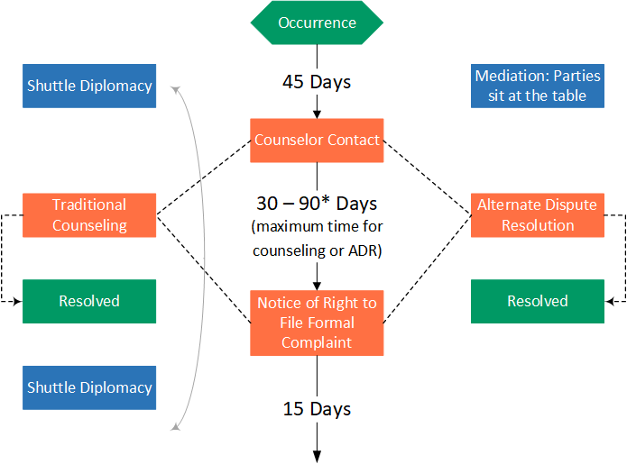
Figure 3. Process flow diagram of the Formal Complaint Process (Under 29 C.F.R. 1614) Stage 2

Reports
The Regional Directors (RDs), Special Census Manager and Administrative Specialist, are responsible for maintaining the minority statistics records and reporting system, which shows the effectiveness of the EEO Program within the Census Bureau. They must ensure at the time of appointment, all RCC appointees complete a Form SF-181, Race and National Origin Identification, and a Form SF-256, Self-Identification of Handicap, and the information is transferred accurately. (See Chapter 4, Personnel Administration, of this manual, for details concerning these forms.)

Recordkeeping
The official EEO complaint file is maintained at the DOC/Decennial Office of Civil Rights. A copy is retained in the EEO Office, Headquarters.
The regulations require the RD to retain all records (including scratch notes) pertaining to a complaint until notified by the EEO Office that all litigation has concluded, and the case is closed.
The investigation may require you and other employees of your organization to furnish affidavits regarding matters pertaining to this complaint and to provide access to Census Bureau files and records to answer the complaint. The investigation may require records of employees holding a position like complainants in the same or different branch or division.

Correspondence
Retain all EEO correspondence, documents, records, or memoranda as directed by OPM files retention policies and as directed by the EEO Office and/or DOC Office of Civil Rights.
- Employees and managers who have questions are also encouraged to contact their servicing Office of Civil Rights. To learn more about EEO Laws, please visit the Equal Opportunity Commission’s website at: http://www.eeoc.gov/laws/types/genetic.cfm

This page intentionally left blank.

Payroll Administration
This chapter provides an overview of how Special Census employees are paid, explains allowable reimbursable expenses and how to review staff payrolls.
In addition, this chapter addresses payroll processing procedures for employees paid under the payroll system managed by the National Finance Center (NFC). The extent of processing NFC payrolls is limited to the Web Time and Attendance (GovTA) program. Preparation of payroll is administered by employees or timekeepers and certified by supervisors.
Depending on RO guidelines, some of these activities may be performed in the Special Census Office or in the Regional Office. Regardless of which office conducts the activities, the procedures remain the same.

Overview

Special Census Supervisor Responsibilities
The Special Census Supervisor is responsible for the administration of all payroll-related activities. Some of these duties may be delegated to Field Managers or clerks, if authorized by the RO.

SC-13, Budget Allocation
The SC-13, Budget Allocation, is completed by Special Census HQ staff and serves as the Special Census budget authorization. An example of Form SC-13 is shown in Illustration 6.1. This form is prepared prior to opening the SCO and should be used to monitor expenditures against the allocated Special Census budget. The RO also uses the SC-13 to monitor the SCO’s expenditures.

The Special Census Project Number
The Census Headquarters (HQ) assigns a project code to each Special Census to track supervisory payroll and other charges.
The Special Census project code is shown in Item D of the heading, on Form SC-13, Budget Allocation.

Figure 4. Example of Form SC-13, Budget Allocation (Not real cost data; for illustration only)
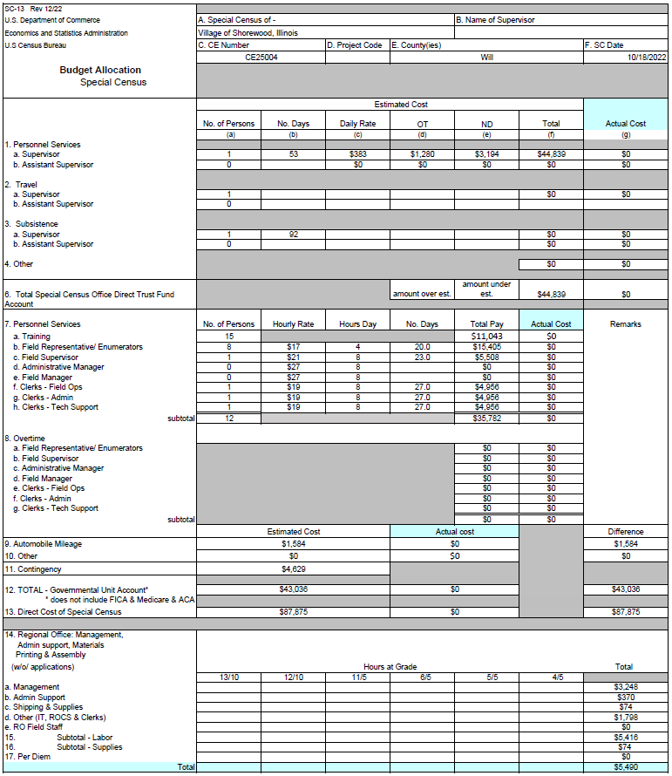

Staff Hours and Pay Guidelines

The Special Census Supervisor Pay
The Special Census Supervisor wages, travel, and per diem, if authorized, are charged directly to the Special Census project code and submitted to the Regional Office (RO) for processing. The RO will provide the guidelines to the Special Census Supervisor for submitting his or her payroll and expenses to the RO.

Special Census Office and Field Staff
Apart from the Special Census Supervisor, all Special Census staff are intermittent employees. They are Schedule A, temporary employees with an intermittent work schedule.

Intermittent Field Employees
Intermittent field employees include the following positions:
- Field Supervisor
- Field Representative
Intermittent field employees are paid on a biweekly pay cycle. Every Special Census week begins at 12:01 a.m. Sunday and ends midnight on the following Saturday.
Field employees do not have a regularly scheduled tour of duty and do not earn annual or sick leave. Field employees are not allowed to work overtime hours without prior written approval from the supervisor. If overtime is necessary, the RO must approve the overtime hours before they can be worked. If a field employee works overtime without supervisory approval, they will be subject to termination. See Topic 3 for more information about the Special Census overtime policy. 180-Day FRs will not have census email accounts, they will not receive email notification of approved OT requests, or similar requests, Therefore, notification of approval or denial of OT must be a manual process. They may have to use their personal email accounts to send documents to the SCO or RO, providing they are not emailing PII information.
Field employees use the BC-27A, Field Employee’s Reimbursement Expenses and the BC-27, Time, Attendance, and Cost Report to record their hours, mileage, telephone, and miscellaneous expenses daily as work is completed or as reimbursable expenses are incurred. The entries made on the fillable BC-27A and BC-27 for intermittent employees are emailed to the Regional Office no later than Monday of Week 1 for the previous payroll week. RO Admin staff will key the data from the timesheet into GovTA. The Special Census Supervisor is responsible for reviewing and certifying all field employee payrolls.

Official overnight travel must be approved by a supervisor and must use the E2 travel system.

Intermittent Office Employees
Clerks are intermittent office employees.
Intermittent office employees, like intermittent field employees, are paid on a biweekly pay cycle. Each week begins at 12:01 a.m., Sunday and ends midnight on the following Saturday. If an office employee works more than five consecutive hours in any day, they must take an unpaid meal period of 30 minutes.
Office staff will be assigned a work schedule by their supervisor. They are expected to work these hours, which should be no more than 8 hours in a day. Unlike intermittent field employees, office employees are not allowed to work more than 8 hours in a day because they have a scheduled tour of duty. If overtime is necessary, the RO will approve the overtime hours before they can be worked. If an office employee works overtime without supervisory approval, they will be subject to termination. See Topic 3 for more information about the Special Census overtime policy.
Office employees will use GovTA to record their hours by Thursday of the 2nd week of the current pay period. The following day, which is on Friday, employees may make changes or additional entries in GovTA and validate it for affirmation on the accuracy of the information.
Mileage, telephone, and miscellaneous expenses will be entered into E2 for reimbursement.

Paying the Staff
The pay rates for locally hired special census employees is determined for the geographic area in which the Special Census is being conducted. The applicable pay rates for the various positions (Field Representative, Field Supervisor, clerk, etc.) within the Special Census area are shown in Item 7 on the SC-13, Budget Allocation (See Illustration 6.1 on page 6-3).

Field Staff Pay
Field Supervisors and Field Representatives are paid the regular hourly rate as specified on the SC-13. Field staff who use public transportation or use an automobile for enumeration are also reimbursed for fares paid or miles driven, as appropriate, while on official business.
Field staff are also entitled to claim the time spent traveling to and from their home to their assignment area while working. Field staff are also entitled to claim the time spent traveling to and from training sessions and for the time spent in training.

Office Staff Pay
Clerks are paid the regular hourly rate as specified on the SC-13.
Intermittent office employees are not paid for travel miles nor travel time to the office because their duty station is the Special Census office. This is unlike field employees, whose duty stations are their homes.

Authorized Work Time
Office supervisors inform intermittent office workers of the hours and days they are to report for duty. SCO office work schedules are established by the SCO Supervisor in consultation with the RO.
Intermittent field employees are expected to work the most productive hours for the Special Census area. Usually, this means late afternoon and evening hours during the week and daytime hours on the weekend.
Full time employees have a scheduled tour of duty. This means they report to work each day at a scheduled time.
All intermittent field employees are paid for time spent:
- Training in the classroom and on-the-job training
- Traveling to and from the training site
- Traveling on official business
- Completing work assignments
- Reviewing work assignments
- Meeting and discussing work with supervisors

Unauthorized Time
Payment will not be made to intermittent employees for:
- Time used for meal periods
- Time spent running personal errands or any other non-Special Census business during the workday

Night Differential Hours
Night differential pay is not authorized for Special Census employees. Under no circumstances will local intermittent employees be authorized night differential pay.
As the Special Census Supervisor, do not perform any of the following activities after 6 PM, without the RO’s advance approval:
- Interviewing job applicants or conducting interviews with respondents.
- Preparing Field Representative materials for assignment.
- Reviewing manuals or instructional memoranda.
- Making travel arrangements.
- Transcribing data, editing, and other clerical duties.

Overtime Policies

Overview
Overtime will be paid to the staff only if authorized or approved by the Regional Director (or designee). If staff overtime is needed, the Special Census Supervisor must discuss the situation with the Regional Office. The RO will determine whether overtime will be approved.
All employees sign a Temporary Excepted Service Agreement and an Overtime Policy Agreement at the time of hiring. Their signature indicates they agree to abide by the regulations stated on the form(s). These agreements state that employees are NOT allowed to work overtime unless the employee receives prior approval from their supervisor.

Overtime Policy for SCO Field Intermittent Employees
To be most effective and complete the operation on time, employees are expected to work most days in the weekly pay period. However, they must not work more than 40 hours or eight hours in a day in any weekly pay period, unless they are specifically authorized to do so in advance. Employees are expected to complete their assignments without having to work overtime. If employees feel they have more work than they can complete in a 40-hour week, they are instructed to contact their supervisor to discuss the situation. It may be that the work can be redistributed to others within the team or can otherwise be completed without needing to work overtime.
Working overtime of more than 40 hours in a week or eight hours in a day, is not permitted without written approval from their supervisor. If the supervisor decides that overtime hours should be authorized, then the supervisor will seek authorization from the appropriate manager or designee and let the employee know if the overtime hours can be worked. Unless you receive explicit directions from your supervisor to work overtime hours, you may not do so.

Unavoidable Circumstances
If a field employee works more than 40 hours in a week or eight hours in a day without supervisory approval, he or she is subject to termination unless the overtime was caused by unavoidable circumstances.
Unavoidable circumstances are defined as unforeseeable circumstances beyond the employee’s control. Unavoidable circumstances included but are not limited to weather-related incidents such as a blizzard, flood, hurricane, etc. Traffic is not considered an unavoidable circumstance unless a field employee is involved in an accident, delayed by an accident or unforeseen road condition.

Accumulating Hours
Field employees are not allowed to manipulate or record hours on their timesheets on days that they were not worked. This means they must not work, for example, 42 hours in one week and record only 40 hours on the payroll forms for that week, and then record the remaining two hours on a payroll form during a subsequent week when they have worked fewer than 40 hours.
This is a manipulation of hours and is grounds for termination of employment.
If the Bureau finds that a supervisor approves or instructs an employee to manipulate or accumulate hours or otherwise submit incorrect payroll forms, then the supervisor will be terminated, and the employee who manipulated the hours may be terminated. Accumulating hours will not be tolerated.
If employees become aware of other employees accumulating hours or any supervisor giving instructions to crews to accumulate hours or to work overtime without compensation, employees must report the incident immediately to their supervisor or the Special Census Supervisor. If needed, the incident can also be reported to the RO Manager.
All employees signed a Temporary Excepted Service Agreement and an Overtime Policy Agreement at the time of hiring in which they agree to abide by the regulations on these forms.

Overtime Policy for Intermittent Office Employees
Overtime is defined as working more than 8 hours a day or 40 hours a week, scheduled and approved in advance.
The appropriate manager or designee must approve all requests for overtime hours in advance before intermittent office employees begin working the additional hours. If they work overtime without supervisory approval, they will be subject to termination.
By signing the Temporary Excepted Service Agreement and Overtime Policy Agreement at the time of hiring, all employees agree to abide by the regulations stated on these forms.

Procedures for Documenting Request for Approval of Overtime Hours
Supervisors requesting overtime must justify in writing, the need for the overtime on a CD-81, Authorization for Paid Overtime and/or Holiday Work, and for Compensatory Overtime.
Office employees request and obtain approval for premium pay through GovTA.
There is no need for a CD-81 if the post approval is in GovTA.
However, due to the nature of field work and following RO policy, field supervisors may obtain verbal approval from their supervisors and then follow-up with the written approval from the appropriate manager on the CD-81 form.
Note: When the dates for the authorized official’s signature at the bottom of the CD-81 are later than the date the overtime request was verbally approved, note in Item 11 the date verbal approval was given. See illustration 6.2 for an example note.
If the request involves multiple employees, the SCS may prepare a list of employee names by Field Supervisor District and attach it to the CD-81.
Complete the CD-81 and route the documents for signature to the appropriate RO manager. In some regions, this may be the Special Census Supervisor. Follow your regional office policy.
Any list of employee names attached to the CD-81 must contain the following for each employee:
- Name
- Title
- Pay rate
- Total number of overtime hours worked
- Estimated cost
Complete the hours and estimated cost fields at the time the CD-81 is prepared for that workweek. For each week that overtime is worked, prepare a CD-81, attach the list of employees with required information, and route for appropriate signatures.
Provide a signed copy of the CD-81 to the payroll section so the clerks can use it when auditing the timesheets. Retain the original CD-81 in a permanent file marked CD-81, Authorization for Paid Overtime and/or Holiday Work, And for Compensatory Overtime

Figure 5. CD-81, Authorization for Paid Overtime and/or Holiday Work and for Compensatory Overtime
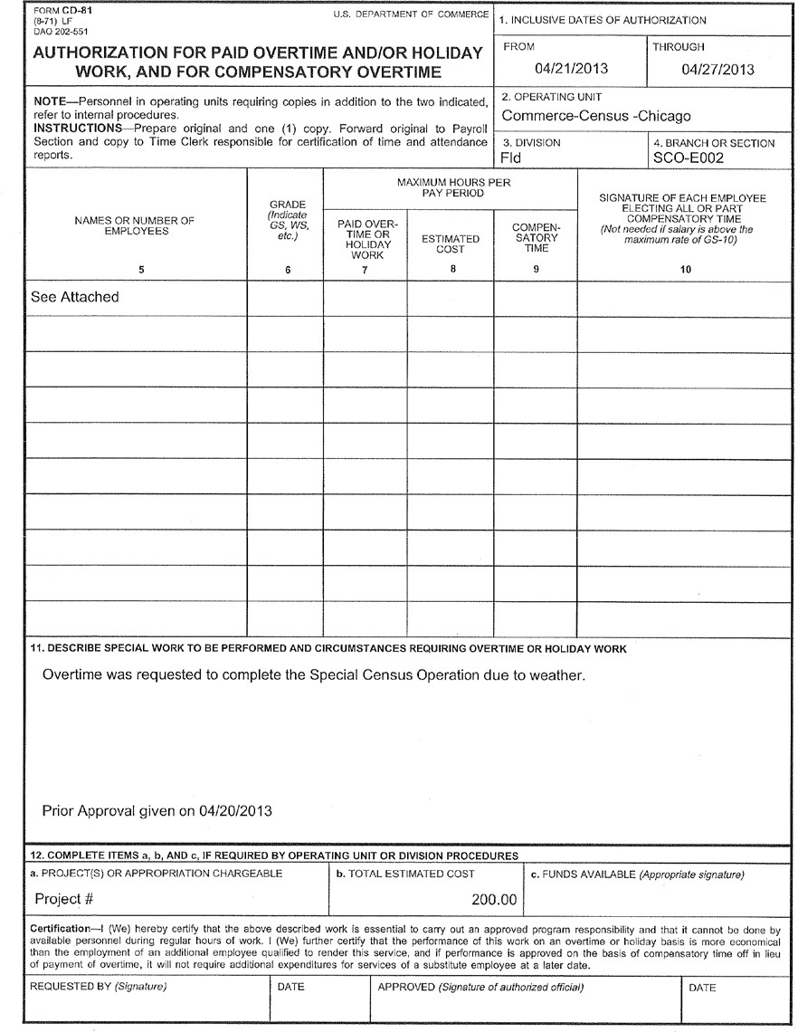

Collecting, Certifying and Reviewing Field Staff BC-27A and BC-27 Payroll Documents
Special Census Field Supervisors (FS) and Field Representatives (FR) record their hours worked on a fillable pdf version of the BC-27, Time, Attendance, and Cost Report and miles driven (field staff only) daily on the BC-27A, Field Employee’s Reimbursement Expenses. See Appendix B for how to complete the BC-27 and BC-27A.
The FR/FS emails their completed timesheet to RO Admin who keys the data into GovTA.
Special Census Supervisors review the BC-27 and BC-27A bi-weekly for the FR staff. The SC supervisors must review and ensure that all entries are complete and accurate and reflect the amount of work performed.

Review the payroll documents
The Special Census Office Manager will review the FR, FS and office employees’ Clerk’s hours in GovTA and certify the T&A once the timekeeper notifies the supervisor to certify.
The Special Census Office Clerks will be responsible for entering and validating their own T&A each pay period and submitting the appropriate supporting documentation to the Timekeeper as soon as the T&A record is validated. The T&A record must be validated by close-of business on the second Friday in the pay period.

Verify FR employee identification items – BC-27, Time, Attendance, and Cost Report
SC Supervisors verify the Identification Items 1 through 6 on the payroll document. Ensure that the full name, employee ID and FR code are entered. Verify that the day of the week corresponds to the correct date.

Training Hours
Employees are paid their regular hourly rate for time spent in classroom training and on-the job-training. This includes the time spent completing appointment documents and travel to and from the training site. If training was approved for more than 8 hours in a day, including the travel time home after the training session, the employee is entitled to claim overtime for those hours.

Verify work hours and daily expenses
SC Supervisors verify that the hours and expenses claimed by Field Representatives are reasonable in relation to the assignment, and that the times of day worked are accurately reflected in the number of hours recorded.

Verify per diem expenses - BC-27A, Field Employee’s Reimbursement Expenses
Per diem expenses must be approved in advance. If approved, per diem expenses for overnight travel are claimed by a field employee, through E-Gov Travel Service 2 (E2). E2 automates and consolidates the Federal travel process in a self-service Web-centric environment, covering all aspects of official travel, including travel planning, authorization, reservations, ticketing, expense reimbursement, and travel management reporting. All Schedule A employees who travel via common carrier (plane, train, or bus) must be processed in the E2 travel system. The travel arranger in the RO or SCO must create a Traveler Profile in E2 for each traveler and before a travel authorization can be created. A request to initialize a traveler in E2, so that a profile can be created is submitted in Remedy. Verify mileage claims - BC-27A, Field Employee’s Reimbursement Expenses
SC Supervisors review the mileage claimed by Field Representatives (FRs) and determine whether the miles driven are reasonable for the number of hours worked, the amount of work completed, and the geographic territory within the AA.
SC Supervisors should be familiar with each assignment area so they can determine what a reasonable mileage claim is. Field Supervisors should question claims for excessive mileage but relatively few hours worked. If the employee works in a sparsely populated area, it may be likely to have relatively large mileage claims in comparison to work hours.
If Field Representatives claim unreasonable mileage, suggest ways the employee can decrease excessive mileage. If excessive claims continue, Field Supervisors must report the situation to their respective supervisor or the Special Census Supervisor

Verify Reimbursable Expenses - BC-27A, Field Employee’s Reimbursement Expenses
Reimbursable expenses are necessary expenses that employees may incur while performing their official duties. All purchases which an employee claims as reimbursable expenses must be approved in advance by the Special Census Supervisor.
In general, employees are provided with all the materials necessary to do their jobs. The Census Bureau will reimburse employees and authorized field staff for the following expenses:
- Miles traveled in a privately-owned vehicle from the office to the training site or other official work destination and return.
- Road, bridge and tunnel tolls, local bus, trolley car, ferry or subway fares when conducting official Special Census activities while in the field or when traveling from the office to an official work destination and return (toll receipts must be attached to the BC-27A).
- All supervisor-authorized purchases. Purchases totaling $5 or more must be accompanied by a receipt.
- Field employees can claim reimbursement for official Census business related telephone calls made from their personal phone that exceed the standard or basic service; or business-related telephone calls made from a prepaid wireless plan. The Census Bureau will not reimburse the employee for charges that are covered by the employee’s basic service plan. The Census Bureau will not pay for the basic service plan itself, or any changes that the employee makes to the basic service plan.
Additionally, the Census Bureau has established a CAP for reimbursement of $240/month. Use of the employee’s personal phone for Census business related calls is voluntary.
The employee will submit an itemized copy of his or her telephone bill that verifies the total of reimbursable expenses that he or she enters on his or her payroll form. The employee agreed to these terms when he or she signed the SC-1129, Personal Telephone Reimbursement Policy Agreement for Special Census Staff (Appendix C).
- Parking fees if free parking is not available at the official work destination and/or parking fees for metered spaces. Parking receipts must be attached to the BC-27A.
Field workers are reimbursed for parking fees that are necessary in the performance of their duties, including parking at the SCO if they must go to the SCO and free parking is not available.
- Because the Special Census Office staff’s duty location is the Special Census Office, they are not eligible for parking fee reimbursement if free parking is not available at the Special Census Office.
- Per diem for meals and lodging expenses when overnight travel is authorized.
- The Regional Office determines the Special Census Supervisor’s official duty station. If the Special Census supervisor is authorized per diem, the Regional Office will provide guidance for travel and expenses.
The Census Bureau will not reimburse the Special Census Supervisor, or any of the staff, for the following expenses:
- Daily parking expenses incurred to park at the Special Census Office if the employee’s official duty station is the SCO.
- The unauthorized use of rental cars and taxis.
- Mileage driven while conducting personal errands, on breaks, or other unofficial time.
- Personal telephone calls made from home or from public telephones.
- Purchases not authorized by the supervisor.
- Any purchase or expenditure (even if approved) costing more than $5 which does not have a receipt attached to the BC-27A.
- Towing charges.
- Parking tickets.
- Gasoline, oils, antifreeze, tires, and vehicle accessories.
- Vehicle insurance premiums.

Approve payroll documents
After verifying a payroll document in its entirety, the SC supervisor indicates approval by signing and dating the fillable BC-27 and electronically signing his or her name in the space provided in Item 11, Certified by. If not already completed, the SC supervisor should have the employee electronically sign his or her name in the space above the supervisor’s name.

Distribute payroll documents
The employee receives the yellow copy of the BC-27 payroll document. The white copy is submitted to the office for processing, and the field supervisor (or other supervisor, as appropriate) should keep the pink copy.

SC-20, Field Supervisor’s Management Record
Field supervisors use the SC-20, Field Supervisor Management Record, to track their employees’ field work and time. The field supervisor records each Field Representative hours and mileage on the SC-20. Field Supervisor must update the SC-20 every time they meet with the Field Representative in their crew.

Distribution of the SC-20
The completed SC-20s are submitted to the Special Census Supervisor at the end of the operation.

Payroll Forms Auditing and Check-in
Field Representatives use the fillable pdf version BC-27A, Field Employee’s Reimbursement Expenses and the BC-27, Time, Attendance, and Cost Report, to maintain a daily record of their hours worked and miles driven while on duty. When a Field Representative’s work assignment is completed for the pay period it will be email to the SCO/RO for processing.
Office staff use GovTA to record their daily hours worked. SC supervisor will review and certify GovTA at the end of the pay period.
It is the SCO’s responsibility to account for all bi-weekly payroll forms from all Special Census staff, both office and field. It is important that these forms are audited for completeness and accuracy. Depending on RO guidance, auditing may be conducted by the SCO staff or the RO staff.

Staff Payroll Check-in
The BC-27A, Field Employee’s Reimbursement Expenses and the BC-27, Time, Attendance, and Cost Report, is shown as Illustration 6.3. The Special Census supervisor should monitor the receipt of all BC-27As and BC-27s as well as conduct a thorough review for reasonableness and accuracy. The BC-27A and BC-27 check-in occurs at the end of the Special Census operation.

Fraudulent Claims
An employee’s claims for hours and reimbursable expenses must accurately reflect the time and cost related to their official duties.
Their claim may be forfeited if they attempt to defraud the government in connection with any expense. Additionally, there are criminal provisions under which severe penalties may be imposed if they knowingly submit a fraudulent claim.

Auditing Intermittent Employees Payroll
Depending on RO guidelines, the BC-27A and BC-27 review and audit for the Special Census staff may be performed at the SCO or the RO. Regardless of who performs the audits, the procedures are the same.
Clerks audit all BC-27A and BC-27 to ensure that they are correct. They may make corrections to an BC-27A or BC-27 if they can be made in the SCO. Types of acceptable corrections include corrections to errors in addition and information. If the SCO edits an BC-27A or BC-27, the employee must receive a copy of the corrected BC-27A or BC-27, along with an explanation of the corrections.
If BC-27A or BC27 contain errors that cannot be corrected by the audit clerk, the forms are returned to the appropriate supervisor, and possibly to the employee, for correction. This should be an infrequent occurrence since the supervisors are required to review these forms.
Clerks perform the following review activities:
- Verify totals for regular and overtime hours worked. Note that time may be claimed in whole, half or quarter hour increments only (e.g., .1 = 15 minutes, .2 = 30 minutes, .3 = 45 minutes).
- If an employee claimed overtime, check that the employee received prior approval documented on a CD-81.
Verify the totals for miles driven and other reimbursable expenses. Verify that the totals reflect the amount claimed on the BC-27A.
- Check that the employee signed and dated the BC-27.
- Check that the SC supervisor (SCS) signed and dated the form.
After the review, the clerk signs and dates the form in Item 9, Payroll Office Use.
In preparation for the next step in processing FR’s BC-27A and BC-27s, the SCO or RO Timekeepers will key data from the BC-27 Time, Attendance, and Cost Report into GovTA on a bi-weekly basis and validate the T&A.

Timekeepers Responsibilities
Special Census Timekeepers are responsible for entering data from the BC-27 to ensuring time and attendance (T&A) data for SC Field Representatives are, entered, recorded, and certified in the GovTA system by the payroll processing deadline.
Timekeepers are responsible for:
- Obtaining supporting documentation, if applicable.
- Creating and updating employee Timesheet Profiles.
- Ensuring T&As are keyed and validated, as required in a timely manner by the payroll processing deadline.
- Notifying the supervisor when T&As are ready to be certified.
- Discussing T&A documentation issues with the supervisor, if applicable.
- Ensuring employees are notified by the supervisor when changes are made to a T&A data.
- Keeping supervisors updated on payroll processes.
- Only the Timekeeper can initiate and validate a corrected T&A.
- Maintaining a payroll folder for employees to file supporting documentation.
- The SCO/RO will email the Earning & Leave Statement to the FR after each pay period.

SC Supervisors Responsibilities
SC Supervisors are responsible for controlling the T&As under their supervision. This includes reviewing T&As for accuracy and completeness, then certifying the T&A record. Supervisors must take great care when certifying T&A records since the supervisor’s certification authorizes pay to the employee for time worked.
SC Supervisors are responsible for:
- Familiarizing themselves with the coding/structure of the T&A record and ensuring their timekeepers/employees have adequate T&A training.
- Providing timekeepers with appropriate information necessary to complete the T&A profile and ensuring appropriate supporting documentation is retained in the employee’s payroll folder.
- Ensuring approval is obtained from the Contract Claims Services, Incorporated (CCSI) prior to certifying the Occupational Workers’ Compensation (OWCP) Injury Leave.
- Ensuring that the hours and reimbursements reported on the T&A Summary are true and correct before certifying the record.
- Ensuring T&As are certified for each employee under their supervision, as required, in a timely manner to enable payment within the payroll processing cycle.
- Ensuring all T&A supporting documentation is maintained/accessible for six years.
- Providing measures to ensure a level of security exists to eliminate the possibility of T&A fraud/abuse.

Figure 6. Example of Form BC-27, Time, Attendance, and Cost Report (front).
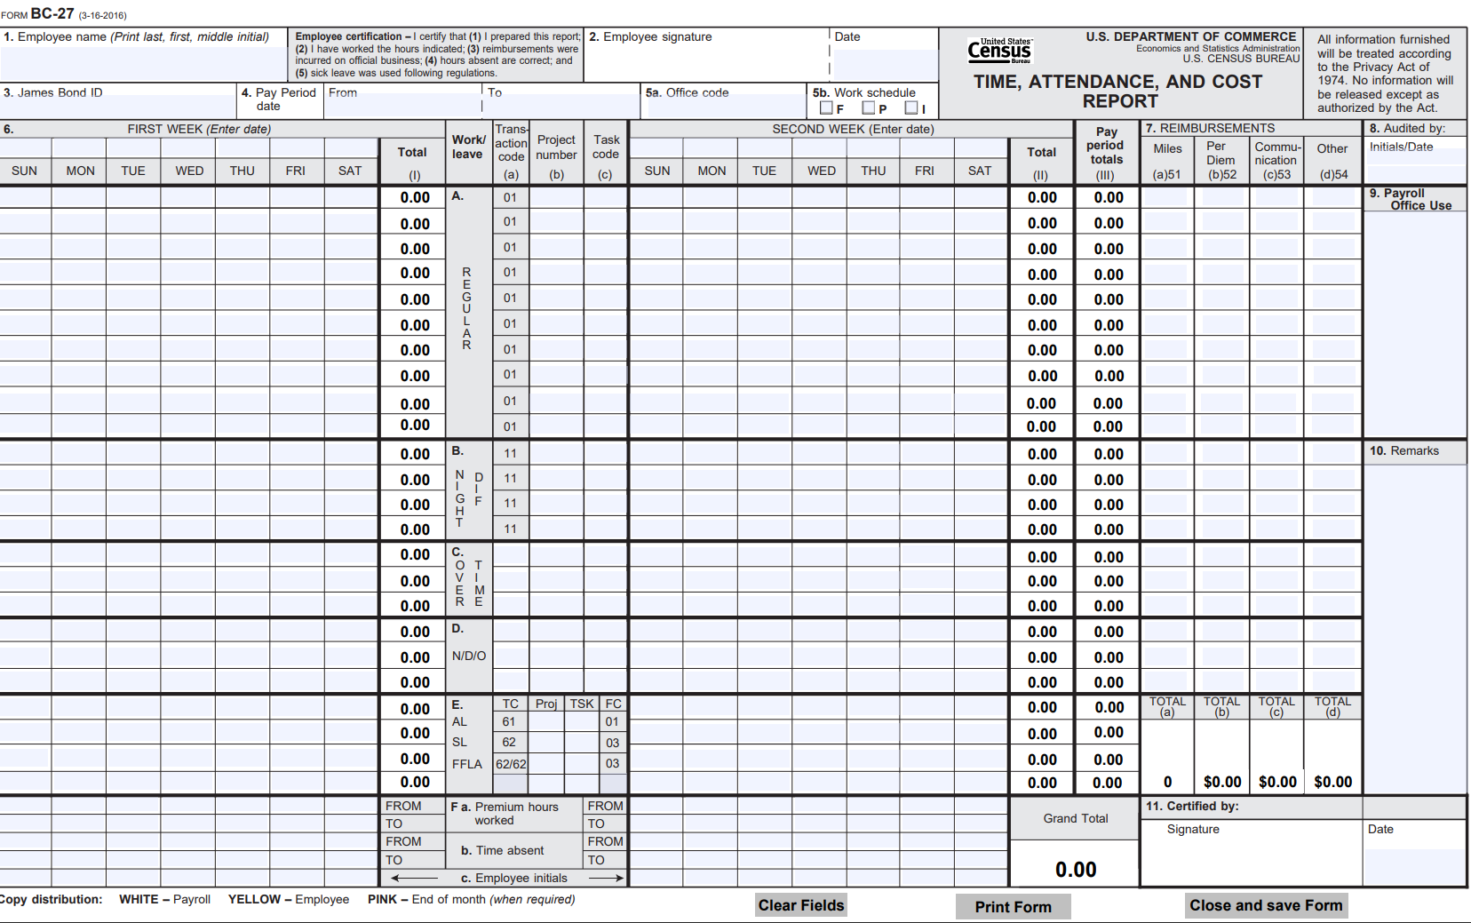

Figure 7. Example of Form BC-27, Time, Attendance, and Cost Report (back).
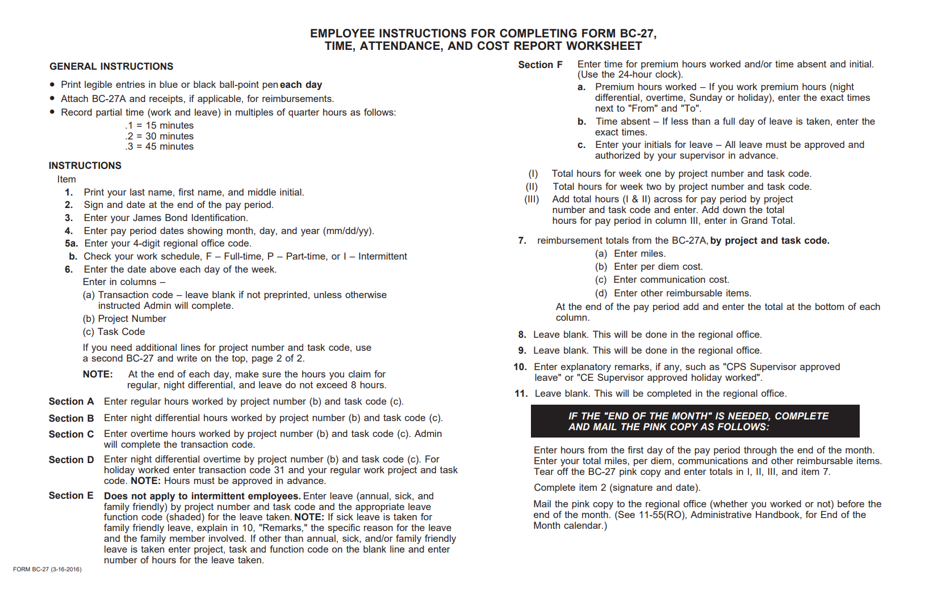

Figure 8. BC-27A, Field Employee’s Reimbursement Expenses (front)
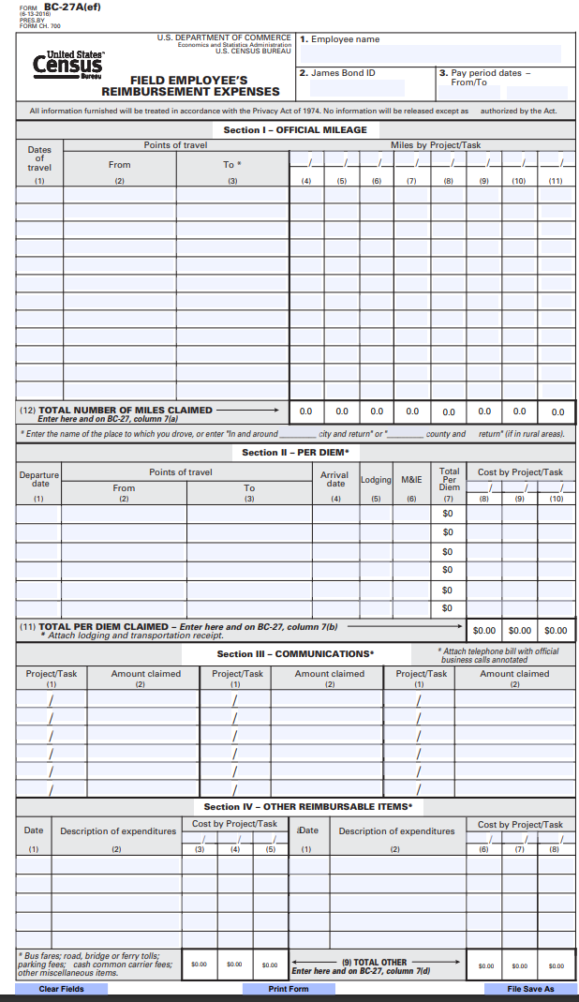

Figure 9. BC-27A, Field Employee’s Reimbursement Expenses (back)
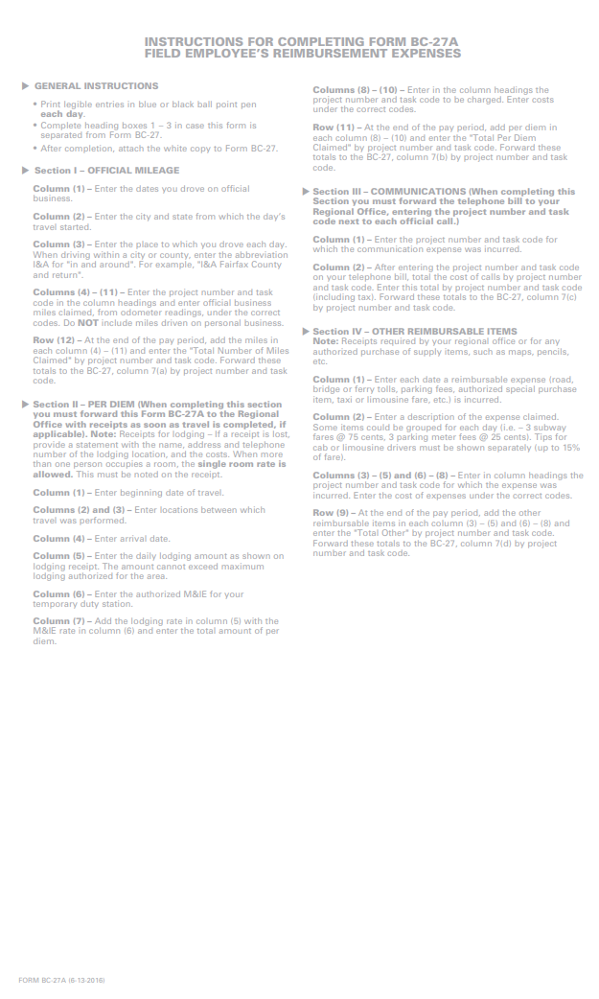
This page intentionally left blank.

Special Census Supervisory and Administrative Duties

Appointing Your Staff During Operational Training

Overview
The Special Census FR employees are appointed to a temporary Schedule A position in the excepted service with a specific not-to- exceed (NTE) date of 180 days from the date. At the end of the 180 days, the FR must be terminated for Expiration of Appointment. If the work is done earlier than the 180 days, the employee is to be terminated for Lack of Work. Between day 90 and 135 of their appointment, the FR can be converted to a current survey vacancy. See ROAM 2024-07 for guidance. Employees are assigned to an intermittent work schedule; that is, they work on an as needed basis and are not eligible for employee benefits or federal retirement.
Employees who work 130 hours in 90 days are eligible for health insurance.
Employees assigned to an intermittent work schedule are paid only for the hours worked, and the number of hours can vary depending on the assignment need. The employee:
- Does not earn or use paid annual (personal) or sick leave.
- Is not eligible for life insurance coverage.
- Is not eligible for federal retirement coverage.
- Is not eligible to receive holiday pay.
- Night Differential pay is not authorized.
Is not eligible to participate in the Thrift Savings Plan
Smart E-Verify and Swearing-In for Special Census Staff
The RO will have several options for handling Smart E-Verify and Swearing-In SC Field Staff
Smart E-Verify must be completed by RO admin prior to day 1 of training. The RO has guidance on this procedure. No one should be allowed to attend training if they have not completed their I-9 verification using Smart E-Verify. The appointee does not need to bring any identifying documents to the training session. The I-9 is not to be included in any of the training packets.
RO Admin can also swear in the appointee while completing Smart E-Verify. If this is done, the appointee should be emailed the BC-61. The appointee should be instructed to print the BC-61, sign, and date it. And then email it back to the RO. The date should be the date the new employee was sworn in by RO Admin. Note: The 180-Day counter begins when the person is sworn in.
The RO can also have the person sworn in at the training. If this is done, the BC-61 must be included in the training packet.
Note: If the RO is swearing in appointees at the training session, the training session MUST be held within 3 days of when the I-9 was verified with RO Admin. That is why we recommend having RO admin conduct the swearing in while also completing Smart E-Verify.

Completing the appointment and training process
It is your responsibility, as the Special Census Supervisor to ensure the trainees complete the required appointment forms.
You are provided complete verbatim instructions on the appointment process in the various operational training guides.
Follow these steps to complete the appointment and training process:
- Ask trainees to introduce themselves, as they do annotate their attendance.
- Distribute to trainees, their individual appointment folder. (You should have already obtained these from the SCO. If you do not have the folders or are missing any, contact your SCO.)
- Have trainees review and complete various personnel documents. Have the trainees verify their folder contains the following forms:
- BC-61, Appointment Affidavits (if being sworn in during training)
- OF-306, Declaration for Federal Employment. Require 17B signature
- SC-186F, Special Census Employment Agreement Temporary Excepted Service
- SC-999, Overtime Policy Agreement SC-287, Post Employment Restrictions
- SC-1129, Personal Telephone Reimbursement Policy Agreement
- SC-472, Top 10 Ethics Rules for Special Census Employees
- SC-473, General Ethics Principals
- W-4, Employee’s withholding Allowance Certificate
- Upon completion of the first day of Operational training, hand-carry or send by UPS (next day or overnight) all appointment folders and folders for the no-shows to the appropriate Special Census Office or the Regional Office for immediate processing. You must account for and return all appointment folders. A delay in returning the appointment folders to the SCO or RO will cause a delay in the employee’s paycheck.

Effective Dates
The effective date is the date that a personnel action takes place. No personnel action can be made effective prior to the date the manager/supervisor approves the request for processing an action unless the action is death or resignation.
When processing a Hire or Rehire, use the date the Oath of Office was administered on the BC-61, Appointment Affidavits.

Position Descriptions
A position description (PD) is a narrative statement of specific duties and responsibilities comprising the work assigned to an employee. An employee may receive a copy of their assigned PD, upon request, and their SF-50, Notification of Personnel Action when an action is processed for the employee.

Duty Station
The duty station represents the official city, county, and state in which the employee works.
- The duty station for employees assigned to a field position (i.e., Field Supervisor, and Field Representative) will be their home address.
- The duty station for employees assigned to an office position who work most of their work in the office (i.e., clerk) will be the location (city, county, and state) of the Special Census Office (SCO).

Initiating Personnel Actions

Type of Personnel Actions the Special Census Supervisor Can Request
There are several personnel actions you can request as a supervisor including:
Extension of Appointment: The administrative staff at the RO will notify the Special Census Supervisor of those employees that are coming to the end of their current appointment. The Special Census Supervisor will decide based on the status of the current operation and terminate the employee for End of Temporary Appointment or request an Extension of Appointment. See ROAM 2024-07 for additional guidance.
Cancellation: If a previous personnel action was requested in error, the RO will initiate a PAR action CHRIS to request a cancellation of that personnel action.
Any terminations processed for Performance and/or Conduct must have been documented to support the termination and be approved by both ERB and the RO.
Termination: The RO will need to initiate termination actions for Lack of Work, Expiration of Appointment, Resignation, or Performance and/or Conduct. Discuss performance and conduct terminations with ERB and the RO. Do not allow employees that should be terminated for performance or conduct issues to be terminated for Lack of Work or Expiration of Appointment. If this was done erroneously, the employee will be available for future job openings.
Refer to Topic 3 PERFORMANCE AND CONDUCT-BASED ACTIONS.
Name Change: If an employee has a name change due to marriage or divorce, attach a copy of the marriage certificate or legal document so the RO can initiate the name change.
Personal Updates: Employees can request updates to their home or mailing address, telephone number, tax deductions, race, and ethnicity. The employee can log into EPP to make these updates if the employee has a census email address. If the employee is requesting change in tax status, a W-4 should be submitted by the employee.

Performance and Conduct-Based Actions

Conduct
Unacceptable conduct covers a range of employee work behaviors. Some of them include, but are not limited to:
- Tardiness.
- Insubordination, which is an employee’s refusal to obey an order, such as refusing an assignment or not completing a work assignment by a deadline; The burden is on the supervisor to phrase the order in such a way that there are no options. Make it very clear that the work must be completed by a certain time, for example: “You must complete this by the end of the day.”
- Creation of work disturbances.
- Hitting or striking another employee or respondent.
- Falsifying data on job applications.
- Falsifying Census Bureau data.
- Permitting employees to work unauthorized hours, manipulate hours or work unauthorized overtime.
When a conduct-related situation occurs, counseling the employee should be the immediate starting point for dealing with conduct problems. The employee is to be counseled and the counseling session must be documented along with recommended steps for correction given to the employee as well as a recommendation for action. For Field Staff, document the discussion on the Form BC-282, Documentation of Conduct and/or Performance Problems. Make certain to alert your manager and Employee Relations Branch (ERB) specialist when you need to counsel or provide OJT to a team member.
The nature and seriousness of the misconduct may warrant going directly to a recommendation for termination of employment as the most appropriate action. Given the temporary nature of these appointments, termination of employment without progressive discipline may be warranted in many cases. If the Field Supervisor decides that termination is the recommended action, the Field Supervisor will discuss the situation with the Special Census Supervisor, and Employee Relations Branch (ERB) specialist who will make the final decision.

Performance
Unacceptable performance occurs when an employee fails to meet acceptable performance standards. Unacceptable performance could be deficient production, response, accuracy, and/or transmittal/timeliness rates.
First line supervisors must advise an employee with less than satisfactory work performance of their performance deficiencies and advise that an improvement is expected within 24 to 48 hours, or termination from census duty will result. Employees who continue to exhibit less than satisfactory work performance or conduct problems must be terminated from employment.

Conduct and Performance Provisions
Statutory and regulatory provisions that apply to conduct and performance-based actions are different. However, there are some basic rules of thumb to follow when dealing with either conduct or performance problems:
- The supervisor needs to respond in a timely manner to a conduct or performance problem counseling the employee and providing him or her with specific steps for improvement. The supervisor will consult with the Special Census Supervisor about the counseling plan prior to providing the counseling to the employee. The supervisor will try to secure the employee’s commitment to positive change.
- The supervisor selects the response that fits the problem. The supervisor considers the nature and seriousness of the problem, including any history of a similar problem and the action, if any, taken at the time.
- The supervisor needs to be consistent in responding to similar problems.
- The supervisor will ensure the employees are aware of what is expected of them and the possible consequences for not improving their conduct or performance.
- The supervisor providing the counseling must document all counseling sessions including date and time, the matters discussed, the supervisor’s responses, including recommendations, and those of the employee. Make sure you clearly state your expectations for improvements and the consequences if these expectations are not met.
For 180 Days Field Reps Only: All documentation must be completedon Form BC-282, Documentation of Conduct and/or Performance Problems.

Disciplinary Adverse Action File (DAAF) and Documenting Conduct and Performance Issues
The Disciplinary Adverse Action File (DAAF) is an individual file for each employee involved in a performance or conduct based action. The file, which is maintained at the SCO/RO in a locked cabinet, will contain record counseling session(s) with an employee. The DAAF will be created for the employee, and it will be included in the employee’s folder that is kept at the SCO/RO.
The first line supervisor must document all counselling sessions and terminations for cause on the BC-282, Documentation of Conduct and/or Performance Problems for FR. This file will be used to document the reason(s) for termination and to respond to any unemployment compensation claims, congressional inquiries, or EEO complaints that might arise.

Summary
It is critical that conduct and performance issues be addressed in a timely manner. When discussing the issue with the employee, the supervisors need to accurately describe the issue to the employee, recommend steps to resolve the problem, get feedback from the employee, and make sure that the employee understands that future occurrences will result in termination.
The employee will be given a specific date for performance issues to be corrected. If it is a conduct issue, the employee must understand that termination will result if it happens again.
The employee’s immediate supervisor seeks approval from the Special Census Supervisor or designee to conduct the counseling session and document on the on the BC-282, Documentation of Conduct and/or Performance Problems

Releasing Your Staff
Employees can be released for various reasons, some of which are:
- Resignation
- Expiration of appointment
- Lack of work
- Unsatisfactory work performance
- Conduct problems (for example, refusing an assignment)

Release upon Resignation
Employees who wish to resign must submit a written request for resignation to their supervisor. The request should include the employee’s name, effective date of resignation, and a brief reason for the resignation. Employees determine the effective date of their resignation.
If the resignation is made verbally, the immediate supervisor will try to obtain written confirmation of the resignation from the employee. If this is not possible, the person to whom the resignation request is made (usually the supervisor) must prepare a memorandum for the record documenting the employee’s request to resign.
The immediate supervisor must ask employees to complete their final SC-308, Daily Pay and Expense Record. The supervisor certifies the SC-308 and forwards it to the SCO for processing.
RO will initiate a termination action in HRC and attach either the employee’s written resignation or a memorandum for record. A copy of the SF-50, Notification of Personnel Action will be forwarded to the employee.

Release upon Expiration of Appointment (Not-to- Exceed Date) or Lack of Work
FRs cannot work past 180 days. They may be converted to a current survey vacancy between days 90 and 135. See ROAM 2024-07 for more guidance.
At 180 days, terminate the FR for Expiration of Appointment. If the work ends early, terminate the FS and FR for Lack of Work.

Terminating Employees for Conduct or Performance Problems
Employees who exhibit continued performance or conduct problems must be terminated from employment. The first-line supervisor should have already advised an employee whose performance is less than satisfactory that improvement is expected within 24 to 48 hours, or release from census duty could follow.
The counseling session for FR’s should have been documented on the BC-282, Documentation of Conduct and/or Performance Problems and reviewed with their supervisor. During the counseling session, the employee’s immediate supervisor offered suggestions on how to improve and, if necessary, re-trained the employee through on-the-job activities. If the employee’s performance is still less than satisfactory, or misconduct reoccurs, the employee’s immediate supervisor will discuss the termination with the Employee Relations Branch (ERB) specialist and Special Census Supervisor.
The employee’s immediate supervisor will document what suggestions for improvement were made and what the outcome was; and then make a recommendation to terminate the employee. If the Employee Relations Branch (ERB) specialist. approves the termination, he or she will work with the RO to process a termination. Also, the Special Census Supervisor needs to consult with the RO when it is recommended that an employee be terminated for cause.
Additionally, after the Employee Relations Branch (ERB) specialist approves the termination recommendation, the SCO will request a termination action due to conduct and/or performance. The immediate supervisor will reassign any remaining work to another employee within the Field Supervisor District.
Unacceptable conduct covers a range of employee work behaviors including, tardiness, insubordination, creation of work disturbances, hitting or striking another employee or respondent, and falsifying data on employee applications or census questionnaires or other documents.

Release for refusing an assignment
If an employee refuses an assignment for ANY reason, they are to be released from census duty. The immediate supervisor will document on the BC-282, Documentation of Conduct and/or Performance Problems stating the refusal for a work assignment and make a recommendation for termination to the Special Census Supervisor. If the termination is approved, the Special Census Supervisor will work with the RO.

Reporting the Death of an Employee
Report all Census Bureau employee deaths immediately to the RO. Provide the RO the following information:
- Employee’s name, age, and address
- SCO name
- Date and time of death
- Cause of death (circumstances surrounding the death), if known
- Duty status (on duty/off duty)
- Position title
- The RO will communicate this information to Field Division and Human Resources at Census
- HRD will process the action.
- RO Admin should confirm in HRConnect that the personnel action was processed by HRD.

How to release employees
The immediate supervisor will follow the steps in Table 7.2: Separation Action chart below when an employee separates for expiration of appointment, lack of work, resignation/termination, or termination for performance and/or conduct problems. The immediate supervisor should advice the employee there may be a delay in receipt of their final paycheck if they fail to return any government owned property.
- If appropriate, the employee’s immediate supervisor may thank the employee for their help in performing the tasks assigned.
- The employee’s immediate supervisor collects all government property, employee identification card, all used and unused census forms, questionnaires, maps, or other materials, from the employee.
- The employee’s immediate supervisor collects any remaining completed census work and payroll forms from the employee. The employee’s immediate supervisor reviews and certifies the payroll form and give copy 3 to the employee.
- The employee’s immediate supervisor forwards all collected census and government materials to the SCO.
- The employee’s immediate supervisor tells the employee to expect a copy of the separation personnel action (termination or resignation) in the mail within two weeks from the effective date of the separation. (The employee can use this document as proof of employment when applying for unemployment benefits at their local state employment office.)

Employee Grievances

Employee Grievances
The Administrative Grievance Procedure is a streamlined complaint process which provides Special Census Office (SCO) employees an opportunity to seek resolution to employment concerns. Specifically, this is a one-step grievance system which incorporates a higher-level management concurrence requirement when the deciding official does not grant the full relief requested by the grievant.
When employees voice displeasure about any facet of their working environment, supervisors should attempt to resolve the matter by discussing the issue with the employees. Importantly, experience has shown that supervisors resolve most concerns informally through dialogue with the employees. However, employees have a right to file a grievance under the Administrative Grievance Procedure.
Note: Separated employees and applicants who have not been hired by the Census Bureau are not entitled to file a complaint using the Administrative Grievance Procedure.
A grievance is a request by employees for personal relief in a matter of concern or dissatisfaction regarding their employment that is subject to the control of Census Bureau or Department of Commerce management officials.
Employees are considered to have elected the Administrative Grievance forum at the time they complete, in writing, the SC- 244, Administrative Grievance Intake Form, and present it to the SCO Supervisor. When the SCO Supervisor receives a grievance, they must promptly notify the Regional Office Administrative Officer who will contact the Equal Employment Opportunity Specialist. When employees have already filed an EEO complaint about the same issue, the grievance is dismissed.

Employee Options
Employees who elect to file a formal EEO complaint regarding an aspect of their employment are precluded from raising the same matter under the Administrative Grievance Procedure.

Time Limits
Employees must complete and submit a SC-244, Administrative Grievance Intake Form, to their supervisors within 15 calendar days following the date of the act or occurrence or on the date the employee become aware of the grievance.

Deciding Official
Generally, SCO employees must file a grievance with the SCO Supervisor who supervises their work. In cases where the SCO Supervisor does not have responsibility for the matter being grieved or does not have authority to grant the requested relief, the SCO Supervisor should forward the grievance directly to the RO and advise the grievant of such. When SCO Supervisors are unsure who the appropriate decision official should be, they must consult with the RO.

Personal Relief
The grievant must specify the personal relief sought. Personal relief is a specific remedy directly benefiting the grievant. A request for disciplinary action or other action affecting another employee of the agency is not personal relief

Official Time
Allow the grievant a reasonable amount of official work time to present the grievance. The grievant is not entitled to official work time to prepare the grievance.

Processing Requirements
The appropriate SCO deciding officials must confirm that the following items are completed on the SC-244, Administrative Grievance Intake Form:
- The name of the deciding official.
- The name of the grievant.
- The subject of the grievance.
- The dates of the incident(s) forming the basis for the grievance.
- The date the grievant submits the SC-244.
- The date of the grievance meeting or telephone conference call.
- The personal relief requested.
A grievance cannot be processed until all the above information has been entered on the form. If the employee refuses to provide any of this information, this will serve as a basis for dismissing the grievance.
Deciding officials complete the back portion of the SC-244, Administrative Grievance Intake Form, documenting the acceptance or rejection of the grievance, the reasons for the rejection, if applicable, and the final written grievance decision.
Deciding officials do the following when determining the acceptability of the grievance
- Confirm that the grievance is filed according to the specified time limits. If the grievance is not filed in a timely manner, deciding officials reject the grievance and cite the basis for the rejection on the SC-244.
- Confirm that the grievance falls within the scope of the Administrative Grievance Procedure. Refer to the next section, Exclusions, for a list of subject areas that are excluded from the Administrative Grievance Procedure. If the grievance concerns an excluded subject, deciding officials reject the grievance and cite the basis for the rejection on the SC-244.
- Establish a grievance file containing a copy of the SC-244 and any other documentation submitted by the employee.
- Conduct whatever fact-finding is appropriate to the situation.
- Issue a written decision to the employee within 15 calendar days after receipt of the grievance.
When deciding officials grant less than the full relief requested by employees, the deciding official’s supervisors must make the final decision. In this case, deciding officials provide their supervisors with a written recommendation with justification and a copy of the grievance file.

Exclusions
The Administrative Grievance Procedure does not apply to:
- A decision which is appealable to the Merit Systems Protection Board (MSPB) or subject to final administrative review by the Office of Personnel Management (OPM) or the Equal Employment Opportunity Commission (EEOC).
- Published policy or regulations of Field Division (FLD), the Census Bureau, or the Department of Commerce.
- Non-selection for a higher paid position or the failure to receive a conversion to a higher paid position under battlefield conditions.
- An action that terminates a temporary promotion and returns the employee to the position from which he or she was temporarily promoted.
- An action that terminates a term promotion at the completion of the project and returns the employee to the position from which promoted, or to a different position of equivalent grade and pay.
- The granting of or failure to grant an employee award, or the adoption of or failure to adopt an employee suggestion or invention.
- The receipt or failure to receive an award or quality step increase.
- A preliminary warning notice of an action which, if effected, would be covered under the grievance system, or excluded from coverage because it is appealable to the MSPB or subject to administrative review by OPM or the EEOC.
- The substance of the critical elements and performance indicators of an employee’s position.
- A return of an employee from an initial appointment as a supervisor or manager to a nonsupervisory or nonmanagerial position for failure to satisfactorily complete the probationary period.
- Any separation actions.
- A matter previously grieved by the same employee.
- An action taken in response to a formal agreement that was voluntarily entered into by employees which assign them from one geographical location to another.
Additionally, upon a grievance becoming moot due to the employee’s death or separation from employment with the Census Bureau, the deciding officials must cancel the grievance unless the personal relief sought by the employee involves compensation or other personal relief that could be granted after termination of their employment.

Employee Rights
Advise individuals who have access to grievance-related information of the requirements for confidentiality, privacy, and need-to-know.
Persons involved in the processing or adjudication of a grievance must protect the confidentiality of all related communications with the grievant and others involved in the grievance and the right of the individuals to privacy. Additionally, persons with access to information related to the grievance must not disclose that information to anyone except those who have a legitimate need to know.
Employees, in pursuing resolution of a grievance under the Administrative Grievance Procedure, should have:
- Freedom from restraint, coercion, interference, discrimination, or reprisal in connection with filing a grievance.
- Full, impartial, and prompt consideration of the grievance by appropriate supervisory or management officials.

Additional Employee Rights
When employees have questions that fall outside the scope of the Administrative Grievance Procedure, they are entitled to communication with and advise from:
- A supervisory or management official of higher rank than their supervisor.
- The Census Bureau’s EEO officer or EEO counselors.
- The Regional Director (RD).

Records Maintenance
The SCO Supervisor must establish a grievance file for each case. The following documents are the only records that are maintained in each file:
- The SC-244, Administrative Grievance Intake Form, prepared by the grievant and reviewed/completed by the appropriate SCO Supervisor.
- All documents supplied by the grievant and any documents used by deciding officials to decide on the case.
- The recommended grievance decision or the final grievance decision, as appropriate, that is documented on the SC-244.
- A copy of any settlement agreement.
Maintain Administrative Grievance Procedure files as follows:
- Keep grievance files in a secure area within the SCO. Retain active cases in the SCO, but forward resolved cases to the RO.
Forward all remaining grievance files to the RO when the SCO closes. Grievance files will be retained for a period of seven (7) years from the decision date.
For further guidance regarding the Administrative Grievance System, contact your supervisor at the RO

Employee Assistance Program

Employee Assistance Program (EAP)
The Special Census Office employees can receive assistance for marital or family stress, alcohol and /or drug abuse, mental or emotional problems, financial difficulties, and other problems. Employees should call the SCO Supervisor.

Guidance
To assist employees with personal problems, SCO Supervisor should provide the employee with the appropriate national hotline number, which is 1-800-211-6015. Expenses for outside services will be the employee’s responsibility

SCO Supervisors Function
The SCO Supervisors role is to ensure accurate referral information reaches all employees, as needed. The SCO Supervisor should not attempt to diagnose or counsel employees with personal problems

Voluntary Use
The use of the EAP is voluntary (that is, an employee may choose not to use the referral resources and may not be required to call the Headquarters EAP office is referred). Conversations with the Headquarters EAP Counselor are confidential. The SCO Supervisor should also treat all inquiries as confidential.

Special Sworn Status

Definition
Individuals with Special Sworn Status (SSS) are defined as non-Census Bureau personnel who require access to census information or confidential data, and/or are working in Census Bureau space. Individuals with SSS are paid by a third party and are not considered Census Bureau employees for pay purposes. These individuals’ salary and related job expenses are actually paid by the company that hired them and contracted them to perform a service in the RO/SCO. These individuals with SSS could be researchers, private industry personnel and individuals from other government agencies working on special projects sponsored by the Census Bureau, or work performed by members of a formal Census Advisory Committee for the purpose of responding to a request for advice from the Census Bureau. This includes individuals serving on an Intergovernmental Personnel Act assignment. In addition, they could be janitors, building inspectors, building maintenance staff, construction workers, electricians, copy machine repair people, security guards employed by lessor, contractors, and other service organizations with access to Census Bureau space.
To preserve the confidentiality of census data, no person may begin work, or be allowed access to sensitive data until the Contracting Officer’s Representative (COR)/ Personal Identity Verification (PIV) Sponsor has received notification of a favorable suitability determination by the Census Investigative Service Division. And, if they have been appointed and administered the Affidavit of Nondisclosure using Form BC- 1759 or BC-1759(DV), Special Sworn Status. A notary is not required if the individual is administered the Oath of Office by a Census Bureau employee who has been delegated the authority to administer the oath (for example, Administrative Specialist). While individuals with SSS are not considered Census Bureau employees, they are required to have favorably cleared the pre-employment suitability process.
Use the BC-1759 for SSS individuals not exempt from the OSY, Counter-Espionage Branch clearance processing. Use the BC-1759(DV) for SSS individuals who are exempt from the OSY, Counter-Espionage Branch clearance processing. These SSS individuals are usually visitors, observers, GAO auditors, or Oversight Committee members.

COTR
Each RO/SCO should designate an employee to serve as the COR. The COR must be someone from the administrative staff who has been delegated authority to administer the Oath of Office. The COR is responsible for technical management of a contract and ensures that required paperwork is accurately completed in a timely manner.

Appointment Procedures
The following HSPD-12 process must be followed to achieve the pre-employment suitability clearance:
The COR will access the Centralized Application of Managing Personnel Investigations and Non-Employees (CAMPIN) tool and submit an onboarding application. This application will contain the necessary data to initiate the onboarding/clearance process of any new Special Sworn Employee. The Census Investigative Services (CIS) will contact the Special Sworn Employee to provide the necessary requirements dependent upon their requested Position Sensitivity Level. In addition, the COR may be required to provide the following required forms in person or via mail:
- BC-1759, Special Sworn Status
- A copy of two Forms of Identification (one must be a picture I.D.)
- Form I-9, Employment Eligibility Verification
- BC-1085-Contractor/Position Sensitivity Level Designation
- Fair Credit Reporting Act form
- FD-258, FBI Fingerprint Card (two cards) or the individual may be printed via livescan at the local Regional Offices.
- OF-306, Declaration for Federal Employment
- Current Fiscal Year Title 13 Data Stewardship Certificate
- Management (OPM), Electronic Questionnaire for Investigations Processing Questionnaire for Public Trust Positions (e-QIP) website at www.opm.gov/e-qip. (Contractor or SSS individual will be invited in to OPM’s website (e-QIP) to complete the appropriate investigation form (SF-85 or SF-85P) by CIS personnel, upon receipt of initial investigation package.)
The contractor or SSS individual must submit their completed forms to the CIS two weeks prior to the expected start date in the RO or SCO. They must also present two original identity documents as identified on the I-9 Form. (Non-U.S. citizens must provide INS documentation, such as passport, permanent resident card, alien registration card, or work VISA, and so on.) Special Sworn Employees who are not U.S. Citizens and have a valid Visa, Employment Authorization Card, etc. must wait 30 calendar days before accessing any Census data/centers. Permanent Residents are exempt from the 30 day wait period.
Please note the Foreign National visit request must be submitted via CAMPIN in the Foreign National section of the tool.
The FD-258, Fingerprint cards must also be turned in as part of the completed forms. Fingerprints may be taken at local police station.
Only use the FD-258, Fingerprint cards for contractors or SSS individual(s).
If the COR opts to collect all the required documents, they must forward the completed package (original copies), along with clear and legible copies of the contractor or SSS individual’s two acceptable identity source documents to Census Investigative Services by the way of KTA. Note: The contractor or SSS individual must retain a signed copy of the BC-1759 with them while in the Census Bureau space, and/or while performing service with the Census Bureau.
The Administrative personnel and CIS Office, will review the package for completeness and will, concurrently, submit the fingerprint cards for initial clearance. (Incomplete package will be returned to the COTR and will create delay in the clearance processing.)
A contractor or SSS individual is not allowed to work in the RO/SCO until the COR has received notification of a favorable suitability determination from the Census Investigative Services (CIS).
After completion of a fingerprint check and review of all required forms, the COR will be notified via e-mail of any unfavorable suitability determinations, as well as favorable results with instruction for issuance of a badge.
At scheduled appointment time, the contractor or SSS individual appears to the COR and presents identity source documents. The contractor or SSS individual is sworn to uphold Title 13, and is given Title 13, IT Security, No Fear Act, and Personal Identifiable Information training documents, as appropriate.
For questions concerning security clearances of contractors and SSS individuals, contact the Census Investigative Services (CIS) at (301)763- 4191 from 7:30 a.m. to 5:00 p.m. Eastern Standard Time

Position Sensitivity Level Designation
It is the COR responsibility to determine the position sensitivity level for the Special Sworn Employee. The level is determined by the actual tasks the contractor or SSS individual is performing or will be performing, for example, a janitorial service would be a low risk whereas a computer support would be moderate risk-IT.
If the sensitivity level designation is moderate risk-IT or higher, then a Fair Credit Reporting Act form is required, and SF-85P is also completed instead of the SF-85. Since additional time is needed for the processing of suitability packages containing the SF-85P, request contractor or SSS individual’s forms three weeks prior to the expected start date in the RO or SCO.
Request for James Bond ID (IT access) and any special requirements must be indicated on the BC-1759 and the CAMPIN application approved by the COR.

Instructions for Completing BC- 1759(SC), Special Sworn Status (SSS)
The contractor or SSS individual must complete Part A, Identification; Part B, Waiver of Compensation; top portion of Part C, Affidavit of Non-Disclosure; and Items 1 through 3 of Part D of the BC-1759, SSS.
Part B must be signed by the contractor or SSS individual in the presence of a witness; that is, designated census employee or a notary public. Witnesses must sign their name on the Witness signature line and enter the date in the space provided.
A contractor or SSS individual who refuse to sign Part C will not be allowed to work for the Census Bureau.
Part C must be signed by the contractor or SSS individual in the presence of an employee authorized to administer the Affidavit of Non-Disclosure, or a notary public. The employee authorized to administer the affidavit or notary public must sign their name on the Signature line.
The COR signs item 4c of Part D of the BC-1759. The authorized signature indicates that the COR is responsible for the actions of the contractor or SSS individual.

SSS Individual(s) Exempt from OSY Counter-Espionage Branch clearance process
The following individuals with SSS are exempt from the CIS clearance processing because of the special nature of their contract with the Census Bureau:
- Tribal Liaisons
- Advisory Committee Members
- Volunteers assisting in questionnaire assistance centers
- Local Update of Census Addresses (LUCA) state and local officials
- Oversight Committee Members
- General Accounting Office (GAO) Auditors
The above individuals are exempt from completing the clearance processing, that is, Fingerprinting, completion of SF-85/SF-85P, and so forth; but they are required to complete the BC-1759(DV), SSS and be sworn in before they are allowed access to protected data.

BC-1515, Temporary Visitor Pass
Issue this ID to all other SSS personnel exempt from the clearance processing, excluding the questionnaire assistance center volunteers. The NTE expires at the end of a contract or service performed with the Census Bureau and must not exceed six months.

SSS Renewal
The COR will be required to recertify the SSS individual during the semiannual recertification. Each valid and active COR will receive an automated e-mail to complete the process.
The renewed SSS and approved access will be granted upon verification of individual’s record and provided investigation requirements are met. A new or updated investigation will be initiated at that time, if required.

SSS Termination
The COR must immediately terminate the SSS by accessing CAMPIN when a contractor or SSS individual separates from the Census Bureau.
By exiting the contractor using CAMPIN, a remedy ticket will be executed to terminate all network accounts. All accounts will be terminated within 24 hours from the date of separation.
When the contractor or SSS individual terminates their contract with the Census Bureau, the COR must collect the contractor or SSS individual’s ID badge, office key(s), and parking permit, if applicable on the day of separation.
The badge should be attached, and the word Terminated written in red on the BC-1759. This package should be filed in Inactive SSS file.

Recordkeeping
Establish a separate folder for contractor or SSS individuals completed BC-1759 forms, and for SSS individuals exempt from the clearance processing. File forms alphabetically by last name in a locked cabinet.
Maintain copies of BC-1759, and file as follows:
- SSS Individuals (Active) – documents from contractors or SSS individuals that have been cleared by CCCPB to work within census space. To include, actively working SSS Individual(s) exempt from the CCCPB clearance processing.
- SSS Individuals (Inactive) – documents from contractors or SSS individuals identified as a security risk and those who have not been cleared by CCCPB to work within census space. To include, SSS individual(s) exempt from the clearance processing when their service expired.
Figure 10. Example of the Form BC-1759(SC), Special Sworn Status
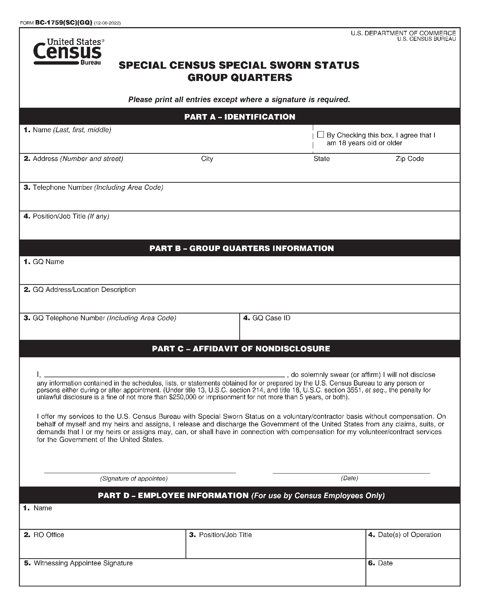

Other Administrative Items

Use of Personal E-mail
With the exception of mailing your BC27 and BC27a, never use your personal e-mail account (i.e., your AOL, Yahoo, Hotmail, GMAIL, or any other personal e-mail account) to send Title 13 data, such as information about the addresses you are working with, or the information collected from a census respondent.
Never use your personal e-mail account to send Personally Identifiable Information (PII), such as the name and address, name and Social Security number, or other information that could be used to identify another person. Also, never send e-mail with attachments to your Special Census Office except for your BC-27 and BC27A. These attachments may contain hidden computer viruses that damage census files or create a security risk.
Finally, be aware that if you use your personal e-mail account for work related business, the messages could be used as evidence in an investigation (for example, if a complaint is filed by another employee). The Census Bureau does not require you to use your personal e-mail to do your job (with the exception of your BC-27 and BC27A) and will NOT provide reimbursement for your Internet connection or the use of your personal e-mail account. If you have questions about the definition of Title 13 or PII, please refer to the Title 13 or PII materials you received when you were hired

Information that Can be Released
All documents required in connection with the employment of an individual are subject to provisions of the Privacy Act. The Privacy Act of 1974 places restrictions on the collection, use, maintenance, and release of specific information about individuals such as Social Security number, date of birth, telephone number, and so forth.
In accordance with 5 CFR 293.311, the following information on federal employees is considered public information and can be released to a third party without specific written consent of the employee, you must forward all such requests to the FOIA Office:
- Name
- Present and past position titles and occupational series
- Present and past grades
- Present and past annual salary rates
- Present and past duty stations (provided it is not employee’s residence)
- Position description and identification of job elements
Requests for information pertaining to current Special Census employees must be forwarded to the RO since they maintain the SF-66, Official Personnel Folder (OPF), for each special census employee. Refer to Chapter 3, Selecting, Appointing, and Training Your Staff, for information on the OPF.

Rights and Duties of a Special Census Employee Arrested or Charged with Criminal Activity
If an employee is arrested or charged with criminal activity while in the conduct of performing census work, the employee (or designated representative) should immediately contact the employee’s supervisor or the Special Census Supervisor, as appropriate. The Special Census Supervisor must inform the RO of the situation and await RO instructions.

Releasing Information to an Employee
An employee or former employee may be given copies of materials in their OPF upon receipt of an original completed and signed Form BC-300, Certification of Identity. If the SCO has closed, the employee can request a copy from the RO.
- Identify the documents or information needed and explain the purpose of your request.
- Full name used during Federal employment.
- Date of birth.
- Social Security Number (if applicable).
- Name and location of employing Federal agency.
- Beginning and ending dates of Federal service.
- Written requests (signed and dated) may be mailed or faxed to:
Policy Coordination Branch/FOIA
U.S. Census Bureau, HQ-8H027
Washington, D.C. 20233-3700

This page intentionally left blank.

Fraud, Waste, and Abuse

Fraud, Waste and Abuse Overview

Recognizing Fraud, Waste, and Abuse
Fraud, waste, and abuse of federal government funds and property occurs through:
- Violations of the federal law or regulations
- Mismanagement
- Theft
- Abuse of authority
- Conditions leading to substantial danger to health and safety

Reporting Acts of Fraud, Waste, and Abuse
Each employee has an obligation to report to his/her supervisor, or to the Office of Inspector General (OIG), information concerning the possible existence of a violation of law, rules, or regulations; mismanagement; gross waste of funds; abuse of authority; or a substantial and specific danger to public health or safety. Employees are protected by law from reprisal for making any disclosure supported by reasonable evidence.
Make reports directly to the Department of Commerce (DOC), Office of Inspector General by email at Hotline@oig.doc.gov.
The Internet is not secure, it is possible, though unlikely, that e-mail complaints may be read by persons other than your intended source. If you are concerned about this, you may choose to mail or call us. Please do not include Personally Identifiable Information (PII) through the website or via e-mail. PII is items containing Social Security numbers, dates of birth, credit card and passport numbers, or other personally identifying information that could adversely affect an individual. E-mails and web submissions containing such information will be blocked by our system administrator and will not be processed by our Complaint Department. Should you desire to provide this information, please contact the Hotline by telephone at the numbers listed below.
Telephone - The OIG Hotline is staffed 24 hours a day, 7 days a week.
Toll Free (800) 424-5197
In the DC metro area (202) 482-2495 TTD Toll Free (855) 860-6950
TTD in the DC metro area (202) 482-5923 Fax (855) 569-9235
Complaints/Issues: https://www.oig.doc.gov/Pages/Hotline.aspx
Mail
Office of Inspector General
Complaint Intake Unit
Mail Stop 7886 1401 Constitution Avenue, N.W.
Washington, DC 20230
Confidentiality
All reported information will be kept confidential. The reporting employee may remain anonymous if he/she desires. However, if the employee provides his/her name, it will not be disclosed without prior consent unless necessary for judicial or administrative proceedings.

Safety, Accidents, Injuries, and Personal Property Loss

Safety
This chapter provides safety information and accident/injury reporting instructions for Special Census Office (SCO) employees.
Office supervisory personnel are responsible for creating a safe environment for all special census (SC) employees. Statistics show that new office employees have the highest accident rate of any employee group. Slipping on paper, paper clips, rubber bands can seriously injure office workers, as well as other objects left on the floor or by tripping over electrical cords. Paper cuts are a hazard of office work. While these cuts are usually not serious, they are painful and can become infected.
Supervisors are responsible for eliminating such unsafe conditions and practices and for the safety of employees under their supervision. Supervisors have the responsibility for the safety education of all employees under their direction, and for the reporting of all hazardous conditions found in their units.

Safe Office Practices
The following safe office practices and conditions help to avoid accidents:
- Arrange furniture and equipment so that it doesn’t interfere with walkways (that is, allows space for extended drawers for filing cabinets, and so forth).
- Keep desk and file cabinet drawers closed.
- Do not lift heavy cartons. Get help or use a hand truck.
- Keep work areas neat and free of clutter.
- Place heavy materials in bottom drawers of file cabinets so that the cabinets don’t become top-heavy.
- Keep corridors and pathways unobstructed for at least a three (3) foot width.
- Keep aisles free of clutter (that is, waste baskets, electrical and/or telephone cords, and so forth).
- Be alert. Watch where you’re going and look out for hazards in your path.
- Move slowly on stairs, in hallways, aisles, and work areas.
- Report falling hazards such as poor lighting, spills, broken stairs, and loose flooring.
- Make sure you can see where you’re going. Don’t carry a load that you can’t see over.
- Use handrails whenever possible when using stairs.
- Be courteous and keep to the right when passing through dual doorways against normal traffic.
- Wear good shoes. Nonskid soles are a good choice. Remember that high heels or platforms are less stable than flat shoes.
- Do not use worn or frayed electrical extension cords or let amateur electricians repair electrical equipment.
- Do not operate defective mechanical and electrical equipment.
- Wear seat belts while operating, or as a passenger, in a motorized vehicle.
- Do not operate electrical equipment in a damp or wet work area.
- Smoking is prohibited in all federal office space. Discard cigarette stubs only in ashtrays when in authorized smoking areas outside of the office only.
The SCO must ensure compliance with Occupational Safety and Health Administration (OSHA) regulations. Failure to comply can result in an OSHA citation. Be aware that OSHA can conduct site inspections at any time and place without notice.
The SCO should prepare for such inspections by ensuring that an RO safety representative is providing the SCO employees with appropriate hazardous materials information and training and is maintaining a centralized listing of hazardous materials used/stored at the SCOs along with Materials Safety Data Sheets for the same.
The SCO will send all safety documentation to the RO. The SCO should display the poster CD-499, Occupational Safety and Health Protection for Federal Employees, in a conspicuous place where notices to employees are customarily posted. The CD-499 should include the name and location of the Regional Office (RO) safety representative.
The form can be printed from the OSHA.gov website. If the SCO cannot print, they should contact the RO to print and send the form to the SCO.

Rules for Evacuating the Building in Case of a Fire
In the case of a building evacuation, secure Title 13 materials to the extent possible given the nature of the emergency.
Follow these rules when evacuating a building:
- Learn where the fire exits are located and know the evacuation routes.
- Stop work immediately at the sound of the alarm and Secure all Title 13 and 26 materials and PII information in a locked area.
- Turn off all electrical equipment and lights.
- Take personal items (for example, keys, purse, and medication) with you.
- Proceed promptly, and in an orderly manner, to the nearest exit. Do not use elevators.
- Activate the fire alarm if the fire is in your area, and telephone the fire department immediately to report the location of the fire.

Safe Field Practices from Experienced Employees
As a part of the Census Bureau’s continuing safety program, the following safety outline for field employees will be an integral part of all initial training sessions. This outline is also included in the various operational field manuals.
To prevent unauthorized persons from viewing or seizing equipment or documents, do not leave laptops, questionnaires, and other materials containing Title 13 data or PII in a visible place in a home

Animals
- Obey the signs displayed in respondents’ yards. If you observe a “Beware of Dog” sign, take extra precaution.
- If warning signs are posted, try to call the respondents to the door before entering the premises. If the owner does not respond DO NOT enter an area where a dog is present.
- Do not run past a dog. The dog’s instinct is to chase and catch prey.
- If confronted by a dog, STAND STILL and slightly sideways without making direct eye contact and back away slowly. Be submissive, but don’t run. If you run, the animal might try to knock you to the ground, and you could be seriously hurt.
- Put something between you and the dog, such as a bag. Do not try to make friends with the dog, don’t try to pet the dog, and do not put your hands or face near it. If the dog does bites you, do not pull away, it will cause a tear and make a worse wound. Instead, try to make the dog release its hold.
- Many dog bites occur inside respondents’ homes. If you encounter a dog inside, ask respondents if they would mind confining the dog to another room during the interview.
- Learn to recognize the warning signs that a dog is about to attack; tail high and stiff, ears up, hair on back standing up, and teeth showing.
- If a bite or scratch from a dog or other wild or domestic animal breaks your skin, consult your doctor or an emergency room about the advisability of receiving rabies inoculation or other medical treatment.

Walking
- Never take walking for granted. Slips, trips, and falls are by far the most frequent cause of serious injuries to Census Field workers.
- Stay on well-lit streets when walking at night. Avoid walking past dark shadows near buildings, or walking too close to doorways, shrubbery, and other potential hiding places. If needed, carry a flashlight.
- In freezing weather, be alert for “black ice.” Walk slowly and take small steps.
- Obey traffic signals including Walk/Don’t Walk signs, and don’t jaywalk. Cross the street only at intersections, using marked crosswalks.
- Carry bags close to your body, with the flap or clasp next to you.
- Be cautious when riding elevators. If you are suspicious of another passenger, wait for the next elevator.
- Carry wallets in an inside or front pocket to avoid pickpockets.
- Avoid walking on uneven, broken, or poorly constructed surfaces or stairs. Never text or use electronic devices while walking. Distracted walking dramatically increases the likelihood that you will trip or fall. Always pay 100 percent attention to your walking and your surroundings. Grasp the handrails along stairways, if one is not provided, proceed with extra caution.
- Wear comfortable easy-walking shoes. These shoes may come in handy should there be a need to run. Dress appropriately for the weather.
- Do not carry valuables, such as large sums of money, expensive jewelry, and watches.
- When entering a building, pause and let your eyes adjust to the indoor lighting before moving on.
- Stay alert for objects that may pose tripping hazards.
- Always be aware of your surroundings.
The U.S. Census Bureau in coordination with the Department’s COVID-19 Task Force is closely monitoring daily changes in the COVID-19 Community Levels as determined by the Centers for Disease Control (CDC) and Prevention. COVID-19 Community Levels can be low, medium, or high and are determined by looking at hospital beds being used, hospital admissions, and the total number of new COVID-19 cases in an area.
We will assess risk metrics for each county in which our facilities are located on a weekly basis to determine the appropriate safety protocols. County-level assessments will be made each Friday to determine protocols for the subsequent week.

Face Coverings Field Employees Conducting Field Operations
According to the Center of Disease Control (CDC), face coverings help decrease the spread of COVID-19. If you have any concerns regarding your ability to comply with this directive, please contact with your immediate supervisor as soon as possible.
Follow your RO’s policy for wearing face masks.
If required by your RO’s policy, always wear face coverings if you are not six feet away from others, avoid contact with people who are sick, and wash your hands often with soap and water or hand sanitizer. A failure to comply with your RO’s directive to wear face coverings or adhere to any other established COVID-19 guidance may result in administrative action, up to and including, termination.

Tips for Wearing a Cloth Face Mask
- Employees should remove their face covering while driving between assignments.
- Wearing a face covering shows respect for all staff around you and the American public. This personal protective item represents one of the most effective ways to protect each other.
- Wash or sanitize your hands before wearing a mask.
- A mask should cover your nose, mouth, and chin.
- Tie the mask behind your head or use the ear loops and ensure it is snug.
- Avoid touching the mask while wearing it.
- If the mask is touched, wash or sanitize your hands immediately.
- While untying the mask, avoid touching the front of the mask.
- Wash your hands immediately after removing.
- Regularly launder your reusable cloth face mask. You can also launder it with your other clothes. Never wash or reuse a disposable face mask.

Mask Precautions
- Do not put masks on anyone who has trouble breathing, is unconscious, or otherwise unable to remove the mask without assistance.
- Do not use face masks as a substitute for social distancing.
For the latest updates on the COVID-19 pandemic, check the Centers for Disease Control and Prevention website and MayoClinic.org.Driving
- Never pick up hitchhikers in your vehicle.
- Watch for erratic movements of other cars. Drive defensively, yielding to other cars to avoid accidents.
- Check your directions and locations before starting out. If you need to look at them again, pull off the road, into a parking lot and stop, while reviewing directions. Only use hands- free devices for maps and directions while driving.
- Observe speed limits.
- It is mandatory to always wear a seat belt, even when pulled to the side of the road.
- Look around and make sure it is safe before exiting your vehicle.
- Keep your doors locked.
- Watch for children, jaywalkers, and pedestrians.
- Keep your vehicle in good operating condition with emphasis on brakes, lights, tires, wiper blades, and belts.
- Park in well-lit parking places at night.
- As you walk towards your vehicle, scan beneath the vehicle for persons waiting to charge out at your ankles. Check the back seat and floor for hidden persons before entering your vehicle.
- If your vehicle stalls, stay inside and hang a brightly colored cloth out the window. If someone stops to assist you, stay in the vehicle, and ask the person to phone the police for help.
- If you are being followed, do not drive directly home. Drive to the nearest police or fire station, hospital, or another public place. Do not exit your vehicle until it is visually safe.
- Have your vehicle keys ready before you reach your car. Do not open your purse or distract yourself when walking to your vehicle.
- Maintain a safe distance from the vehicle ahead of you. Don’t tailgate.
- Cell phones and other handheld devices are not to be used while driving. Do not text, while driving, when the vehicle is in motion you must pay 100% attention to the road.
- Check for other vehicles before backing, turning, or entering an intersection.
- Do not carry valuables in your car; keep your car locked when parked.
- In rural / wooded areas watch for deer, moose and other animals that may be in the road.
- When refueling your vehicle, be alert for theft or carjacking, and avoid any
action that could cause a spark and ignite fumes from the fuel
- Be alert to brake lights or turn signals beyond the vehicle ahead of you. Anticipate when others will slow down.
- When stopping, leave space between you and the vehicle ahead of you. Should another vehicle rear-end you, this may protect you from hitting the car in front of you.
- Drivers who use a motorcycle to conduct Census business, are required to wear a helmet,
regardless of local or state laws.

Intersection Safety Tips for Drivers
Accidents at intersections accounted for most of all work-related accidents reported by Census employees.
When approaching an intersection:
- Enter the correct lane for your intended action well in advance of reaching an intersection. Be sure to signal before changing lanes.
- Watch for other vehicles changing lanes abruptly. Sideswipe collisions are common around intersections.
- Be alert to brake lights or turn signals beyond the vehicle ahead of you. Anticipate when others will slow down.
- After checking to your left when turning right, always look ahead and right before accelerating.
- Vehicles ahead of you should stop for pedestrians crossing the street. Watch for pedestrians in all directions before making a turn at an intersection. Also, keep an eye out for cyclists going straight through the intersection, either on your right or on the sidewalk.
- Don't tailgate. Tailgating behind large trucks is especially hazardous. When stopping, leave a space between you and the vehicle in front of you.
When crossing an intersection:
- Watch for cross-traffic. Running a red light, intentionally or not, is a leading cause of intersection crashes.
- Be alert to traffic from the opposite direction turning across your lane in an intersection. Do not race a yellow light. Do not assume you are safe crossing on a yellow light.
- Always stop behind the marked stop line or crosswalk. Keep your wheels straight and your foot on the brake while you wait.
- Do not enter an intersection if traffic is backed up on the other side. Do not change lanes while driving through the intersection. If you are not in the correct lane before entering the intersection, change lanes after you have cleared the intersection.
- Treat a non-functional traffic signal as an all-way stop.

Trespassing
While Census Bureau employees do have authority to enter a property marked “no trespassing” when conducting official business under Title 13, United State Code, once a property owner asks a field employee to leave the premises, he/she should leave immediately employees must use good judgment. If the situation does not seem to be safe, contact your supervisor before attempting to enter the property.

Accidents and Injuries

Introduction
All accidents and injuries referred to in this chapter are related to those occurring while employees are on official duty and acting within the scope of their employment. Employees are responsible for the prompt reporting of accidents and incidents to their supervisor, the Workers Compensation Specialist (WCS) (1-800-819-4215) and the Special Census Supervisor at the Regional Office. Every Field employee’s New Hire packet should include an ‘Are You Hurt’ wallet card bearing the WCS number.

Employee Rights, Benefits, and Legal Protection
All U.S. Census Bureau employees are covered by the Federal Employees’ Compensation Act (FECA), which is administered by the Department of Labor (DOL), Office of Workers’ Compensation Program (OWCP). The FECA provides compensation benefits for lost wages and medical expenses of employees for disability due to personal injury or occupational disease sustained while in the performance of duty.
Workers’ compensation case management is performed by the Workers’ Compensation Specialists (WCS) staff assigned coverage for HQ, Chicago/Los Angeles, Denver, New York/Philadelphia, and Atlanta. These individuals work closely with HQ workers’ compensation and safety and property claims staff in the Administrative Customer Services Division (ACSD) in the Safety and Claims Branch (SCB).

Legal Action
Public Law 87-258, Title 28 of the Unites States Code, Section 2679, provides that the Attorney General shall defend any civil action brought in any court against an employee of the government for damage to property or for personal injury, including death, resulting from the operation of any motor vehicle by the employee while acting within the scope of his or her employment, that is, performing official government business.
If any legal actions are brought against an employee for any reasons while acting within the scope of their employment, they should advise their supervisor immediately.
If the SC Supervisor becomes aware of any legal actions brought against a Census Bureau employee because of an on-duty accident, notify the RO immediately.

Assault Coverage
Under federal law, employees are protected against verbal and bodily assaults and attacks. Title 18 of the United States Code prohibits persons from intimidating or assaulting census employees while conducting census activities in the field.

Workers Compensation Specialist (WCS)
The WCS is the person responsible for reviewing and handling workers’ compensation requests from employees involved in accidents and/or injured while on duty. The WCS can be reached through the “Are You Hurt” hotline at 1-800-819-4215 and select the prompt for their respective region. The employees are given the contact information for the WCS during training.
The SC Supervisor needs to have this information readily available to provide to employees that may have been injured and/or have an accident while on duty in case the employee forgot or misplaced the contact information.

What to do in Case of an Accident or Injury
In cases of an accident or injury, the employee will contact SC Supervisor at the SCO and the WCS. The employees are told during training the steps they need to take and who to contact if they are involved in an accident and/or are injured while on duty.
Every Field employee should carry the Are You Hurt? wallet card at all times while working for ready reference to injury reporting. Wallet cards are supplied in every new hire kit.
If you suffer an injury while working, regardless of the severity, get emergency treatment from the nearest hospital or physician’s office, if required.
Notify a supervisor and WCS as soon as possible and call the Are You Hurt Workers Comp Hotline: 1-800-819-4215 and select the option for your region.
The WCSs will assist injured workers with all phases of a Workers’ Compensation claim. WCSs function as the Supervisors of Records (SOR) for all Field employee workers’ compensation claim processing.
When an employee notifies the WCS of a work-related injury, the WCS will authorize immediate medical care when appropriate. The WCS will email the injured employee instructions for registering, electronically completing the OSHA 301 injury report and filing a workers’ compensation claim through the Office of Workers’ Compensation Programs’ ECOMP system.
The SC Supervisor might also receive notice from the employee’s immediate supervisor, such as Field Supervisor (FS), that an employee was in an accident or was injured while on duty. If the employee is unable to contact the WCS due to the seriousness of the accident or injury, the SC Supervisor may call the WCS on behalf of the employee.
When the WCS is notified by an employee that an accident/injury occurred, the WCS will email the SC Supervisor with the employee’s name, date of injury and brief description of accident.

Reporting Assaults or Serious Threat
An assault or serious threat of any kind on Field Representatives (FRs), Field Supervisors (FSs), or other Census employees working with the public is a rare occurrence. However, if SC employees are assaulted or threatened while on duty, they should immediately:
- Notify the local police and fill out a police report.
- Get medical attention, if necessary. Contact the SC Supervisor and the WCS (1-800-819-4215) for ECOMP email instructions for registering, reporting to OSHA, and filing a workers’ compensation claim, and other instructions as appropriate.
- Contact their immediate supervisor, who will assist the employee as necessary.
- Complete a BC-1206, Security Incident Report, detailing the incident.
The SC Supervisor will report the assault or threat to the RO Manager immediately by telephone and will confirm the assault or threat on the BC-1206, Security Incident Report.

Employee Responsibilities

Insurance
Employees are advised to carry adequate liability insurance when using their personal vehicle on official government business. In addition to liability insurance, employees must carry the necessary amount of insurance for property damage to their own automobile. Except in rare circumstances, employees will not be reimbursed for damage to their automobile. The mileage reimbursement is considered sufficient to cover the cost of insurance as well as operating expenses.

Reporting Motor Vehicle Accidents
Employees who suffer a work-related injury while operating their own motor vehicle for official business will:
- Contact the WCS (1-800-819-4215) and the SC Supervisor at the SCO as soon as possible. The WCS will authorize treatment, when appropriate, by faxing form to the medical provider or facility and send email instructions for registering, reporting to OSHA on form -301, and filing workers’ compensation claims through the ECOMP system.
- Complete the SF-91, Operator’s Report of Motor Vehicle Accident, and SF-94, Statement of Witness.
- Notify their supervisor as soon as possible following an accident.
- Notify and provide to state, county, or municipal authorities such information concerning the accident as required by law.
- Furnish name and address on the request of a law enforcement officer, but employees should NOT write their name on a card or paper for anyone except as required by a law enforcement officer.
- Not sign a statement or express opinions as to the responsibility for the accident, except to their supervisor or a law enforcement officer.
- Complete the SF-91, Operator’s Report of Motor Vehicle Accident, immediately after the accident, if possible, at the scene of the accident regardless of the extent of damage.
- Have witnesses complete and sign the SF-94, Statement of Witness.
- Give the completed Forms SF-91 and SF-94 to their Administrative Specialist in the RO.
- Complete any required accident report forms provided by their own insurance company and follow their advice.

Supervisor Responsibility
If an employee receives an accident report, citation, subpoena, summons, tag, or ticket as the result of an accident investigation by state or local police, the SCO Supervisor will immediately notify the RO and forward a copy of the document to them.
Supervisors are responsible for following up with employees to submit the required forms to the SCO or RO Administrative Area. In the field, the FS is responsible for collecting the FRs completed forms and submitting them to the SCO.
The supervisor is also responsible for notifying the WCS and the SCO when an employee returns to work.

Special Instructions for Reporting Deaths or Multiple Hospitalizations
Immediately after the death of any employee from a work-related incident or in-patient hospitalization because of a work-related incident, the SCO Supervisor, WCS, or the Region’s Administrative Supervisor must report the fatality/multiple hospitalization to the Census Headquarters Safety & Claims Branch (SCB) at (301) 763-3711.
Provide the following information:
- Location of the incident.
- Date and time of the incident.
- Date and time you received notification
- Number of fatalities or hospitalized employees.
- Name of any deceased or injured employees.
- Decedents or injured employees job title.
- Decedents or injured employees work status at the time of death.
- Contact person(s) name and their phone number.
- A brief description of the incident.
- Information on next kin, if available.
The SCB will notify the Occupational Safety and Health Administration (OSHA), the Department of Commerce (DOC) and the Office of Workers’ Compensation Programs (OWCP) within 8 hours of a fatality, and within 24 hours of a work-related overnight hospitalization
WCS will also be responsible for completing Form CA-6, Official Supervisor’s Report of Employee Death, if needed for a workers’ compensation claim for a deceased employee.

Penalties
Supervisors may be fined not more than $500 or imprisoned for not more than one year, or both, if convicted of:
- Willfully failing, neglecting, or refusing to make a report of any of the proceeding.
- Knowingly filing a false report.
- Inducing, compelling, or directing an injured employee to forego filing of any claims for compensation or other benefits provided for under the Federal Employee’s Compensation Act, extension, or application of it.
- Willfully retaining any notice, report, claim, or paper which is required to be filed under the Federal Employee’s Compensation Act, extension, application, or other regulations issued under it.

Submission of forms
All reports of accidents and injuries are to be reported to the WCS as soon as possible, through the Are You Hurt hotline at 800/819-4516. All reports of on-the-job accidents and injuries to OSHA and OWCP are processed electronically through the Employee Compensation Operations and Management Portal (ECOMP).
The WCS will provide guidance to the injured employee on the type of claim forms to use, and benefits to which they may be entitled. The WCS will send an email to the injured employee with step-by-step instructions on how to register an account in the ECOMP, and report the accident on the OSHA-301, and file a claim for workers’ compensation benefits with OWCP, if they choose, through the ECOMP system.
In the rare event the injured employee does not have access to Internet to electronically register, report, and file, on a case-by-case basis the WCS will coordinate and assist the injured employee to facilitate the reporting to OSHA and filing of claim form with OWCP through ECOMP.

Personal Property Claims
Employees are encouraged to carry private insurance against damage or loss of their personal property.
Claims for loss or damage to personal property (property belonging to an individual) are to be prepared on a CD-224, Employee Claim for Loss Of or Damage to Personal Property and CD-137, Report of Incident, Injury, Illness, Motor Vehicle Accident, Property Damage, or Fatality submitted to the SCO along with a copy of supporting evidence and appropriate accident forms (if not already submitted). Claims for property loss/damage and claims for on-the-job injury are processed by two separate HQ offices and employees filing both types of claims must file duplicate copies of forms and evidence to support each claim.

Conditions Required for Allowable Claim
There are five conditions that employees must meet to receive reimbursement for loss of, or damage to, their personal property:
- The loss or damage to their personal property must have resulted from their official census duty.
- They file a claim within two years after the incident occurs.
- The loss or damage was not caused, wholly or partly, by the employee’s negligence or wrongful act.
- The loss or damage is not otherwise covered by insurance.
- Witnesses can verify the loss or damage, or you have other evidence such as a receipt or similar document which proves the value of the property.
- It was reasonable for you to have the property on your person at the time of the loss or damage.

Allowable Claims
The following types of claims are allowable:
- Claims for losses or damages due to unpredictable behavior of animals.
- Claims for losses of property used for the benefit of the government at the direction or with approval of superior authority.
- Claims for losses or damages as a direct result of extraordinary risks to which the employee or the property has necessarily been subjected in the performance of official duties.
- Claims for loss of or damage to personal property when employees are forced to evacuate transportation facilities while traveling in the course of their duties.
- Claims for theft or burglary of employee’s property when there is a clearly established positive evidence of the existence of the theft or burglary and that all reasonable and practicable protection and security measures were taken, and that the item involved was incident to the service of the employee. The employee shall furnish satisfactory proof that such measures were taken. If a police report is filed, it should be submitted with claim.

Items not reimbursed
The following types of claims ordinarily will not be payable:
- Theft of items whose prior existence cannot be proven.
- Theft of articles of excessive value or those that can easily be stolen.
- Loss of currency or intangible property unless payable under other conditions.
- Loss or damage to motor vehicles.
- Loss or damage that is covered by insurance.
- Loss or damage to tattered or unserviceable property.
- Loss or damage to property that is owned by the U.S. and for which they are not financially responsible.
- Loss or damage to property that they normally use for their own private business or profit.
- Repair estimate fees for damaged property which the SC Supervisor has not approved in advance of their obtaining the estimate.
- Property that is acquired, possessed, or transported in violation of the law.

Providing evidence
Provide all appropriate supporting documentation as evidence to support their claim. If they cannot provide the proper evidence, they should prepare a statement indicating why supporting documentation is unavailable or is impractical to obtain.

List of supporting documentation
These items are considered appropriate supporting documentation:
- A statement from one or more witnesses which gives details of the incident.
- A statement that the property has been recovered or replaced in kind.
- A detailed written estimate of the repair cost that is prepared by a person or company licensed to make such repairs (If a fee is charged for the estimate, they must first obtain approval from the SC Supervisor).
- Itemized repair bill and/or receipt for repairing damaged property.
- Receipts or similar documents proving the value or cost of the original property.
- A statement of insurance coverage, including copies of claim papers if they made a claim through their insurance company.
- Power of attorney, or other acceptable evidence of authority, must support any claim filed by an agent or survivor.
- Written justification establishing a claimant’s right to have the property on-person, or located at the place of work, when lost or damaged.
- Copy of a police report, if applicable.

Computation of Awards
The amount awarded on any item of property will be based upon its estimated fair market value at the time and place of loss. The amount payable for property loss or damage beyond economical repair is found by determining its depreciated value immediately before loss or damage, less any salvage value.
If the cost of repair is less than the depreciated value, it will be repaired and only the cost of the repair allowed.
Claims will be payable only for such types and quantities of personal property, the possession of which shall be determined to have been reasonable, useful, or proper under the circumstances at the time of loss or damage. And, taking into consideration the hour of the day and the locality where the loss occurred, and any other factors pertinent to the determination.

Recovery From Third Parties
If employees have submitted a claim to their insurance company, a copy of such claim(s) should be included with the CD-224.

Third Party Claims for Loss of Property or Personal Injury or Death (Tort Claims)
In any case of damage to, or loss of, property or of personal injury or death in which there is any question of negligence or wrongful act on the part of Census employees, the SCO Supervisor must:
- Notify the RO Manager immediately.
- Submit the SF-95 and attachments to the RO.
- Send the SF-95, Claim for Damage, Injury, Or Death, to the claimant(s).
- Inform the claimant to attach any additional statements of support evidence which might be pertinent to a proper adjudication of the claim filed on the SF-95.
- Get a statement from the employee involved, CD-137.
The completed SF-95 and attachments should be submitted as soon as practicable to expedite settlement, although claims may be submitted no later than two years after the date of the injury or damage.

This page intentionally left blank.

Office Setup

Acquiring Office Space

Introduction
The governmental unit (GU) is required to make the arrangements for acquiring the Special Census Office (SCO) space. The proposed SCO space is inspected and be approved by the Regional Office (RO). The RO provides the Special Census Supervisor (SCS) with the keys to the SCO and briefs him or her on any necessary information regarding the space.
Depending on RO guidance, some activities in approving the space for the Special Census (SC) might be performed by the SCS. The RO provides guidance to the SCS on office space requirements prior to reviewing the proposed office space and/or inspecting the office space.
Office Space Requirements
The SCS or RO manager and the GU official discuss the SCO space requirements during the initial meeting. The office space needed depends on the workload of the SC. The RO provides guidance to the GU related to the space needed to conduct the SC.
Areas of consideration about the office space include:
- Can the office accommodate the number of planned staff to be hired for the SC?
- Is the office space open or is it divided, for example, into multiple office spaces? It is preferable to have an open room as opposed to divided space.
- Does the office space have parking? Office space should have parking space, as field staff may visit the office regularly to pick up and drop off field work.
- Is the office space available during and after normal work hours? How many days a week and how many hours each day?
- Does the office space comply with the American with Disabilities Act (ADA) requirements and the National Institute for Occupation Safety and Health requirements?
- Is the office space in proximity to police departments or local law enforcement agencies? The Census Bureau prefers having office space away from law enforcement buildings to assure people the Census Bureau is not associated with any police department or law enforcement organization.
- Who is performing the office cleaning/maintenance work? The GU is responsible for making the arrangements for the office custodial work. In addition, the custodial staff need to be sworn using the Special Sworn Status form. Custodial work needs to be done during the SCO’s business hours. These requirements should be discussed with the GU during the initial meeting.
- If the office space is shared with other non-Special Census office staff in the same building/area, how will this affect the SC operation; if so, how?
- Is there a potential access problem by non-SC personnel?
- Is there noise from other offices?
- Will others be able to hear SC employees?
- If the office requires repairs or cleaning, will it be done in time for the planned opening of the office space? Who is responsible for these items?
- Is office lightning adequate?
- Do windows need to be covered?
- Are the numbers of restrooms adequate for the number of people planned to be hired for the SC? Are the restrooms sanitary?
- Can testing and/or training be conducted in the office space?
- Is the general area where the office is located safe/secure?

Office Space Inspection
The RO manager or SCS conducts an inspection to approve the space. The RO manager or SCS use the checklist on page 151 to conduct the inspection. This checklist is used as a punch list of items that need to be corrected in the proposed space before it can be approved for use.
The SCS needs to contact the RO immediately if the office space is unacceptable. The RO will provide guidance on how to manage this situation.
The following information is discussed with the SCS or the RO manager and the space landlord or GU representative, either during the inspection of the space, or in a follow-up meeting after the inspection.
- The correction or completion of punch list items (for example, paint touch up, repair to wall base covering, missing face plate on outlet, missing switch cover, other cosmetic items to be completed or repaired).
- Any building-specific issues.
- Utilities issues.
- Emergency exit information; exit lighting; established evacuation plan; hazardous material (Hazmat) plan.
- The janitorial schedule. (The SCO is available to janitorial staff only during office hours.)
- The security and/or alarm system training (that is, how to alarm/disarm the security system) and a contact list for security issues. (This list should be maintained/updated and provided to the local authorities.)
- Storage space and specific office boundaries.
- A copy or diagram of the office space.

This page intentionally left blank.

Special Census Office Space Checklist
Date of Inspection: _____________ Inspector: _______________________________________
Governmental Unit Sponsor: ______________________________________________________
Point of Contact: ________________________________________________________________
Telephone: ________________________________ Size of Space (sq. ft.): __________________
SCO Address: __________________________________________________________________
Do you recommend this space? ☐ Yes ☐ No
Physical Item Checklist

In what type of environment is the space located?

☐ Village/City Hall
☐ Strip Mall
☐ Office Complex
☐ Other (specify in comments)

Comments: ____________________________________________________________________________________________________________________________________________________________________________________

What is the overall condition of the space?

☐ Excellent
☐ Good
☐ Acceptable (with improvements)
☐ Not Acceptable (specify in comments)

Who will provide the custodial services?

☐ Governmental Unit Employee
☐ Custodial Service

Consideration | Yes | No | Comments
Does the SCO space have to be accessed after accessing the building in which it is located (i.e., you must access a secure building before accessing the secured SCO space.) | ☐ | ☐
If the SCO is in a locked facility, will Census have access to the building during the office hours required (evenings and Saturdays)? | ☐ | ☐
Is the space associated with a law enforcement facility, such as a police department? | ☐ | ☐
Is the space associated with a fire department? | ☐ | ☐
If associated with a fire department, can the alarms and loudspeakers be heard in the SCO space? | ☐ | ☐
Does the SCO room lock? | ☐ | ☐
Is the SCO room lock a cipher lock? | ☐ | ☐
Is the SCO room lock a key card lock? | ☐ | ☐
Is access limited to Census Bureau employees only? | ☐ | ☐ | If no, who else has access?
Will the office space be accessible on weekends, if necessary? (Saturday and Sunday) | ☐ | ☐
Is the space ADA compliant? (handicapped accessible) | ☐ | ☐
Is the space OHSA compliant? | ☐ | ☐
Is there an emergency evacuation plan established? | ☐ | ☐ | If yes, get a copy.
Is a fire extinguisher present? | ☐ | ☐
Is there an emergency exit? | ☐ | ☐
Is the emergency door unlocked so egress is not prohibited? | ☐ | ☐
Are the walls, flooring and ceiling finished? | ☐ | ☐
Is there any evidence of water leakage? | ☐ | ☐
Is there adequate lighting? | ☐ | ☐
Is the exiting lighting row lighting? | ☐ | ☐
Is the existing lighting tract or recessed lighting? | ☐ | ☐
Is the existing lighting another type of lighting? (provide description in comments) | ☐ | ☐
Does the sponsor replace the lights?  If no, specify in the comments who replaces the lights. | ☐ | ☐
Are there working light controls in the SCO space? | ☐ | ☐
Is there air conditioning? | ☐ | ☐
Is there heating? | ☐ | ☐
Are there heating/cooling (HVAC) controls within the physical SCO space? | ☐ | ☐
Can Census staff access the HVAC controls? | ☐ | ☐
Are the HVAC controls operational? | ☐ | ☐
Is the HVAC available after hours as needed? | ☐ | ☐
Are the bathrooms inside the SCO space? | ☐ | ☐
Are the bathrooms handicapped accessible? | ☐ | ☐
Is there adequate parking for the office staff and visiting field staff? | ☐ | ☐
Is the parking area well lit? | ☐ | ☐
Infrastructure and Furniture
Item | Number  Requested | Number Present | Comments
Tables
Chairs
Locking File Cabinets (legal size)
Locking File Cabinets (letter size)
Telephone Lines
Internet Connections (specify in the comments whether they are in the correct locations.)
Electrical Outlets

Comments

Opening for Business
One of the office space requirements is that access to the office space must be provided during normal hours of operation. Each SCO is required to have someone at the office Monday through Friday during specified hours, usually 8:00 a.m. to 4:30 p.m., or as instructed by the RO. If an SCO cannot meet this requirement, the SCS must contact the RO.
During peak SC operations, double shifts may be necessary. These shifts typically overlap by 15 minutes (for example, a shift would begin at 4:15 p.m. to overlap with a shift ending at 4:30 p.m.) and last if needed (that is, at the SCS’s discretion).
The SCS is responsible for notifying the GU or RO, if necessary, when the office will remain open later than normal hours. This notification may be necessary, for example, if additional heat or air conditioning services need to be obtained.

Office Areas Set-up

Setting Up Work Areas
The SCS might be provided with a general floor plan of the SCO prior to opening the SCO that can be used to plan the office work areas, and the positioning of furniture and equipment. The space should be configured to optimize the layout of the office and to support areas within the SCO. How the space is used during the SC may change depending on the needs of the operations.
It is the SCSs responsibility to make several 8½ x 11 copies of the floor plan, draw evacuation routes in red, and post copies on the walls next to the banks of desks and doors within the first week of opening.
The office setup may vary from RO to RO and from SC to SC because the office setup depends on the workload size and the space made available by the GU. The guidelines that follow are recommendations for how to setup the office space. The RO has discretion as to how to set up the SCO office space.
The SCO functional areas on the floor plan include:
- Administration
- Recruiting (optional)
- Field operations—production
- Field operations—quality assurance
The SCO support areas that should be created on the floor plan and as space allows may include:
- SCSs office or space
- Multipurpose room
- Storage room
- Sensitive information disposal bin
- Break area
- Entrance/reception area

Administration Area
The Administration area should include space for:
- Clerk spaces
- Computers
- Mail receipt
- Supply storage
- Locked filing cabinets for personnel and payroll records

Recruiting Area (optional)
If the GU implemented a good recruiting plan that provided sufficient applicants for the SC, then a Recruiting area is optional. However, in some SCs the SCS may need to assist the GU in their recruiting efforts. In this case, the SCS may consider creating a separate recruiting area for these activities.
The Recruiting area should include space for the:
- Clerk spaces
- Applicant file storage

Field Operations Area– Production and Quality Assurance
The Field Operations area should be divided into the production and quality assurance areas. These areas need to be close because the work from the production area feeds into the work of the quality assurance area.
The Field Operations area should include space for:
- Managers (FMs) space, if applicable.
- Clerk spaces for checking work in and out to the field.
- Map storage.
- Space for incoming and outgoing Field Supervisor work.

Multipurpose Room
Each SCO should have a multipurpose room. This room has chairs and folding tables, which staff can move around to create work areas to use for a variety of activities. This room can be used for assignment preparation and distribution, testing, or training.

Box for Title 13 and PII Materials Needing Disposal
The SCS also needs to set up a locked box where staff can dispose of sensitive information that needs to be properly destroyed. Sensitive information includes documents or other materials that may contain:
- Title 5 data – Personnel and other Privacy Act protected information.
- Title 13 – Confidential SC collected information.
- Any other information such as budget or financial information that is handled in the SCO.
This box needs to be marked as Title 13 and PII Document Disposal Box. This box must be locked and always safeguarded. The SCS is responsible for ensuring that office staff know how to properly handle sensitive information and know where to dispose of sensitive materials that need to be destroyed. If in doubt, the staff should assume the material contains sensitive information.
All paperwork that contains sensitive information needs to be disposed of properly. At the end of the SC, the materials in this box will be packed and shipped out of the office, along all other enumeration materials, to be properly destroyed at the Regional Office. See Chapter 18 for more information about packing these sensitive materials for proper disposal.

Optimizing the SCO Space for Operations
The space should be optimized to make sure the office operations flow smoothly. Some considerations for optimizing the space follow:
- The entry/reception area should be access controlled. Only authorized SC employees are allowed into the office.
- The receiving and outgoing bins should be placed as close to the entrance as possible. During operations, FSs drop off work completed in the field and pick up work they need to complete or assign to Field Representatives (FRs).
- Organize the completed field work by FSA and store it in a convenient location in the SCO where it can be locked. Keep the boxes from the field materials sent the office as these can be used as storage bins and later used to ship the materials for processing.
- The multipurpose room, if one is available, should be located away from the field operation areas, so it does not disrupt SC operations.
- The administrative area should also be located away from the field operations area. It is also important that this area has locking file cabinets for employee folders and payroll. See Topic 4 for more information on furniture requirements.
See Figure 11 for an SCO space mock-up and Figure 12 for an SCO workflow of the most frequently performed activities in the office.

Other Office Space Use Guidance
All office space management issues are the responsibility of the GU. The GU is responsible for interpreting and enforcing leases, if there is one, and resolving any problems related to the use of the office space.
The SCS is responsible for the overall control of the telephone and enforcement of the rules governing its use, for example, that telephones are used only for business.
With guidance from the RO, the SCS must ensure that SCO staff members follow all guidelines related to the proper use of the office space. A simple example is ensuring that the front door (or any other entrance to the office space) is secured/locked when the SCO is not in use.
Sometimes the office spaces may contain restrictions that SCO staff members need to be aware of so that they do not violate the office space use guideline. For example, asking for a change in janitorial services or asking the building manager to run the heat or air conditioner on the weekend may affect a lease. When requesting any changes related to the use of the property or related services, the SCS (with approval/funding from the RO manager) must first check with the GU and the RO to determine if it is within the scope of office space use.
The SCS is responsible for reporting problems related to office space requirements to the GU and the RO or taking appropriate action to resolve issues when necessary. The SCS must keep a log of property management problems encountered. The RO may periodically ask for updates related to problems with the office space. An example of this log is shown on 167. The RO may modify this log as necessary.
Figure 11. SCO Space Mock-up Areas and Office Flow (Example only – ROs may setup the office space as needed)
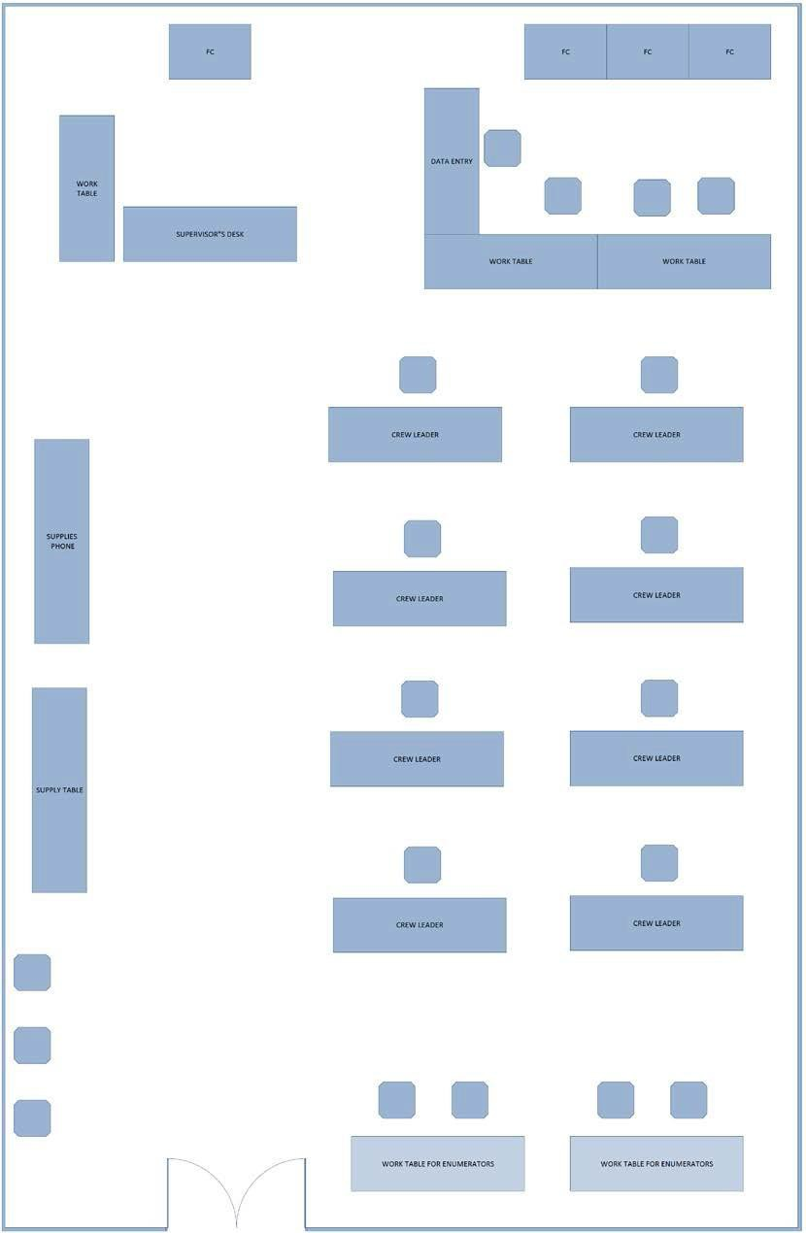
Figure 12. An example of an SCO Workflow diagram.
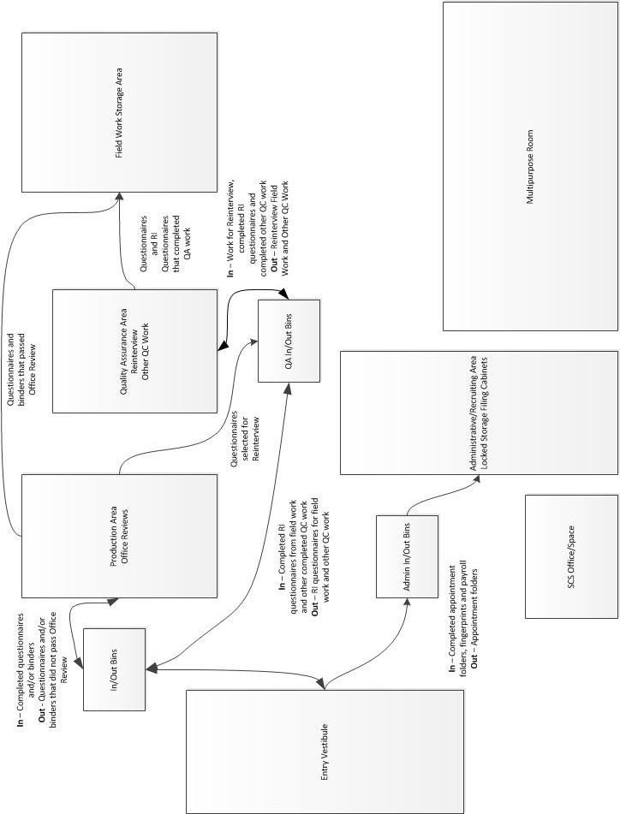

Special Census Office Use Problem Log
Date Problem Reported | Area where problem is located | Description of the problem | Date and time when problem was reported to GU | Person contacted at the GU | Response, if one was given | Date when problem was resolved | Other comments

This page intentionally left blank.
Special Census Office Contact List
The SCS must also keep and maintain a list with the contact information for building managers or landlords to report problems with the office space or to report emergencies. This contact list should be obtained during the initial meeting with the GU.
An example of a suggested contact list is shown on page 171. The ROs can modify this list as necessary.
GU/RO CONTACT | PHONE NUMBER(S) | ADDRESS (sTREET, eMAIL)
RO Manager: | Office:  Cell:
RO Administrative Contact: | Office:  Cell:
Governmental Unit Official Representative: | Office:  Cell:
Governmental Unit Property Manager: | Office:  Cell:
Building Manager: | Office:  Cell:

This page intentionally left blank.

Furniture, Equipment, Bulk Items, and Office Supplies

Introduction
The furniture, office equipment, and locking file cabinets provided by the GU must be in the office prior to the opening of the SCO. Contact the GU and the RO if the items above are not in the office by the time the SCO is scheduled to open. The RO informs the SCS when the items from the RO or NPC are scheduled to arrive at the SCO.

Telecommunications Equipment
The number of telephones required for the special census office depends on the size of the special census and the number of authorized office and field staff. Telephones must be non-cellular and connected to direct lines.
Because of the Census Bureau’s privacy and confidentiality requirements, the lines cannot be routed through a switchboard or be part of the governmental unit’s telephone network. If telephone lines must be installed, please check with the local telephone company regarding their installation timeline(s). Be aware that there can be a significant time from the request date until installation.

Office Furniture
The Census Bureau attempts to minimize the amount of time and money a jurisdiction must spend to equip a special census office. Office furniture requirements are based on the need for simple work surfaces and the need to secure personally identifiable information protected under Title 13 of the U.S. Code.

Workstations
At a minimum, each workstation should consist of a table and a chair. Desks are not necessary but can be provided for the special census supervisor and office clerks if they are available. Sufficient electrical outlets near each workstation are also required to support computers and a printer. Field staff will come into the special census office to meet with their supervisors and drop off work. Tables and chairs to use while reviewing materials are sufficient for these staff.

Locking File Cabinets
Locking vertical or lateral file cabinets are required to secure the Title 13 and personally identifiable information materials. Legal size cabinets are required to accommodate the oversized address registers and maps. The number of cabinets required is specified in the initial letter from the Census Bureau’s regional director.

Information Technology (IT) Equipment
For this decade, the Census Bureau is requiring that GUs provide their own equipment and support. This allows for the GUs to use equipment they already possess as opposed to procuring it from the Census Bureau. This will decrease the overall cost to the GU. GUs should provide, at a minimum, computers (laptops or desktops), monitors if appropriate, printers, and barcode scanners. Detailed IT requirements will be provided to the GU through the Memorandum of Agreement process.

Shipment of Bulk Office Supplies, Training and Data Collection Materials
The Census Bureau, through NPC, ships office and bulk supplies such as paper, pens, pencils, manuals, training guides, workbooks, etc. to the SCO. The NPC also assembles and ships the Address Registers (AR), including map envelopes, to the SCOs.

Tips for Managing Inventory and Storage
Some suggestions for handling materials shipped to the SCO from the NPC or RO:
- Inventory all materials as they arrive. Do not assume that a shipment of materials is complete.
- Do not assume that a shipment contains materials for just one operation. You may receive materials for several operations at once, for example, materials for housing unit (HU) enumeration, group quarters (GQ) enumeration, and transitory location (TL) enumeration. Be sure to inventory what you receive.
- It is important to know where all materials are stored in the SCO. Organize and store your materials logically in the SCO, such as by FSA/FR in Case ID order.
Plan your workspace so you have or can easily set up a materials staging area. A lot of materials will be going out of and returning to the SCO simultaneously. It is critical that the materials staging area is always organized and neat.

Receipt of Office Supplies
The RO and/or Headquarters sends, through NPC, office supplies to the SCO. The quantity of office supplies depends on the workload for the SCO.
The office supplies for field and office staff are:

- Clips, Paper, No 1, 1/8”
Erasers
- Pens, black
Pencils, red
Electric pencil sharpener

The SCO also receives supplies for the office such as:

Staplers and staples
Staple removers
Shear scissors
Filament Strapping tape for boxes, 2x60 yard
Tape dispenser
Transparent tape, ¾ side, 36 yd, 1 core
Telephone message pad
Messenger envelopes, large
- Rubber bands, size 33
- Stapler remover
Packing knives
Markers, black
Marking pens, fine tip, black
Labels, 2x4, 10 labels per sheet
Label, 8.5x11, 2-slit back
Memo pads, 3x5, white
Paper, Letterhead (RO provides)
Paper, copying, 8 ½ x 11
Paper, copying, 8 ½ x 14
Carton, 18x12.5x 6, 25 count bundles
Flashlights
Reflective Vests

Verify that the materials expected to be shipped to the SCO are received in the office. Refer all problems regarding supplies or shipping arrangements to the RO.
The SCS should inform the RO if additional supplies are needed. The RO initiates the resupply order with the NPC. The NPC sends the supplies directly to the SCO.
It is critical that the SCS or designee monitor the consumption of office supplies carefully to ensure timely reordering and replenishment. The SCO cannot afford to wait until the office has run out of needed supplies.

Bulk Supplies
The bulk supplies include the following materials:
- Training guides, manuals, job aids, and workbooks for field staff,
- Address registers for the SC Area.
- Questionnaires (housing unit, group quarters, and transitory locations, and reinterview).
- Other field operation specific Special Census forms for GQ, TL, and HU.
- Other field operations support materials and administrative forms, such as:
- SC-ID, Language Identification Card
- SC-CN(E/S), Confidentiality Notice
- SC-NV(E/S), Notice of Visit
- SC-IS, Information Sheet
- SC-225, INFO-COMM
- SC-308, Daily Pay and Work Record
- SC-282, Documentation of Conduct and /or Performance Problems
- SC-336.1, Reassignment Worksheet
- SF-91, Motor Vehicle Accident Report
- SF-94, Statement of Witness
- CD-224 Employee Claim for Loss or Damage to Personal Property

Training Materials
Depending on the RO, many materials delivered to the SCO may be packaged already as training kits. These packages contain materials that are grouped for specific purposes. For example, training packages can include:
- FS and FR supplies
- Training materials for trainers
- Training materials for trainees.
For those ROs that will have the SCO assemble the training packages, refer to each of the operational training guides to determine the contents and quantities of the training packages. Each training guide includes a table with the specific materials that need to be included in the training package.

Organizing Bulk Supplies
When bulk supplies are received, the SCO staff check them against the shipping list, unload the cartons, and store them in the office designated for bulk storage. A bulk supply list is provided for each SCO once the Memorandum of Acceptance MOA is signed.
In storing bulk supplies, staff should:
- Ensure that all exits, and fire extinguishers are readily accessible and not obstructed
- Ensure the contents of all cartons are labeled on the outside and stored so the labels are visible
- Stack all similar materials together. For example, stack cartons of questionnaires together in one place and cartons of training packages in another
- Leave 36-inch walkways between stacks of different materials
- Keep the supply storage area neat and orderly and free of litter and empty cartons
Many supply shortages in the SCO result from incorrectly sorted and stored boxes. Be sure all boxes are opened and stored in their proper places.
Keep in mind that bulk supplies can be overwhelming. For example, the SCO may receive numerous training materials. These materials must be stored, and the SCS and other office staff need to know where each item is located.

Managing SCO Materials
The SCS is ultimately responsible for the check-in, control, storage, and distribution of SCO materials and supplies. All materials must be properly inventoried, organized, and neatly stored for efficient control and distribution.
If any materials have not been received by their scheduled delivery date, the SCS should inform the RO after checking that sufficient time has been allowed for delivery and the materials have not been misplaced.

This page intentionally left blank.

Geography
A special census is a basic enumeration of population, housing units, group quarters and transitory locations that the U.S. Census Bureau conducts at the request of a governmental unit. The success of a Special Census (SC) depends on the collection of accurate living quarters (LQ) data, the population associated with those LQs and the further association of these data to the correct geographic area.

Introduction

The Importance of Geography
Geography is crucial to both census data collection and data tabulation for several reasons:
- Geography provides the framework for detailed population and housing information at the local geographic level, and more specifically, for the SC area.
- It enables the Census Bureau to determine where living quarters (LQ) are located so they are tabulated in the correct jurisdiction.
- Specific geographic entities ensure that canvassing and enumeration procedures are systematically conducted.
- Specific geographic units help to ensure that LQs and the associated residents are consistently identified and enumerated at the correct location.
- The SC is organized by geographic areas.
- The SC outcome affects the sponsoring governmental unit (GU), including possible state and federal funding.

Full Special Census vs. Partial Special Census
An SC can be conducted for an entire GU (a full SC) or for part of a GU (a partial SC). A full SC is usually sponsored by a county, city, village, town, or other legally functioning unit of government.
A partial SC is conducted for only a selected area of a GU, usually in states where the results of a partial SC are recognized by the state for funding or planning purposes. Partial SCs are usually requested for a specific area or areas that have been annexed by a jurisdiction since the most recent Decennial census or since the last SC, whichever is more recent. A partial SC may also be requested for areas with newly built HUs or group quarters (GQs).
Regardless of whether an SC is a full or partial SC, SC data are collected and tabulated by census geography.

Types of Census Geography

Special Census Geography Hierarchy
The basic concept of census geography is that it is directly related to the field positions established for either collecting the data or supervising the data collection. These staff work in the field and cover specific geographic areas.
The area that a Field Manager (FM) covers is called a Field Manager Area (FMA). Each FMA is broken down into several smaller areas called Field Supervisor Areas (FSAs). Each FSA is covered by a Field Supervisor (FS) working for the FM. One FM can typically manage up to eight FSAs, with each FSA containing approximately 1,200 HUs.
Each FSA is further divided into Assignment Areas (AAs) that Field Representatives (FRs) work. Each FSA contains approximately 16 AAs. Each AA contains approximately 75 HUs.
Each SC includes all types of census geography even though the specific position associated with the geography type may not be authorized for every SC. The positions authorized depend on the size of the SC. For a smaller SC, an FM position may not be authorized because there is an insufficient number of field staff to require this supervisory position.
An overview of each SC geography and the approximate number of staff associated with each of the supervisory positions is provided in this topic.

Special Census Area (SCA)
The Special Census Area (SCA) is the entire geographic area included in the SC. The SCA represents the geographic extent of the area to be enumerated.

Field Manager Area (FMA)
The territory covered by an FM, reporting to the Special Census Supervisor (SCS). For a given SC program, there may not be an FM. Only the larger SCs are authorized FM positions. An FMA is comprised of a group of eight FSAs, on average. An FMA contains approximately 9,600 HUs.

Field Supervisor Area (FSA)
The territory covered by an FS, reporting to an FM. Each FSA is comprised of approximately 16 Assignment Areas, with approximately eight FRs reporting to the FS. An FSA contains approximately 1,200 HUs.

Assignment Area (AA)
An AA is the geographic area that makes up an assignment intended for one FR. An AA is comprised of one or more blocks. For the SC program, an AA is approximately 75 HUs.

Block
The block is the smallest geographic area for data collection.

Special Census Maps

Special Census Maps Overview
There are two general categories of maps used for the SC. The first category includes the maps that the SC sponsor receives and reviews prior to the start of their SC. The second category includes the operational maps used by Census Bureau staff for data collection.

Sponsor Maps Overview
The SC Sponsor maps are large format maps reviewed by the GU prior to the start of the SC. Sponsor maps include the Boundary and Annexation Survey (BAS) map and the Verification map. Each of these maps may be viewed by the GU in either paper or digital format.

Boundary and Annexation Survey Map
The Census Bureau conducts the BAS annually to collect information about selected legally defined geographic areas as of January 1 of each year. The BAS is used to update information about the legal boundaries and names of all GUs in the United States.
For each SC, the BAS helps ensure the SC boundaries are accurately represented for SC data collection and subsequent tabulation. The Census Bureau will send a current BAS map, or shapefiles if requested, to the BAS contact for the SC GU. This official may be the Highest Elected Official or another government official, such as a city administrator or manager, or a Geographic Information System staff member. The BAS contact for every GU is maintained in the Geographic Program Participant database. Field Division’s geography staff can assist SC staff in determining the BAS contact on record.
The BAS map and shapefiles show the legal boundaries the Census Bureau has on record for the requesting GU. The GU reviews their legal boundaries and may provide boundary changes to these maps. Updates made on the BAS maps are reflected on the Verification map (see Figure 13).

Special Census Verification Map
After a GU has certified their legal boundaries on the BAS map, the Census Bureau produces and sends the GU an SC Verification Map or shapefiles that reflect the changes they submitted. The Verification map and shapefiles are produced for both full and partial SC requests.
The verification map is based on the area included in the Special Census Area and highlights the census blocks within that area. The GU again verifies and confirms the enumeration area and legal boundaries are correct or provide any update as necessary.
The full extent of the GU may not be included in the verification map. If a boundary change was provided that is not included or near the special census area, it may not be visible.
Figure 13. Example of a Special Census Verification Map.
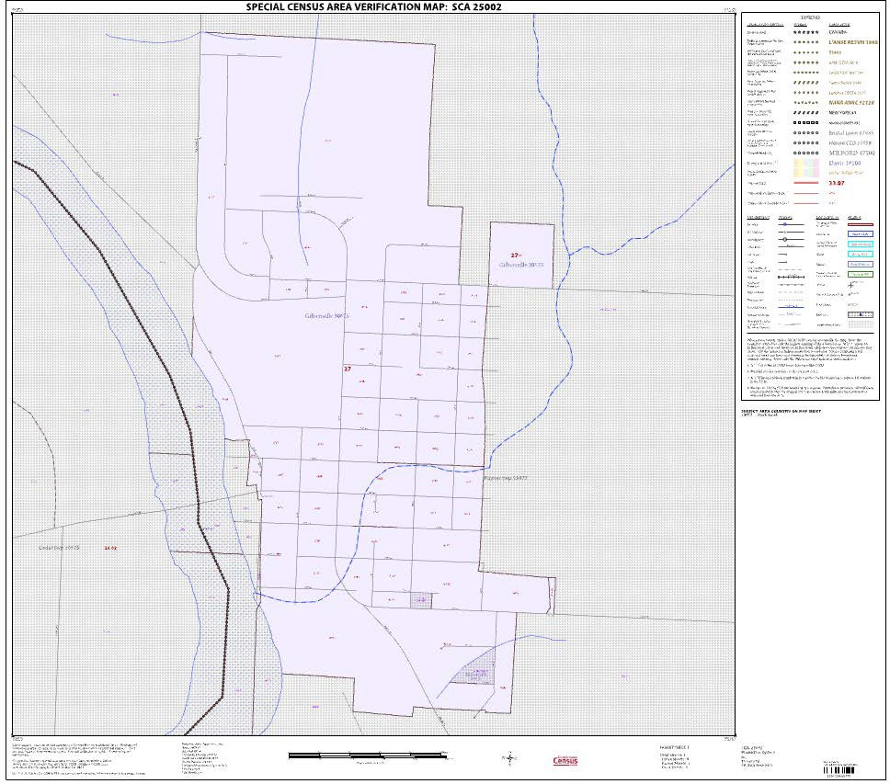

Operational Maps Overview
Operational maps are used for assignment management and data collection. The operational map category can be further subdivided into two categories:
The operational maps, including the SCA Map, are for internal use only and should not be shared with the GU sponsoring the SC.
- Large format maps (36 x 32) are plotted in color and include:
- Special Census Area (SCA) with Field Manager Area (FMA) map
- Field Manager Area (FMA) with Field Supervisor Area (FSA) map
- Field Supervisor Area (FSA) with Assignment Area (AA) map
- Small format maps (11 x 17) are printed in black and white and include:
- AA Locator maps
- AA maps
- Block maps

Large Format Maps Overview
Large format color maps are used by the SC supervisors to plan, manage, and control work assignments for field staff.
The National Processing Center (NPC) will plot two copies of each large format map and then ship them to the Special Census Office (SCO). Both copies of the SCA maps are retained in the SCO. Retain one copy of each subsequent supervisory map type (FMA and FSA) in the SCO. Provide the second map copy to the appropriate FM.

Special Census Area with Field Manager Area (FMA) Map
The SCA with FMA large format map shows each FMA within the SCA. This map is only available if an SC requires more than one FM to manage the field workload. The SCS may wish to annotate each FMs name on the map under the FMA Number, which may be helpful when reviewing production reports generated from MOJO.
It may also be helpful to annotate the SCA Map with areas of new housing developments, areas of large GQs locations such as college dormitories, or other areas of general interest that may impact the data collection process.
For partial SCs, the blocks to be enumerated are highlighted on this map.

Field Manager Area with Field Supervisor Area (FSA) Map
The FMA with Field Supervisor Area (FSA) large format map shows and labels within the subject FSA. The FM uses this map to determine the geographic area within each of their FS boundaries. The FM may wish to annotate each FS’s name on the map under their area.
See Figure 14 for an example of an FMA with FSAs map.
Field Supervisor Area with Assignment Area (AA) Map
The FSA with Assignment Area (AA) large format map shows and labels the AAs within the subject FSA. This map is used to determine FR assignments. The SCO makes initial AA assignments to the FS. The FS then assigns AAs to the FRs. As a rule, FRs are usually assigned the AA in which they live, and subsequent AAs closest to their home locations. Efficient assignments minimize the time and travel required by field staff and helps to contain costs to the sponsoring government.
The FS should pinpoint the home location of each FR on their copy of the AA Map. This will aid in the review and approval of payroll submissions and mileage claims by the field staff, to determine whether the claims submitted are reasonable for work completed.
Figure 14. Example of a Special Census – FMA with FSAs Map.
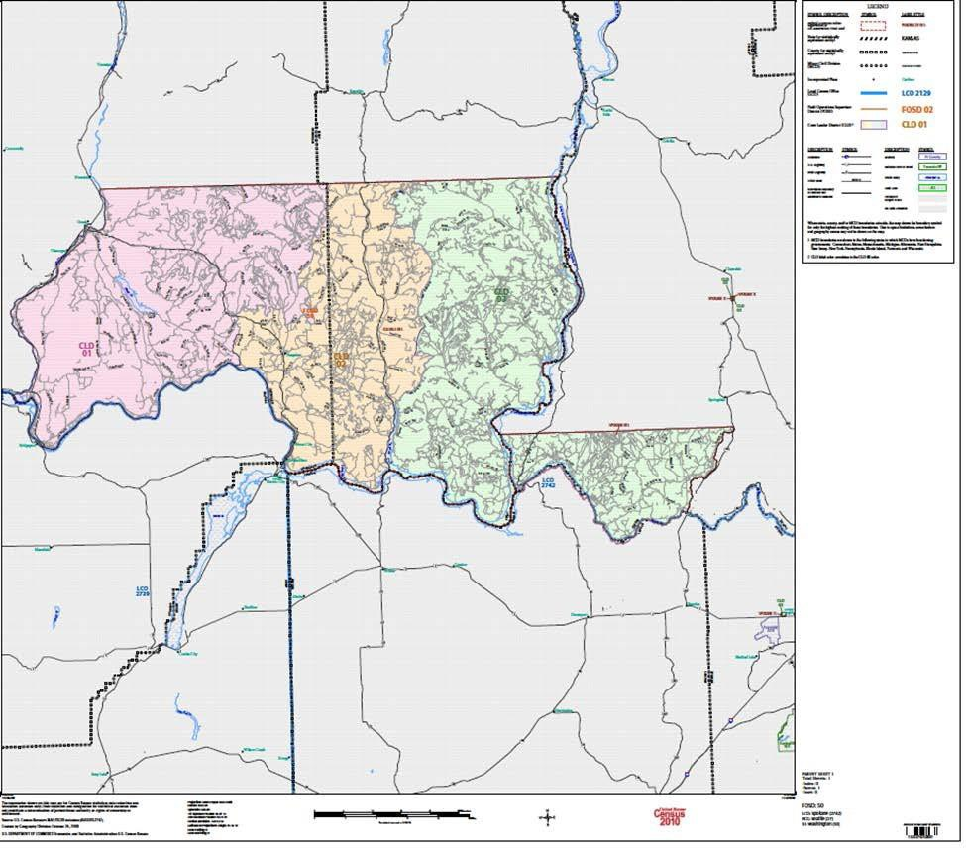

Small Format Maps Overview
The small format (11x17) maps include the AA Locator Map, the AA Map, and the Block Map. These black and white maps are used by FRs for data collection purposes in the field.
The NPC print the maps and insert them into a map pouch in the back of the corresponding Address Register. The address registers are then sent to the appropriate Special Census Office.
Each AA contains its own set of maps, an AA Locator Map, an AA Map, and a Block map for each block in the AA. A single separate small format map legend is included in the map pouch with the maps.
The sections below provide a general overview of each small format map type. Refer to Chapter 3 of the SC-1202, Field Representative Manual for detailed information on each of the operational maps.

AA Locator Map
The AA Locator map shows where the AA is located within the general vicinity of the FSA.
The AA is highlighted on the map. The map shows neighboring streets and other nearby geographic features.
The AA Locator map is used to locate the AA on the ground and to plan an efficient route of travel through the AA. Updates should not be made on the AA Locator map.
See Figure 15 for an example of this map.

AA Map
The AA map shows the geographic area of the AA bounded on all sides by visible features, such as streets or roads, railroads, or rivers; or by nonvisible features, such as county, city, or property boundaries. The map shows all the blocks in the AA. An AA is identified with a six-digit number on the map, for example, 005001.
The FRs use the AA map to locate the blocks within their assigned AA. Updates should not be made on the AA map.
See Figure 16 for an example of an AA map.

Figure 15. Example of a Special Census Assignment (AA) area Locator Map.
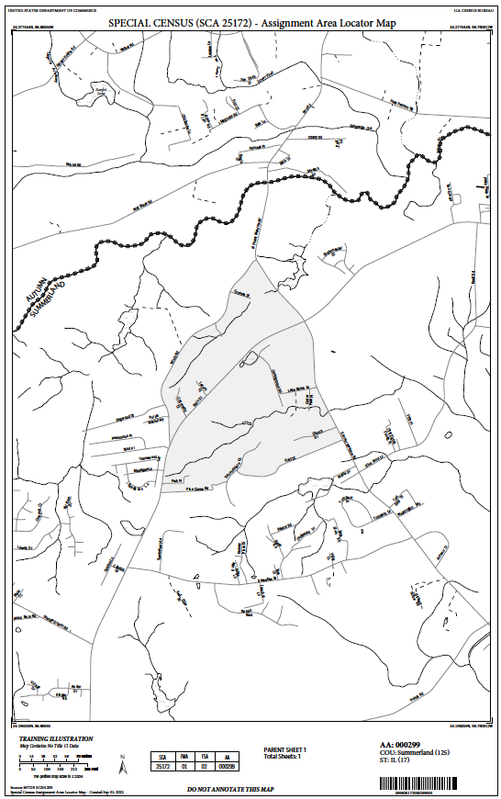
Figure 16.Example of a Special Census Assignment Area map.
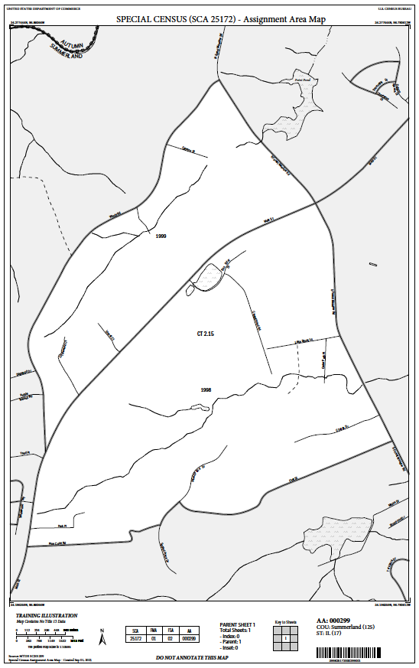

Block Map
This map shows the boundaries and features of a specific block where the FR conducts listing and enumeration activities. The block map also shows map spots and map spot numbers for known HUs within the block boundaries.
Although most block maps are comprised of a single parent map sheet, a block may be multi-sheeted. There are three types of map sheets: parent sheet, inset sheet, and index sheet. These sheets help to show more detailed areas that cannot be shown clearly on the block map. Map spot distribution and density affects the display of map spots and their labels. Each block is covered by one or more parent map sheets at a single scale. Inset map sheets at larger scales are created as required for areas with high map spot density that cannot clearly be shown on the parent map sheet. An index map sheet showing the sheet configuration is created for all blocks requiring more than one parent map sheet. The type of map sheet is identified in the map margin. FRs do not make updates on the block maps.
After the FR completes canvassing a block, in addition to circling the block number on the SC-114, Block Listing, they should also circle the block number on the map. This helps them to track which blocks they have completed canvassing.
See Figure 17, Figure 18, and Figure 19 for an example of a block map, block map containing an inset, and a block map inset.

Figure 17. Example of a Special Census Block Map.
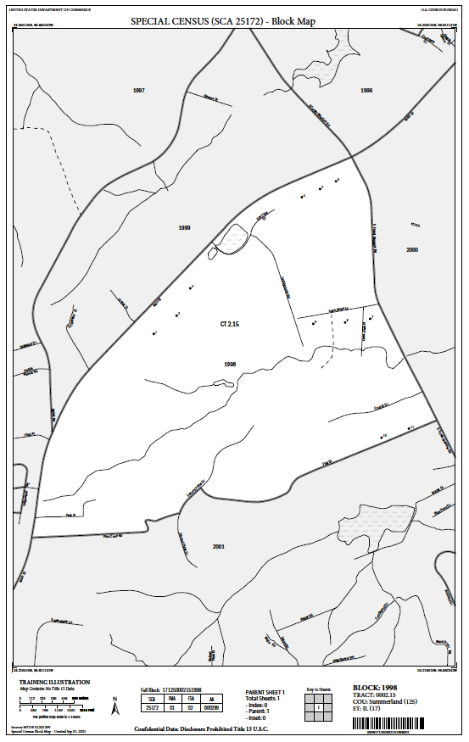
Figure 18. Example of a Special Census Block Map with Inset
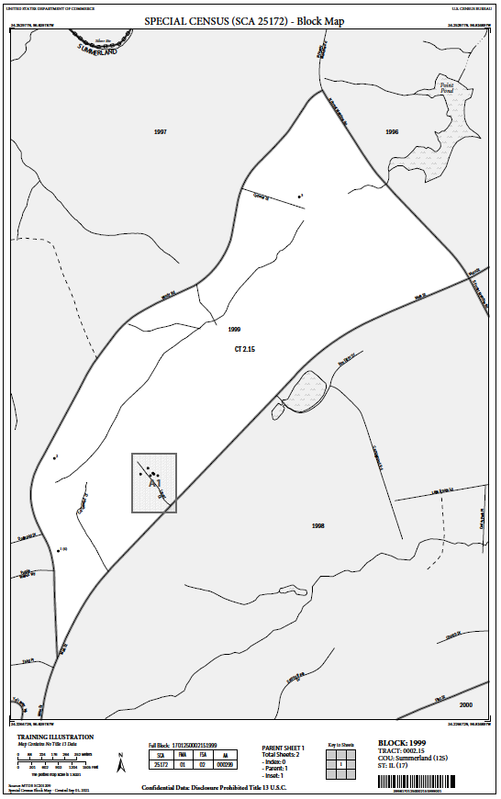

Figure 19. Example of a Special Census Block Map Inset.
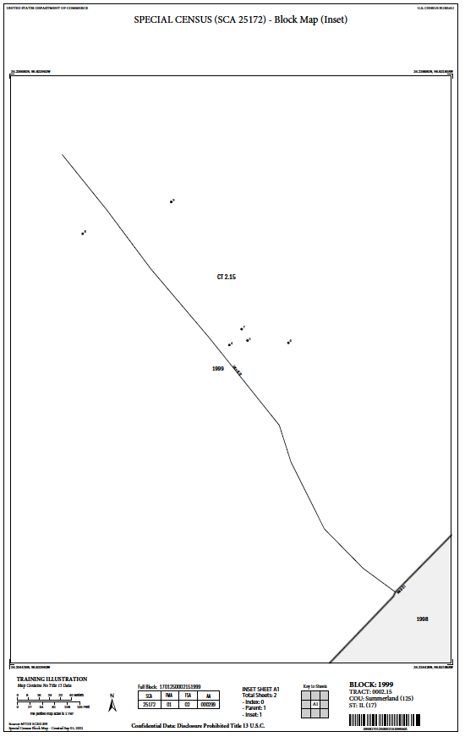

Map Spots and Map Spot Numbers
Map spots for HUs are shown on the SC block maps, if they exist, along with an accompanying map spot number. The map spot number is considered part of the geographic code for the LQ. The map spot number is also displayed in Column 10, Map Spot No., on the SC-920, Address List Page. Areas of newer HU development (after the most recent Decennial census) may not have maps spots.
Map spots and their map spot numbers on the maps, when used in conjunction with the address register, can help FRs locate existing HUs during canvassing. Map spots can be especially useful when the house number and street name listed in the address register are not complete. The SC Program does not include map spotting in the canvassing procedures. Consequently, FRs do not add map spots to the block maps nor update existing map spot locations.

Map Spots
A map spot is a symbol showing the location of a structure containing one or more LQs.
Single Unit Map Spot Multi-Unit Map Spot
● 5  14(22)

Map Spot Number
A map spot number is a number assigned to each structure containing HUs and GQs in the AA. The map spot number is printed next to the map spot. Map spots representing multi-unit structures will have a map spot number, followed by the number of HUs at the structure in parentheses.

This page intentionally left blank.

Receiving and Preparing Assignments for the Field

Introduction
This chapter is mainly for office clerks. The purpose of this chapter is to provide the instructions for confirming receipt of and checking in Address Registers from the National Processing Center (NPC), reviewing the contents of the Address Registers for accuracy, and for preparing Address Registers for check-out to the Field Supervisors (FSs).
The NPC prints the contents of the Address Registers, assembles the map envelopes, and ships the Address Registers to the Special Census Office (SCO). This chapter explains how the materials are processed in the SCO and sent to the field.

Check-in Materials From NPC

Overview
The NPC ships assembled Address Registers to the SCO. Upon receipt of the Address Registers at the SCO, the clerks are responsible for opening and unpacking the boxes and checking Address Registers and map envelopes received from NPC into MOJO.

Receipt of Address Registers from the NPC
The NPC ships assembled Address Registers to the SCO. Upon receipt of the Address Registers, the clerks:
- Open, unpack, and sort the boxes of Address Registers.
- Check-in Address Registers and map envelopes received from NPC.
- Determine if any Address Registers are missing.

Step 1: Open and Unpack Boxes of Address Registers
Carefully open the boxes of Address Registers and sort the Address Registers by Field Supervisor Area (FSA). For each FSA, sort the Address Registers in ascending order by Assignment Area (AA).
Some AAs may consist of more than one Address Register, depending on the number of housing units (HU) in the AA. If an AA requires multiple Address Registers, then each Address Register for the AA will have a label indicating Register __ of __ that will be affixed to the top right corner of the Address Register’s front cover. If an AA contains more than one Address Register, all Address Registers for the AA will be strapped together for shipment. Be sure to keep all Address Registers for an AA together. If the number of Address Registers received do not match the number of Address Registers indicated on the label, then immediately notify the SCO manager.
Do not discard the Address Register shipping boxes. Use the shipping boxes to transport training materials to the training site and to ship Address Registers and materials to the NPC at the end of the SC.
Make sure there is a map envelope included for each AA. If there are multiple Address Registers for an AA, the map envelope will be in the back of the first Address Register for the AA.
Using the packing list, cross off AAs as you confirm each AA was received.
If Address Registers are missing, search the SCO for the missing Address Registers. Inform the Special Census Supervisor (SCS) if the missing materials cannot be found in the SCO.
If any map envelopes are missing from the Address Registers, notify the SCS immediately, so the RO can be contacted to notify NPC.
Step 2: Check-in Address Registers and map envelopes received from NPC
Every Address Register and map envelope received from NPC must be checked in to MOJO individually before Address Registers can be checked out to field staff. Some AAs may contain more than one Address Register, but only one Address Register for the AA needs to be checked into MOJO. Refer to the SC-445, User Guide for the MOJO for steps to check-in Address Registers and map envelopes received from NPC.
Step 3: Check MOJO to determine if there are any AAs that were not received from NPC
Sort and filter the Case Search table in MOJO to determine if any AAs were not received from NPC. Refer to the SC-445, User Guide for the MOJO for instructions on sorting and filtering the Case Search table in MOJO.
If Address Registers or map envelopes are missing, review the packing slip from the NPC shipment to determine if the Address Registers and map envelopes were included in the box. Search the SCO for the missing Address Registers and map envelopes. Inform the SCS if the missing materials cannot be found in the SCO.
If the missing materials were not included in the shipment(s) from NPC, then contact the SCS. The SCS contacts the Regional Office (RO) to communicate the issue. The RO contacts NPC to inform them of the missing materials so they can be assembled and shipped to the SCO again.
If all Address Registers and map envelopes were received and checked into MOJO, then proceed to Topic 3 to confirm the contents of the Address Registers.

Confirm Contents of Address Registers

Overview
After checking in the Address Registers and map envelopes from NPC, the clerks verify the contents of a sample of Address Registers to confirm the contents are accurate, in the correct order, and have the correct quantities.

Confirming Contents of Address Registers
Print Form SC-336, Assignment Directory, from MOJO. Refer to the SC-445, User Guide for the MOJO for instructions on printing Form SC-336, Assignment Directory. This report provides a listing, in numerical order, of every AA in each FSA within the SCO.
Form SC-336, Assignment Directory is printed from MOJO and is used by clerks in the office to track the review of the contents in the Address Registers for each AA in the SCO. Organize the Address Registers in the same order the assignment areas are presented on Form SC-336, Assignment Directory, prior to confirming contents of the Address Registers.
The SC-336, Assignment Directory, contains the following information:
Column (1), SCO used by the clerks to track review of the contents in the Address Register for each AA in the SCO.
Column (2), Date Assigned – the date the AA was assigned to the FS.
Column (3), AA – the Assignment Area number.
Column (4), Employee Name – the last name, first name, and middle initial of the employee to whom the AA is assigned.
Column (5), Employee ID – the Employee ID of the employee to whom the AA is assigned.
Column (6), HUs – the number of housing units in the AA.
Column (7), State – the state code and abbreviation.
Column (8), County – the county code and name.
Column (9), FS – used by the FS to indicate the AA has been assigned to a FR.
An Address Register is a legal size (8 ½ inch X 14 inch) binder that opens from right to left. Address Register contents are listed in the order in which they appear in the Address Register from front to back. The following table provides a brief description of each item in the Address Register.
Form | Description | Quantity
SC-101A.1, Special Notice Page | This form is a reminder that all information in the Address Register is confidential, and all entries made need to be clear and legible | 1
SC-940, Address Register Cover Page | This form is used to track assignment information and indicate work progress. | 1
SC-114, Block List Page | This form lists the Block Number of each block within the Assignment Area | 1
SC-920, Address List Page | These pages list all known housing unit (HU) addresses, Group Quarters (GQs), and Transitory Locations (TLs) in the AA | Varies by AA
SC-921, Add Page | FRs use this page to list housing units (HUs), Group Quarters (GQs), and Transitory Locations (TLs) found during their work that are not listed on Form SC-920, Address List Page | 8
SC-901, Notes Page | FRs use this form to enter any relevant notes about addresses. | 1
SC-435, Dependent Quality Check Record | This form is used by Quality Control Field Supervisors while performing dependent quality checks on the completed assignment | 1
Map Envelope | Contains an AA Locator map, AA map, Block map(s), Map Legend, and possibly an Index map and an Inset map (depending on the assignment). If there are multiple Address Registers for an AA, then the map envelope will be included in the first Address Register. | 1
Open each Address Register and confirm the order and quantities of the pages match the expected contents in Table 12.1. Be sure to check contents of the Address Registers based on the order the AAs appear on Form SC-336, Assignment Directory.
The clerks check a sample of Address Registers for each FSA To ensure that the Address Registers are accurate.
For Address Registers, clerks:
- Conduct a content check for each of the first three AAs in each FSA (some AAs may contain more than one Address Register) listed on Form SC-336, Assignment Directory
If all three AAs for the FSA pass the content check, continue reviewing each Address Register in the FSA to make sure the same AA number is printed on the forms.
If any one of the first three AAs for the FSA fail the content check, immediately notify the SCS. The SCS contacts the RO to communicate the issue. The RO contacts NPC to inform them of the error and works with NPC to ensure the materials are corrected and resent to the SCO. Place the Address Register(s) that failed the content check aside.
- For the remaining Address Registers in the FSA, check to ensure that the AA number printed on the following forms match the label on the front of the Address Register(s):
- Form SC-940, Address Cover Page
- Form SC- 114, Block List
- Form SC-920, Address List Page(s)
- Form SC-921, Add Pages
- Form SC-901, Notes Page
- Form SC-435, Dependent Quality Check Record
- Map envelope (at a minimum, there must be one AA Locator Map, an AA Map, and a Block map for each block in the AA)
Using Form SC-336, Assignment Directory, write a check mark in the left side of Column 1, SCO, if the Address Register passed the content check of AA number check.
Using Form SC-336, Assignment Directory, write a X in the left side of Column 1, SCO, to identify there is an issue with the Address Register(s). Place the Address Register(s) that failed the content check or AA number check aside.

Prepare Address Registers for Check-out

Overview
Prior to checking out Address Registers to the FS, clerks:
- Update the SC-920, Address List Page(s) to identify housing units that self-responded.
- Write X in Column 3, Special Situations and Column 4, Action Code, on the SC-920, Address List Page.
- Update the SC-920, Address List Page(s) to identify dangerous addresses.
- Write PC in Column 3, Special Situations to indicate Proceed with Caution for a dangerous address and leave Column, 4, Action Code blank.
- Write X in Column 3, Special Situations to indicate Cease Contact for a dangerous address and Column 4, Action Code.
- Locate the supply of messenger envelopes from the SCO materials supply.
- Print labels for housing units on the SC-920, Address List page(s).
- Affix the labels for the housing units on the SC-920, Address List Page(s) to blank SC-Q, Special Census Questionnaires, keeping the questionnaires in the same order as the addresses appear on the SC-920 Address List Page(s).
The SCO is provided with both blank questionnaires and questionnaires with a pre-printed barcode ID/Case ID. The blank Forms SC-Q, Special Questionnaire, are used for known addresses on Form SC-920, Address List Page. As part of the preparing Address Registers for check-out, clerks print labels for known addresses that require an interview and affix the label to a blank questionnaire.
Questionnaires with a pre-printed barcode ID/Case ID are mainly used by field staff when conducting an interview at a new housing unit.

Preparing Address Registers
Prepare Address Register(s) for one AA at a time, working in order as the AAs are listed on Form SC-336, Assignment Directory. Complete all preparation steps for an AA before continuing with the next AA listed on Form SC-336, Assignment Directory. As preparation steps for each AA are complete, place a checkmark in the right side of Column 1, SCO, on Form SC-336, Assignment Directory.
Continue preparing Address Registers until all AAs in the FSA have been prepared. Then continue with the next FSA until all registers in each FSA have been prepared. Keep the Address Registers organized by FSA.

Step 1: Update the SC-920, Address List Page(s) for Addresses that Do Not Require an Interview
The Address Registers were printed and assembled prior to the self-response phase. As a result, Form SC-920, Address List Page(s) for each AA need to be updated to indicate that FRs do not need to make contact or interview at housing units that self-responded and addresses that are dangerous with a cease contact classification. The SC-920, Address List Page(s), also need to be updated to identify addresses that are dangerous with a proceed with caution classification.
The SC- 300 Self-Response/Dangerous Address Report in MOJO contains a list of the addresses that self-responded or are identified as dangerous. To update Form SC-920, Address List Page(s) the clerks:
- Review the SC-300 report in MOJO. Refer to the MOJO user guide for steps to view and print SC-300 report from MOJO.
- Update the SC-920, Address List Page(s) to identify housing units that self-responded.
- Write X in Column 3, Special Situations and Column 4, Action Code, on the SC-920, Address List Page.
- Update the SC-920, Address List Page(s) to identify dangerous addresses.
- Write PC in Column 3, Special Situations to indicate Proceed with Caution for a dangerous address and leave Column, 4, Action Code blank.
- Write X in Column 3, Special Situations and Column 4, Action Code, to indicate Cease Contact for a dangerous address.

Step 2: Locate Supply of Messenger Envelopes
Locate the supply of messenger envelopes from the SCO supply of materials. Use one messenger envelope per AA.

Step 3: Print Labels for Housing Units on the SC-920, Address List Page(s)
Before printing labels ensure the sheet of labels is properly installed in the printer. Labels only print for addresses that require an interview. If a self-response was received for an address or if an address is dangerous with a classification of Cease Contact, then labels will not print for those specific addresses. As labels are printed, make sure the printed text on the label is legible. If the printed labels are not legible, properly dispose of the illegible labels and reprint the labels. Refer to the SC-445, User Guide for the MOJO for steps to print labels for housing units listed on Form SC-920, Address List Page(s).

Step 4: Affix Labels to blank SC-Q, Special Census Questionnaires for Housing Units on the SC-920, Address List Page(s)
After the AA labels are printed, clerks:
- Retrieve a stack of blank Forms SC-Q, Special Census Questionnaire, from the SCO materials supply.
- Working in order of addresses as they appear on the SC-920, Address List Pages(s), carefully peel off the corresponding housing unit label and carefully affix it to the Apply Label Here section on the front page of a blank Form SC-Q, Special Census Questionnaire. Labels should only be printed and affixed to a blank Form SC-Q, Special Census Questionnaire for addresses on Form SC-920, Address List Page if column 4, Action Code, is blank. Make sure the label is completely within the label box. Continue this process until all address labels for the entire AA have been placed on questionnaires. Be sure to keep labeled SC-Q, Special Census Questionnaires in the same order as the housing units appear on the SC-920, Address List Page(s).
- To ensure that each listed address requiring an interview has a labeled SC-Q, Special Census Questionnaire, match each labeled questionnaire to its corresponding Special Census address on the Form SC-920, Address List Page(s), in the AA address register. All addresses with a blank Column 4, Action Code, require an interview and should have a labeled questionnaire. Immediately notify the FM or SCS if any addresses requiring an interview on Form SC-920, Address List Page(s) do not have a barcode ID label. Keep Forms SC-Q, Special Census Questionnaire(s) in the same order as they appear on Form SC-920, Address List Page(s).
After confirming that every address in the AA that requires an interview has a corresponding labeled questionnaire, place all labeled questionnaires in the 12 by 16 messenger envelope. Refer to Form SC-336, Assignment Directory, to obtain the AA numbers. Write the AA number in legible, large print using a black ink ballpoint pen on the outside of the 12 by 16 messenger envelope.
Place the stuffed 12 by 16 messenger envelope inside the front cover page of the Address Register and place a rubber band around the Address Register with the questionnaires. If there are multiple Address Registers for an AA, place the stuffed 12 x 16 messenger envelope inside the front cover of the first Address Register for the AA.

Step 5: Fill out Form SC-940, Address Register Cover Page
On Form SC-940, Address Register Cover Page, in Section 1, Assignment Information, under row (a) FS, enter the Name, Employee ID, and Telephone Number of the FS to which the AA will be assigned.

Print and Prepare Forms for Field Supervisors

Overview
Prior to checking out AAs to Field Supervisors, clerks are responsible for gathering the materials to be provided to the FSs along with their AA Address Registers. Clerks are responsible for gathering the:
- Form SC-20, Field Supervisor Management Record
- Form SC-1019C, Employee Listing by FSA

Step 1: Locate Form SC-20, Field Supervisor’s Management Record
Locate the SC-20, Field Supervisor Management Record in the SCO materials supply. Clerks:
- Write the Field Supervisor’s Name, SCID number, and FSA number in the top right corner of the SC-20, Field Supervisor Management Record.
- Make a copy of the completed Form SC-20, Field Supervisor’s Management Record to keep in the SCO.
- Write each AA number in Section 1, Assignment Information, in the space provided. The AAs must be written in the order they appear on Form SC-336, Assignment Directory.

Step 2: Print Form SC-1019C, Employee Listing by FSA from MOJO
Print Form SC-1019, Employee Listing by SCID and FSA, from MOJO. Refer to the SC-445, User Guide for the MOJO, for printing procedures. This report provides a list of all employees in the FSA. FSs use this list to contact FRs on their team and when making reassignments in the field.
Form SC-20, Field Supervisor’s Management Record, and Form SC-1019, Employee Listing by SCID and FSA, must be provided to the FS along with the Address Registers for their FSA. Keep these two forms with the Address Registers for the FSA.

Check-out Address Registers

Overview
Clerks use MOJO to check-out the Address Register and select the FS to whom the AA is being assigned. Refer to the SC-445, User Guide for the MOJO for procedures on assigning and checking out AAs. All Form SC-Q, Special Census Questionnaires, associated with the AA, need to be checked out separately from the Address Register.
After the assignment areas are assigned to an FS in MOJO, the clerks:
- Print a new Form SC-336, Assignment Directory showing that the Address Registers are assigned and checked out to the FS.
- Place Form SC-336, Assignment Directory with the materials that are provided to the FSs along with Address Registers.
Below is a list of the contents that go out with each assignment to the FS:
- Address Register
- Map pouch with the associated maps
- SC-Q labeled questionnaires
- SC-336, HU Assignment Directory, showing all assignments made to the FS
- SC-20, Field Supervisor’s Management Record
- SC-1019, Employee Listing by SCID and FSA

Initial Reassignment of Address Registers to Field Representatives
FSs assign AAs to the FRs after classroom training. The FSs update Form SC-336.1, Reassignment Worksheet, with the name of the FR to which the AA was reassigned. The FS writes the:
- SCID, Date, FSA Number, and Page _ of _ in the Header section.
- AA number in Column 1, AA.
- Name of Employee who was previously assigned the AA (which is the FS) in Column 3, From: Employee Name.
- Name of the employee to whom the AA was reassigned (which is the FR) in Column 4, To: Employee Name.
- Employee ID to whom the AA was reassigned in Column 5, To Employee ID.
When the updated Form SC-336.1, Reassignment Worksheet, is returned to the office, the clerks update MOJO to reflect the new reassignment. Refer to the SC-445, User Guide for the MOJO for procedures on assigning AAs. It is important to keep MOJO updated as reassignments are made in the field.

Subsequent Reassignments of Address Registers to Field Representatives
As AAs need to be reassigned during the SC, FSs use Form 336.1, Reassignment Worksheet to document the reassignments. The FSs send the Form 336.1, Reassignment Worksheet to the SCO as reassignments are made. When a Form 336.1, Reassignment Worksheet arrives in the office, the clerks update MOJO to reflect the new reassignment. Refer to the SC-445, User Guide for the MOJO for procedures on reassigning AAs.

Conducting Telephone Interviews
Clerks may need to conduct telephone interviews during the SC. The production clerk may conduct production telephone interviews for production. The production clerk conducts a production telephone interview when a FR is unable to make contact at a housing unit. The FR leaves Form SC-NV(E/S), Notice of Visit, which provides the SCO phone number so the respondent can complete the interview over the telephone.
The Quality Control (QC) clerk will conduct telephone reinterviews in instances when a telephone number is available. During telephone reinterview, a QC clerk may only complete Form SC-RQ, Special Census Reinterview Questionnaire and they may also need to complete a full telephone interview using Form SC-Q, Special Census Questionnaire, based on responses provided during reinterview.
Sometimes an interview will need to be conducted in Spanish. In these instances, the cases should be reassigned to a Spanish speaking person. When this occurs, a Spanish version of the SC-Q, Special Census Questionnaire, must be used. Also, a Spanish version of the label must be printed and affixed to the Spanish questionnaire before the questionnaire is checked in.

Production Clerks Conducting a Telephone Interview Using Form SC-Q, Special Census Questionnaire
When a phone call is received in the SCO and the caller refers to Form SC-NV(E/S) Notice of Visit for a SC, the production clerk must first ask the caller for their phone number in case the call becomes disconnected. The production clerk must also ask the caller to provide the following information, which is located on the bottom of the Notice of Visit:
- Case ID
- Line Number
- Which box is checked, SC-920, Address List Page or SC-921, Add Page
After receiving the requested information, the production clerk must use an unlabeled Form SC-Q, Special Census Questionnaire, to complete the telephone interview. The clerk hand writes the Case ID in the label section of an unlabeled Form SC-Q, Special Census Questionnaire. All entries on Form SC-Q, Special Census Questionnaire, must be made using a black ink ballpoint pen. Refer to Form SC-50.1, Special Census Office Job Aids for details on conducting a production telephone interview.
When the telephone interview is complete, the production clerk prints a label from MOJO that matches the Case ID the respondent provided from Form SC-NV(E/S) Notice of Visit. The production clerk affixes the label to the unlabeled Form SC-Q, Special Census Questionnaire. If a Spanish questionnaire is used, then a Spanish label must be printed and affixed to the completed Spanish questionnaire before the questionnaire is checked in.
During a telephone interview, if the caller refuses to answer questions, the production clerk records an Outcome Code of RE, Refusal in the Record of Contact section.
The production clerk completes the last page of the questionnaire. Refer to SC-50.1, Special Census Office Job Aids for instructions on completing the last page of the questionnaire.
The production clerk follows procedures in Chapter 13, to check-in Form SC-Q, Special Census Questionnaire.
After the production clerk completes a telephone interview for a housing unit where the FR left Form SC-NV(E/S), they must notify the FM that the interview was conducted. The production clerk must provide the FM with the Case ID associated with the interview, the address, form number from Form SC-NV(E/S), Notice of Visit, line number from Form SC-NV(E/S), Notice of Visit, and the date when the interview was conducted. The FM must notify the FS, who then notifies the FR that the interview was completed via telephone at the SCO. The FR will be instructed to write a large X on each page of the questionnaire. When the questionnaire marked with a large X arrives at the SCO, the questionnaire should be held until confirmation of the version completed by the production clerk has been checked in to MOJO. Once confirmed, these questionnaires are boxed up and sent to the RO. The RO will destroy once them have received confirmation from NPC that all forms are scanned.
It is possible for the FR to complete Form SC-Q, Special Census Questionnaire, in a similar timeframe as when the production clerk completed the telephone interview. The system will notify the user, during check-in, if the questionnaire has already been checked in. If this happens, the production clerks must locate the initial version of the questionnaire and compare it to the subsequent version.
If the questionnaire completed the production clerk via telephone and the subsequent version of the questionnaires completed by the FR do not match, then refer both questionnaires to the SCS for guidance. If the SCS determines the version completed by the FR should be kept, then he or she checks the REP bin box in item E, Interview Outcome Code, in the Interview Summary on the questionnaire completed by the FR and the clerks checks in the questionnaire.
For the other form not accepted (but still needed since there is partial information), the SCO will cross out the barcode label and put the form in the box. For forms with duplicate barcode IDs, MOJO assumes one form only. So, if there's a duplicate that gets crossed out, it doesn't exist to MOJO. The SCO can put the form in any box they'd like without scanning it into the system. Once the form arrives at NPC, NPC will affix an ATAC label over the crossed-out label so the form can be image scanned.

Replacement Materials
In the event Address Registers and various questionnaires become lost, missing, or stolen, following these steps to request replacement materials.
Address Registers: NPC will need to print the entire register and overnight it to the SCO (including maps) and send the replacement register through Kiteworks to avoid delays. Address labels will be printed in the SCO from MOJO. If questionnaires were checked in, the clerk will place a check mark in column 3 on the SC-920 so the FR does not conduct another interview. The clerk must also transcribe address updates on SC-921 address list page. Recreate Add Page(s) based on SC-Qs for added housing units that have been received in the office and checked in. Follow initial preparation procedures to mark addresses that self-responded and mark cease contact and proceed with caution addresses that are dangerous. Check INFO COMMS to see if any GQ/TLs were added to the Add Page and make sure they are on the replacement materials.
DQC Register: NPC will need to reprint if lost during or after DQC. Office clerks needs to recreate the Add Pages in the SCO by looking at the checked in questionnaires. The clerks need to transcribe the adds on the Add Pages (based on checked in questionnaires). The HU status will need to be transcribed as well.
SC-Q Production Questionnaire: The office clerk prepares a questionnaire with a label and sends it to the FR.
SC-RQ: Follow same process as preparing for RI. Copy information from the production form onto the RI form.
SC-20: If replacing, the clerk lists all AAs, but writes a large X in section 1 when the AA is complete. If an AA is not complete, the clerk writes in assignment information, based on data in MOJO.

This page intentionally left blank.

Receiving Production Assignments from the Field
The activities clerks perform as completed work from the field is returned to the Special Census Office (SCO) is the focus of this chapter. The clerks check work in to MOJO as it arrives to the SCO after production work is complete.
Clerks review Form SC-Q, Special Census Questionnaire(s) and Address Registers for completeness and accuracy. If a Form SC-Q, Special Census Questionnaire contains errors, the clerks attempt to resolve the issue in the office. If unable to resolve error in the office, Form SC-Q, Special Census Questionnaire must be placed in Supplemental Reinterview. If Address Registers contain errors, clerks prepare Form SC-320, Error List, to go out with the Address Register during the Dependent Quality Check (DQC), and the Quality Control (QC) Field Supervisor (FS) corrects the documented errors while performing DQC.

Introduction
Every completed Form SC-Q, Special Census Questionnaire, and Address Register is checked into MOJO after work is completed in the field. Every Form SC-Q, Special Census Questionnaire, Form SC-CQ, Special Census Continuation Questionnaire, and Address Register flows through several quality checks before they are sent to the National Processing Center (NPC) at the end of the operation.
The Special Census Supervisor (SCS) monitors workflow in the SCO to ensure that:
- Materials received from the field are sorted and routed to the appropriate areas of the SCO for various processing activities
- Completed Forms SC-Q, Special Census Questionnaire, Forms SC-CQ, Special Census Continuation Questionnaire, and Address Registers are promptly checked in to MOJO as they arrive in the office from the field
- Form SC-RQ, Special Census Reinterview Questionnaire is prepared for Form SC-Q, Special Census Questionnaire, when selected for Reinterview
- Payroll forms, personnel forms, and other administrative forms are promptly processed
- Office reviews of completed Form SC-Q, Special Census Questionnaires, Form SC-CQ, Special Census Continuation Questionnaires, and Address Registers are promptly conducted
- Form SC-225, INFO-COMM containing information about added Group Quarters (GQs) and Transitory Locations (TLs), dangerous addresses, describing problems, procedural questions, safety concerns, supply requests, and other work-related issues are reviewed and resolved

Receiving and Sorting Production Work

Overview
Assignment Area (AA) materials are returned to the SCO on a flow basis as work is completed. Form SC-Q, Special Census Questionnaires and Form SC-CQ, Special Census Continuation Questionnaires are returned as interviews are completed. The Address Registers are returned after the entire AA has been completed.

Receiving and Sorting Area in the SCO
The SCS and clerks organize work areas to receive and sort Special Census (SC) materials received from the field daily. The SCO staff use IN and OUT bin boxes for receiving and sorting materials. Separate IN and OUT bin boxes are needed for Form SC-Q Special Census Questionnaires, the Address Registers, and all other forms received in the office.
The SCO staff must always keep the receiving area neat and orderly by ensuring that incoming materials are placed in the appropriate bin boxes.
Most of the previous day’s completed work from the field arrives in the morning; however, work may arrive in the SCO anytime throughout the day. The SCO may also receive group quarters and transitory location enumeration materials to check-in to MOJO. Refer to Group Quarters Enumeration and Transitory Locations Advance Contact (TLAC) and Enumeration at Transitory Locations (ETL) for the instructions to check-in the GQ and TL enumeration materials to MOJO.
It is recommended that at least one clerk should be in the SCO during the entire work shift. The materials received from the field contain Personally Identifiable Information (PII) and Title 13 information and the SCO is responsible for ensuring that this information is distributed as quickly as possible and checked in to MOJO.

Reminders about Form SC-Q, Special Census Questionnaire
As Form SC-Q, Special Census Questionnaires and Form SC-CQ, Special Census Questionnaires flow through the office, ensure that staff are aware of how to handle these materials.
- Form SC-Q, Special Census Questionnaires tend to stick together because of static electricity. Be sure they are separated. This is especially important when the Form SC-Q, Special Census Questionnaires, are being checked into MOJO, because every Form SC-Q, Special Census Questionnaire, must be accounted for.
- If there are more than six people living in a housing unit, the Field Representative (FR) uses Form SC-CQ, Special Census Continuation Questionnaire, to collect data for the additional persons. The FR is instructed to keep all continuation questionnaires together for housing units (HU) by placing Form SC-CQ, Special Census Continuation Questionnaire(s), inside the parent Form SC-Q, Special Census Questionnaire. Clerks must keep the SC-Q, Special Census Continuation Questionnaire(s), with the parent Form SC-Q, Special Census Questionnaire, throughout all office processes.
- Unlabeled Form SC-Q, Special Census Questionnaires, for added HUs do not need to be processed separately. They can be mixed with labeled Form SC-Q, Special Census Questionnaires.
- Clerks must use a black ink ballpoint pen when marking questionnaires. Also, for Form SC-Q, Special Census Questionnaires, selected for Reinterview, clerks use a red pencil to write the letters RI on the Form SC-Q, Special Census Questionnaire, to indicate it was selected for reinterview. See Topic 3 for the instructions to check-in SC-Q, Special Census Questionnaires and Reinterview selection.
- There is the potential to receive BOTH an English SC-Q and a Spanish SC-Q for a HU. Assuming the Spanish version is accepted, the office needs to print a Spanish label and then check-in ONLY the Spanish SC-Q. The English SC-Q must be placed in a destroy bin.

Overview of Production Check-In
After materials are sorted, the completed field work is checked in to MOJO. Refer to Figure 20 for an explanation of the overall check-in process.
Figure 20. Overview of office check-in procedures for production.
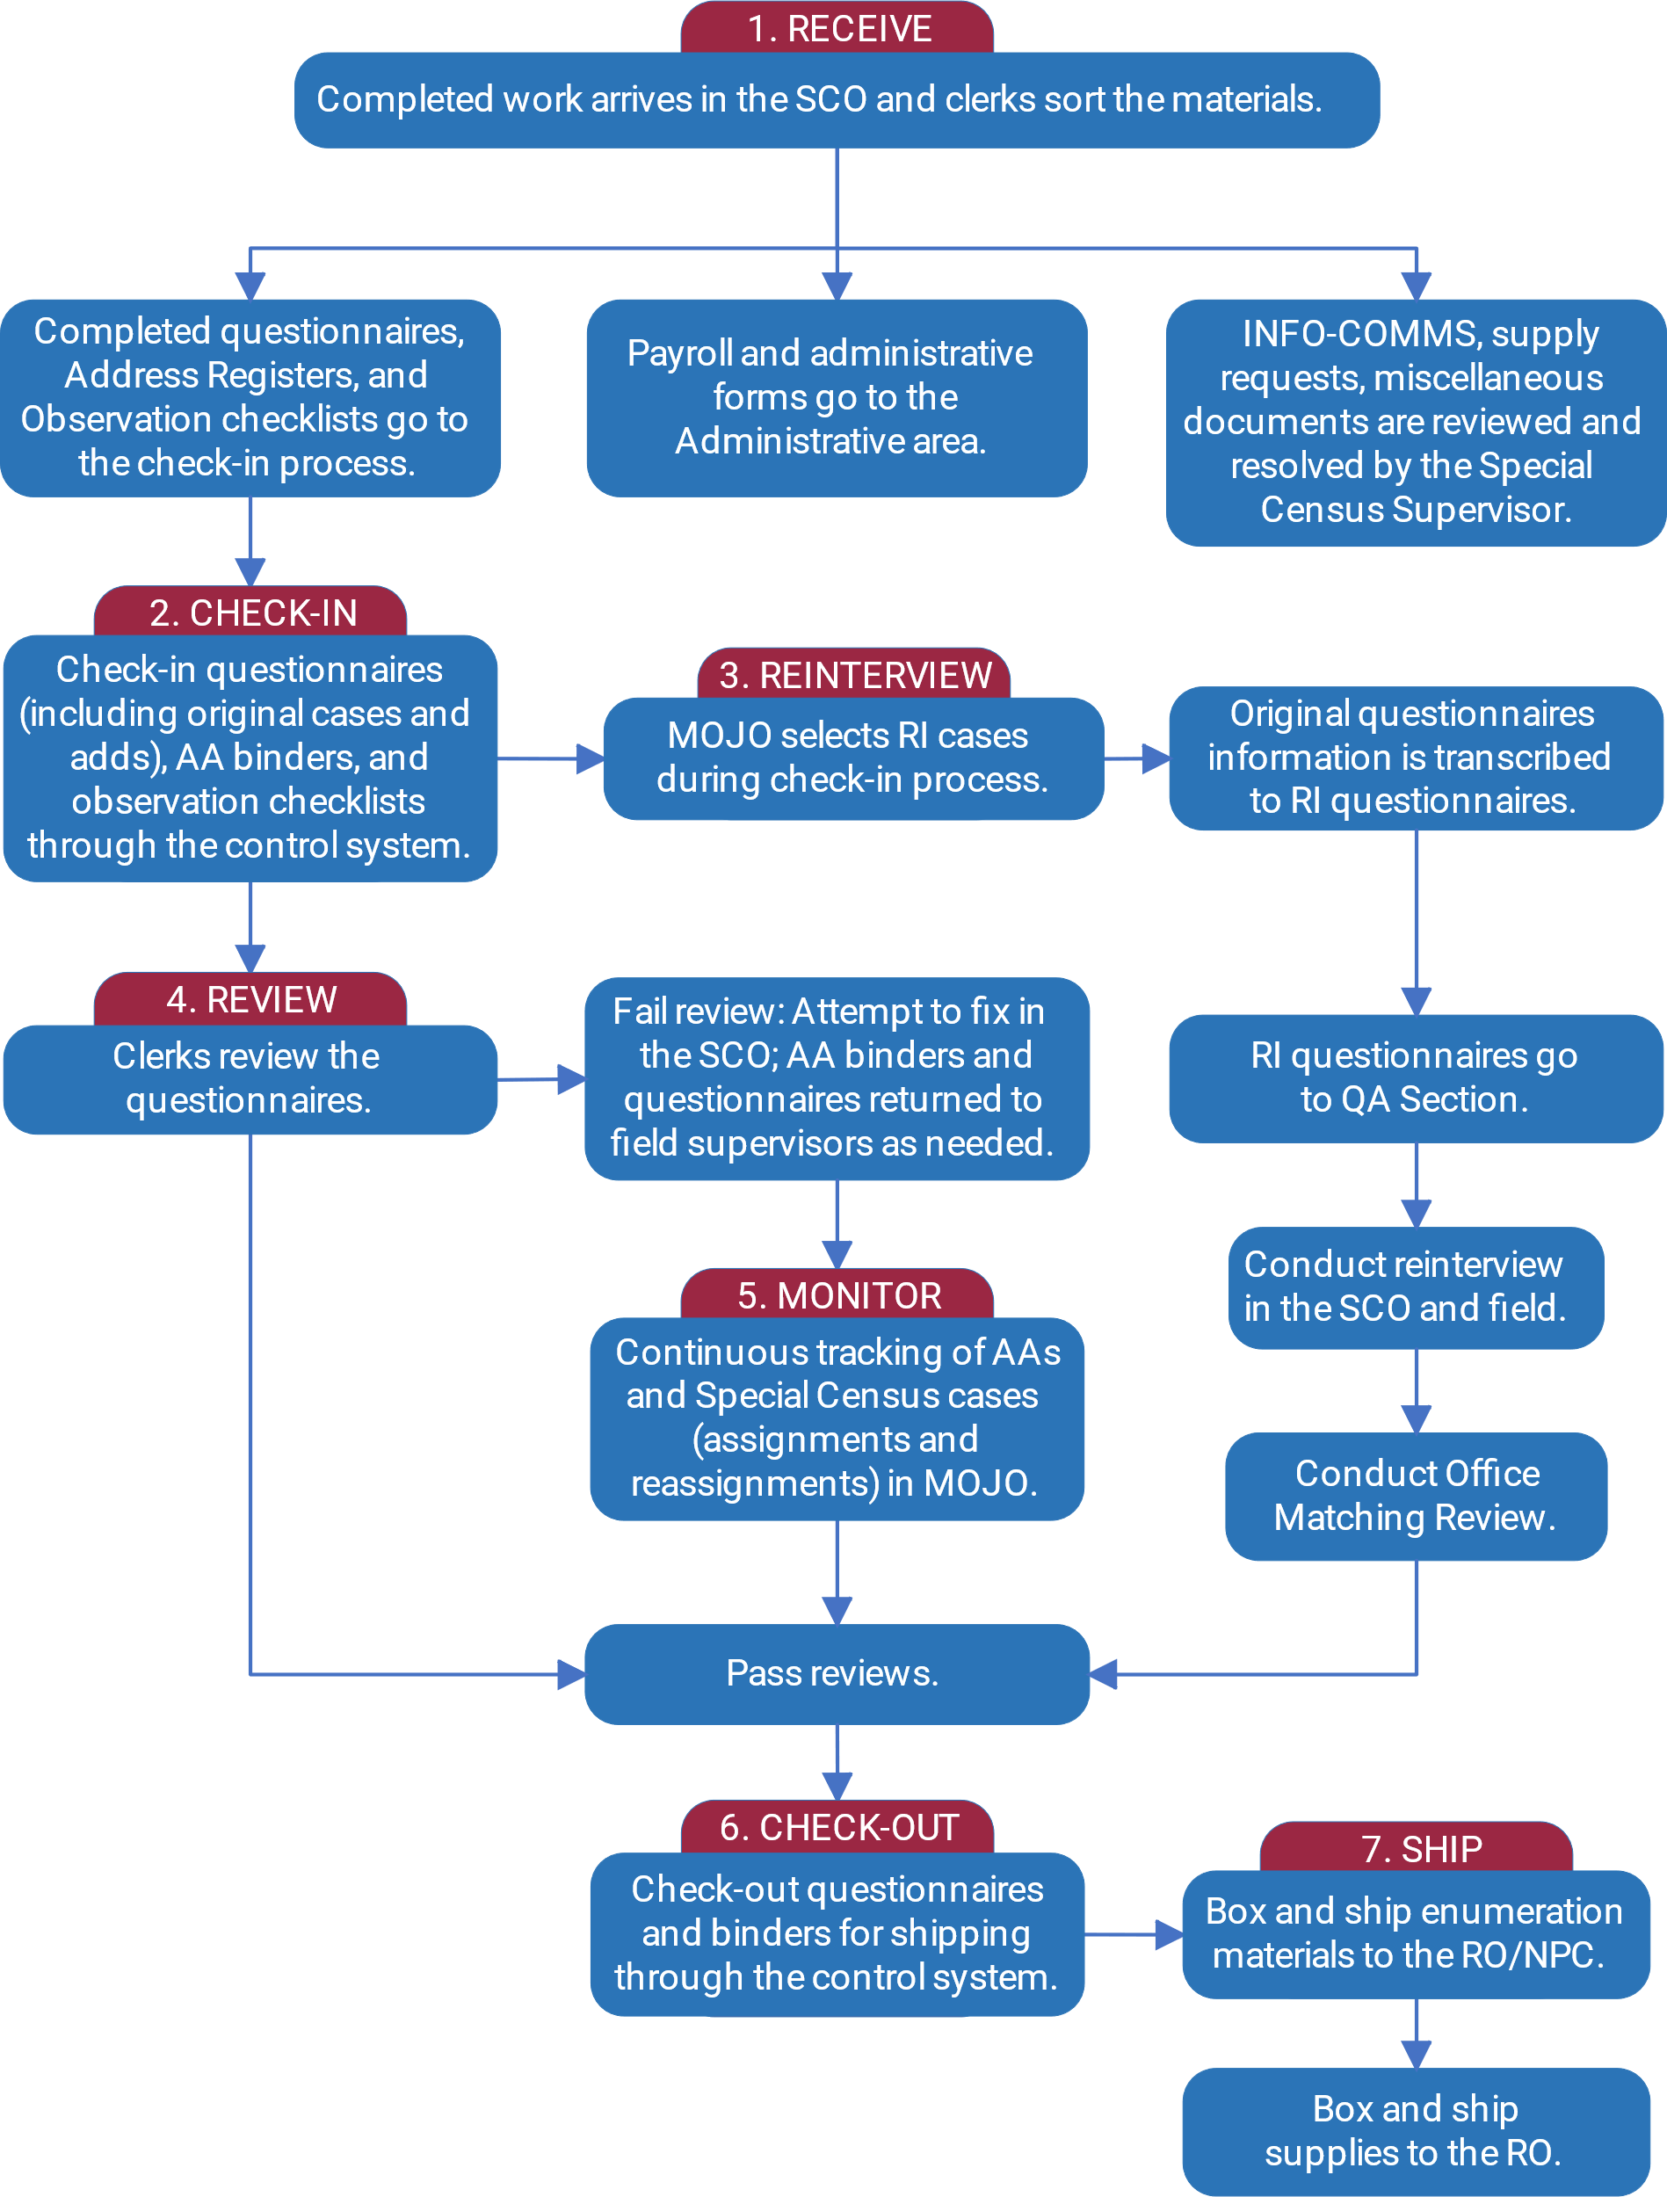

Check-in Questionnaires
Production work is checked into MOJO as it arrives in the SCO. Form SC-Q, Special Census Questionnaires and Address Registers are checked in to MOJO one at a time.

Check In Questionnaires and Continuation Questionnaires
Form SC-Q, Special Census Questionnaires and Form SC-CQ, Special Census Continuation Questionnaires, are returned to the SCO as interviews are completed. Clerks check each Form SC-Q, Special Census Questionnaire, into MOJO. Refer to the SC-445, User Guide for the MOJO for instructions on checking in Form SC-Q, Special Census Questionnaires(s).
If an interview is conducted in Spanish, then a Spanish version of Form SC-Q, Special Census Questionnaire, will be returned to the SCO, along with the corresponding English version of Form SC-Q, Special Census Questionnaire. The English version of Form, SC-Q, Special Census Questionnaire, will be placed inside of the Spanish version. When a Spanish version of the questionnaire is used, then a Spanish label must be printed and affixed to the Spanish version of Form SC-Q, Special Census Questionnaire, before it is checked in. The corresponding English version of Form SC-Q, Special Census Questionnaire, will have a large X on the front page. The corresponding English version must be placed in a destroy bin and not be checked in to MOJO.
The following data from the SC-Q, Special Census Questionnaire, are scanned or keyed into MOJO upon check-in.
- Barcode ID label on front cover – scanned or keyed.
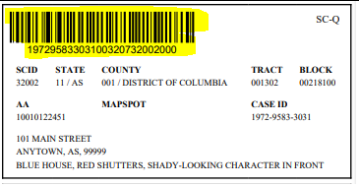
- Name of FR who completed the interview – keyed from the Certification section.
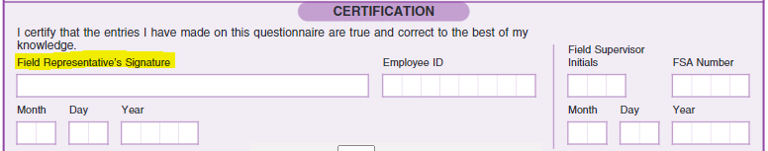
- Key the following from the Interview Summary section of the SC-Q, Special Census Questionnaire.
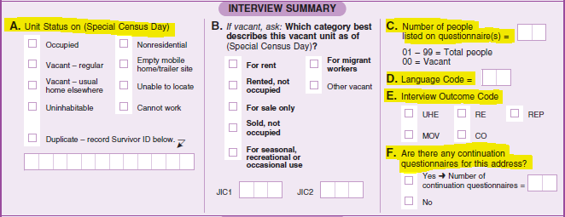
- Unit Status– keyed from Item A .
- Number of People listed on questionnaire(s) – keyed from Item C.
- POP Count is 7 or more – the system prompts for the SC-CQ, Special Census Continuation Questionnaire(s). The clerk follows the system prompts to check these in.
- Language code – keyed from Item D.
- Interview Outcome Code – keyed from Item E.
- Usual Home Elsewhere (UHE) – This option is marked when the respondent lives in a usual home elsewhere on the Special Census Day.
- Refusal (RE) – This option is marked when the FR is instructed by the FS to mark the outcome code as a refusal when a case is determined to be a refusal versus having another FR work the address.
- Replacement (REP) – This option is only marked by office staff in the SCO for a replacement questionnaire.
- Movers (MOV) – This option is marked for address with movers.
- Closeout (CO) – This option is used at the end of the operation to close the remaining cases. The FS instructs the FR when to make this option. Also used when an FR has visited the address the maximum six times and wasn’t able to make contact.
- Number of Continuation Questionnaires – keyed from Item F.
If the questionnaire is for an added housing unit, the clerks also enter the following information into MOJO:
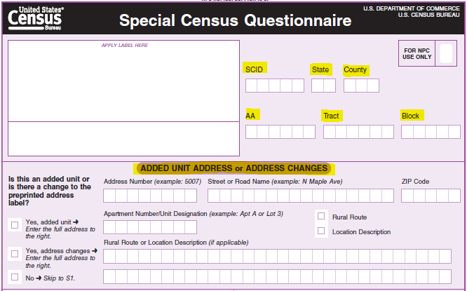
- SCID, State, County, Tract, Block, and AA from the header section of the questionnaire
- The complete address which includes the house number, street name, unit designation (if present), and ZIP Code; or street name, unit designation (if present), location description, and ZIP Code
- If there are Forms SC-CQ, Special Census Continuation Questionnaire, then MOJO prompts the clerk to check-in each Form SC-CQ, Special Census Continuation Questionnaire, associated with the parent Form SC-Q, Special Census Questionnaire.
- As Form SC-Q, Special Census Questionnaires, are checked-in, MOJO randomly selects cases for Reinterview. If a case is selected for RI, the clerk writes the letters RI in red pencil on the upper-right corner of Form SC-Q, Special Census Questionnaire. The clerk sets the case aside so the information can be transcribed to the SC-RQ, Special Census Reinterview Questionnaire. While MOJO selects cases for RI upon check-in of the SC-Q from production, the SC-RQ can be printed after check-in.
- Place Form SC-Q, Special Census Questionnaires that are not selected for Reinterview in office review. See Topic 6 for more information on questionnaire office review.

Preparing the Form SC-RQ, Special Census Reinterview Questionnaire
Preparing Form SC-RQ, Special Census Reinterview Questionnaire, should be completed in the afternoon when most or all the Form SC-Q, Special Census Questionnaires, have been checked into MOJO. Clerks conduct Reinterview in the SCO if a respondent telephone number is available. Reinterview FRs also conduct RI in the field. Production clerks prepare Form SC-RQ, Special Census Reinterview Questionnaire, for Reinterview. QC clerks conduct the Reinterview in the office if a telephone number is available. QC clerks have three attempts to conduct the telephone Reinterview. If the QC clerks are unable to complete the telephone Reinterview in three attempts, then the Reinterview will be assigned to a RI FR. Reinterview FRs conduct reinterview in the field, if a QC clerk is unable to complete the telephone Reinterview in three attempts or if a telephone number is not available.
It is important that the clerk who prepares Form SC-RQ, Special Census Reinterview Questionnaire, is not the same clerk that may conduct the Reinterview over the telephone.
Reinterview is an independent check of the contents of Form SC-Q, Special Census Questionnaire. For this reason, the clerk that makes the telephone call for the Reinterview should not have prior knowledge of Form SC-Q, Special Census Questionnaire, responses.
At the end of the day, the clerks:
- Print Form SC-RQ, Special Census Reinterview Questionnaire, from MOJO for Form SC-Q, Special Census Questionnaires, that were selected for Reinterview for the day. Form SC-RQ, Special Census Questionnaire, contains a printed barcode ID. Refer to the SC- 445, User Guide for the MOJO for the instructions on how to print Form SC-RQ, Special Census Reinterview Questionnaire.
- Print the appropriate English or Spanish version of Form SC-RQ, Special Census Reinterview Questionnaire, to match the version used for the production interview. MOJO provides an indicator of whether the production interview was conducted in English or Spanish on the screen used to print Form SC-RQ, Special Census Reinterview Questionnaire.
- For known addresses (SC-Q, Special Census Questionnaires with a label), check MOJO to determine if the address is a known dangerous address flagged as proceed with caution. Refer to the SC-445, User Guide for the MOJO, for the instructions on determining whether an address is flagged as proceed with caution by reviewing information on the screen for printing the SC-RQ.
- If the address is dangerous and flagged as proceed with caution, then add a note in the Notes section on the bottom of the back of the corresponding Form SC-RQ, Special Census Reinterview Questionnaire. Include the reason the address is dangerous and a note to inform the FR to proceed with caution when approaching the address.
- Dangerous addresses that are cease contact and new dangerous addresses added will not be eligible for RI, since they are coded as cannot work during production.
- Transcribe items R1, R2, R3, and R4 in the Respondent Information from Form SC-Q, Special Census Questionnaire onto the corresponding SC-RQ, Special Census Reinterview Questionnaire Original Respondent’s Information section.
- Item R1, First and Last Name to OR1, Original Respondent’s Name.
- Item R1 (Address of proxy) to OR4, Address – Address of Neighbor or Proxy.
- Item R2 to OR2, Telephone number.
- Item R3 to OR3, Original respondent type.
- OR4, Address – Neighbor or Proxy only, is left blank if R3 is marked Live or stay in this [house/apartment/mobile home] on the Special Census Date or Move into this [house/apartment/mobile home] after the Special Census Date.
- If not live of stay in this [house/apartment/mobile home] is checked in R3, then the clerk enters the Address of proxy from R1 and telephone number from R2, into OR2 in the SC-RQ, Special Census Reinterview Questionnaire.
Refer to Figure 21 for an example of the completed Form SC-RQ, Special Census Reinterview Questionnaire.
Figure 21. Example showing how information is transcribed from the SC-Q to the SC-RQ when a respondent lived at the address on Special Census Day.
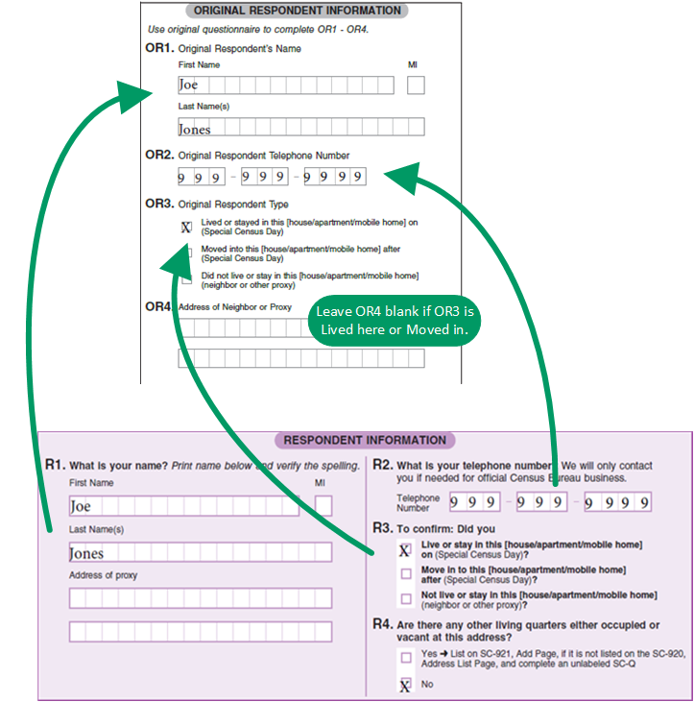

Preparing Form SC-RQ, Special Census Reinterview Questionnaire
Refer to Figure 22 for an example of Form SC-RQ, Special Census Reinterview Questionnaire.
Figure 22. Example showing how information is transcribed from the SC-Q to the SC-RQ when a respondent did not live at the address on Special Census Day.
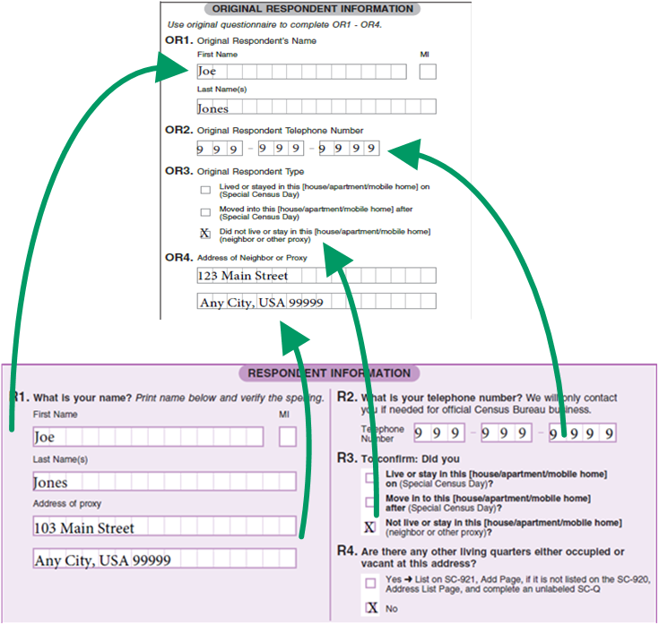
After transcribing Forms SC-RQ, Special Census Reinterview Questionnaires for the day, the clerks place the original Forms SC-Q, Special Census Questionnaires selected for Reinterview in office review. Follow procedures in Section 1, Questionnaire Review in Form SC-1131, Office Checklist for Reviewing Materials.
After office review is completed, the original Form SC-Q, Special Census Questionnaire, is placed in a secured temporary bin box in the Reinterview area until the corresponding Form SC-RQ, Special Census Reinterview Questionnaire is completed.
When Form SC-RQ, Special Census Questionnaire is completed and returned to the office, the clerk compares the original Form SC-Q, Special Census Questionnaire to the completed SC-RQ, Special Census Reinterview Questionnaire to determine whether the Field Representative followed the Special Census procedures. Refer to Chapter 16: Quality Control Operations for information on Matching Review.

Check-in Address Register

Overview
Address Registers are returned to the SCO after all listing for an Assignment Area (AA) is complete. As AAs arrive in the SCO, the Clerks check-in each Address Register and conduct a quality check of the completed work.

Check-in Address Register
Clerks check-in Address Registers through MOJO. Refer to the SC-445, User Guide for the MOJO for instructions on checking in Address Registers. The clerks:
- Retrieve Address Registers from the IN bin.
- Scan the barcode ID from the cover of the Address Register into MOJO.
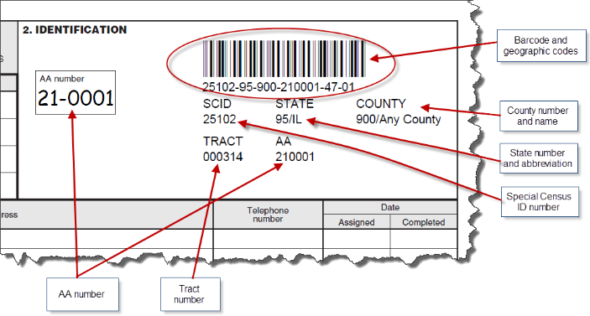
- Select/confirm the name of the Field Representative that completed the Address Register.
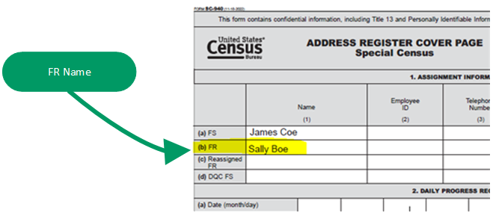
- Enter the number of lines used on Form SC-921, Add Page into MOJO.
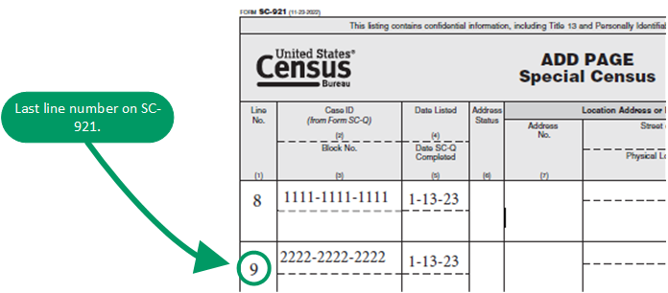
- Draw a line, using red pencil, under the last address added for Form SC-921, Add Page, during production.
- If there are no adds on Form SC-921, Add Page, then write NO ADDS in red pencil in the first row of Form SC-921, Add Page.
- Conduct an Office Review of the Address Register, following procedures in Section 2, Address Register Review in Form SC-1131, Office Checklist for Reviewing Materials, prior to preparing the Address Register for DQC.
- Prepare the Address Register for DQC. Refer to Chapter 16: Quality Control Operations for steps to prepare the Address Register for DQC.

Erroneous Adds
Addresses added in error are referred to as erroneous adds. If an address was added in error, it can be deleted in MOJO. Refer to SC-445 User Guide for the MOJO for instructions on deleting an erroneous add.

Check-in Other Forms

Overview
Other forms are returned to the SCO throughout the operation. These forms include:
- Form SC-1222, Special Census Observation Checklist
- Form SC-225, INFO-COMM
- Form SC-308, Daily Pay and Work Record
- Miscellaneous items, such as notes or letters
The items should be sorted as they arrive in the SCO and routed to the appropriate area for processing or resolution.

Form SC-1222, Special Census Observation Checklist
Form SC-1222, Special Census Observation Checklist, is used by the Field Supervisor (FS) during Field Representative observations to determine whether the Field Representatives are performing the work according to the Special Census procedures. Refer to Chapter 16, Topic 2 for more information about the observation checklist and its uses.
The Field Supervisor conducts an observation for each Field Representative and completes Form SC-1222, Special Census Observation Checklist, within the first week of the operation. The SCO should expect Form SC-1222, Special Census Observation Checklist, for every Field Representative to arrive in the SCO within the first two weeks of the operation.
Clerks in the SCO enter data from Form SC-1222, Special Census Observation Checklist, into MOJO. Refer to the SC-445, User Guide for the MOJO, for instructions on entering data from Form SC-1222, Special Census Observation Checklist, into MOJO.
The clerks:
- Retrieve Forms SC-1222, Special Census Observation Checklist, from the IN bin.
- Ensure that items 1 through 9 in the top section of Form SC-1222, Special Census Observation Checklist are completed. If any information is missing, prepare Form SC-225, INFO-COMM, and send it back to the FS for resolution.
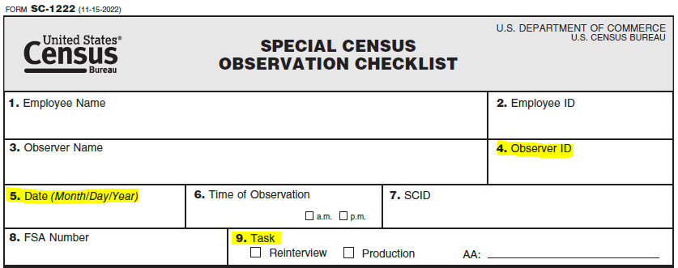
- Enter the result from Section II - Recommendation of Form SC-1222, Special Census Observation Checklist, into MOJO. Refer to the SC-445, User Guide for the MOJO, for instructions on entering observation results.
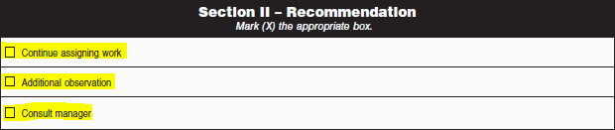

INFO-COMMs Review
Form SC-225, INFO-COMM, is completed in the field for several reasons, including when GQs and TLs are added to Form SC-921, Add Page, and when dangerous addresses are identified. Some issues documented on Form SC-225, INFO-COMM, require resolution by the Special Census Supervisor. Some examples of issues to resolve include requesting additional enumeration materials, requesting guidance, or informing the Special Census Supervisor about performance or conduct issues, and requesting guidance for issues related to field activities.
Form SC-225, INFO-COMM, contains three copies. The original or top copy is sent to the SCO. Copies 1 and 2 remain with the initial receiver and sender, respectively.
A common issue encountered in the field is gaining access to multi-unit buildings or gated communities that deny access to Special Census Field Representatives. The Special Census Supervisor can request the RO send a letter to a building manager or administrator to request access to a building or community. A sample of this letter is in Appendix E. Consult the RO for guidance on how to manage access issues.
When a new GQ or TL is found during listing, the FR completes Form SC-225, INFO-COMM, by checking the Added GQ/TL/TNSOL box, writes the address, name of the GQ or TL, contact person name and phone number, and the Add Page line number for the listing. The FRs provide Form SC_225, INFO-COMM, to the FS during their scheduled meeting. The FS calls the office to report the information for the new GQ or TL. New GQs and TLs need to be added to MOJO immediately to ensure they are added to the workload and completed by the end of the operation. Refer to Form SC-445, User Guide for the MOJO, for procedure to enter a new GQ or TL into MOJO. Additionally, the Form SC-225, INFO-COMM, containing the information that was called into the office about the new GQ or TL will be sent to the SCO. Upon receipt of Form SC-225, INFO-COMM, in the office, clerks must verify that the information on Form SC-225, INFO-COMM was correctly entered into MOJO.
Form SC-225, INFO-COMM, is also used to report dangerous addresses encountered in the field. In situations where Form SC-225, INFO-COMM, is submitted due to a dangerous address, the form will be placed inside the respective Form SC-Q, Special Census Questionnaire. When Form SC-225, INFO-COMM, is used to report a dangerous address, the SCO must communicate, to the RO, the address, and the reason it is dangerous. The RO enters the information into the Dangerous Address Database.
After Form SC-225, INFO-COMM, has been reviewed and resolved, be sure to remove the INFO-COMM from inside the questionnaire and store it in the appropriate bin box.

SC-308, Daily Pay and Work Record
Form SC-308, Daily Pay and Work Record is used by field staff to document the date, times and hours worked as well as miles driven. Form SC-308 is returned to the SCO daily. Form SC-308 must be routed to the Administrative area for review and keying into GovTA.

Office Review of Form SC-Q, Special Census Questionnaire

Overview
After checking the production work in, the clerk conducts an office review of Form SC-Q, Special Census Questionnaires as they arrive in the SCO on a flow basis as interviews are completed to ensure that the entries are legible and completed with a black ink ballpoint pen. The clerks also make sure that Form SC-Q, Special Census Questionnaire, pages are not torn, damaged, or wrinkled.
Clerks conducting office review of the SC-Q, Special Census Questionnaire, perform the following tasks:
- Conduct a review to ensure all Form SC-Q, Special Census Questionnaires, have entries for required items. Refer to Section 1 – Questionnaire Review on Form SC-1131, Office Checklist for Reviewing Materials.
- If an error is found in the Form SC-Q, Special Census Questionnaire, the clerks attempt to correct the error in the office. The clerk may call the Supervisor to obtain the needed information. A black ink ballpoint pen must be used to make corrections. All entries must be legible. Cross out incorrect entries with a single line and write the correct information in all capital letters near the crossed-out entry.
- If errors are resolved in the office, Form SC-Q, Special Census Questionnaire, can be placed in storage.
- If errors are not resolved in the office, Form SC-Q, Special Census Questionnaire, must be placed in Supplemental RI.

Office Review of Questionnaires
The clerks review several sections of Form SC-Q, Special Census Questionnaire, to determine if the information was captured. Refer to Section 1 – Questionnaire Review, Part A, Form SC-Q, Special Census Questionnaire, Part B, Form SC-CQ, Special Census Continuation Questionnaire, and Part C Certifications of the SC-1131, Office Checklist for Reviewing Materials, for details on conducting office review.

Production Address Register Office Review

Overview
After the Production Address Registers are checked-in, the clerks perform an office review on every Address Register.
Clerks conducting office review on the Production Address Registers: perform the following tasks:
- Conduct a review to ensure every Address Register was updated appropriately and was returned with all the applicable contents. Refer to Section 2 – Address Register Review on Form SC-1131, Office Checklist for Reviewing Materials.
- Attempt to correct errors in the office by contacting the FS. If the error is not resolved in the office, the clerks prepare Form SC- 320, Error List, to document the error(s) that need resolution. During DQC, the QC FS resolved the errors on the SC-320, Error List.

Production Address Register Office Review
The clerks review every Address Register after the Production work is complete. Refer to Section 2 – Address Register Review of the SC-1131, Office Checklist for Reviewing Materials for details on conducting Production Address Register office review.
Refer to for instructions on preparing the Address Register for DQC.

Group Quarters Enumeration

Group Quarters Introduction
Group quarters (GQ) are places where people live or stay in a group living arrangement that is owned or managed by an entity or organization providing housing and/or services for the residents. These services may include custodial or medical care as well as other types of assistance, and residency is commonly restricted to those receiving these services. This is not a typical household-type living arrangement. People living in GQs are usually not related to each other. Group Quarters Enumeration (GQE) covers Group Quarters Advanced Contact (GQAC), GQE and Service-Based Enumeration (SBE).

Group Quarters Advance Contact
Before we can enumerate group quarters, we must first let the GQ staff know that we are coming and explain the enumeration process to them. We do this during GQAC, which has two components:
- An office operation when clerks call to collect certain information about each GQ to plan for enumeration and enter the information into MOJO.
- A field operation to follow up on any Unresolved cases from the phone operation where a Field Representative (FR) conducts GQAC in person at those locations. Unresolved cases can include:
- Phone interview was not completed
- Contact Person did not set an enumeration appointment
- Case status is Nonresidential
- Refusal
- 999 GQ Type Code that has not been updated
Clerks key in the information collected during the field into MOJO. When the GQAC operation is over, its workload becomes the GQE workload.

Group Quarters Enumeration
The GQE counts individuals who reside in group settings. Not everyone lives in a house, apartment, or mobile home. Some people live or stay in group settings. Counting individuals where they live or stay requires the use of specially designed operations. These operations are called GQE and SBE. The SBE operation is a part of the GQE operation. Enumeration is another word for counting. The GQE operation will count people who live or stay at GQs such as skilled-nursing facilities, hospitals, correctional facilities, group homes, residential treatment centers, and college residence halls.

Service-Based Enumeration
Some people do not have a usual residence and often get assistance and meals at service-based locations. The SBE operation is a subset of GQE. It is conducted at places where people experiencing homelessness stay overnight, such as emergency and transitional shelters. SBE also includes Targeted Non-Sheltered Outdoor Locations (TNSOLs). For Special Census (SC), FRs will only enumerate Emergency and Transitional Shelters and TNSOLs in teams.

Emergency and Transitional Shelters
Emergency and Transitional Shelters (with sleeping facilities) for People Experiencing Homelessness. They include:
- Shelters that operate on a first-come first-serve basis, where people must leave in the morning and have no guaranteed bed for the next night.
- Shelters where people know they have a bed for a specified period (even if they leave the building every day).
- Shelters that provide temporary shelter during extremely cold weather (such as churches). This category does not include shelters that operate only in the event of a natural disaster.

Targeted Non-Sheltered Outdoor Locations
The SBE operation also includes outdoor locations where people experiencing homelessness live without paying to stay. We call these places Targeted Non-Sheltered Outdoor Locations’. TNSOLs differ from TLs because they are locations where people are unlikely to live year-round due to the transitory/temporary/impermanent nature of the location. People living in these locations are counted in places such as alleys, under bridges, and in parks.

Group Quarters Requiring Unique Procedures during Special Census
There are some GQ facilities that require unique procedures during the SC. The SCO needs to know about these GQs exceptions to handle them appropriately. The GQs that fall into this exception group are GQs on American Indian Reservations (AIRS), Domestic Violence Shelters (DVS), GQs on military installations, Salvation Army and TNSOLs. There are currently no special enumeration procedures for GQs that are part of the Salvation Army. Should the SCO staff find any of these GQs in their assignments, refer them to the Field Manager (FM).

American Indian Reservations (AIRS)
There are special procedures to enumerate GQs on AIRS. AIRS cases are only assigned to residents of the AIRS and SCO staff at the supervisory level. The SCO will determine the staff who enumerates these cases.

Domestic Violence Shelters
DVSs are shelters that house individuals fleeing emotional, sexual, and physical abuse. DVS can be community-based homes, crisis centers or shelters. This operation requires discretion and is extremely sensitive. The identity and addresses of these shelters are kept strictly confidential, and steps will be taken in MOJO so that information about these places is not available to everyone that works on the system.
Clerks will not contact a DVS. If a DVS is inadvertently on the list of GQs, you are to contact the FM or SCS immediately for further guidance. The FM or SCS will inform the clerk to not discuss the case any further. DVSs are managed separately from the regular GQ workload and are not enumerated.
If a DVS is discovered during AC (before interviewing):
- Select Cannot Locate in item 27 of the INFO-COMM, as shown in the following image.
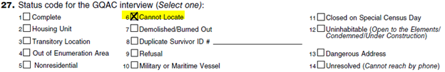
- Write Special situation in the notes section as shown in the following image.
- Select Cannot Locate on item 34 on the INFO-COMM, as shown in the following image. The GQ is closed out and stays in the SCO.
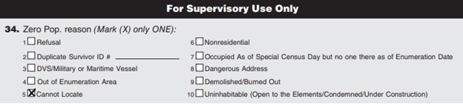
If a DVS is discovered as DVS after AC - assuming code in item 27 is complete and FR goes to GQ and discovers it is a DVS:
- Complete a Form SC-225, INFO-COMM. On the form, indicate the name and address of the Domestic Violence Shelter.
- Once the SC-116, blank ICQ forms, and INFO-COMM are returned to the SCO, the SCO will mark item 34 as cannot locate.

Military Installations
Military installation GQs include barracks, bachelor officer quarters, base hospitals, base stockades, and so forth. There is a possibility that a military installation may fall within the SC area. If that is the case, a Regional Office (RO) manager or the SCS will conduct the initial contact. The clerks will not contact military installations to set up enumeration appointments. If there are military installations in your assignment, tell your supervisor. The RO manager or SCS will use the SC-351 Special Census Group Quarters Advance Contact Script to set up an enumeration appointment with the installation.
Regardless of enumeration method chosen by the military, the initial contact is handled by both the RO manager and the SCS. There may be additional security procedures that must be followed. When the installation is contacted, the contact person is asked to provide a list of the installation’s GQs and the approximate population for each GQ.
Military installations will be enumerated if they are inside the SC enumeration area. Military installations, in most cases, contain housing units (HU) as well as group quarters. Enumerating people at military installations requires careful planning since they operate under the need for extreme privacy. They also need to protect standard routine activities against disruption. If there are HU within the military installation, then they will be enumerated by the HU operation.

Salvation Army
When you arrive at a Salvation Army location, they may change their method of enumeration. Please accommodate them. Also, accept the information they provide the first time and do not ask for more data. They will not provide any names on the enumeration materials, and we accept that. No follow up after the review of the ICQs.

Targeted Non-Sheltered Outdoor Locations
The FM or SCS assign staff to go by these locations to complete a much of the advance contact information as they can on the Control Record. This is done so the assignment materials can be prepped in the office. If there is a gatekeeper, that person needs to be identified as the contact person on the Control Record. This person can be of help in gaining cooperation from the residents. The other two items that need to be completed on the GQ Control Record are how many people stay at this location and the best time to visit.
TNSOL Enumeration is generally conducted late at night into the early morning, between the hours of 12:00 a.m. to 7:00 a.m. There is an exception, locations (such as parking lots or parks) that serve as places for individuals sleeping in cars and/ or trucks are enumerated early night hours starting at 9:00 p.m. A TNSOL must have a specific location description; for example, the Brooklyn Bridge at the corner of Bristol Drive or the 700 block of Taylor Street behind the old warehouse. SCO staff must be prepared because some TNSOLs may change depending on weather conditions. The SCO will receive additional guidance from the RO as to when to conduct these types of enumeration, as they will choose an appropriate or convenient time to conduct this operation.
Types of Enumeration Methods
Enumeration methods refer to the approach used for data collection. There are three methods of enumeration used during SC. They are:
- In-Person Interview – a team of FRs conducts a personal interview with each resident who was served or was staying at the facility on Special Census Day using the Individual Census Questionnaire (ICQ).
- Administrative Records – The FR collects an administrative list that has certain demographic data about each resident who was served or was staying at the facility on Special Census Day.
- Drop Off/Pick Up – The FR leaves an ICQ for each resident who was staying at the facility on Special Census Day to fill out and return to a contact person at the GQ by a set date and time.
The enumeration method used is chosen by the GQ Administrator during the Group Quarters Advance Contact.

Group Quarters Staff and Responsibilities

Staffing Overview
A FR or a designated staff will conduct the enumeration of the GQ in the SC. Trainees will receive the entire production training followed by a GQ specific training.
If the SCO is conducting HU and GQE, all trainees will attend the FR training. FRs assigned to the GQE operation will also receive GQE training. The trainer will use the SC-669.12, Special Census Group Quarters Enumeration Guide for Training FRs to train the GQ FRs.
The SCS or designated FS will already be assigned the GQ for enumeration. After training, the supervisor coordinates with his or her team to make assignments based on the information on the Form SC-116, Group Quarters Control Record. The FR receives their assignments from their supervisor who gives them materials to conduct the enumeration. The GQE might happen immediately after training or shortly thereafter.
The staffing will depend on the estimated number of people that will be enumerated at the facility and the method of enumeration selected for the facility. It is possible that if there are several small group quarters in the workload, the SCS or designated supervisor can handle these alone
There will be instances where the supervisor will need a team of FRs, for example, at large facilities such as prisons or hospitals. This is especially true at TNSOLs, where these locations must be enumerated by a team of FRs.
The SCS needs to determine which FRs to assign to the GQ operation so they can be trained in the GQ procedures. The SCS should assign FRs that live nearby the GQs that will be enumerated.

Service-Based Enumeration Staffing
As previously mentioned, SBE operation is a subset of GQE. It is conducted at places where people experiencing homelessness stay overnight, such as emergency and transitional shelters. SBE also include TNSOLs.
For SC, FRs will enumerate Emergency and Transitional Shelters and TNSOLs in teams. Teams are created based on the number of expected population (expected pop) at the SBE location. The SCO assigns one (1) FR for every twenty (20) respondents when enumeration is conducted at shelters. At minimum there should be at least two (2) for shelter enumerations. For the SC this would be the Supervisor plus one FR. For unusually large shelters, more than one team may be assigned to conduct the enumeration.
The SCO will use its best judgement based on the expected pop to determine if only 1 team or several teams are required to conduct the shelter enumeration. Knowing the hours operation for the shelter is critical to having a successful enumeration. SCO staff must be organized and work quickly complete the enumeration. Shelter enumerations must be conducted as close to SC Date as possible.
Each team will consist of the team leader and the team members. The team leader oversees coordinating enumeration at the given shelter. It is important for the team leader to plan and create the teams by writing the team members names on a piece of paper then an alphabetic designation next to their name. This is particularly helpfully when tracking the work completed by the different team members. The team leader should make it clear to the team that this is the only time they can conduct the enumeration. There will not be an opportunity to return to the shelter. The team leader makes all assignments, and hands out the enumeration materials to the team on the day of enumeration. Once at the GQ, the team leader meets with the contact person to discuss the enumeration and the best method for collecting the required information at the shelter. The team will then enumerate all residents and turn in the completed work.
The number of ICQs completed should equal the number of ICQs the FR reports that they have completed. The team leader writes this by their name on the control sheet. After adding up the totals and checking to ensure that all forms are collected, the Record is completed and signed.

Targeted Non-Sheltered Outdoor Locations (TNSOLS)
Staff needs to be very careful when working at these locations. There are guidelines the staff will follow to be safe and effective during this operation. Even though this type of location can be enumerated using one person, one person alone will not be allowed to enumerate an outdoor location. A team is needed to conduct this enumeration. One FR must watch over the whole team and if there is any cause for concern, everyone should leave the area immediately. The SCS or designated supervisor must account for everyone in their team.
A team will never go into a TNSOL or an encampment by themselves or volunteer to stay behind to finish the enumeration. The supervisor will always pair off with another FR and always be aware of your surroundings.
When conducting enumerations at TNSOLs, the creation of teams will be slightly different. The SCO assigns teams of four or more FRs for each TNSOL. When making the assignments, you should give each team only enough work that they can enumerate that day. You want to use each team efficiently but must make sure you have enough teams to complete the SBE enumeration in one day. Each site is only enumerated once. When you arrive at the encampment, the SCS or designate supervisor will introduce themselves to the gatekeeper, if there is one. A gatekeeper is someone that knows everyone at the encampment and is trusted by them.
Having a gatekeeper would greatly facilitate the enumeration at an outdoor location. The team will then:
- Ask the gatekeeper to let everyone at the encampment know that the Census Bureau is conducting an enumeration.
- Enumerate quickly and diligently.
- Interview everyone at the encampment, including children.
You will also be enumerating people in pre-identified cars, Recreational Vehicles (RVs) and tent encampments. The encampments are ad-hoc locations where people who have no usual home elsewhere are not paying to stay. Examples can be cars and RVs in large department store and municipal parking lots. Included in this example are encampments on open lots and undeveloped land. These encampments do not include RV parks and campgrounds where people pay to stay.
Please see the GQ FR Manual for more SBE Guidelines for Safety Tips.

Military Installations
Military installations can include HU and transitory locations (TLs) as well as GQs. This includes all branches of the service and the Coast Guard. The enumeration at military installations requires careful coordination because the need to operate under the need for extreme privacy, the need to protect standard routine activities against disruption, and safety issues for the visiting Census Bureau staff as well as for the residents of the facility. It is likely that GQs inside military installations will be enumerated through administrative records. During the Initial Contact to the facility, the SCS or a Census Representative spoke to a point-of-contact person and arrangements were made to enumerate the base. The SCS needs to build a team that will enumerate each area at the base. It is suggested to determine ahead of time if HUs need to be enumerated at the base, so a team of FRs complete the HU enumeration at the time when the GQ enumeration is scheduled. The SCS or other RO manager will discuss the details about enumerating the military installation at the initial meeting with the governmental unit.
Special Census Office Staff Responsibilities
SCO Supervisor and Managers are responsible for supervising the work conducted in the office and the enumeration activities in the field. They are expected to supervise the work of the staff who conduct In-Office GQAC, prepare materials for In-Field GQAC and GQE operation. Managers will also:
- Review or approve the workload by reviewing GQs added by FRs in the field,
- Provide the clerks with their assignments
- Check that approved adds are entered into MOJO,
- Check that clerks call each GQ in the GQAC workload using the SC-351, GQ Advance Contact Script and complete the SC-116, GQ Control Record which includes scheduling an enumeration appointment. Please note that the SC-116, GQ Control Record is used for Advance Contact and Enumeration.
- Check that the clerks prepare materials for any GQs that must go to the In-Field GQAC operation.
- Check that the clerks have printed the SC-116 (CP), GQ Control Record Continuation Pages as part of the preparation for GQE and SBE operations.
- Supervise any assignment preparation
- Supervise staff production and quality control phases
- Identify the staff to enumerate the GQs
- Train the staff on GQAC and enumeration procedures.
The SCO Managers will use Form SC-1055(GQE), Special Census Supervisor Checklist, to do the review of the completed enumeration materials.
The SCS or another supervisor in the SCO will select and appoint the staff that will work on the GQ operations.
First is the GQ Advanced Contact operation which requires selection of office clerks and FRs. The office clerks and FRs are trained by a supervisor. The clerks call the GQs assigned to them and conduct an interview using the SC-351, GQ Advanced Contact Script. The answers provided by the GQ contact are written on the SC-116, GQ Control Record. If the interview cannot be completed or there is some other issue with the case preventing a completed interview, the case then goes to the in-field GQAC.
The clerk gives the SC-116, GQ Control Record for any incomplete or unresolved case to the supervisor. The supervisor assigns the case to a FR who will conduct an in-person interview, if possible. The FR reviews any notes on the Control Record from the clerk and goes to the GQ to do an interview. The FR uses the GQAC script and writes any additional information on the Control Record the supervisor provided. After the FR has completed the case, the Control Record comes back to the SCO. The Control Record is also used during enumeration operations.
In many cases, the FS will assign a FR to enumerate a GQs. In the situation of a large GQ and during SBE operations, the FS creates a team of enumerators from their FRs. One FR is selected to be the lead FR in charge of enumerating the large GQ or SBE.
The GQ Field Supervisor or lead FR and their respective teams will:
- Visit the GQ on the scheduled day and time,
- Introduce themselves to the contact person and explain how the GQ enumeration will be conducted,
- Conduct GQ enumeration using the GQ contact’s chosen enumeration method of In-Person Interview, Drop-off/Pick-up, or Administrative records,
- Verify all questionnaires are turned in, review questionnaires and other enumeration materials, and
- Turn in completed materials to the SCO.
Clerks Responsibilities
SCO clerk plays an integral part in GQ operations because they support the operations through the following tasks:
- Inventory GQ kits and bulk supply materials received.
- Assemble training materials.
- Print SC-116, GQ Control Records.
- Conduct In-Office GQAC.
- Perform a variety of tasks using MOJO.
- Prepare GQE and SBE field assignment materials.
- Review completed materials and check in completed materials.
The clerk will use Form SC-1056(GQE/SBE), Group Quarters Quality Control Office Review Checklist, to do the review.

Group Quarters Advance Contact Overview

Group Quarters Advance Contact Introduction
To update group quarters information and schedule the enumeration for each facility, you use the GQAC script. Collecting this information gives the SCO valuable data to prepare for enumeration operations.
During the GQAC operation, you identify someone at each GQ to serve as the contact person. During the phone interview:
- Explain the SC to the contact person.
- Explain the enumeration procedures for Service-Based or GQE to the contact person.
- Ask the GQ contact to select a method of enumeration appropriate for their GQ.
- Update information about each GQ such as the GQ name, GQ Type Code, maximum population, expected population, address, and the contact person’s information, including name, telephone number, and title.
- Set an enumeration appointment.
- Gain cooperation from the contact person by explaining confidentiality issues and ask that the contact person let their residents/clients know that all information that the Census Bureau collects is confidential.

Group Quarters Advance Contact Assignment Preparation
The office and field staff need the materials in the following table to do GQAC.

SC-116, Special Census Group Quarters Control Record
The SC-116, Special Census GQ Control Record contains all the pre-GQAC information about the GQs. Clerk and FRs use the SC-116, Special Census GQ Control Record to conduct GQAC. Must print one for each GQ in the SCO workload.

SC-116(CP), Group Quarters Control Record Continuation Page
Used to create a list or roster of the GQ. FR fills in each resident’s information on the SC-116(CP) as they conduct interviews or create ICQ packets for drop off /pick up.

SC-351, Special Census GQ Advance Contact Script
GQAC Script guides the clerk and FR through the interview. Tells the staff what and where to fill in the answers on the GQ Control Record.

SC-637, GQ Type Code Job Aid
Used to help determine the correct GQ Type Code if the current code is incorrect or there a new GQ

SC-640, GQ Frequently Asked Questions
Provides answers that respondents may ask during an interview that are not covered in the GQ materials.
As part of GQAC assignment prep, you need a printout of the GQ workload. As the GQ control records are printed out, check them off the workload printout. As cases are given to the staff, you can write their names on the printout as well. You must have a control record for every GQ in the SC enumeration area.

Group Quarters Advance Contact Tasks
In addition to the items listed above during the GQAC operation, the clerk or FR will:
- Check the materials and make sure they have everything to do their job.
- Collect the expected population count.
- Write the data from the interview onto the contact record.
- Address concerns related to confidentiality, legal, and security matters.
- Document any issues on the control record and INFO-COMM.
- Turn in the completed materials to their supervisor.

SC-920, Address Listing Page
The SC-920, Address Listing Page contains known addresses for the block(s) listed in the Assignment Area (AA). The information on the SC-920, Address Listing Page will be pre-printed on the form.

SC-920, Address Listing Page Columns
The SC-920, Address Listing Page consists of a header, a body that is divided into 17 items, and the footer. The address listing page will include every known address in the AA as well as the GQ(s) you will visit. The following image is an example of the SC-920, Address Listing Page.
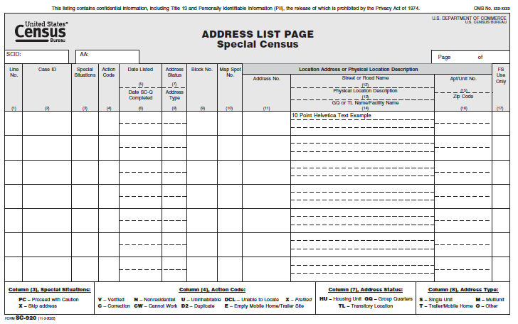

Header Information
The first line at the top of each page informs you that the SC-920, Address Listing Page, contains the confidentiality statement including Title 13 and Personally Identifiable Information (PII) information, both of which are protected by the Privacy Act of 1974.
The remaining information in the header identifies the report by form number and name, and the geographic location of the addresses.
The following information is entered in the heading of the form:
- SCID: The 5-digit number identifying your SCO.
- AA: The 6-digit number identifying the AA.
- Page __ of __: Indicates the current page and the total number of pages.
The body of the form contains 17 items, each briefly described below:

Item (1), Line No.
Every line on the SC-920, Address Listing Page, has a line number on item 1. This includes lines for blocks that have no living quarters (NLQ) in them. Usually, the lines are numbered in sequential order, beginning with line number 1 on the first page of the Address List and ending with the last address (or NLQ, if applicable) on the last page of the Address List.
Every address is given a line number, starting with 1 and increasing sequentially.
Since you will only receive the page or pages with the GQ(s) assigned to you, the pages might start with numbers other than 1. The rest of the address listed will then be consecutive starting from the number at the top of the page.

Item (2), Case ID
All addresses on the SC-920, Address Listing Page have a 12-digits Case ID. This number uniquely identifies each address in the address listing page. This code uniquely identifies the address and matches the Case ID printed on the labeled Form SC-Q, Special Census Questionnaire, for HU addresses or on the SC-116, GQ Control Record.
Note: If a block contains no known living quarters, one line for the block will appear on the Form SC-920, Address List Page. The block number will be entered in Column (9), Block No., and No known LQs in this block will be entered in Column (12), Street or Road Name. Xs will be entered in several columns on the same line.

Item (3), Special Situations
If X is entered, do not make contact at the address (skip and continue canvassing). If PC (proceed with caution) is entered, work the address as usual but be aware that residents may not want you on their property.

Item (4), Action Code
If X is entered, do not make contact at the address (skip and continue canvassing). Otherwise, after completing a questionnaire for the address, enter the appropriate code to indicate the address’s status. In some situations, you will not complete this item until meeting with your supervisor.

Item (5) Date Listed
This item does not apply to GQ, but only completed for HU addresses. You will leave this item blank. Item 5 is where enumerators conducting the housing unit enumeration will enter when they completed a Form SC-Q, Special Census Questionnaire for that address.

Item (6) Date SC-Q Completed
This item does not apply to GQ, but only completed for HU addresses. You will leave this column blank. Item 6 is where enumerators conducting the housing unit enumeration will enter when they completed a Form SC-Q, Special Census Questionnaire for that address.

Item (7), Address Status
Displays the status of the living quarters: housing unit (HU), group quarters (GQ), or transitory location (TL).

Item (8), Address Type
Indicates if the housing unit address is a single unit (S), multi-unit (M), trailer/mobile home (T), or other (O) type of structure, if known.

Item (9), Block No.
Displays the Block Number where the provided address is located.

Item (10), Map Spot No.
If known, the location of the structure containing the address is indicated on the corresponding Block Map by a dot (map spot) and number. This same number appears in Item (10).

Item (11), Address No.
Displays the address number assigned to the structure, if known.

Item (12), Street or Road Name
This item contains a street or road name, a rural route and box number or a P.O. Box number for where the address is located. Roads without a known name may display as:
- UN RD – Public, unnamed road
- PR RD – Private, unnamed road (such as a driveway)
- VE TR – Vehicular trail, usable only by a 4-wheel drive vehicle

Item (13) Physical Location Description
If an address number and street name are not known for an address, a physical description or location description for the address is displayed here. An example of a description might be House 1/10 mile north from intersection of Baseline Rd. & Front St, east side of Front St. This column may also include the name of the GQ.

Item (14) GQ or TL Name /Facility Name
If the address identifies a GQ or TL, this column displays the name of the group quarters or transitory location, if known.

Item (15), Apt/Unit. No.
The Apt. No. is the unit designation for living quarters at multi- unit locations, such as an apartment building. Unit designations may be Apt. A, Unit 6, First floor right front Apt. and so forth. This item will usually be blank for GQs.

Item (16) ZIP Code
Displays the ZIP Code where the address is located.

Item (17) FS Use Only
This item is for FS use only. Do not make any entries in this item.

The Footer Information
The codes listed on the footer do not apply for GQ Enumeration. The footer of the SC-920 contains information to help the HU enumerators use the listing page during canvassing work.

SC-921, Add Page
FRs use the SC-921, Add Page to record GQ addresses found while canvassing in their Assignment Area. The Add Page is used to add both new HUs, GQs and TLs. The SCS will review and approve all address adds. After approval of any of the GQ adds, they are then included in the GQAC workload to make an enumeration appointment and enter the GQ into MOJO. Refer to the SC-445, for procedures on how to enter an added GQ in MOJO.
The SC-921, Add Page have designated fields for the FRs to input information found in the field. It is important that these fields are completed accurately to ensure that address verification can occur in the office. FRs will number each SC-921, Add Page using the Page ___ of ___ spaces in the upper right corner. The pages are to be numbered one after the other using the first blank space. For example, if an FR has 3 sheets of Add Pages, the FR will complete each like this:
Page 1 of 3
Page 2 of 3
Page 3 of 3
The following image is an example of the SC-921, Add Page.
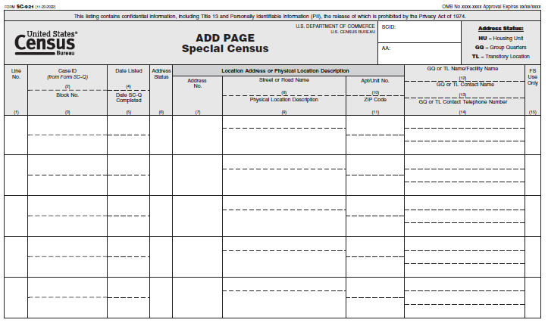

The Form SC-921, Add Page Columns
The Form SC-921, Add Page consists of a header and a body that is divided into 15 items. In these items you will fill the address and contact information from the group quarters assigned to you.

The Header Information
The first line at the top of each page informs you that the Form SC-921, Add Page, contains the confidentiality statement including Title 13 and PII information, both of which are protected by the Privacy Act of 1974.
The following information is entered in the heading of the form:
- SCID (Special Census ID): The 5-digit number identifying your SCO
- AA (Assignment Area): The 6-digit number identifying the AA
The body of the form contains 15 items, each briefly described below:

Item (1), Line No.
A sequential number, following the last line number printed on the Form SC-920, Address List Page.
This is the line number for the added address. This Add Page may contain more than one group quarters. The SCO will highlight the number of the group quarters assigned to you.

Item (2), Case ID
This item does not apply to GQ, but only completed for HU addresses. The Case ID is copied from the unlabeled Form SC-Q, Special Census Questionnaire, used for the address.

Item (3), Block No.
The number of the block where the address is located.

Item (4) Date Listed
The numeric date (month/day) the group quarters is entered on the Add Page.

Item (5) SC-Q Completed
This item does not apply to GQ, but only completed for HU addresses. You will leave this item blank.

Item (6), Address Status
Indicates the living quarters status of the address – HU, GQ, or TL.

Item (7), Address No.
The number assigned to the structure. If not known, a physical description and/or location information must be entered in Item (9).

Item (8), Street or Road Name
The name of the street or road associated with the structure. If not known, a physical description and/or location information must be entered in Item (9).

Item (9), Physical Location Description
Completed when an address number or street name for the group quarters is not known.

Item (10) Apt/Unit No.
If the address is in a multi-unit structure, such as an apartment building, the apartment or unit number identifying the unit. If the number is not known, a description uniquely identifying the unit’s location in the structure, for example, front left, 2nd floor right, or 3rd floor middle.

Item (11), ZIP Code
The ZIP Code associated with the group quarters.

Item (12) GQ or TL Name/ Facility Name
The name of the group quarters facility or location.

Item (13) GQ or TL Contact Name
The name of a contact person at the group quarters facility.

Item (14) GQ or TL Telephone Number
The telephone number of the contact person provided in Item (13).

Item (15) FS Use Only
This Item is for FS use only.

SC-116, Special Census Group Quarters Control Record
The SCO clerk prints the SC-116, Group Quarters Control Record for the case assigned to them. The Special Census Group Quarters Control Record consists of four parts: a Header, Section A, Section B, and Section C.

Header Section
The Header contains the address and geographic codes information about the GQ.
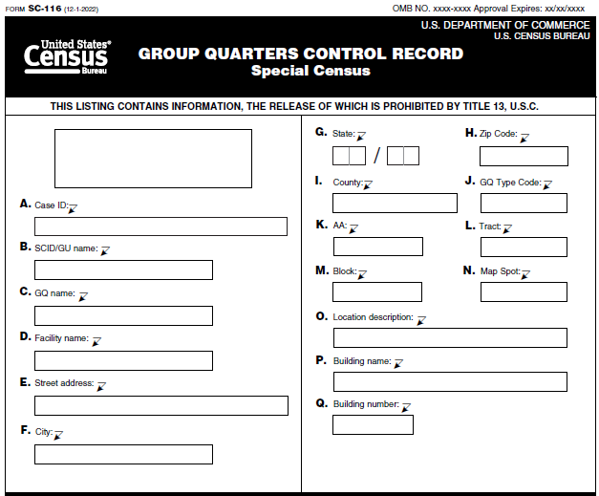
The clerk confirms that the address information is still correct during the interview with the GQ Contact Person. Each header will have a unique Barcode ID for each Special Census Group Quarters Control Record. The information in items A through Q is printed on the form.

Section A – the Group Quarters Facility Contact Information
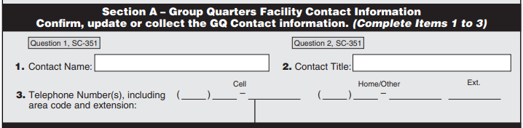
The fields in Section A of the GQ Control Record may be preprinted. Otherwise, the clerk will complete them during the interview. Section A Items 1-3 correspond to Questions 1 and 2 on the Advance Contact Script. The SCO clerk confirms, updates, or collects information about the GQ contact. The clerk lists the GQ contact’s name, title, and phone number. The clerk updates any of the contact information. If there is new or different contact person now in charge, the clerk adds that information on the Control Record.

Section B –Group Quarters Information
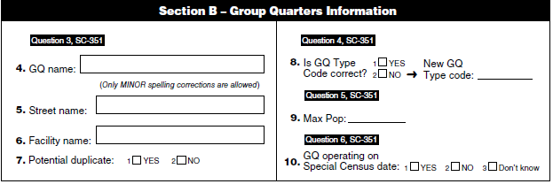
The SCO clerk needs to be thorough when completing this section. The FRs use this information to locate the GQ and conduct enumeration. Items 4-27 of the Control Record corresponds to Questions 3-17 on the SC-351, GQ AC Script. Items 4-27 are as follows:
- Item 4. Group Quarters Name – This is asking for the Group Quarters name. The GQ contact will either verify the GQ name or the clerk will need to make updates to this information.
- Item 5. Street Name (Minor Change) – The clerk can only make minor spelling changes to the street name. An example of this would be the GQ street name is 100 Main Street, but Main is spelled Mane. A minor change is defined as making an address change where the GQ remains in the same block. If there are any other changes to the address information, this case will be considered a potential GQ add. If possible, the clerk should ask about what is now at the original address and conduct an interview with a contact at the original address. If the clerk cannot do this, the case goes to the field for a GQAC interview.
- Item 6. Facility Name – The clerk enters the name of the facility
- Item 7. Potential Duplicate – The clerk will indicate whether it is a duplicate or not and provide the Duplicate Survivor ID in Item 27.
- Item 8. Is the GQ Type Code Correct – When calling a facility, the GQ Type Code may be already included in the SC-325, Group Quarters Assignment Directory. The clerk will ask the GQ facility contact to verify that the facility type is correct. The SCO clerks will need to be familiar with the SC-637, GQ Type Code Job Aid Special Census.
- Item 9. Max Pop – Is the maximum population of people that the GQ can accommodate. The clerk will record the max population information. This information will be used to determine how many questionnaires will be needed to enumerate this GQ.
- Item 10. GQ Operating on Special Census Date – The clerk will record a Yes/No/Don’t Know response for this item.
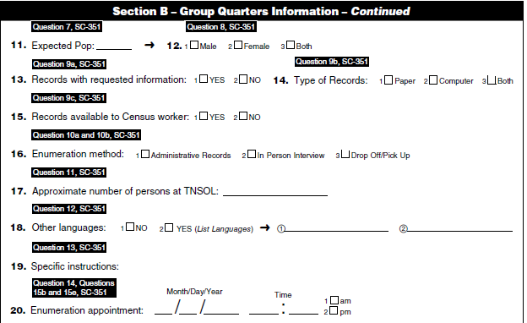
- Item 11. Expected Pop – The maximum population and the expected population can be different because the GQ may not always be at capacity. The clerk will record the Expected population which is based on the number of people who lived or stayed at the GQ on Special Census Day.
- Item 12. Males/Females/Both – This information would have been taken into consideration when making assignments. A GQ for males only would not be assigned to a female FR or vice versa. This could be disruptive and may cause problems during the enumeration.
- Item 13. Records with requested information – The clerk will mark a Yes/No response. This is trying to ascertain if the GQ will provide an Administrative Record. An administrative record helps the clerk to prepare the right number of forms for the FRs to conduct enumeration.
- Item 14. Type of Records – The clerk will mark one of the options available. The options are Paper/Computer/Both.
- Item 15. Records available to Census worker - The clerk will record a Yes/No response for this item.
- Item 16. Enumeration Methods – The clerk provides the enumeration method options and asks the GQ contact person for the enumeration method best suited for the GQ. The options are Administrative Records/ In Person Interview/ Drop Off/Pick Up.
- Item 17. Approximate number at the TNSOLS – is specific for Targeted Non-Sheltered Outdoor Locations. The clerk asks this question only if these locations are in their area. If no contact information is provided, a team of supervisors will visit the TNSOLs to gather this information.
- Item 18. Other Languages – The clerk will ascertain if there are other languages at the GQ. This alerts the FRs to the potential need for interpreters. If Yes to other language, then list the other languages in the space provided.
- Item 19. Specific Instructions – Some GQs may have specific instructions for the FRs to follow when conducting enumeration. These instructions will vary. These instructions are to be placed in the notes section of the Control Record.
- Item 20. Enumeration Appointment – The clerk asks the GQ contact person for a day and time for the FR to visit the facility. The clerk writes the date and time for the enumeration appointment.
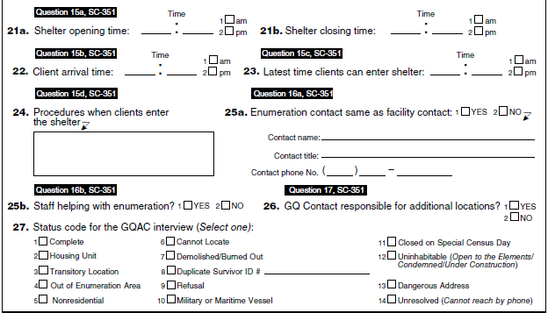
- Item 21a. Shelter Opening time – This item is related to only shelters. The clerk will confirm with the GQ contact the opening times (when the Shelter is open for operation) and work with the GQ contact to select an ideal enumeration time.
- Item 21b. Shelter Closing time – This item is related to only shelters. The clerk will confirm with the GQ contact the closing times (when the Shelter is closes for operation). This is important to know so the FRs will have an idea of when they will finish.
- Item 22. Client arrival time – This item is to determine when the doors are open and when clients start to show up at the GQ.
- Item 23. Latest time client can enter shelter – This item determines the latest time clients can enter the GQ.
- Item 24. Procedures when client enters – This item provides an idea of what to expect when FRs arrive at the GQ.
- Item 25a. Enumeration contact same as facility contact - This item is to verify that the name of the person to contact as well as their title and phone number is the same as facility contact.
- Item 25b. Staff helping with enumeration - This item is to determine if a staff member from the facility with help with the enumeration.
- Item 26. GQ responsible for additional GQs – The clerk will ask the GQ contact for additional GQs that the contact is responsible for during the enumeration period. The clerk will record a Yes/No response for this item.
- Item 27. Status code for the GQAC interview – After conducting the GQAC, the clerk or FR will select one code best describing the outcome.
The clerk should note that there are no corresponding questions on the Calling Script for some Items, specifically the Status Code Items -- Item 27 on the SC-116, GQ Control Record. In this case, the clerk will need to enter the status code for Item 27 on the SC-116, GQ Control Record after the call with the GQ contact has ended. If the case has any other status code except for complete, the clerk will hand the case to the SCO Manager/Field Supervisor for review, before entering the outcome in MOJO. The SCO clerk can make notes about the case in the Notes section of the form.
Section C – Enumeration Information
Section C is completed by the FR and the SCO Manager or FS after the enumeration.
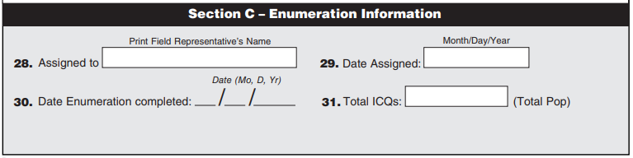

SC-351, Special Census Group Quarters Advance Contact Script
The SC-351, Special Census Group Quarters Advance Contact Script, is a conversational document used by the clerks to schedule enumeration appointments. The SC-351, Special Census Group Quarters Advance Contact Script is written in bold and italicized text -- the text serve different purposes. The bold black text is read to the GQ contact by the SCO clerk during the interview, and the blue italicized text are instructions guiding the clerk through the interview. The SC-351, Special Census Group Quarters Advance Contact Script contains a total of 19 questions, with several skip patterns. To become familiar with the questions and skip patterns, the SCO clerk should read each question repeatedly and carefully before conducting any appointment calls. The clerk should also look at the preprinted information on the Control Record to learn a little bit about the GQ before they call. The questions on the Advance Contact Script correspond to the questions on the SC-116 Group Quarters Control Record.
When the clerk makes the phone call, the first task is to be sure they are speaking with the correct person before they start the interview. The following pages will illustrate how to use the script to update group quarters records and document the enumeration method the facility contact selects. The instructions on the script tell you how to complete an interview.
In summary, at the beginning of the call, the clerk introduces himself/herself and reads the confidentiality statement. The confidentiality statement is important because it explains the purpose of the SC and how the data collected will be used. The SCO clerk will confirm, the GQ information including the GQ contact name, number, business email, and the address of the existing GQ with the GQ contact. The clerk will also obtain a location description if possible. If the GQ contact confirms that the information is correct, the SCO clerk will continue with the interview to set an enumeration appointment and obtain other information that will be used to prepare the assignment.
The SCO clerk must also be prepared if the GQ Contact has changed or if the address is not correct, for example the GQ has moved. If the GQ called by the clerk is no longer at the address listed, the clerk tries to find out what is currently at the listed address. In cases where the GQ address has changed, or a new facility is at the listed address, the clerk asks the GQ contact for the new address and documents the information on an SC-225 INFO COMM. The information is then passed to the Managers/Field supervisor to resolve. The manager reviews the case to determine whether the GQ is inside the SC Area or not and if the case is already listed in the workload. The manager also determines if the case requires field verification to confirm the GQ location.
If the case is inside the SC Area and is not already included in the workload, the case will be added to the workload. The SCO will delete the old GQ case as Cannot Locate and the new case will be added as a new GQ with the new address. This case will be worked in the same manner as any other GQ. If the case was confirmed to be outside of the SC Area, the SCO will delete the original GQ from the workload as Cannot Locate and the new case will not require any further processing.

Group Quarters Advance Contact
The SCO clerks need to understand that GQAC is critical to the success of the GQ enumeration. SCO clerks make GQAC calls to all GQ facilities using the SC-351, Special Census Group Quarters Advance Contact Script and the SC-116, Group Quarters Control Record. The responses given during the interview are written on the Group Quarters Control Record. The workload for GQAC is on the SC-920, Address List Page and the SC-921, Add Page. If a GQ is on either of these forms, the page with a GQ is copied and becomes part of the GQAC assignment materials.
There are a few items the clerk needs to be aware of as they make the calls and update the Control Record.

Facility Name vs Group Quarters Name
On the Control Record, there is pre-filled information from the Census Bureau address file. You ask the GQ contact to verify information about the location, including the GQ Name and Facility name.
For example, you may have a Control Record for the local hospital so the Facility Name could be Community Hospital and the GQ Name could be Psychiatric Unit. Another example is for a college. The Facility Name is State University and GQ Name Dorm One. Some types of facilities can have several GQs under their management. This helps us know which GQs belong together and are likely the responsibility of the same GQ Contact Person.
In many cases, these two items can be the same. For example, a group home is likely that its GQ and Facility Name are the same. Facility Name is not a required field. Do not feel you have to fill in this item if it the same as the GQ Name.

Updating GQ Names or Collecting a New GQ Name
When updating a GQ, be sure to enter the specific GQ name. Use the proper name for the GQ. Entering a generic GQ name will not truly identify the GQ and could make it difficult to determine if one GQ is a duplicate of another. To avoid this, look at the following list of examples of GQ names that should NOT BE used to complete the GQ name field.
Generic GQ Name Example  (Do NOT Use) | Specific GQ Name Example
Unknown GQ Name
Unknown
Vacant
Orphanage | Hope Orphanage
Student Housing | Coe Hall
Private School | Excellence Academy
College | Anytown College
Staff | Building 1 Staff Housing
Residence Hall | Dorm One
Nursing Home | Skilled Nursing – Floor 2
Rooming House | Doe Rooming House
Adult Group Home | Stepstone Group Home
Group Home | Coe Group Home
Assisted Living Facility | Sunshine Estates Assisted Living
Retirement Home | Pleasant Meadows Retirement Home
Skilled Nursing Facility | Specialty Care Skilled Nursing
Home for Aged | Paramount Home for the Aged
Nursing Home | Best Care Nursing Home
Adult Group Living | Rise Adult Group Home

Enumeration Methods
In the script, there is guidance on how to present the different enumeration methods to the contact person. There may be times when the GQ contact person continues to ask you for help on which enumeration method they should use. If you have already read all the details provided in the script and looked at the FAQs, here is some additional information you can use:
- In-Person Interview
- Field Representatives use paper Individual Census Questionnaires to conduct the interview.
- Very time consuming. This method is best for locations with a small number of residents or when you can have multiple enumerators to help conduct interviews at the same time.
- Not ideal for GQs whose residents have varied schedules like college students, who may have issues with answering questions or be alarmed by a stranger approaching them.
- Administrative Records
- The GQ contact agrees to provide the FR with a printed administrative list.
- The printed spreadsheet should include all the requested demographic information as specified by the Census Bureau.
- Census needs to ensure facility will only provide demographic and usual home elsewhere data and to exclude Social Security Numbers and other PII.
- The printed administrative list must be legible and the print large enough to be read easily. Columns clearly separated and labeled. If handwritten, print the info
- The FR completes an Individual Census Questionnaire for each person on the list either on site or off, depending on if the enumerator can take the list with them.
- No contact with the residents/clients at the GQ.
- Minimal time required of the GQ facility contact.
- Drop off/Pick up of Questionnaires
- FRs will drop off ICQ packets for each resident in the GQ and schedule a time to pick them up.
- Requires some help from the facility such as providing a list of current resident/clients and possible passing out and collecting forms.
- Will use ICQs and ICQ Envelopes.

GQ Type Codes
Before calling any GQs, it is very important that you know a few things about certain GQ Type Codes. Much of this is also in the In-Field script so you do not have to memorize this.
Most of the interviews you conduct will gather details about the residents that live or stay at a GQs. However, in some cases you need to gather information about the staff at a GQ.

GQ Type Code 501, 502, 701, 801, 802, 901, 902 and 903
Staff who live or stay at a GQs with a GQ Type Code of 501, 502, 701. 801, 802, 901, 902 and 903 are counted with their residents during GQE. If you call a GQs with one of these Type Codes, ask the GQ contact person if they have any staff that live at the GQ. If so, inform the GQ contact person that the questions you are asking apply to the residents and staff who are living or staying there.
For any Non-SBE GQ, the reference date for enumeration and any population numbers is the Special Census Day. For the SBE GQs, their Special Census Day and reference date for any population numbers is the date of their enumeration appointment.

GQ Type Code 901
A GQ Type Code of 901 is for Workers Group Living Quarters and Job Corps Centers. This GQ type also includes staff living quarters at certain GQs (101-106, 201-203, 301, 401-405) who are counted separately from residents during enumeration.
For example, if you have two GQs – one is for GQ Type Code 203 –and the other is 901, both with the same address of the Juvenile Dentation Center, when you speak with the GQ contact person, you have to be clear that you need the information about the staff that are living or staying at that facility on a permanent basis as of the Special Census Day as well as the detainees. You write the staff GQ data on the Control Record with GQ Type Code 901. The information for the other GQ – the detainees - is entered on the other Control Record with GQ Type Code 203.
If, however, the GQ is a Job Corps Center, vocational training facility, or Workers Group Living Quarters you will ask about residents and staff. They are counted all together in the one GQ with Type Code 901.
For example:
(1) If you visit a GQ Type Code 901 facility that is a Jobs Corps Center, or migratory farm worker living quarters, you include both residents and staff who are living there as of the Special Census Day.
(2) If you visit a GQ Type Code 901 facility that is part of or associated with a correctional facility –include ONLY the staff who are living there as of the Special Census Day. This GQ should not include any of the inmates housed at the facility. The building where inmates live is a separate GQ with a different GQ Type Code.

GQ Type Code 999
You may have a GQ Type Code of 999 (unknown) in your workload. In this case, during Question 4 of the script you should tell the GQ Contact Person that their GQ type is unknown. Use the SC-637, GQ Type Code Job Aid to classify their location.
Work closely with the GQ contact to find the best GQ Type Code to describe their facility. If you cannot update the GQ Type Code from 999 because you cannot speak with a knowledgeable person who can identify what is at the address, try to continue the interview. Collect as much information as you can. You should not add a GQ with Type Code 999 or change an existing GQ Type Code to a 999.

GQ Type Code 703
There is one type of GQs that you do not visit/interview and that is a Domestic Violence Shelter (DVS). If you find during your interview that the GQ it is a DVS:
- Apologize to the contact person and end the call.
- Write in the Notes section of the Control Record or use an INFO-COMM that says, For SCO Contact Designee only.
- Do not use the term DVS, do not identify what kind of GQ this is.
- Do not discuss this location with anyone else.
- Place all the materials related to the DVS into a messenger envelop and write on the envelope, To be Opened by SCO Contact Designee only.
- Give this to your supervisor.

Housing Unit
Some of the GQs in your assignment may now be HU. You thank the contact person, end the interview, and mark the Housing Unit status code on the Control record and end the call. Inform the SCO Supervisor of the need to conduct a HU interview.

Out of Enumeration Area
As you try to locate your assignment, the address may be outside of the SC area. If you have a case like this, make note on the Control Record and mark the appropriate status code. Give all the materials for this case to your supervisor.
# | QUESTION | ACTION
(1) | Hello. My name is (Your name). May I speak with (Say the CONTACT NAME printed on the Control Record)?  I am from the U.S. Census Bureau. (In-Field Interview only, show your Census ID Badge) We are conducting a Special Census for this area. I need to talk with someone about this facility and to schedule an appointment to count your residents/clients. Are you the contact person for this location?  If there is no contact name on the Control Record, use the following introduction:  My name is (Your name). I am from the U.S. Census Bureau (In-Field Interview only, show your Census ID Badge.) We are conducting a SC for this area. I need to talk with someone about this facility and to schedule an appointment to count your residents/clients. Are you the contact person for this location? | - If this person is still serving as the contact person, verify their phone number and title as shown on the SC-116. If their phone number or title has changed, write the new information in Items 2 and 3 on the SC-116.  - If the contact person has changed or the person you are speaking to is not the right person to interview, ask for the right person. Once you are speaking with the right person repeat your introduction.  - Ask for and write their information in Items 1,2 and 3 on the Control Record  - If there is no contact name on the Control Record, use the other introduction on the script to identify the appropriate person. Once you are with the new contact:  Repeat your introduction  Ask for and write their information in Items 1, 2 and 3 on the Control Record.  Go to QUESTION 2.  - If this is a Housing Unit, put an X in the appropriate box in item 27 and end the interview by saying: Thank you very much for your time and participation. This is all the information I need.  - If the address is now Nonresidential, put an X in the appropriate box in item 27 and end the interview by saying: Thank you very much for your time and participation. This is all the information I need.  For In Field interviews only:  - If the address is uninhabitable, demolished, burned out under construction or dangerous, put an X in the appropriate box in Item 27, write an explanation in the NOTES space and go to your next assignment.  - If you cannot locate the address printed on the Control Record, put an X in the appropriate box in Item 27, write Cannot Locate, and an explanation in the NOTES space and then go to your next assignment.
(2) | We estimate this interview will take approximately 15 minutes.  Before we start, this is our confidentiality statement.  The U.S. Census Bureau is required by law to protect your information (Title 13, U.S. Code, Section 9). The Census Bureau is not permitted to publicly release your responses in a way that could identify you or your household. We are conducting the Special Census under the authority of Title 13, U.S. Code,  Section 196. By law, the Census Bureau can only use your responses to produce statistics.  Title 13 of the U.S. Code protects the confidentiality of all your information. Violating the confidentiality of a respondent is a federal crime with serious penalties, including a federal prison sentence of up to five years, a fine of up to $250,000, or both. Only authorized individuals have access  to the stored data, and the information you provide to the Census Bureau may only be used by a restricted number of authorized individuals who are sworn for life to protect the confidentiality of your  individual responses. Your answers cannot be used against you by any government agency or court.  For more information about how we protect your information, please visit our Web site at census.gov and click on Data Protection and Privacy Policy at the bottom of the home page. This page also includes information about the collection, storage, and use of these records. Click on System of Records Notices (SORN) and look for Privacy Act System of Records Notice COMMERCE/CENSUS-3, Special Censuses, Surveys, and Other Studies.  Although the individual responses are voluntary, the information the Special Census receives from you ensures the completeness and accuracy of the results. Tribal, state, and local governments use census data to make a wide variety of decisions to improve their communities. The Census Bureau estimates that completing the questionnaire will take 10 minutes on average.  Thank you for your cooperation. The Census Bureau appreciates your help. | If this is a phone interview, read the statement as shown below. If this is an in-person interview, hand the contact person a copy of the Confidentially Statement, Form SC –CN(E/S) and allow them time to read it.
(3) | Now I am going to read you a summary of the group quarters information that I have. Please let me know if anything is incorrect, or if any information is missing. | Read all the information for the GQ on the top of the SC-116 and information handwritten on the SC-116 to the contact person, spelling the GQ Name, Facility Name, and Street Name, Location Description, Building Name or Building number.  - If GQ or Facility Name is incorrect or missing, make changes in the Items 4 and 6 on the SC-116. The only other change you can make are minor misspellings of Street Name and you update that in Item 5. Go to Question 4.  - If no updates to the street name or only minor misspellings of the street name, mark No for Potential Duplicate in Item 7 and then go to Question 4.  For Phone Interview only:  - If any of the other address fields have changed or there are major changes to the street name, complete an INFO-COMM to collect the new information. End the interview with the following: We will check to see if your new location is in the Special Census area. Mark Yes for Potential Duplicate in Item 7 for this address and then skip to QUESTION 19.  If the case is a military GQ, you must write or update the military installation name in the Facility Name field.
(4) | We currently have the structure at this address listed as the following type of group quarters: (Read the GQ Type description from the GQ Type Code Job Aid for the GQ Type Code shown at the top of the SC-116.) Is that correct? Mark the appropriate answer in Item 8 on the SC-116 and follow the instructions below based on the answer given. | You read the GQ Type Code description on the GQ Type Code Job Aid. Mark the appropriate answer in Item 8 on the SC-116 and follow the instructions below based on the answer given.  - Yes, go to Question 5.  - No, different GQ Type: Use GQ Type Code Job Aid to update GQ Type Code.  Write the new Type Code chosen from the job aid in Item 8 of the SC - 116 and then go to Question 5:  - If the GQ Type Code is 706, Targeted Non-sheltered Outdoor Locations, go to Question 11.  If not a GQ or this location is a Military or Maritime Vessel, follow the instructions below based on status of the address.  Military/Maritime Vessel: End the interview by saying: Thank you very much for your time and participation. This is the all the information I need.  Then go to Item 27 and mark the appropriate status code.  Transitory Location: End the interview by saying:  Thank you very much for your time and participation. This is the all the information that I need. Someone from the Census office will contact you to complete an interview for this specific location.  Write down all the information you have about the TL on an INFO-COMM and provide it to your supervisor. Then go to Item 27 and mark the appropriate status code. .  Housing Unit: End the interview by saying:  Thank you very much for your time and participation. This is the all the information I need. We will send a Special Census worker to conduct an in-person interview for each person who was living or staying at this location on the Special Census Day.  Then go to Item 27 and mark the appropriate status code.  Nonresidential Then end the interview by saying: Thank you very much for your time and participation. This is the all the information I need.  Then go to Item 27 and mark the appropriate status code.
(5) | What is the maximum number of people who can live or stay here at this group quarters? | Write the contact’s answer in Item 9 on the SC-116. Remember if the:  - GQ Type Code is 501, 502, 701, 801, 802, 901, 902 and 903, the max pop must include any staff who live or stay at the GQ.  - GQ Type is 901, and the GQ is a separate staff quarter, the max pop includes staff only.
(5) cont. |  | - GQ Type is 901 and the GQ is a Job Corp Centers, Workers Group Living Quarters or vocation training facility, the max pop includes staff and residents in the maximum number.  Go to QUESTION 6.
(6) | Will this facility be operating on (Special Census Date)? | Mark the appropriate answer in Item 10.  Yes, go to QUESTION 7.  No. Then say: This facility will not be counted during the Special Census. Someone from the Special Census Office may contact you by telephone to verify that we spoke with you about counting the people residing in this facility. Write 0 into Expected Pop in Item 11 of the SC-116. Skip to QUESTION 17.  Don’t Know Go to QUESTION 7.
(7) | What is the expected population at this facility on (Special Census Date)? | If you do not know the exact number right now, please provide an estimate. Enter the answer in Item 11 on the SC-116.  - GQ Type Code is 501, 502, 701, 801, 802, 901, 902 and 903: include any staff who live or stay at the GQ in this number.  - GQ Type is 901, and the GQ is a separate staff quarter, include in the expected pop number staff only.  - If GQ Type is 901 and the GQ is a Job Corp Centers, Workers Group Living Quarters, or vocation training facility, include staff and residents in the expected pop number.  Expected pop cannot be greater than Max Pop in Item 9. If it is greater, change the max pop to equal the expected pop.  Go to QUESTION 8.
(8) | Does this group quarters serve males only, females only, or both males and females? | Mark the appropriate box in Item 12 on the SC-116 and then go to QUESTION 9a.
(9a) | Does your facility keep records that provide demographic information such as age, race, Hispanic origin, and/or sex of your residents and/or clients? (Note: If the contact person has most of these items, mark Yes below.) | Mark the appropriate box in Item 13 on the SC-116. Based on the answer, go to the next appropriate question.  NOTE: If the Facility contact says they only have some of the information, that is acceptable.  Yes – Go to Question 9b.  No - Go to Question 10b.
(9b) | Are these paper records, computer records, or both? | Mark the appropriate box in Item 14 on the SC-116 and then go to Question 9c.
(9c) | If requested, could you make these records available to the Special Census worker? | Mark the appropriate box in Item 15 on the SC-116. Based on the answer, go to the next appropriate question.  Yes - Go to Question 10a.  No - Go to Question 10b.
(10a) | Since you have records or a listing of your clients/residents you are willing to share with the Special Census worker, you can select from the following enumeration methods.  Administrative Records.  A Special Census worker will visit your facility and using your records, fill out a separate Census questionnaire for each person that was served or stayed at your facility on the (Special Census Date).  In-Person Interview  You will need to provide a list of persons who were served or stayed at your facility on the (Special Census Date). The Special Census worker will conduct a face-to-face, in-person interview with each person on your list.  Drop Off/Pick Up of Questionnaire  You will need to provide a list of persons who were served or stayed at your facility on the (Special Census Date). A Special Census worker will leave census questionnaires with you to distribute to each person who was staying at this facility on the (Special Census Date). You will be sure that each person completes and returns the questionnaires, and then a Special Census worker will pick up the completed questionnaires from the you at an agreed-upon time. | Mark the appropriate Enumeration Method in Item 16 on the SC-116. Go to Question 12.
(10b) | Since you do not have a listing or do not want to share a listing with all the information, you can select from the following enumeration methods.  In-Person Interview  You will need to provide a list of persons who were served or stayed at your facility on the (Special Census Date). The Special Census worker will conduct a face-to-face, in-person interview with each person on your list.  Drop Off/Pick Up of Questionnaire  You will need to provide a list of persons who were served or stayed at your facility on the (Special Census Date). A Special Census worker will leave census questionnaires with you to distribute to each person who was staying at this facility on the (Special Census Date). You will be sure that each person completes and returns the questionnaires, and then a Special Census worker will pick up the completed questionnaires from the you at an agreed-upon time. | Mark the appropriate Enumeration Method in Item 16 on the SC-116. Go to Question 12.
(11) | Approximately, how many people will be here on (Special Census Date) from 12:00 midnight to 6:00 am? | Enter the number given in Item 17 on the SC-116. Go to Question 12
(12) | Are there any people at this location that do not speak or understand English? | Mark the appropriate answer in Item 18 on the SC-116 and follow the instructions below.  Yes, then ask: What languages do they speak? List the languages in Item 18 on the SC-116. For example, Spanish, Vietnamese, Korean, etc.  No  Go to Question 13.
(13) | Are there any specific instructions that the Special Census workers need to know to count the people at this location? | (For example, if need to enter a certain door, stay in one area during the counting process, parking options.)  Yes, list the instructions in Item 19 on the  SC-116,  No,  If the GQ Type Code is:  -- 701, Emergency and Transitional Shelters, go to Question 15a.  --706, Targeted Non-sheltered Outdoor Locations, mark In Person for Enumeration Method and go to Question 18.  All other GQ Type Codes, go to Question 14.
(14) | What is the best date and time for us to conduct the interviews at this location between (Special Census Dates)? | Enter the date and time in Item 20 on the SC-116 and check am or pm as appropriate.  Go to Question 16a.
(15a) | What time does the shelter open and close for clients? | Enter the times in Item 21a and 21b on the  SC-116 and check am or pm as appropriate.  Go to Question 15b.
(15b) | How early do the clients arrive? | Enter the time in Item 20 and Item 22 on the SC-116 and check am or pm as appropriate.  Go to Question 15c.
(15c) | What are the latest time clients can enter the shelter? | Enter the time in Item 23 on the SC-116 and circle am or pm as appropriate.  Go to Question 15d.
(15d) | What are the general procedures clients follow when they enter the shelter? | Enter the answer in Item 24 on the SC-116.  Go to Question 15e.
(15e) | What is the best date for us to conduct the interviews at this location between (Special Census Dates)? | Enter the date in Item 20 on the SC-116.  Go to Question 16.
(16a) | When the Special Census worker comes to conduct the count, are you the person they should speak with? | Mark the appropriate answer in Item 25a and follow instruction based on the answer.  Yes - Go to Question 16b  No – Ask for the name of the person to contact as well as their title and phone number and enter the information in Item 25a on the SC-116.
(16b) | Will you or a staff member be helping with the enumeration? | Mark the appropriate answer in Item 25b.  Go to Question 17.
(17) | If GQ Type is 501, 502, 601,701, 801, 802, or 901-903, ask: Are you responsible for any additional facilities, either at this address or elsewhere?  If GQ Type is 101-106, 201-203, 301, or 401-405, ask: Are you responsible for any additional facilities, either at this address or elsewhere? Include workers group living quarters that staff use as their usual residence. | Mark the appropriate answer in Item 26 and follow instructions based on the answer.  Yes, Complete an INFO COMM for each additional facility. Be sure to ask that these addresses are NOT housing units – you should only list potential group quarters.  NOTE: If contact tells you they are not responsible for other facilities but know their organization has other facilities, document those on an INFO-COMM as well.  Once you have collected the information, say: We will check our current address file to see if we have these facilities and will contact you at another time to complete an interview for each one. Now let us continue.  No.  If the GQ contact has facilities that will be enumerated, go to QUESTION 18.  If the GQ contact does not have facilities that will be enumerated, end the interview saying:  That is all the information I need. If you have any additional questions, please call the Special Census Office at (Please provide the SCO telephone number). Thank you very much for your time and participation.
(18) | Special Census workers will arrive at your facility at the scheduled date and time.  We ask that you let the residents/clients know that there will be a Special Census at that time and encourage their cooperation. All data we collect are protected by law and kept confidential. Someone from the Special Census staff will contact you before your appointment as a reminder and to discuss further details about counting your residents. We appreciate your cooperation.  To learn more about our privacy policy and data protection, please visit our website at census.gov and click on Data Protection and Privacy Policy at the bottom of the home page. | Go to QUESTION 19.
(19) | If you have any additional questions, call the Special Census Office at (Please provide the SCO telephone number).  That is all the information I need. If we need further information, we may call you. Thank you very much for your time and participation. | Then go to Item 27 and mark the appropriate status code.

Status Codes
Status codes tell what action you took for a particular address. Each address is assigned a status code so we know which cases need to go to in Field GQAC, those that can move on to enumeration, and those that should not continue to be part of the SC. When you begin your interview, some of these codes will apply right away and you will mark it on the control record. Others are chosen after you have completed some of the questions with the contact record. During the phone interview, you can select the following status codes:
- Complete
- Housing Unit
- Transitory Location
- Out of Enumeration Area
- Nonresidential
- Cannot Locate
- Demolished/Burned Out
- Duplicate Survivor ID #
- Refusal
- Military or Maritime Vessel
- Closed on Special Census Day
- Uninhabitable (Open to the Elements Condemned/Under Construction)
- Dangerous Address
- Unresolved (Cannot reach by phone)
If the status code is anything other than Complete, tell your supervisor. They need to review those cases and confirm if the status code is correct. Your completed work will be reviewed so be sure any additional notes you made about the address must be clear and thorough on the control record and/or INFO-COMM. The definitions for each status code are below.
Complete - An interview was completed for a GQ. This means that an enumeration method and appointment date and time have been set.
Housing Unit - A house, an apartment, a mobile home, a group of rooms or a single room that is occupied (or if vacant, is intended for occupancy) as separate quarters.
Transitory Location - A TL is a location where people are unlikely to live year-round due to the transitory/temporary/impermanent nature of the location. TLs include places such as campgrounds, recreational vehicle (RV) parks, marinas, hotels, motels, racetracks, circuses, or carnivals. Generally, people living or staying at a TL either pay fees to stay there, or they work there temporarily.
Out of Enumeration Area - the address is not within the boundaries of the SC area.
Nonresidential - Any locations where people do not live or stay, such as a formal office building, a bank, car dealership, etc.
Duplicate Survivor ID # – the GQ is already in the workload and only one should be kept in the workload. The GQ you decide to use is the survivor GQ. You mark the duplicate box then write the ID of the survivor. There is space provided on the Control record to write in the survivor ID. Also write an explanation in the Notes section to explain that the record is a duplicate. Be sure to include the GQ Control Number of the remaining Enumeration Record in your note.
Refusal - The GQ Contact Person refused to participate in Census activities or complete the interview as well as when you are not allowed onto the GQ property.
Military or Maritime Vessel – no interview is conducted, and you report the case to the appropriate supervisor.
Unresolved – during the phone interview there may be cases that could not be reached by phone. The case goes to the field interview for verification. During the in-field interview, this status code would only apply if none of the other codes can identify the situation at the address. Detailed notes about an unresolved case must be written on an INFO-COMM.
Note: Some GQs will include multiple GQ Types, but the address may be the same.
Closed on Special Census Day – the GQ was not open on the Special Census Day, so it is not enumerated.
The status codes that can be selected after the In Field interview include those listed above plus these:
Cannot Locate - Location could not be found by the field employee.
Based on the outcome of the GQAC interview, you mark the appropriate status code in Item 27.
Demolished/Burned Out – for GQs which are already demolished, or to be demolished if there is reinforcing evidence, such as a sign, notice, or mark on the structure or in the block, indicating that the structure is to be demolished but on which demolition has not yet been started. Also, for structures that have been torn down or burned out.
Uninhabitable (open to the elements/Condemned/Under Construction) – the structure is exposed to the elements, that is, if the roof, walls, windows, or doors no longer protect the interior from the elements. There is reinforcing evidence, such as a sign, notice, or mark on the structure or in the block, that the unit, has been condemned but not yet demolished (see Demolished/Burned Out), the structure is falling, in disrepair or is still being built but no one is living there yet.
Dangerous Address - There is reason to believe that hurt, harm, or injury may occur at the location, or the location is currently deemed dangerous.

GQ Without a Scheduled Enumeration Appointment or No Longer Exist
There might be instances where the GQ might no longer be in operation, does not exist or there is no scheduled enumeration appointment. This occurs if the SCO does not have a good telephone number for the facility or the telephone contact attempts were not successful. In some cases, the GQ contact that answered the clerk’s questions might say that the facility might not be in operation or is no longer in operation. The clerk will write a note on the Group Quarters Control Record to indicate this GQ needs to be checked in the field. In these cases, the clerk will prepare an assignment with the Control Record for field verification. The FR will do one of two options:
- Complete the partially completed SC-116, GQ Control Record and take it back to the SCO, where the clerk prepares an assignment with the required number of enumeration documents needed for GQ enumeration, or
- Verify the facility is still operating as a GQ. In some cases, the GQs might no longer be in operation, is no longer a GQ, might not exist on the ground, etc. In these cases, the clerk will be instructed that the GQ needs to be deleted from the workload.

Address Changes Guidelines for Existing GQs
When there is an address change for existing GQs (those listed on the SC-325) additional steps are required. The clerk writes the new address written on the INFO COMM, then checks if the new address is:
- Already in the workload and if not,
- Still located within the same block as the original address and if not,
- Still within the SC enumeration area.
Details about adds are in the next topic.

Processing of GQAC materials
The GQAC phone call can result in a completed case. The updated Control Records are used during enumeration.
If the GQAC phone call does not result in a completed case for any of the reasons explained above, it must go to the In-Field GQAC for resolution. The FR will need the Control Record, possibly a copy of the associated Address List page or Add page, and INFO-COMM, if applicable. Using the same script, the FR will go to the address as shown on the Control record and attempt to complete the GQAC interview. When the FR finishes with the case, the Control Record and any other materials for the case are returned to the SCO.
The SCO staff will review the Control Record to check that the FR has marked a status code and if not, are there notes to explain why.

Group Quarters Adds and GQ Type Code Job Aid
There will be times when a potential GQ is found and must be checked before adding it to the workload. This can happen during the GQAC interviews and in field operations.
If a newly discovered GQ is found, take the following steps:
- Complete an SC-225, INFO-COMM with all the information about the potential add. If done in the field, give the INFO-COMM to your supervisor.
- SCO receives INFO-COMM from field of a not listed GQ
- SCO verifies against SC-325 GQ Assignment Directory that this GQ isn’t listed somewhere else
- After verifying that this new GQ doesn’t exist in another location, it will be added to the workload in MOJO using the instruction in the SC-445, User Guide for the MOJO
- After the new GQ is added, print the SC-116 and follow same process to conduct advance contact and enumeration
Form SC-637(GQ), GQ Type Code Identiﬁcation Job Aid Special Census
While FRs are performing their duties for GQAC In-Field operations, they may have to do other procedures in addition to completing the scripts. It is very likely that a contact person may tell them about other GQs that they do not have in their workload. This will require completing an SC-225, INFO-COMM with all the information about the potential add. Some interviews may require that they change to a different script because the GQ Type Code has changed from what is printed on the corresponding SC-116, Group Quarters Contact Record and now requires a different script.
When the GQ Type Code printed on the SC-116, Group Quarters Contact Record is no longer correct for the facility they are visiting, the Special Census GQAC Script tells them to use the GQ Type Code Job Aid to determine what the correct Type Code should be.
The GQ Type Code Job Aid leads them through all the appropriate questions to help determine the correct GQ Type Code for the facility. Follow the skip pattern based on the answers the GQ contact gives them. After the GQ Type Code is identified, they will go back to the in-field script to finish the interview.

Preparing and Distributing Enumeration Assignments
Introduction
The SCO clerk performs Assignment Preparation by putting together all the documents needed during the GQE operation. The steps for Assignment Preparation are to be followed as laid out in this manual to ensure an efficient process during enumeration. The manager will instruct the SCO staff to store GQ packets in a designated space in the SCO.

GQE Enumeration Forms
The assignment contains the following forms:
Materials | Use
SC-116, SC Group Quarters Control Record | Provides the information currently known about the group quarters that must be updated or confirmed during the GQAC interview.  - The SC-116, GQ Control Record contains all the pre-enumeration information about the GQs.  - FRs use the SC-116, GQ Control Record to conduct enumeration.
SC-116 (CP), SC Group Quarters Continuation Page | - This is a listing of the rooms or bed locations and names of those enumerated at a specific GQ. Each resident’s room or bed number and name will be listed in the appropriate columns. In rare cases, a name will not be available, but the room or bed number should be completed.  - Enough pages to list the max pop plus 10% at the GQ.
SC-Q-GE, Special Census Individual Census Questionnaire (ICQ) | Each ICQ has a unique identifier printed on the form, so never make photocopies to use for enumeration.  - The SC-Q-GE, Individual Census Questionnaire (ICQ) is used to collect respondent information.  - FRs interview respondents using the ICQ or complete the ICQ from an administrative record.  - Enough to count the max pop plus 10%.
SC-Q-GE(S), Special Census Individual Census Questionnaire – Spanish (ICQ-S) | - The SC-Q-GE(S), Individual Census Questionnaire (ICQ) is used to collect respondent information. The ICQ is written in Spanish for Spanish speakers.  - FRs interview respondents using the Individual Census Questionnaire or complete the ICQ from an administrative record.  - Provide enough to count the number of Spanish speaking residents as noted on the Control Record plus 10%.
SC-E-GE(E/S), Individual Census Questionnaire Envelope | - The ICQ Envelope holds completed ICQs.  - The ICQ Envelope also has the confidentiality statement for respondents to read.  - FR collects the ICQ Envelope from Respondents.  - Enough to cover the max pop plus 10%.
SC-1054(GQE/SBE), GQE and SBE Field Representative Checklist | - The SC-1054 (GQE/SBE), GQE and SBE Field Representative Checklist provides the abbreviated steps for the FR to conduct enumeration.
SC-225, INFO COMM | - The SC-225, INFO COMM is used by the FR to document the details of any situation that requires further action by the SCO Manager.  - Clerks also use the INFO COMM to document address changes during enumeration appointment calls.
SC-CN-(E/S), Confidentiality Notice | - The SC-CN-(E/S), Confidentiality Notice contains information about collecting Census data that the respondent needs to know before answering questions.  - A copy of the Confidentiality Notice is given to all respondents unless they received an ICQ packet.  - The FRs should have a supply of these from their training kit.
SC-LFM-GE(ES), GQ Facility Manager Letter | - The SC-LFM-GE(ES) is a letter for the contact person that explains the Special Census, what data is needed, and lets them know that the Census Bureau will be enumerating their facility.
BC-1759(SC)(GQ), Special Census Special Sworn Status Group Quarters | - The BC-1759, Data Collection Special Sworn Status form is used to swear in anyone who is helping with enumerations.  - FRs and Supervisors give this form to anyone helping with enumeration, while ensuring that they understand the requirement. The individual then signs to give their consent to follow the enumeration guidelines.
SC-637(GQ), GQ Type Code Identification Job Aid | - The GQs Type Code gives an overview of the kind of GQs a FR will enumerate.
Reflective Vest and Flashlight | - Used by SCO staff enumerating TNSOLs.
Z1079 | - Carrying bag, U.S. Census, 16 x 11-1/2 x 3, Black, Nylon Oxford, Briefcase, W/Adj Shoulder Strap
EG-7510-00-161-4292 | - Clip, Paper, N0 1, 1/8
EG-7520-00-254-4610 | - Clipboard Legal, 9 x 15 12/
OF-65C | - 12 x 16 Messenger Envelope with String and Button Tie
Other Materials | - Pens  - Pencils

Preparing Group Quarters Assignment Materials
Once the GQAC calls and in-field visits are completed, the clerk begins assignment prep. The clerk will prepare the assignment using the materials listed above. The clerk will put all the enumeration forms in a messenger/large envelop. This will help the FRs to stay organized during enumeration. The clerk gives the FRs enough forms to complete their assignment. The number of ICQs needed for each GQ is dependent on the max number of persons at the GQ plus 10%. The clerk is responsible for preparing the assignment will write the GQ name and SCID number for each GQ in the upper right corner of the envelope.
For larger GQs there may be more than one messenger envelope for a GQ. The clerk will write the GQ name and the SCID on all envelopes. Each envelope will also be numbered
Page 1 of 3
Page 2 of 3
Page 3 of 3
The clerk will assemble the GQ assignment. Every assignment will contain GQ forms for only one GQ assignment. The clerk will prepare the assignment that will include all forms needed for enumeration. The clerk will perform the following steps to prepare the assignment:
- Locate the SC-325 with the list of GQs to be enumerated. This helps with organization and efficiency when creating assignments. The clerk will mark off each case on the SC-325 as the materials are being put together.
- Check item 9 in the Control Record for the max number of people the facility serves to determine the number of Individual Census questionnaires (ICQs) to prepare.
- To determine the number of ICQs to include in the packet, multiply the number of persons in item 9 by 10 percent. For example, if a facility can accommodate 50 persons, multiply 50 by .10 and you get 5 forms. Therefore 5 additional blank forms are to be included in the assignment.
- Add pens, pencils, or any other supplies needed to conduct the operation. Refer to the table above.
- When the address register arrives in the SCO and before it is checked out for work, it is advisable to make a copy of the SC-920, Address Listing Pages where the GQ is listed (for existing GQs) or make a copy of the SC-921(GQ), Group Quarters Add Page where the GQ is listed (for added GQs). If there is more than one GQ listed on the listing page, the clerk will use a highlighter to indicate the GQ that corresponds to the assignment.
- When the map pouch (that accompanies the address register) arrives in the SCO and before it is checked out for work, it is advisable to make a copy of the AA Locator Map, AA Map, and Block Map where the GQ is located and insert the maps in the GQ envelope.
- For Service Based and/or Targeted Non-Sheltered Outdoor Location Enumeration cases, the clerk will also include flashlights and reflective vests to the assignment package.
- Once the packets are assembled, the clerk will check the total packets created and the number of GQs to ensure that the number of packets is equal to the number of GQs. Additionally, the clerk will conduct a quality check to ensure that the correct packet is prepared for the right GQ. The clerk checks:
- There is a stack of materials for each case on the SC-325.
- There is an SC-116 GQ Control Record for each case on the SC-325.The correct number of ICQs and ICQ Envelopes are with each GQ Control Record.
- The cases are stacked by appointment.
- SBE cases have the correct number of documents and the associated items such as a flashlight and reflective vests.
When all GQ assignments are prepared, the clerk will check-out the assignment to a FS or other designated staff responsible for the assignment. The clerk will check out items using MOJO.
Assembling of each GQ packet is very similar except for those for the military. After completing all GQ packets, they should be grouped by installation. The clerk must exercise great care in keep in the materials for the respective installation together as this reduces the number of contact the SCO will need to make with the installation. Furthermore, the SCO Supervisor must be able to give the installation all the enumeration materials needed at once. The clerk will print the maximum number of documents required plus the additional 10% needed.
The clerk will:
- Locate the SC-325 with the list of military GQs to be enumerated.
- Gather the number of SC-Q-GEs, based on the maximum pop of each facility.
- Prepare all SC-Q-GEs and ICQ envelopes for the Control Record for each Military GQ
- Also include extra Confidentiality notices.
Additionally, the clerk should conduct a quality check for materials and grouped by installation.

Supervisor Role
The FS will distribute assignments to his or her staff to conduct the operation. Be sure each FRs has the supplies they need to conduct the enumeration. The SCO supervisor must check to ensure that all materials are prepared for the FRs to complete their assigned tasks. These materials will include:
- Form SC-116, Special Census Group Quarters Control Record
- Form SC-116 (CP), Special Census Group Quarters Control Record Continuation Page
- Form, SC-Q-GE, Individual Census Questionnaires (there should be enough ICQs for the max pop, and an additional 10%)
- SC-CN-(E/S), Confidentiality Notice
If an item is missing from the assignment, the FS will contact the SCO. The FS will make assignments ahead of time to minimize delays in performing enumeration. The FR will enumerate only one GQ at a time. The FS will determine regularly scheduled times to meet with the FRs to discuss cases, their progress and provide materials as needed. The FS will keep track of the FRs and ensure that they are completing their assignment. If FRs are struggling to complete their assignments, they will have their workload reduced and cases reassigned. The SCO should be mindful not to overextend FRs who are productive as this could lead to falsification of assignment. For each GQ assigned an FR, give that FR the appropriate assignment package. Be sure that you complete Section C items 28 and 29 on each Control Record as you give them to the FR. Make sure you give the right package to the right FR. Hold the packages for any GQs that are not initially assigned until later.
For GQs that fall into the GQs without a scheduled enumeration appointment or GQs that might no longer be in operation or does not exist category, the supervisor will hold these GQ assignments until in field operation is completed, then the cases are assigned to respective FRs. Additionally, if a GQ contact chooses Drop-off/Pick-up as the enumeration method, the date for enumeration should be noted on the SC-116, GQ Control Record.

Enumeration
There are three different procedures used to enumerate GQs. A GQ’s residents/clients can be enumerated by in-person interviews. The other procedures are a FR can drop off enumeration materials with the GQ and pick them up later or use administrative records where the GQ provides a paper listing with the census response data the FR uses to complete ICQs for each person at the GQ.

Procedures for In-Personal Interview
Be sure that the GQ contact person has given the FR permission to go room-to-room, etc.
For In-Person interviews, the FR will not leave ICQ packets. The FR will go to each resident’s room/bed/unit to conduct a personal interview with the prepared ICQ packets as follows:
- Knock on the resident’s door.
- Introduce themself to the resident and explain that they are there to take the census.
- Show the resident their Census ID badge.
- Hand the resident the SC-CN (E/S), Confidentiality Notice to read and keep.
- Explain that they need to conduct an interview by asking a few questions to fill out the census questionnaire. Tell them that it will take approximately ten (10) minutes.
- Conduct the interview. Read each question and the response options exactly as written.
- Go to Item B in the For Official Use Only section on the back of the ICQ. Mark (X) Respondent for Item B.
- Make sure you have written the PN in Item A in the For Official Use Only section on the back of the ICQ. The PN number comes from the SC-116(CP) GQ continuation page.
- Put the completed form in the ICQ Envelope.
- Mark this case as checked in on the Control Record Continuation Page in Column (5).
- Take the envelope and its ICQ with them.

Procedures for Drop Off/Pick Up
Ultimately, the FR is responsible for the distribution of ICQs to the residents of the GQ. If the GQ contact person wants to hand out the forms instead of the FR doing it, make sure the contact person is provided clear instructions how to do this. The FR must swear in any staff at the GQ who helps with the enumeration.
- If the FR hands the ICQ Packet to the resident, do the following:
- Emphasize the importance of filling out the form completely and legibly.
- Tell each resident to seal his or her completed form in the envelope provided.
- Point out the date/time on the envelope for when the FR (or the GQ Contact Person) will return to pick up the completed ICQ in the sealed ICQ envelope.
- If the GQ contact person or other staff member distributes ICQs, do the following:
- Give the packets to the GQ contact person to distribute to the residents.
- Explain to the GQ contact person that they must deliver each packet to the resident whose name/room number is written in the FOR section on the envelope.
- Explain to the GQ contact person that they must tell the residents to seal their census questionnaires in the envelopes provided when they finish completing the forms.
- Tell the GQ contact person that they must not look at the completed census questionnaires or open the returned envelopes.
- Tell the GQ contact person that you will return to pick up the completed ICQ on the date and time you wrote on the ICQ envelopes. Work with the GQ contact person to select a date that is soon after the materials have been dropped off (3-5 days). Make sure the FR writes this date and time on the GQ Control Record, in the Notes section.
- Remind the GQ contact person not to photocopy the ICQ. Each ICQ has a unique barcode/identifier, which is vital to correctly process the completed forms.
- Before leaving the GQ, the FR should call their supervisor to notify them that they have dropped off the prefilled enumeration materials.

Procedures for Administrative Records
The FR can use administrative records where the GQ provides a paper listing with the census response data the FR uses to complete ICQs for each person at the GQ.
If using administrative records, then do the following:
- Secure a quiet place to work.
- Using the listing supplied by the contact person, fill out the ICQ for each person who is living at the GQ on Special Census Day.
- Put a check mark in column (5) of the SC-116 (CP) as you finish a form. The check mark goes on the line corresponding to that person’s name and PN.
- On the ICQ, copy the PN for the individual from the SC-116(CP) to PN box in the For Official Use Only section.
- Go to Item B in the For Official Use Only section on the back of the ICQ. Mark (X) Group Quarters Administrator for Item B.

Review and Check in Materials
The review and check-in process takes place post enumeration. The materials are first reviewed in the field before they are returned to the office by the Supervisor/Lead FR. Then the clerk conducts an office review before they check in any materials into the system.

Review Completed Materials in the field
If SCO has assigned a supervisor/ Lead FR for the enumeration tasks, then the FR turns in the completed materials to the supervisor/ Lead FR. If there are any problems, the supervisor will address it with the FRs. The Supervisor/ Lead FR use the SC-1055(GQE), Census Field Supervisor Checklist, to review completed enumeration materials. The supervisor/ Lead FR will confirm that the following items are completed:
- The SC-116, GQ Control Record has been completed for the correct GQ.
- The enumeration date is correctly filled out.
- The FR’s name and signature is completed.
- The SC-116 (CP), Group Quarters Continuation Page (GQ Listing Sheet).
- This is a listing of the rooms or bed locations and names of those enumerated at a specific GQ. Each resident’s room or bed number and name will be listed in the appropriate columns. In rare cases, a name will not be available, but the room or bed number should be completed. The Supervisor or Lead FR will check that the information in the header of the form is complete and correct for the appropriate Control Record. The Lead FR’s name is listed in the Field Representative space in the footer if the enumeration was a team effort. Column (1) is the Room/Bed Number; Column (2) Person Name; Column (3) Participant Number; Column (4) Check in Mark (X) if received; Column (5) is marked as Complete or Incomplete on each line to indicate that the ICQ for each respondent was complete or incomplete. If any ICQs are blank, the GQ population is zero or incomplete then the notes section of the Control Record, or an INFO-COMM should be filled out.
- The number of ICQs recorded match the number of ICQs received. If the number of ICQs recorded do not match the number received, the Supervisor/ Lead FR should have the FR check if they have misplaced an ICQ in their cars or if an extra one is in their bags or stuck to any turned in materials. If the ICQs have the correct Bar Code ID Number, then update the SC-116, Special Census GQ Control Record with the correct total. The Supervisor/Lead FRs may need to also review the Control Record Continuation page to ensure that the ICQ corresponds to the number on the SC-116, GQ Control Record. Moreover, they need to ensure that the ICQs turned in are not photocopied, but if there are photocopied ICQs, then the information should be transcribed onto a blank ICQ.
- All ICQs should be filled out. The Supervisor/Lead FR will confer with the FR if a note is not provided regarding incomplete ICQs.
- If there is a zero population, mark the appropriate status code based on the notes from the FR. If the FR did not provide a note regarding the zero population, then the Supervisor or Lead FR will contact the FR and enter the status codes. Status codes indicate why there may be a zero population or why no ICQs were turned in for a GQ.
- If the location is a HU or TL, make sure this is recorded in the notes section of the SC-116, GQ Control Record and a completed SC-225, INFO-COMM. If it is a HU, we mark it as HU in GQ AC and it doesn’t go to GQ enumeration. We then alert the FS/FR to go there and add it as an HU and conduct the enumeration. GQ FRs should only focus on dealing with GQs; however, they can complete an INFO-COMM for any new housing developments or group quarters that they are made aware of. The INFO-COMM should include the type of living quarter that they wrote up as a potential add - Group Quarters/Service-Based Location, HU, or TLs.
- After the Supervisor/Lead FR has confirmed that all the enumeration materials are completed and accurate, the Supervisor/Lead FR will bring the completed materials and hand them to the clerk for office review and check in.

Review Completed Materials in the SCO
After each case is returned to the office, the clerks must complete a quality check. This quality check includes counting the ICQs to be sure that it is equivalent to the Special Census Day population. The case will then be checked in. Any discrepancies between the total ICQ count and the Census Day population should be reported to the Manager/Field Supervisor.
The Enumeration items on the Control Record are 28 to 36, which covers Assignment, Certification, Supervisory Use Only and Reinterview (RI). The Assignment Area shows the Name of the FR who has been assigned the case, the date the case was assigned, the date enumeration was completed, and the Total population.
- Item 28. Assigned to (Print FR’s Name) – The manager assigning the case printed the FRs name in this section.
- Item 29. Date Assigned – The date the case was assigned to the FR.
- Item 30. Date Enumeration Completed – The date that the FR conducted enumeration.
- Item 31. Total ICQs – The total ICQs should be equivalent to the Total population at the GQ.
- Item 32. FR Signature & Item 33. – The FR will also need to sign and date the form certification statement.
- Item 34. Supervisory Use Only – Based on the information received from both the clerk and the FR the SCO Manger/FS will mark one option in the For Supervisory Use Only section.

Review and Check-in by the Clerk
The clerk will use the Form SC-1056, Group Quarters Quality Control Office Review Checklist to do their review of the completed materials. The clerk reviews and documents on the checklist any errors/problems found. The checklist has an instruction section and a Task List, which consists of six (6) Items. Each clerk uses only one Group Quarters Quality Control Office Review Checklist per completed case. During the office review, the clerk reviews the GQ Control Record and the ICQs completed for the GQ before checking in the work. The clerk should take extra care to review any additional documents or attached Continuation Pages that belongs to the GQ. All this review is done BEFORE you check in completed materials to make sure you have everything ready for check in MOJO. Refer to the SC-445 to check in GQ materials from the field into MOJO.
To begin the review process, the clerk needs the following items:
- Completed SC-116, Special Census Group Quarters Control Record
- Completed SC-Q-GE (E/S) Individual Census Questionnaires (ICQs) that belongs to each Control Record
- Completed SC-116 (CP), Group Quarters Continuation Pages, if applicable
- Associated completed SC-225, INFO-COMMs
- Blank copies of the SC-1056, Group Quarters Quality Control Office Review Checklist
- Pencil – use to complete the checklist
The clerk may receive unused materials such as extra ICQs or Continuation pages. Return blank ICQs or Continuation Page to bulk supply.
When completing the SC-1056, Group Quarters Quality Control Office Review Checklist complete the following information in the top righthand corner of the Office Review Checklist:
- Date Prepared: Write in the date you are doing the review.
- Name of Office Clerk: Write in your name.
- Name of FR: Copy the name of the FR (or the Supervisor/Lead FR in some cases) from the Control Record.
- Name of GQs: Copy the name of the GQ from the Control Record.
- Case ID: Copy the Case ID from the Control Record.
- State: Copy the State from the Control Record.
- Block: Copy the Block from the Control Record.
- County: Copy the County from the Control Record.
The clerk conducts the review of the Control Record following the directions on the SC-1056, Group Quarters Quality Control Office Review Checklist by marking off each task in the right-hand column. If a task is not completed or there is a problem, mark the Error(s) column. Notify the supervisor of the problem and work to fix it. If the mistake can be fixed, then the clerk will initial in the last column on the right-hand side. The clerk will make notes in the Notes Section of the form to bring about clarity concerning the case review.
If the clerk cannot fix the problem, then the case is given to the supervisor after finishing the review. The clerk will then tally the total errors marked and the total corrections made in the appropriate spaces. Give the checklist with the case materials to the supervisor; if the clerk discerns that they need help with resolving errors the case should also be given to the supervisor.

Review of the SC-116, Special Census Group Quarters Control Record and SC-Q-GE, Individual Census Questionnaires
The clerk will complete a review of the Control Record to make sure it is accurate and complete. This review is done independently without the associated GQ documents. Associated GQ documents should be set aside briefly and reattached to the respective Control Record once the review is done. To complete a review of the Control Record, the clerk will check to ensure that there are no errors. If errors are found, then:
- Mark the appropriate boxes in the Error(s) column.
- Enter the total errors in the space provided at the bottom of the Error(s) column.
- Provide any notes in the Notes section on the back of the checklist about the error and what was already done to fix the problem.
- If necessary, give the materials to the supervisor for resolution.
After the successful independent review of the Control record, the clerk will then conduct a thorough review of the Control Record, and its associated ICQs. The review of the Control Records and ICQs are done together to ensure that the materials are for the correct GQ and that the forms are properly completed. The clerk uses the SC-1056, Group Quarters Quality Control Office Review Checklist Task List to complete the review.
There are six (6) items on the Task List on the SC-1056, Group Quarters Quality Control Office Review Checklist. Each item helps the clerk to determine thoroughness of the work completed during enumeration and the appropriate actions to be taken to rectify any discrepancies before checking in. The six items are expounded on below:

Item 1: All ICQs are original, not photocopies
The clerk checks all ICQs ensuring they are the original, not a photocopy. If there are photocopies or info copies, the clerk transcribes the data from those to new ICQs. This includes the PN and Bar Code ID Label on the back of the ICQ. The clerk talks to the supervisor first, so the supervisor knows what is being done to get this case through review. All photocopied ICQs will be destroyed.

Item 2: All ICQs have the GQ Case ID written on the back of the form
The clerk checks to see that the GQ Case ID (found on the SC-116) is transcribed in the GQ Case ID Box on the back of the ICQ. The clerk then checks:
- Is this person and the associated Participant Number (PN) on the GQ Continuation Sheet for the GQ?
- Is the PN is unique to this case’s materials?
The clerk then checks the Continuation Page, once they are sure the ICQ belongs to the Control Record.

Item 3: The number of ICQs received for this GQ matches the Total Pop number written on the Control Record.
The clerk will count the ICQs and ensure that they have all the ICQs for the associated Control Record. If there is a difference, check the Notes section on the Control Record for an explanation. If there is written explanation for the discrepancy, then proceed with check in.
If there is no explanation, continue with the following steps:
If there are more ICQs than what is on the Control Record:
- Check that all the ICQs belong to that Control Record. The FR may have accidentally included ICQs from another GQ, or the Facility Manager might have duplicated or photocopied ICQs.
- Verify the case ID on the Control Record matches the case ID on the back of the ICQs. If they all match, make a note of this on the Notes section located on the back of the Office Review checklist to show the correct total.
- Let the supervisor know about this so they can follow up with the Supervisor/Lead FR. Be sure to document the answer they provide in the Notes section on the checklist.
If the number of ICQs is less than what is on the Control Record:
- Then check the other assignment materials turned in by the same FR. The ICQs may be mixed in with another case. If you do not find the missing ICQs, make a note on the Control Record that the Initial Count was short.
- If the missing forms cannot be found in the office, you or your supervisor will contact the Lead FR or the Supervisor
- Continue to review and process this case. Any additional forms for the case can be checked in later.
- Once you have an answer, immediately document that on the Notes section located on the back of the Office Review Checklist.

Item 4: The Date Enumeration Completed box is filled in (Section C, Item 30 on the SC-116).
If this box is not filled in on the Control Record, contact the Supervisor/Lead FR to collect this information.

Item 5: If the number of ICQs is 0 (zero) or this GQ has incomplete ICQs, then there is documentation in the Notes section of the Control Record or an accompanying SC-225, INFO-COMM.
If the GQ has 0 ICQs or incomplete ICQs, there should be notes to explain the 0 ICQs or incomplete ICQs. If there are no notes on the Control Record or an accompanying INFO-COMM, ask the Supervisor/Lead FR to provide the missing information. The clerk will also check the Continuation Page to determine if it list any incomplete ICQs.

Item 6: If the number of ICQs is 0 (zero) then there is a box marked in the For Supervisory Use Only section.
If the number of ICQs is 0 (zero), then there is a box marked in the For Supervisory Use Only section of the Control Record. If no box is marked but there is documentation about this on the Control Record or an accompanying INFO-COMM, ask your supervisor to review and provide guidance as to the appropriate box to mark. The clerk is not allowed to decide on their own in this instance.

Corrected and Error Free Control Records
When the errors are corrected, the individual who makes the correction enters their initials in the appropriate box on the Office Review Checklist. They will also enter the Total Number of Corrections Marked. When all the errors are corrected (Total Number of Errors Marked equals Total Number of Corrections Marked), the case is ready for check in.
If the materials do not have any errors, then on the Office Review Checklist:
- Check the boxes in the Free from errors column.
- Enter 0 in the space provided for Total Number of Errors.
- Proceed to check in the case.

Reinterview
Overview of Group Quarters Reinterview Process
Reinterview RI is an important part of the quality control procedures during SC. During SC all completed cases are eligible for RI with a few exceptions listed below. RI procedures involves checking the completed work for veracity. RI involves checking all turned in materials and calling the GQ contact to confirm that the FR conducted enumeration on the date and time specified on the GQ Control Record.
Cases Eligible and Ineligible for Reinterview
Some of the cases received from the field will qualify for RI while others will not. A case is eligible for RI when the case is:
- Completed through an in-person interview.
- A drop-off/pick up of questionnaire.
- Enumerated using Administrative Records.
- Completed by multiple FRs. (These cases will still have a lead FR.)
- Conducted by any user role.
Cases are not eligible for RI when the case:
- Has a GQ Type Code corresponds to a Maritime (900), Military (106, 404, 601, 602) or SBE (701, 702, 704, 706) or the Type Code is unknown (999).
- Does not contain at least one ICQ.
- Was previously selected for RI.
- Was assigned for Rework.
- Is a domestic violence shelter (703).
Conducting Reinterview
Before conducting RI, the clerk will check and sort through all the turned in field materials including the SC-116, Special Census Group Quarters Control Record and the SC-116(CP), Special Census Group Quarters Control Record Continuation Page.
The procedure for conducting RI is one where the clerk will call the GQ contact to obtain the information for RI. During each phone call, the clerk should ensure that they are speaking with the GQ contact who was present on the day of enumeration. If this is not possible, the clerk will inform the Manager. During RI, the clerk will use Items 35 and 36 on the SC-116, Special Census Group Quarters Control Record to complete RI. The questions are as follows:
- Item 35. Our records show our Census Field Representative visited your facility on ____________ (transcribe date from item 20 above) to count your residents/clients. Is that correct?
- Item 36. What is the approximate number of residents/clients you think were counted as a result of that visit? This number might be different than the maximum number of persons you could have at your facility.
When applicable, the clerk will check the appropriate response or write the appropriate response from the GQ contact for each question. The completed forms are turned into the Manager, who will then assign an outcome to the case.
Status Assigned to RI cases
The SCO Supervisor will review each RI case and assign it an outcome code before it is checked in by the clerk. The SCO Manager/Field Supervisor or designee will complete Items 35 and 36. See the For Supervisor Use Only – RI Result Section on the SC-116. There are four outcomes for cases assigned during RI, they are:
- Pass – The results of reinterview RI and the original FRs agree.
- Soft Fail – The results of RI indicate honest FRs error or a reasonable explanation. For example, the FR accidentally went to the wrong HU to complete a questionnaire.
- Hard Fail - Discussed the case with the FR and the FR does NOT receive a reasonable explanation. The SCS or FM determines the FR intentionally falsified or deviated from procedures. After further research the FR has a pattern of not following procedures after feedback was provided to correct the patterns; or was found falsifying some or all the data in the questionnaire.
- Noninterview - Neither the clerk nor the Manager could contact the GQ for interview.
If the cases pass RI, or the clerk was unable to contact the GQ contact then the case is given back to the clerk to be checked in and prepped for shipment, because the case is now done with the quality control process. If the case does not pass RI, then there are additional steps that the manager must take. If the case receives a fail, then it may need a minor correction or needs to be reworked. The Manager will make the decision about the cases that need to be reworked.

Transitory Locations Advance Contact (TLAC) and Enumeration at Transitory Locations (ETL)

Transitory Locations Advance Contact (TLAC) and Enumeration at Transitory Locations (ETL) Operations Overview

Special Census ETL Operation
The purpose of the Special Census ETL operation is to enumerate (count) people who live or stay at census-defined transitory locations (TLs) on the Special Census date who do not have another place where they live or stay most of the time (no Usual Home Elsewhere (UHE)).
The Special Census enumerates people in seven defined types of transitory locations with in-person interviews using a paper questionnaire. Transitory locations include:
- Campgrounds (TL Type Code 10)
- Recreational Vehicle (RV) Parks (TL Type Code 20)
- Marinas (TL Type Code 30)
- Hotels/Motels (TL Type Code 40)
- Racetracks (TL Type Code 50)
- Circuses/Carnivals/Fairs (TL Type Code 60)
- Other (TL Type Code 90)
The Special Census ETL operation consists of two phases:
- Transitory Locations Advance Contact (TLAC)
- Enumeration at Transitory Locations (ETL)

What is TLAC?
The Special Census TLAC is an in-office and field-based operation conducted by the office clerks, Field Supervisor (FS) or Lead Field Representative (FR) before the ETL operation. The office clerks conduct in-office phone interviews to gather information about the transitory locations. They identify a contact person to verify the address and other information and schedule the best date and time for field representatives to conduct the count of residents during the Enumeration at Transitory Locations Operation (ETL). FS or Lead FR conduct the in-field interviews and uses the Form SC-688 (TLAC), TLAC In-Field Script to complete the TLAC section of the Form SC-117, Transitory Locations Control Record (TLCR).
The purpose of the TLAC operation is to:
- Conduct phone interviews to verify or identify a respondent at each transitory location to serve as a contact person and collect or update if it’s a new contact person, the person’s name, title, and telephone number(s).
- Conduct a phone interview to verify or obtain information about the TL such as the TL name and address, TL Type Code, Maximum Units, Estimated Occupied Units, among other data.
- Prepare for the TLAC in-field interviews completed by the FS or Lead FR if the TLAC in-office interviews were not successful.
- Set an enumeration appointment to enumerate (count) the TL residents during the ETL operation (see below).
- Gain cooperation from the contact person by providing the Form SC-CN (E/S), Confidentiality Notice and Form SC-LFM-TL (E/S), Transitory Locations Facility Manager Letter and ask that the contact person advise their residents of the upcoming ETL operation.
- Use the information completed in Section A, Transitory Locations Advance Contact of the Form SC-117, Transitory Location Control Record (TLCR), to prepare for the ETL.
There are two phases of the TLAC operation. The first is an in-office component which the clerks will attempt to conduct the TLAC interviews by phone. The second is an in-field component. TL cases that could not be contacted by phone will be sent to the field with a FS or Lead FR for an in-person interview.
What is the Enumeration at Transitory Locations (ETL) operation?
- The Special Census Enumeration at Transitory Locations (ETL) operation is conducted in-field after the TLAC to interview the residents of transitory locations who have no Usual Home Elsewhere (UHE) and who live at the location on Special Census Day.
- Either the FS or Lead FR conducts ETL fieldwork with a team of FRs on a scheduled date and time, to list each living quarter (Transitory Unit, TU, and mobile home/permanent structure) in the transitory location and interview residents of all occupied living quarters, using a Form SC-693.2, Transitory Location Listing Sheet and Form SC-Q-TL, Transitory Location Questionnaire (EQ).

Transitory Locations (TLs) Defined

What are TLs?
TLs are defined by the Census Bureau as places where people are unlikely to live year-round due to the transitory, temporary, or impermanent nature of the locations. These types of locations include campgrounds, Recreational Vehicle (RV) parks, marinas, hotels/motels, racetracks, carnivals, fairs, and circuses.
Due to economic and social changes in society, people have become more mobile and living space has shrunk. Some people no longer maintain a traditional residence, such as a house, apartment, condominium, or mobile home, etc., but instead have chosen alternative types of housing, which could be in a boat in a marina, a hotel or motel room, a tent at a campground, or a RV at an RV park.
Generally, people living or staying at a transitory location either pay fees to stay there, or they work there temporarily. A transitory location is, therefore, a business that may provide some type of space (site, space, unit, slip, etc.) for erecting, parking, or mooring a portable living quarter and/or offer other amenities in exchange for some form of payment.
We usually think of a transitory location as a place where people do not stay very long. The usual types of residents we expect to find in a TL are staying only temporarily, a few days, or maybe a week or two; they may be away from home on business for a period of travel and/or leisure. The assumption is that although these people are in-transit between one destination or another, they will eventually return to their permanent or UHE.
The Special Census ETL:
- Counts (interviews) ONLY those individuals who live or stay on an extended, long-term, or permanent basis in a census-defined transitory location, not the people who are passing through. In other words, for inhabitants of a TL, the TL is their recognized place of residence; they have no UHE. Include owners, managers and other employees who usually live or stay in the transitory location and have no UHE.
- Does NOT count (interview) people in transitory locations who have a UHE; in other words, people who do not usually live and sleep at the transitory location will not be interviewed. The premise is that since these people have a UHE, they will return to the place where they usually live and be counted there.
- Does NOT count people who live or stay at two or more residences (during the week, month, or year), such as people who travel seasonally between residences (for example, snowbirds) – Counted at a residence where they live and sleep most of the time. If they cannot determine a place where they live most of the time, they are counted where they are staying on Census Day.
- Does NOT count (interview) people in transitory locations, such as a hotel, motel, hostel, or YMCA, if the residents do not live or stay there on a long-term basis. Hotels without long-term guests are considered Non-Residential.
- Do NOT count (interview) people in transitory locations, such as a hotel, motel, hostel, or YMCA, when it is used 100% to house people who are experiencing homelessness.
- In such a case, the hotel is not a transitory location but a group quarter. This population is counted in the Group Quarters Enumeration (GQE) operation called Service-Based Enumeration (SBE).
- However, if there is ONE or more persons living or staying in the hotel with the residents who are experiencing homelessness, the hotel is a transitory location.
- Does NOT count (interview) people who are experiencing homelessness and living in what appear to be transitory-type locations, such as city parks, sidewalks, under bridges, parking lots, or wooded areas behind local stores in makeshift shelters or in vehicle encampments. This population is counted in the Service-Based Enumeration (SBE) operation.

Transitory Units (TUs)
In transitory locations, the dwelling that the resident occupies is called a Transitory Unit; or a portable/mobile housing unit, because, in most cases, it can be moved from place to place.
- TUs are not permanent structures, which are fixed in place (anchored to the ground), and unable to be moved around. Although, technically, any housing unit can be moved, the point is that most TUs are intended to be mobile. Note that this definition does not apply to hotels, which are structures with living quarters, such as rooms or suites (TUs).
- For purposes of TL enumeration, examples of a portable housing unit or TU would be:
- A Recreational Vehicle (RV) parked in a space in an RV park or campground.
- A tent erected on a site in a campground.
- A slip where a yacht, houseboat, floating house, Floating on Water Residence (FOWR), or house barge is or can be moored.
- A single room or suite in a hotel, motel, hostel, lodge, resort, inn, bed-and-breakfast, if that room is occupied by persons living or staying on an extended or long-term basis.

A TL consists of Sites, Slips, Pads, Spaces, Rooms, or Units
A TL will contain designated spaces where TUs (see above) can be erected, set up, parked, moored, or located. A TL may also contain semi-permanent or permanent structures such as mobile homes or cabins where people can live or stay.
For Special Census purposes, list and enumerate only those permanent structures in a transitory location that are used or intended to be used as a living quarter, such as a standard house, cabin, cottage, bungalow, or mobile home. Do NOT list any non-residential or commercial type structures, such as storage sheds, drydock facilities, garages, etc., with no living quarters.

Special Census Office (SCO) Staff Duties

SCO Managers
SCO managers, who include the Special Census Supervisor (SCS), Field Manager (FM), and Field Supervisor (FS) are responsible for supervising the work conducted in the office and the enumeration activities in the field. They coordinate and monitor the work of the staff who prepare the materials for TLAC and ETL operations.

Field Manager (FM)
- Leads and directs the activities of the SCO staff.
- Supervises the research of any potentially new TLs, provided by the Governmental Unit or FRs using all possible sources (local knowledge, internet search applications, and other references, as required).
- Approves the addition of new TLs to the SCO workload and ensure its accurate entry into MOJO.
- Collaborates with the FS to select TLAC/ETL field staff.
- Oversees the training of all TLAC/ETL staff, including in-office and field.
- Supervises the preparation of all TLAC and ETL in-field materials.
- Supervises the review, check-in, and proper disposition of all Special Census TLAC/ETL materials.
- Responds to and resolves all TLAC and ETL in-office/field related operational issues, including Dangerous Addresses, Refusals, possibly new TL locations,
- Monitors the timely completion of all TLAC and ETL office and field work.
- Assists in the selection of a Lead FR to conduct the TLAC and lead a team of ETL FRs.
- May also conduct TLAC for transitory locations on U.S. military installations.

Field Supervisor (FS)
- Trains the TLAC/ETL field staff.
- Makes assignments to TLAC and ETL FRs.
- Oversees the timely completion of TLAC and ETL Field activities.
- Meets frequently with the FM to discuss the progress of field activities.
- Meets frequently with the Lead FR and team of FRs.
- Reviews completed work of TLAC/ETL FRs.
- Ensures that all completed TLAC/ETL work materials are returned to the SCO for review and check-in.
- Approves Form BC-27, Time, Attendance, and Cost Report and Form BC-27A, Field Employee’s Reimbursement Expenses, submitted by field staff.

Lead Field Representative (Lead FR)
A Lead FR will be appointed to conduct the TLAC in-field visit and lead a team of FRs for the ETL operation. They will also:
- Perform other duties as assigned by the FS, such as assisting in the training of FRs; they will also collect, review, and return completed enumeration materials to the SCO.
- Conduct the in-field interviews at all assigned transitory locations, review their work, and submit completed enumeration materials to the Lead FR/FS for approval.
- Submit the Form BC-27, Time, Attendance, and Cost Report and Form BC-27A, Field Employee’s Reimbursement Expenses, to the FS for approval.
- Review the Form SC-693.2(ETL) TL Listing Sheet for completeness and correctness.

Field Representative (FR)
- Conducts the in-field interviews at all assigned transitory locations, review their work, and submit completed enumeration materials to the Lead FR/FS for approval.
- Submits the Form BC-27, Time, Attendance, and Cost Report and Form BC-27A, Field Employee’s Reimbursement Expenses, to the FS for approval.
- Reviews the Form SC-693.2(ETL) TL Listing Sheet for completeness and correctness.

TLAC Clerk
The TLAC Clerk will:
- Conduct phone interviews for TLAC.
- Key information into MOJO and document updates.
- Prepare assignments for TLAC in-field operation. Perform all assignment preparation tasks for the TLAC operation, including the printing of the Form SC-117, Transitory Location Control Record (TLCR) from MOJO, and checking out assignments to the field.
- Protect all Title 13 and PII. Store all PII materials in a secure area in the SCO until receipt of disposition instructions.
- Review all returned Forms SC-117, TLCR to ensure completeness and correctness and to determine which cases will be assigned to the ETL operation.
- Advise the supervisor of any TLAC field related issues notated on the Forms SC-117, TLCR and SC-225, INFO-COMM.
- Identify and add new TLs to MOJO. Assist in the research of possibly new TL adds, or GQ conversions and make the appropriate entries in MOJO.
- Key the Form BC-27, Time, Attendance, and Cost Report and Form BC-27A, Field Employee’s Reimbursement Expenses, data into the GovTA system.
- Ship materials to the RO and/or the National Processing Center.

ETL Clerk
The ETL Clerk will:
- Assemble and inventory ETL kits.
- Perform all assignment preparation tasks for the ETL operation.
- Advise the supervisor of any ETL field related issues notated on the Forms SC-117, TLCR and SC-225, INFO-COMM.
- Assist in the research of possibly new TL adds, or GQ conversions and make the appropriate entries in the SCOCS.
- Review completed ETL materials according to instructions in the Form SC-691(ETL), ETL Clerk Office Review Checklist.
- Store all PII materials in a secure area in the SCO until receipt of disposition instructions.
- Key the Form BC-27, Time, Attendance, and Cost Report and Form BC-27A, Field Employee’s Reimbursement Expenses, data into the GovTA system.
- Ship materials to the RO or National Processing Center.

TLAC Assignment Preparation and Checkout

Background
A Lead FR or FS will be assigned to make personal visits to transitory locations in the SCO workload to conduct TLAC interviews. The clerks will prepare kits for the FS or Lead FRs containing materials to conduct the in-field interview. After the in-field visit, the FS or Lead FR will return the completed materials to the SCO, and you will:
- Review the completed materials (see TLAC Assignment Check-in and Review).
- Key required information into MOJO for the case.
- Prepare cases for the ETL operation.
Your SCO manager will advise you when TLAC field activities begin and when you must start preparation for the operation.

Assignment Preparation
The table below describes the materials needed to prepare the in-field kit for each TL. This list does not include other items used by the Lead FR that are in their supply kit.
Materials | Description
SC-117, Transitory Location Control Record | Printed from MOJO and used by the Lead FR to verify TL contact and address details and to complete the TLAC interview.
SC-688, Transitory Location Advance Contact In-Field Script | An interview script used by the Lead FR to conduct the TLAC in-field interview.
SC-945, Enumeration at Transitory Location (ETL) Frequently Asked Questions (FAQs) | Frequently Asked Questions and answers from respondents that they may ask during an interview that are not covered in the TL materials.
SC-946, Transitory Location Type Codes and Definitions Job Aid | Job aid used to help determine the correct TL Type Code for transitory locations if the current code is incorrect or if there is a new TL.
SC-CN(E/S), Confidentiality Notice | Legal statement given to the respondent to notify them that their information is confidential.
SC-LFM-TL (E/S), TL Facility Manager Letter | Letter from the Director of the Census Bureau given to the TL contact person to notify them of the upcoming ETL operation.
SC-225, Information Communication (INFO-COMM) | Used to document problems and details of any situation about the TL requiring action by the SCO management.
SC-ID, Language Identification Card | Used to help identify the language spoken at the TL, if the language spoken is not English.
Other Lead FR assignment and training materials included in the TL kits are listed in the following table.
Materials | Description
SC-569.30 | Special Census Enumeration at Transitory Locations Field Representative Manual
SC-569.30A(TLAC) | Special Census Transitory Locations Advance Contact (TLAC) Lead Field Representative (FR) Self-Study
SC-ID, Language Identification Card | Used to help identify the language spoken at the TL, if the language spoken is not English.
BC-1199 | Official Business Sign/Employee
Other Supplies | - Blue or Black ink pens  - Special Census Shoulder Bag  - Paper and Binder Clips  - Notebook  - Rubber bands  - Clipboard  - Messenger Envelopes

Form SC-117, TL Control Record (TLCR)
The Form SC-117 contains PII information and must be stored in a secure location.

Print and Staple Form SC-117
Print the Form SC-117 from MOJO and staple the pages together in the upper left-hand corner. Make certain that the pages are in the correct order.
The Header information and the TL contact name and telephone number (if available), in Section A, Transitory Location Facility Contact Information of the Form SC-117, will be prepopulated from the record in MOJO to the form. The following image is an example of Form SC-117.
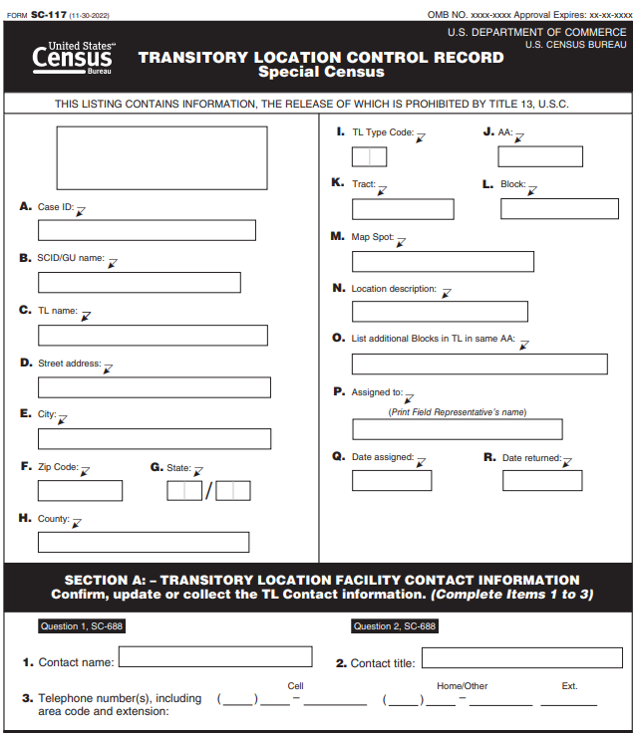

Assign the Case to the Lead FR
In the Header section:
- Print the FR’s name to whom the case is assigned in Item P, Assigned to field as provided.
- Enter the date assigned in MO (01-12), DAY (01-31), YEAR (4-digit year) format (MM/DD/YYYY) in Item Q, Date assigned field. This is the date that you complete the assembly of the kit, and it is available for pick up by the Lead FR.
- Leave Item R, Date returned field blank until the Form SC-117 is returned by the Lead FR after the in-field interview (see Topic 5, TLAC Assignment Check-in and Review).

List Additional Blocks in TL in Same AA
Sometimes a TL may consist of several blocks but only one block can be printed in Item L, Block field in the Header. This section allows you to list additional block numbers if necessary. Your supervisor will advise you when this occurs.

Assemble TLAC Kit Materials
For each case, paperclip (do not use rubber bands) the following forms together:
- Form SC-688, TLAC In-Field Script (1)
- Form SC-CN, Confidentiality Notice (1)
- Form SC-LFM-TL (E/S), TL Facility Manager Letter (1)
- Form SC-ID, Language Identification Card (1)
- Form SC-945, ETL Frequently Asked Questions (FAQs) (1)
- Form SC-946, TL Type Codes and Definitions Job Aid (1)
- Place the assembled forms in a messenger envelope.
- Paperclip the associated printed Form SC-117, TL Control Record, to the outside of the envelope.

Quality Control Assignment Materials
Another TL clerk should double-check the assignment packages to make certain that all materials for each case are in the envelope.
- Place in a bin labeled TLAC CHECKOUT.
- Print the TL Assignment Directory Report (List of all TLs in the workload)
- The Field Manager will print a spreadsheet containing the list of all TL cases. You will use the spreadsheet to keep track of cases checked-out (assignment packages taken from the SCO by the Lead FR and checked-in (returned to the SCO by the Lead FR). The FS will notify the Lead FR when to pick up and return completed TLAC assignments.
- Enter the date in MO (01-12), DAY (01-31), YEAR (4-digit year) format (MM/DD/YY), the Lead FR left the SCO with the assignment package (this date may be different from the DATE ASSIGNED on the Form SC-117).
- Enter the Lead FR’s name.
- Enter your initials to indicate you approved the release of the materials.
- Keeping a record of the chain-of-custody of these documents is vital to security of the Special Census data. If materials are not returned in the timeframe allotted, you or your supervisor must contact the Lead FR to find out the status.

TLAC Assignment Check-in and Review

TLAC Assignment Check In
The clerk will check in all materials returned from the TLAC in-field visit. Materials will be reviewed to determine which TL cases will be prepared for the ETL operation.

Prepare TLAC Review area
Organize your work area so that you can sort and place reviewed materials in a recognizable and well-labeled space.
- Label a bin or other container, ETL. SC-117 cases that will be moved to the ETL operation will be placed in this bin.
- Label a bin or other container, NO ETL. SC-117 cases that will not proceed to the ETL will be placed in this bin.
Remember that the Forms SC-117 and SC-225 contain PII data and must be safeguarded. After reviewing, store the completed forms in the secure area designated by your SCO.

TLAC Assignment Receipt
When a TLAC Lead FR finishes an assignment, they will return the following materials to the SCO:
- Form SC-117, Transitory Location Control Record
- Form SC-688, TLAC In-Field Script
- SC-225s, INFO-COMMS, completed and/or blank
- TL Site Maps
- Unused/extra Forms SC-CN (E/S), Confidentiality Notice
- Unused/extra Forms SC-LFM-TL (E/S), TL Facility Manager Letter

Check-in TLAC Assignment
Using the printout of the TL workload (see TLAC Assignment Preparation and Checkout) for TLAC assignments:
- Go to Item P, Assigned to field to locate the Lead FR’s name to whom you made the assignment for the TL.
- Go to Item R, Date returned field and enter the date in MO (01-12), DAY (01-31), YEAR (4-digit year) format (MM/DD/YY), the assignment was returned.

Collect Unused/Blank TLAC Forms
Collect blank Form SC-225s, Form SC-688, unused/extra Forms SC-CN (E/S) and SC-LFM-TL and place them in the allocated storage area in the SCO.
- The Form SC-688, TLAC In-Field Script, can be reused if no stray markings or if in good condition.
- The Lead FR should not have made any entries to questions in the script in lieu of writing on the Form SC-117.
- If you have a Form SC-688 with answers circled and there is no Form SC-117 with Sections A1 and A2 completed:
- Contact the Lead FR. Since they visited the TL, they must be responsible for transcribing the information to the Form SC-117.
- Also refer the case to your supervisor. The Lead FR may need to be retrained on the TLAC in-field procedures.

Review and Edit TLAC Forms
- Sort the Forms SC-117 by TL Name/Barcode ID:
- Keep duplicate Forms SC-117 together.
- Keep any Forms SC-225, INFO-COMMs and TL site maps with the accompanying Form SC-117.
- Write the date the Form SC-117 was returned in Item R, DATE RETURNED field of the Form SC-117 header section. Enter MO (01-12), DAY (01-31), YEAR (4-digit year) format.

Section A2: TLAC Status
Check Section A2: TLAC Status, to determine the outcome of the TLAC in-field visit:
- If COMPLETE (ETL Appointment Scheduled, including appointments for Housing Units) was marked (X), make certain Section A1, Item 12, contains the DATE and TIME (am or pm circled) scheduled for the ETL visit and that Item 13 is marked (X) YES. Note that if a housing unit is located at the address on the Form SC-117, the Lead FR must make an appointment for the ETL interview (see instructions in Item 3.b.iv, below).
- If Item 12 is complete and Item 13 is marked (X) YES, go to Item 4 of these instructions.
- If no DATE and or TIME (am or pm circled) in Item 12, and Item 13 is marked (X) YES, contact the Lead FR to resolve the discrepancy and make the appropriate entries in Items 12 and/or 13. Based on the information the FR provides, you may have to change the TLAC status code.

Other TLAC Status Codes
- Out of Enumeration Area
- Check the Notes section for a reason why the case is out of the SCO enumeration area.
- Check for an accompanying SC-225, INFO-COMM for additional information.
- Refer the case to your supervisor for additional research and confirmation of the status. If confirmed, the case will not move forward to the ETL.
- Place in a bin labeled NO ETL.
- Duplicate: Survivor ID#
- You should have already sorted the Forms SC-117 by TL Name/Barcode ID and would have identified any duplicate forms.
- Make certain the TL Barcode ID of the Survivor Form SC-117 is written in the field provided beside Duplicate.
- Review the Survivor SC-117 starting with Item 2.
- Place the duplicate Form SC-117 in a bin labeled NO ETL.
- Dangerous Address
- Check the Notes section for a reason why the case was identified as dangerous.
- Check for an accompanying SC-225, INFO-COMM. If none, contact the Lead FR for an explanation.
- Refer the case to your supervisor for additional research and confirmation of the status. If confirmed, the case will not move forward to the ETL.
- Place in a bin labeled NO ETL.
- Housing Unit, No Appointment
- The Lead FR may have determined that a housing unit is at the address on the Form SC-117 but was unable to conduct the TLAC in-field interview and/or make an appointment for the ETL (no one home, vacant, refusal).
- Check the Notes section for any explanations.
- Check for an accompanying SC-225, INFO-COMM. If none, contact the Lead FR for an explanation.
- This case will move forward to the ETL.
- Place in a bin labeled ETL.
- Group Quarters
- The Lead FR may have determined that a group quarter is at the address on the Form SC-117.
- Check for an accompanying SC-225, INFO-COMM. If none, contact the Lead FR for an explanation.
- Refer the case to your supervisor for additional research and confirmation of the status. Group Quarters are handled during the Group Quarters Advance Contact (GQAC) and Group Quarters Enumeration (GQE) operation. The SCO will delete the GQ from the TL workload and add it into the GQ workload.
- Closed on Special Census Day
Check Item 6, Will you be open between (Special Census Dates)? on the Form SC-117:
- If NO is marked, the TLAC Status is valid. Place in a bin labeled NO ETL.
- If YES or DON’T KNOW is marked, then Items 7-17 of the Form SC-117 should contain an entry. If not, contact the Lead FR for an explanation.
- Refer the case to your supervisor for additional research and confirmation of the status, if necessary. If confirmed, the case will not move forward to the ETL.
- Place in a bin labeled NO ETL.
- Demolished/Burned Out
- Check the Notes section for an explanation.
- Check for an accompanying SC-225, INFO-COMM. If none, contact the Lead FR for an explanation. The case will not move forward to the ETL.
- Place in a bin labeled NO ETL.
- Uninhabitable (Open to the Elements/Condemned/Under Construction)
- Check the Notes section for an explanation.
- Check for an accompanying SC-225, INFO-COMM. If none, contact the Lead FR for an explanation. The case will not move forward to the ETL.
- Place in a bin labeled NO ETL.
- Closed/Not Operating/Vacant
- The Lead FR may have arrived at the address and determined that the transitory location is closed, not operating or vacant (devoid of inhabitants).
- Check the Notes section for an explanation.
- Check for an accompanying SC-225, INFO-COMM. If none, contact the Lead FR for an explanation.
- The TL may have been closed at the time of the TLAC visit but may be open during the Special Census ETL timeframe. The case will move forward to the ETL.
- Place in a bin labeled ETL.
- Refusal
- The TL contact may have refused to cooperative with the TLAC in-field interview or may not have allowed the Lead FR to enter the premises of the TL.
- Check the Notes section for an explanation.
- Check for an accompanying SC-225, INFO-COMM. If none, contact the Lead FR for an explanation.
- Refer the case to your supervisor. They will attempt to convert the refusal and conduct a TLAC interview.
- Whether the case is converted or not, it will move forward to the ETL.
- Place in a bin labeled ETL.
- Nonresidential
- The Lead FR may have determined that the structure/place at the address is Nonresidential (commercial establishment, such as a store, bank, car dealership or used for storage of equipment, machinery, or other goods).
- The case will not move forward to the ETL.
- Place in a bin labeled NO ETL.
- Cannot Locate
- The Lead FR may have been unable to locate the address of the transitory location. This may happen more often if the TL is a Type Code 60, Circus/Carnival/Fair because the event moved to another location and the FR was unable to find it at the new location.
- Check the Notes section for an explanation.
- Check for an accompanying SC-225, INFO-COMM. If none, contact the Lead FR for an explanation.
- The case will not move forward to the ETL.
- Place in a bin labeled NO ETL.
- Other
If Other is marked, make certain there is a written entry in the space provided for the category.
- Check the Notes section for an explanation.
- Check for an accompanying SC-225, INFO-COMM. If none, contact the Lead FR for an explanation.
- Depending upon the description/explanation provided, the case may or may not move forward to the ETL.
- Refer the case to your supervisor if you cannot make an accurate determination of the TLAC status.
- Place in the proper disposition bin based upon the review.
If the TLAC Status is COMPLETE or Housing Unit (No Appointment Scheduled), Closed/Not Operating/Vacant, or Refusal (and your supervisor determined that the Refusal case should move forward to the ETL):
- Check Section A: Transitory Location Facility Contact Information, Items 1, 2 and 3 to determine if there are corrections to any of these fields. Make the appropriate changes in MOJO.
- Review each Item in Section A1, Transitory Location Advance Contact Information:
Item 4/5, TL Name/Street Name:
- The Lead FR may have made corrections to the TL Name and/or Street Name, if necessary, on the lines provided.
- If the TL name is other than the one printed in the Header of the Form SC-117, refer the case to your supervisor for additional instructions. This may not the same location as the one in the workload. See Topic 2, Adding Transitory Locations to the Workload.
- If the street number, street name, and/or directional prefix is different from what is printed in the Header of the Form SC-117, refer the case to your supervisor for additional instructions. Only MINOR spelling corrections are allowed. This may not the same location as the one in the workload and could be a new TL. See Topic 2, Adding Transitory Locations to the Workload.
Item 6, Will you be open between (Special Census Dates)?
- If YES or DON’T KNOW, there should be an entry in Item 7.
- If NO, the FR should not have made any other entries in Section A1 but should have marked Closed on Special Census Day in Section A2: TLAC Status, of the Form SC-117.
Item 7, TL Type Code:
- One of TL Type Codes 10-60 will be marked.
- If TL Type Code 40, Hotel/Motel is marked, Rooms should be marked in Item 8, Type of spaces or units.
- If TL Type Code 90, Other, is marked, there should be a description that might assist in determining which specific TL Type 10-60 could apply.
Item 8, Type of spaces or units:
- More than one type may be marked as the transitory location may be mixed use (e.g., TL Type Code 10, Campground and TL Type Code 20, RV Park).
- If TL Type Code Hotel/Motel is marked in Item 7, make sure Rooms is marked in Item 8. If not, mark (X) the box beside Rooms.
- If Other, is marked, there should be a description that might assist in determining which specific type of spaces or units could apply.
Item 9, Maximum Number of Spaces or Units at Location:
- Check to make certain there is a number entered on the line provided. You will use this number to estimate the number of Forms SC-Q-TL, Transitory Location Questionnaires (EQs), needed for the enumeration of the location.
- If no number, contact the Lead FR.
Item 10, Average Number of Occupied Units:
- Check to make certain there is a number entered on the line provided.
- If a housing unit, the Lead FR should have entered the number of people expected to occupy the unit on Special Census Day.
Item 11, Are there any people who live or stay at this hotel/motel on an extended basis?
- The Lead FR completed this Item only for TL Type Code 40, Hotel/Motel (Item 6 of the Form SC-117).
- If YES is marked, go to Item 12.
- If NO is marked, there should be no further entries in Section A1 of the Form SC-117.
- Make certain that Nonresidential is marked in Section A2, TLAC Status.
Item 12, What is the best day and time to conduct the Special Census at this location?
- Check to make certain there is a date and time on the appropriate lines, if Item 11 was YES or if any of the previous Items 1 through 10 contain an entry.
- If there should be an entry and there is none, or it is incomplete (e.g., date but no time or a.m./p.m.), contact the Lead FR.
Item 13, Appointment Scheduled?
- Check to make certain Item 11 is marked YES, if Item 12 contains an entry.
- If Item 12 does not contain an entry, check to make certain Item 13 is marked NO.
Item 14, Are there any specific instructions that Special Census staff need to know to count the people at this location?
- Make certain that if YES is marked, one or more of the options (Gated Community, Locked Entrance, or Other: Describe) is marked).
- Otherwise, NO should be marked.
Item 15, Are there people at this location who do not speak or understand English?
- If YES is marked, make certain there is a language written in the lines provided for language(s) spoken. A FR who speaks the language or a translating service may be needed for the ETL visit.
- Otherwise, NO should be marked.
Item 16, TL site maps:
- If YES is marked, then make certain the maps are attached. If there are no maps, contact the Lead FR for clarification. Keep the TL site maps with the SC-117; the FS/Lead FR will distribute them to the ETL team members.
- Otherwise, NO should be marked and there will be no site maps.
Item 17, TL Contact responsible for additional location(s):
- If YES is marked, there should be information in the Notes section and/or a Form SC-225, INFO-COMM, regarding the possible additional locations. These locations may or may not be in the Special Census TL workload or could have been assigned to another Lead FR.
- Refer the SC-117 and SC-225 to your supervisor.
- The transitory locations will have to be researched to determine whether they are already in the workload, should be added to the workload for a TLAC visit, or are out of the SCO enumeration area.
- See Transitory Location Adds, of this chapter.

Ensure that all Forms SC-117 are Checked-in and Stored
Make certain that you have accounted for all Forms SC-117 that have been checked-in and/or referred to your supervisor for further research. If your supervisor does not return a Form SC-117 to you for correct allocation (ETL or NO ETL), follow-up with them.
- Forms SC-117 and associated TL site maps that will be used during the ETL operation (ETL bin) should be stored in a secure location in the SCO. These forms will be used for ETL assignment preparation.
- Forms SC-117 that will not be used during the ETL operation (NO ETL bin), should be stored in a secure location in the SCO until final disposition instructions are received.

TLAC Add Cases

TLAC Transitory Location Adds
During the TLAC interview, Lead FRs may learn that:
- The assigned transitory location has undergone a name or an address change (Form SC-117, Section A1, Transitory Location Advance Contact Information, Item 4, TL Name and Item 5, Street Name fields are different from what is in the Header of the Form SC-117). They could have visited the incorrect location, or it may be a new TL.
- Notify your supervisor.
- You may be instructed to conduct research or to accept the correction and continue with checking-in the case.
- The TL contact person manages another TL (Form SC-117, Section A1, Item 17 is marked Yes) but the Lead FR does not have another Form SC-117 for that location, therefore they could not conduct an in-field interview for that TL. They should have completed information in the Notes section of the Form SC-117 and a Form SC-225, INFO-COMM about the potentially new TL.
- Notify your supervisor.
- You may be instructed to conduct research.

Conducting TL Research

TL Name/Address Changes
You need to determine if the Lead FR visited the right location.
- Search the TL workload to determine if that location is already in the workload. It may be in the workload under the corrected name/address, but a different TL Case ID.
- Use Google Search for the original address to determine what is at that location.
- Use Google Search for the TL name to determine what the address is (and to verify if it is within the SCO enumeration area).
- If you determine that the address is not in the workload, then you must add the location to the TL workload via MOJO.

Potentially New TLs
If there is information in the Notes section of the Form SC-117 and/or a Form SC-225 containing information about another TL that the TL contact person manages:
    - Search the TL workload to determine if that location is already in the workload. It could be assigned to another Lead FR.
    - If it is already in the workload, indicate on the Form SC-117/SC-225 that the TL is a duplicate of a case in the workload and will not be added.
- If you determine that the address is not in the workload, then you must add the location to the TL workload via MOJO.
    - Print the Form SC-117 for the new TL.
Your supervisor must assign a Lead FR to the case for a TLAC in-field interview. Follow instructions in Topic 4, TLAC Assignment Preparation and Checkout, for preparing the TLAC in-field assignment.

ETL Assignment Preparation and Check-out

Background
A Lead FR or FS will be assigned to lead a team of FRs to make personal visits to transitory locations to conduct the ETL interviews. Clerks will prepare kits for the Lead FRs/FRs containing ETL materials to conduct the interview. After the in-field visit, the Lead FR will return the completed materials to the SCO.
Your SCO manager will advise you when ETL field activities begin and when you must start preparation for the operation.

ETL Materials
The following table describes the materials needed for ETL Enumeration. This list does not include other items used by the FR that are in their supply kit.
Materials | Description
ETL Master List Report | Printed from MOJO and attached outside of assignment envelope.(Used by the Lead FR ONLY)
SC-117, Transitory Location Control Record | Pre-printed record, used by the Lead FR/FS to prepare for the ETL and to record information about the outcome of the ETL visit. The SC-117 is assigned ONLY to the Lead FR/FS and is not duplicated for the entire ETL team.
SC-693.2 (ETL), Transitory Location Listing Sheet | The FR uses the TL Listing Sheet to list and record information about each site, space or unit located at the TL and the outcome of the visit.
SC-Q-TL, Transitory Units Questionnaire (EQ) | The FR completes an EQ for every occupied TU at the TL. The EQ collects information for up to six (6) household members.
SC-Q-TL, Transitory Units Questionnaire (EQ) (Spanish) | The Spanish version of the EQ.
SC-CQ-TL, Transitory Units Continuation Questionnaire (CQ) | If there are more than six people living or staying in a transitory unit, the FR completes a CQ for the additional household members.
SC-CQ-TL, Transitory Units Continuation Questionnaire (CQ) (Spanish) | The Spanish version of the CQ.
SC-CN(E/S), Confidentiality Notice | Legal statement given to the respondent to notify them that their information is confidential.
SC-LFM-TL (E/S), TL Facility Manager Letter | Letter from the Director of the Census Bureau to notify the TL contact person of the upcoming ETL operation.
SC-225, INFO-COMM | Used to document problems and details of any situation about the TL requiring action by the SCO management.
SC-ID, Language Identification Card | Used to help identify the language spoken at the TL, if the language spoken is not English.
TL Site Maps | TL site maps obtained from the TL contact person during the TLAC visit.
SC-590 | Special Census Employee Handbook for Field Representatives
SC-569.30 | Special Census Enumeration at Transitory Locations Field Representative Manual
SC-569.40 | Special Census Enumeration at Transitory Locations Field Representative Workbook
SC-671 | Special Census Enumeration at Transitory Locations ETL Field Representative Checklist
SC-IS-TL(PAD) | TL Information Sheet (English) (pad of 50 sheets each)
SC-IS-TL(S)(PAD) | TL Information Sheet (Spanish) (pad of 50 sheets each)
SC-688(TLAC) | Special Census Transitory Location Advance Contact In-Field Script
BC-1199 | Official Business Sign/Employee
Other Supplies | - Blue or Black ink pens  - Special Census Shoulder Bag  - Notebook  - Clipboard  - Messenger Envelopes

Retrieve the Forms SC-117, TL Control Records (TLCRs)
After TLAC, the cases eligible for ETL were stored in a bin labeled ETL. There should be only one TLCR per transitory location. These include:
- Cases that were marked as COMPLETE in Section A2, TLAC Status, of the Form SC-117 (Item 12 contains an appointment date and time, and Item 13 is marked (X) YES for Appointment Scheduled)
- Cases that were marked Housing Unit, No Appointment in Section A2, TLAC Status, of the Form SC-117.
- Cases that were marked Closed/Not Operating/Vacant in Section A2, TLAC Status, of the Form SC-117 because the FM/SCS verified that the TL was only temporarily closed or vacant due to repairs or some other reason and could or will be open on Special Census Day.
- Cases that were marked Refusal in Section A2, TLAC Status, of the Form SC-117 because the FM/FOS determined that an enumeration visit should be attempted on Special Census Day (the supervisor was able to convert the refusal).
Transcribe Maximum Number of Spaces or Units to Master List Report
For each TL Case ID on the Master List Report:
- Find the Form SC-117 with the matching TL Case ID/TL Name.
- Transcribe the number written in the space provided for Item 9, Maximum Number of Spaces or Units at Location, on the Form SC-117, to the line for the case on the Master List Report.

Assemble Field Representative Kits
Work on ONE case at a time.
- Locate the SC-117 for the case.
- Starting with the first case on the list, locate the corresponding Form SC-117.
- Attach the form SC-117 to the packet for the lead FR only. The Lead FR is responsible for making entries on this form after visiting the ETL. No additional copies should be provided to the ETL FR team.
- Determine how many SC-Q-TLs are needed.
- Look at the number of Maximum Number of Spaces or Units from Item 9 on the SC-117 and:
Never photocopy any questionnaires. Each form has a unique case id.
- Count out enough Forms SC-Q-TL, Transitory Units Questionnaire (s)(EQs), to match the number on the Master List Report.
- Add 10% more questionnaires (MAX NUMBER + 10%): If the Maximum number is 50, then 50 x .10 = 5. Therefore, include 55 questionnaires.
- Look at Item 15, Are there any people at this location who do not speak or understand English? on the Form SC-117.
- If Yes is marked, check to see if the language(s) spoken is Spanish (or similar Hispanic origin language). The Lead FR should have written the language spoken on the line provided.
- There may also be a notation in the Notes section of the Form SC-117 indicating that Spanish is spoken. If so, but a specific number of Spanish speakers is not recorded, count out five Forms SC-Q-TL(S), Transitory Units Questionnaire (Spanish) (EQ).
- Count out 10 Forms SC-CQ-TL, Transitory Units Continuation Questionnaire(s)(CQs) for each case.
- For each case, complete the Identification section of five (5) Forms D-693.2, TL Listing Sheet(s) or one for each Lead FR or FS assigned to the case.
The FR has blank TL Listing Sheets in their FR supply kit. If they need more than one sheet, they will copy the identification information to the additional sheet(s).
- Copy the following information from the Header section of the Form SC-117 to the corresponding Items in the Identification section of the TL Listing Sheet as follows:
- Copy the five-digit Case ID from the box A on the SC-117 to box a on the SCID boxes on the SC-693.2.
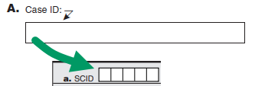
- Copy the name of the Governmental Unit (GU) from the box B on the SC-117 to the Name box on the SC-693.2.
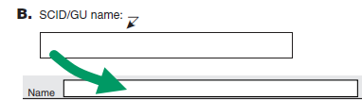
- Copy the two-digit State Code from box G on the SC-117 to Box b on the SC-693.2.
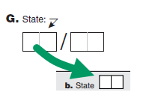
- Copy the three-digit County Code from box H on the SC-117 to box c on the SC-693.2.
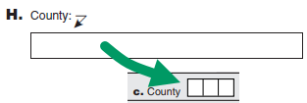
- Copy the six-digit Tract Code from box K on the SC-117 to box d on the SC-693.2.
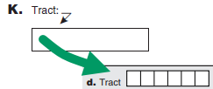
- Copy the six-digit AA number from box J on the SC-117 to box f on the SC-693.2.
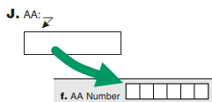
- Copy the TL Name from box C on the SC-117 to box g on the SC-693.2.
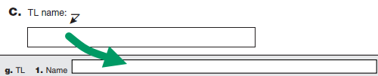

- Copy the TL Name from box C on the SC-117 to box g on the SC-693.2.
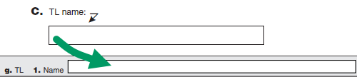
- Copy the street address or location description of the TL from box D or N on the SC-117 to box g2 on the SC-693.2.
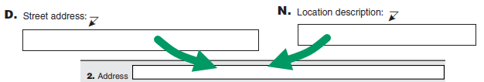

Prepare Assignments
- Clip together all the EQs/CQs/TL Listing Pages for each case; do NOT rubber band them together.
- If a clip will not hold together what is needed for a single case, place them in a messenger envelope and clip the associated Form SC-117 to the outside of the envelope.
- If more than one envelope is needed to hold a case, use as many as necessary.
- Mark the envelopes 1 of 2, 2 of 2, etc., to alert the Lead FR that there are multiple envelopes of materials.
- Write the TL Case ID/TL Name on any additional messenger envelopes.
- If the case is very large, put the materials in a box and affix the associated Form SC-117 to the top so you know which TL the case is for.
- Complete Section B: Enumeration at Transitory Locations Information on the Form SC-117.
- Print the name of the FS/Lead FR to whom the case is assigned in the space provided for ASSIGNED TO.
- Print the date (MM/DD/YY) the case was assigned in the DATE ASSIGNED fields.
- Mark off (draw a line through or checkmark (√) each case) on the TL Assignment Directory Report as you finish packaging the materials.
- When you finish one case, begin the next and repeat this process until you have finished preparing materials for every case on the TL Assignment Directory Report.
- After you have finished, you should have accounted for every Form SC-117. Make certain you did not miss any case on the TL Assignment Directory Report.

Quality Control Check
Have another clerk check the assignment materials. They must make sure that:
- There is a stack of materials for each case shown on the TL Assignment Directory Report.
- There is a Form SC-117, Transitory Location Control Record (TLCR) for each case on the TL Assignment Directory Report. The correct number of questionnaires is included.

ETL Assignment Review and Check-in

Introduction
ETL Assignment review is a three-stage process.
- After the FR completes the enumeration of their assigned area of a TL, they review their materials, using the Form SC-671, ETL Field Representative Checklist.
- The Lead FR/FS collects the completed enumeration materials and reviews them, using the Form SC-682.2(ETL), ETL Field Supervisor Checklist.
- The Lead FR/FS returns the completed TL enumeration assignments to the SCO, where the office clerk reviews them, going through the task list, using the Form SC-691(ETL), ETL Clerk Office Review Checklist.
- Complete one Form SC-691(ETL), ETL Clerk Office Review Checklist, for every Form SC-117, TL Control Record, returned with its associated enumeration materials. Review the materials for one Form SC-117, before checking-in the questionnaires.

ETL Materials Returned to SCO
The Lead FR/FS will return the following materials to the SCO:
- Completed Form SC-117, TL Control Record
- Completed Forms SC-693.2(ETL), Transitory Location Listing Sheets
- Completed Forms SC-225, INFO-COMMs
- Completed Forms SC-Q-TL/SC-Q-TL (S), Transitory Units Questionnaires (EQs, English and Spanish version, if included)
- Completed Forms SC-CQ-TL/SC-CQ-TL (S), Transitory Units Continuation Questionnaires (CQs, English and Spanish version, if included)
- Unused/blank enumeration materials could also be turned in, such as, extra questionnaires, and TL Listing Sheets.
- Store blank questionnaires, unused TL Listing Sheets and Forms SC-LFM-TL(E/S), TL Facility Manager Letter(s), in the bulk supply at the SCO.

Steps to Review ETL Enumeration Materials
Begin your review by using a blank Form SC-691(ETL), ETL Clerk Office Review Checklist, and a pencil to complete the checklist, after completing the following three initial examinations:
- Review Form SC-117, TL Control Record
- Use the TL Assignment Directory Report which contains the list of TLs and the name of the Lead FR assigned to the case. Enter the date (MM/DD/YY) the materials were returned to the SCO beside the FR’s name.
    - On the Form SC-117:
      - Make certain that a date (MM/DD/YY) was entered in the Item 21, DATE ENUMERATION COMPLETED fields.
      - Make certain that the FR certified the results of the ETL visit by signing their name and entering the Date Signed (MM/DD/YY) in Item 22 and Item 23, of the Certification section (Section B, Enumeration at Transitory Locations Information).
      - Check the Notes section for any pertinent information related to the enumeration of the TL that you might need to bring to your supervisor’s attention.
- Review Forms SC-693.2(ETL), Transitory Location Listing Sheets
- Make certain that all TL Listing Sheets for each TL are in block number order (see Block No in upper left corner of each TL Listing Sheet).
- Make certain that all TL Listing Sheets for each TL are numbered (Page__of___ in the Identification section), for example page 1 of 10, page 2 of 10…page 10 of 10.
- Review Forms SC-225, INFO-COMM
- Read associated Forms SC-225 to determine if they contain any pertinent information related to issues or problems affecting the enumeration of the TL.
- Refer all SC-225, INFO-COMM related to aggressive refusals, dangerous addresses, TLs requiring security clearances or payment/fees to access the site to your supervisor. These cases require management attention and need to be addressed immediately!
- Review EQs and CQs and Finish Reviewing the Form SC-117, using the Form SC-691(ETL), ETL Clerk Office Review Checklist
- Complete the Header section of the Form SC-691(ETL):
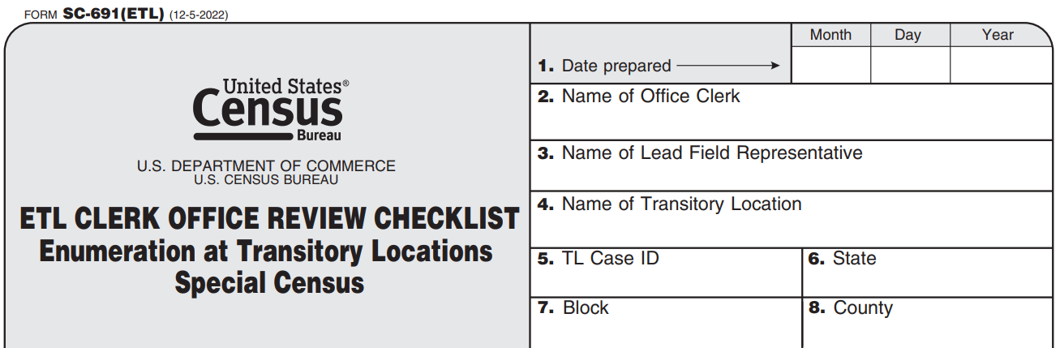
- Using the Task List, review the Form SC-117, Transitory Location Control Record (TLCR) and Forms SC-Q-TL (EQ) and SC-CQ-TL (CQ) for completeness, accuracy, and legibility.
- For each of the Tasks (1-6), mark (X) the box as you complete each one.
- Mark YES if the answer to the question is YES.
- Mark NO if the answer to the question is NO because a correction is required.
- Enter your initials in the appropriate column.
- If necessary, enter any notes in the Notes section of the form.
- If an error is discovered, and you cannot fix it, bring it to the attention of your supervisor.
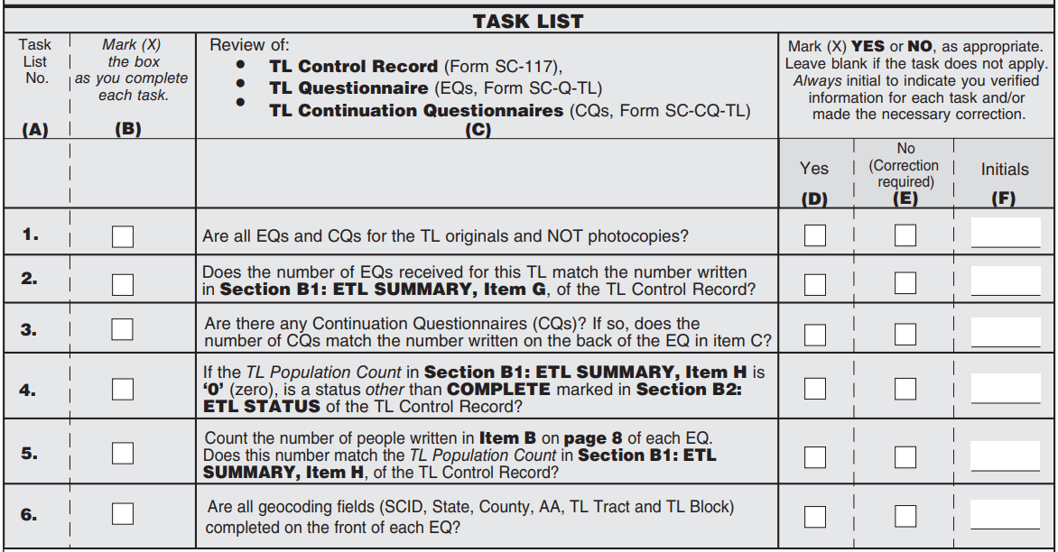
DO NOT:
- Write on any of the EQs/CQs, mark through any of the boxes, or otherwise make any corrections on the form itself. Smudges, marks, or extraneous lines could interfere with the clarity of the digital scan.
- If you find an error, according to the Task List instructions, you may need to complete a new EQ/CQ. Notify your supervisor.
DO:
- Check-in the Form SC-117 and any other enumeration materials, when all errors are corrected.
- Store the Form SC-117 and associated EQs/CQs in a secure location until ready to be shipped once the operation is over.
- Follow the procedures in the office manual in the SC-1131 Special Census Office Checklist for Reviewing Materials, if you find duplicates.
- Do not check-in a case, if you determine that the case requires supervisor or management attention (Refusal or Dangerous Address); instead, take all the materials to your supervisor.
- Store the materials that DO NOT require shipping in Block/County order in a secure location in the SCO.

How to Use the Task List

Task List No. 1 (Column (A))
- Mark (X) the box in Column (B) as you complete Task 1.
- Visually inspect each EQ and CQ for the TL to make certain each one is an original copy and not photocopied.
- If all are originals, then mark (X) Yes in Column (D) and enter your initials in Column (F).
- If any of the EQs or CQs are a photocopy, mark (X) No in Column (E) and notify your supervisor.
- Your supervisor will contact the FR about using photocopied census forms and may instruct you to transcribe the information onto a new EQ.
- Do NOT throw the photocopied EQ/CQ into the trash. They must be destroyed according to SCO instructions as they contain PII information.
- Write DESTROY on the front of the document.
- Place the discarded form in a bin labeled HOLD FOR DESTRUCTION and store in a secure location in the SCO.
- Enter your initials in Column (F).

Task List No. 2 (Column (A))
- Mark (X) the box in Column (B) as you complete Task 2.
- Make sure you have all the questionnaires for the associated Forms SC-117.
- Count the number of EQs received for the TL and compare it to the written number in Item G, Section B1: ETL Summary of the Form SC-117.
- If the number matches, mark (X) Yes in Column (D) and enter your initials in Column (F).
- If the number doesn’t match, mark (X) No in Column E, and look for an explanation in the Notes section of the Form SC-117. If there is no explanation and:
- If there are more EQs than what is indicated in Item G, Section B1: ETL Summary, of the Form SC-117:
- Make certain that you have only the EQs for the TL you are working on by comparing the geocoding data (SCID, State, County, AA Number, TL Tract, TL Block codes) on the EQ to that on the SC-117. If it belongs to another TL, place it with that group.
- If there are fewer EQs than what is indicated in Item G, Section B1: ETL Summary, of the Form SC-117:
- Check the EQs for other TLs you are working on to make certain the missing EQ is not mixed in with another TL’s materials.
- If you cannot find the missing EQs, write Initial Count was Short in the Notes section of the Form SC-117.
- If the missing form cannot be found in the office, you or your supervisor must contact the FS.
- Continue to review and process this case. Any additional forms for the case can be checked in later. Do not hold the case back from check-in to wait on more forms.
- Enter your initials in Column (F).
- When you learn the answer, document the explanation in the Notes section on the SC-691(ETL) ETL Clerk Office Review Checklist.

Task List No. 3 (Column (A))
- Mark (X) the box in Column (B) as you complete Task 3.
- Look at the Interview Summary section on the back of the EQ. If Yes is marked in Item C, compare the number entered in the boxes to the number of CQs that accompany the EQ. Make certain there is a CQ for each EQ that required the use of a CQ.
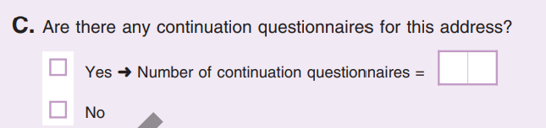
- If the numbers match, mark (X) Yes in Column (D), enter your initials in Column (F), and place the CQ back inside its corresponding EQ.
- If the numbers do not match, look at the Questionnaire of Questionnaire(s) section on the front of each CQ to determine if the FR counted correctly.
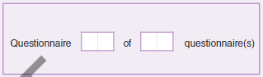
- If the number is greater, make certain that you have only the CQs for the TL you are working on by comparing the geocoding data (SCID, State, County, AA Number, TL Tract, and TL Block codes) on the EQ to that on the SC-117. If it belongs to another TL, place it with that group.
- If the number is fewer, and after recounting, you cannot locate a possibly missing CQ, notify your supervisor, and contact the Lead FR for an explanation.
- Enter your initials in Column (F) and place the CQ back inside its corresponding EQ.
Example: If a TU qualifies for a full interview, and 18 people live or stay in that TU, there should be one EQ and two CQs. Each EQ can hold responses for up to 6 people. The additional 14 people would be enumerated on the two CQs.

Task List No. 4 (Column (A))
- Mark (X) the box in Column (B) as you complete Task 4.
- If the TL POPULATION COUNT in Item H, Section B1: ETL Summary, of the Form SC-117 is zero (0), there should be no EQs or CQs. Confirm that a status other than Complete is marked in Section B2: ETL Status of the Form SC-117.
- If Yes, then, mark (X) Yes in Column (D), enter your initials in Column (F)
- If the TL POPULATION COUNT is NOT zero and there are EQs/CQs, yet a status other than Complete is marked, then change the status to Complete in Section B2, of the Form SC-117.
- Mark (X) No in Column (E) and enter your initials in Column (F).

Task List No. 5 (Column (A))
- Mark (X) the box in Column (B) as you complete Task 5.
- You may wish to use a calculator for this step, so that you do not miscount the population number.
- Add up the number of people written Item B of the Interview Summary section on page 8 of each EQ for the TL and compare the number to the TL POPULATION COUNT in Item H, Section B1, ETL Summary, of the Form SC-117. See Figure 15.12.
- If the numbers match, mark (X) Yes in Column (D) and enter your initials in Column (F).
- If the numbers do not match, mark (X) No in Column (E).
- Reconcile the numbers, and enter the correct number in Item H, Section B1, ETL Summary of the Form SC-117.
- Enter your initials in Column (F).
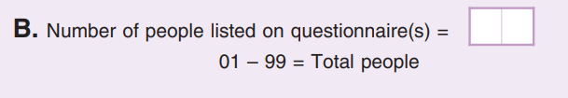

Task List No. 6 (Column (A))
- Geocoding data will be entered only on the front of EQs (See Figure 15.13) in which a full interview was conducted. The FR transcribes this information from the Form SC-693.2(ETL), Transitory Location Listing Sheet.
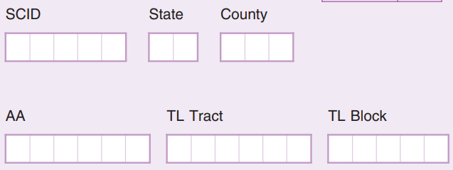
- Confirm that a full interview was conducted by checking that the answer to Screening Question S2, “Do all of the people staying in this [RV/boat/room/unit] have another place where they usually live? was marked No. If the answer was marked Yes, a full interview was not conducted, and the geocoding data need not have been completed on the form.
- Mark (X) the box in Column (B) as you complete Task 6.
- For each EQ/CQ for which there is a complete interview (as described above), verify that all the geocoding fields (SCID, State, County, AA Number, TL Tract, and TL Block codes) are completed correctly and that they match the information in the header of the Form SC-117.
- If Yes, mark Yes in Column (D) and enter your initials in Column (F).
- If No, mark No in Column (E). You may have to complete a new EQ/CQ.
- Enter your initials in Column (F).

Check-in ETL Materials
Once you have completed office review for a TL, using the Form SC-691, ETL Clerk Office Review Checklist, and there are no errors to be fixed, start to check-in the Form SC-117, Transitory Location Control Record (TLCR) and the associated EQs/CQs.
- Separate the EQs/CQs and Form SC-117 from any other materials associated with the TL (Forms SC-225, INFO-COMMs, Forms SC-693.2(ETL), TL Listing Sheets). You will scan only the EQs/CQs and Form SC-117.
- Scan the TL Barcode ID on the Form SC-117.
- Scan each EQ and its associated CQ. Place the CQ(s) back inside the EQ.
- As you scan the EQs/CQs, place them into storage until the end of the operation to eventually get shipped to NPC.
- Place the scanned Form SC-117 on top of the scanned questionnaires.
- Even if a TL doesn’t have TL questionnaires, scan it into MOJO anyways. These questionnaires will have the outcome entered into MOJO.

ETL Add Cases

ETL Transitory Location Adds
During the ETL visit, FRs may learn that:
- The assigned transitory location has undergone a name or an address change (Form SC-117, Section A1, Transitory Location Advance Contact Information, Item 4 and 5, TL Name and Street Name fields are different from what is in the Header of the Form SC-117). They could have visited the incorrect location, or it may be a new TL.
- Notify your supervisor.
- You may be instructed to conduct research.
- The TL contact person manages another TL (Form SC-117, Section A1, Item 17 is marked Yes) but the Lead FR does not have another Form SC-117 for that location, therefore they could not conduct an in-field interview for that TL. They should have completed information in the Notes section of the Form SC-117 and a Form SC-225, INFO-COMM about the potentially new TL. In this situation, you should also notify your supervisor and possibly be prepared to conduct research.

Conducting TL Research
- TL Name/Address Changes
- You need to determine if the ETL team visited the right location.
- Search the TL workload to determine if that location is already in the workload. It may be in the workload under the corrected name/address, but a different TL Case ID.
- Use Google Search for the original address to determine what is at that location.
    - Use Google Search for the TL name to determine what the address is (and to verify if it is within the SCO enumeration area).
- Potentially New TLs
- If there is information in the Notes section of the Form SC-117 and/or a Form SC-225 containing information about another TL that the TL contact person manages, then you should:
    - Search the TL workload to determine if that location is already in the workload. It could be assigned to another Lead FR.
    - If it is already in the workload, indicate on the Form SC-117/SC-225 that the TL is a duplicate of a case in the workload and will not be added.
- If you determine that the address is not in the workload, and it is within the SCO’s enumeration area, then you must add the location to the TL workload via MOJO.
    - Print the Form SC-117 for the new TL.
    - Your supervisor must assign a Lead FR to the case for a TLAC in-field interview if there is time. Follow instructions in Topic 4, Transitory Locations Advance Contact (TLAC) Assignment Preparation and Checkout.

Quality Control Operations

Introduction

Overview
This chapter provides information about the quality control (QC) program used to monitor, control, and enhance the quality of the housing unit data collected by Special Census Field Representatives. This chapter provides information on the different activities performed by the office staff to support the quality control operations.

The Special Census Supervisor’s Role in Quality Control
The Special Census Supervisor implements the QC plan to ensure the collection of the highest possible quality data. The QC activities include field and office reviews of completed work.
For the field work, the Special Census Supervisor ensures that:
- SC-1222, Special Observation Checklists are completed within one week after FRs receive their first assignment
- Based on initial observation results, determines if a Field Representative requires an additional observation they should be marked as Additional observation. The Special Census Supervisor also determines the type of administrative action to take on a Field Representative that is marked as Additional observation
- QC Field Supervisors complete the Dependent Quality Check (DQC) and perform Recanvass for AAs that fail DQC
- Production work is checked in to MOJO and selected for reinterview
- Reinterview work is assigned as soon as Form SC-Q, Special Census Questionnaires, are selected for Reinterview
- Reinterview cases that could not be completed over the telephone are assigned to a RI FR
- A final reinterview status is assigned to cases where Form SC-Q, Special Census Questionnaire, does not match Form SC-RQ, Special Census Reinterview Questionnaires
- Form SC-Q, Special Census Questionnaires, requiring additional reviews are placed in Supplemental Reinterview

QC Program Field Components
The Special Census QC program consists of five distinct components. These components are:
- Initial Observations
- Dependent Quality Check (DQC)
- Zero Housing Unit Recanvass
- Population and Housing Unit Comparison Test
- Reinterviews

Initial Observations

Overview
The Field Supervisor performs an initial observation of each Field Representative within one week after the Field Representative receives their first assignment. The Field Supervisor uses Form SC-1222, Special Census Observation Checklist, to observe the Field Representative in the field. Results from the observation are keyed into MOJO by office clerks. The following images provide examples of the front and back of the SC-1222, Special Census Observation Checklist.
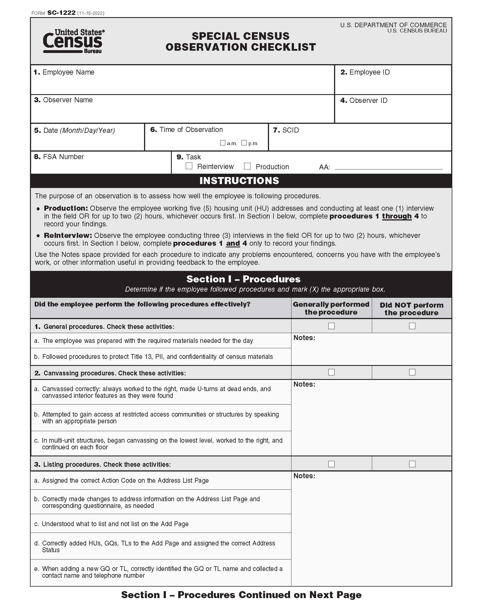

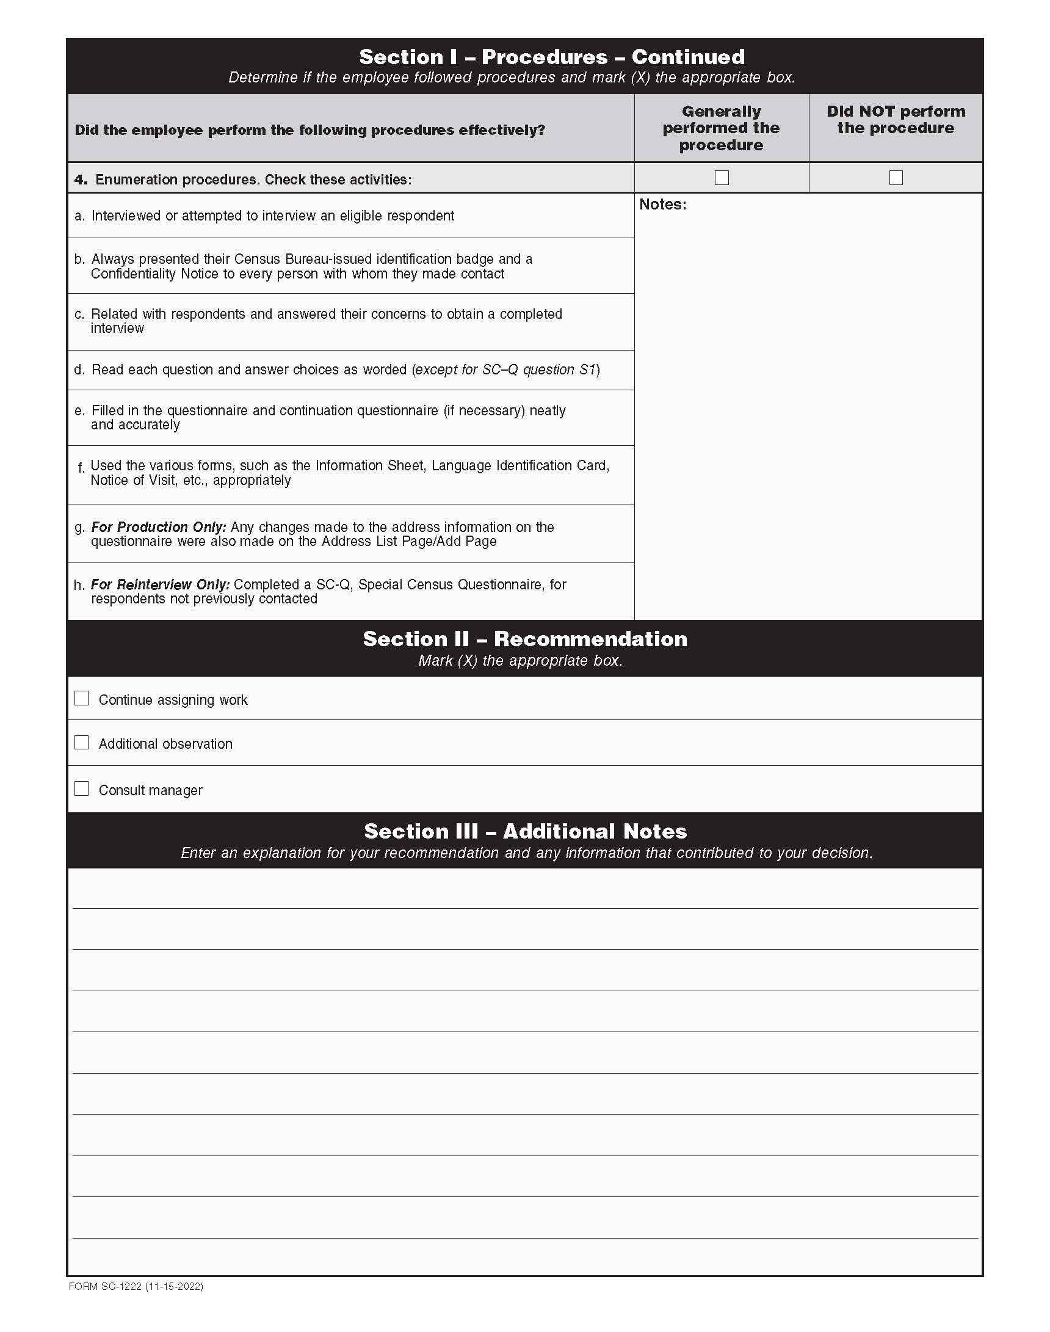

Responsibilities for Initial Observations
The Field Supervisor observes the Field Representative perform his or her duties. For production, the Field Supervisor observes the Field Representative working five housing unit addresses and conducting at least one interview or for up to two hours, whichever comes first. For Reinterview, the Field Supervisor observes the Field Representative conducting three housing unit interviews or for up to two hours, whichever comes first. If the Field Representative performs adequately, he or she is allowed to work without further observation.
If the Field Representative does not perform adequately during the initial observation, the Field Supervisor recommends to the Field Manager that the FR is observed an additional time. Field Supervisors may also recommend discussing other actions with the Field Manager. Field Supervisors can only recommend a termination, but the Special Census Supervisor makes the final decision.
The Manager reviews Form SC-1222, Special Census Observation Checklist, and evaluates the Field Supervisor’s notes from the initial observation. The Field Manager considers the following when deciding whether to allow an additional observation:
- Were the tasks the Field Representative failed to perform adequately difficult?
- Was the enumeration area difficult to enumerate?
- Did the Field Supervisor observe enough housing units to determine a fair outcome?
- Did the Field Supervisor base his or her outcome on only one observed housing unit?
- Does the Field Supervisor think this Field Representative will benefit from on-the-job training and a second observation?
The Field Manager decides to:
- Allow the Field Supervisor to conduct an on-the-job training and an additional observation, or
- Mark the Field Representative as Consult manager
Marking a Field Representative as Consult manager means the Field Representative was unsatisfactory performing the listing and enumeration tasks and providing on-the-job training and an additional observation will not benefit the operation. Even though this is possible, it is unlikely that a Field Representative will not improve his or her performance after an on-the-job training session.
If, after reviewing the results of Form SC-1222, Special Census Observation Checklist, the Field Manager determines that the Field Representative is unsatisfactory in performing listing and/or enumeration activities, the Field Manager must complete Form SC-282, Documentation of Conduct and/or Performance Problems and Form SC-283, Documentation of Termination for Performance and/or Performance Problems and contact the Regional Office to obtain approval to terminate the employee. Refer to Chapter 7 for the instructions for terminating an employee for performance problems.
If the Field Manager allows an additional observation:
- For Production, the Field Supervisor provides further training before observing the Field Representative perform the listing and/or enumeration activities for five housing unit addresses and conducting at least one interview or for up to two hours, whichever comes first. If the Field Representative performs the listing/enumeration tasks adequately, he or she will be allowed to continue working.
- For Reinterview, the Field Supervisor provides further training before observing the Field Representative perform the enumeration activities for three housing unit interviews or for up to two hours, whichever comes first. If the Field Representative performs the listing/enumeration tasks adequately, he or she will be allowed to continue working.
The clerks enter the observation recommendation from Form SC-1222, Special Census Observation Checklist, into MOJO. Depending on the result of the initial observation, the clerks may need to enter information for an additional observation. If an additional observation is needed, a new Form SC-1222, Special Census Observation Checklist, will be completed by the Field Supervisor during the additional observation and returned to the SCO for keying into MOJO. Refer Chapter 13, Topic 5 for more information about updating MOJO when a Field Representatives requires an additional observation. Refer to the SC-445, User Guide for MOJO for steps to enter observation data in MOJO.

Monitoring the Completion of the Observation Forms
All observations and Form SC-1222, Special Census Observation Checklist, must be completed within the first week of field operations. The Special Census Supervisor or Field Manager use Table XXX in MOJO to monitor the completion and results of the observations. The Special Census Supervisor or Field Manager must refer to Table XXX to determine if there are any outstanding observations after the first week of operations. The Special Census Supervisor or Field Manager must follow up with the Field Supervisor to complete the outstanding observations. Refer to the SC-445, User Guide for MOJO for steps to monitor the completion and results of the observations.

Dependent Quality Check

Overview
The Dependent Quality Check (DQC) is used to determine if the Field Representatives (FRs) properly follow listing and canvassing procedures. During listing, Field Representatives canvass blocks in their assigned AA to locate all housing units and verify and update all information on the address registers completely and accurately. The Quality Control Field Supervisor (QC FS) determines whether the AA passed or failed DQC by checking a sample of 12 consecutive addresses on the ground. If fewer than 12 addresses exist in the AA, the QC FS checks all addresses in the AA. The QC FSs use the SC-435, Dependent Quality Check Record to record the results of DQC. If the AA fails DQC, then the QC FS recanvasses the entire AA.
In addition to checking a sample of addresses, if there are blocks within the AA or an entire AA with zero housing units, the QC FS performs a zero-housing unit recanvass during DQC. During this recanvass, the QC FS:
- Verifies that the AA or specific blocks within the AA do not have any housing units.
- Enters a note in the first row of the SC-435, Dependent Quality Check Record, confirming there are no living quarters in the AA.
- Adds housing units and conducts an interview for housing units that were added during DQC.
If blocks have a 10% difference in the housing unit and population counts between the 2020 Census and the Special Census, the QC FS will also canvass those blocks during DQC.

Special Census Supervisor Responsibilities for DQC
The Special Census Supervisor ensures that QC FSs conduct DQC as AAs are assigned for DQC. After DQC is complete, the Address Register is checked in.

Preparing the Address Register for Dependent Quality Check
Every Address Register must go through DQC. After the Address Registers are checked in from production, clerks prepare the Address Registers for DQC. Clerks run report SC-328B, Count Comparison by Block from MOJO to identify blocks that have a population count and/or housing unit count that is 10% over and/or under the 2020 population count/or housing unit count. Clerks prepare Form SC-320, Error List, for each AA and include it with the Address Register for DQC only when:
- Errors from production are identified during the Address Register Office Review process.
- There is a 10% difference (over and under) between the 2020 Census housing unit and population count and the Special Census housing unit and population count
- There are blocks with zero housing units or entire AAs with zero housing units.
Clerks complete the header of the SC-320, Error List, by entering the following items in the provided spaces:
- SCID number
- AA number
- Date the SC-320, Error List, was prepared
- Field Supervisor’s name
The clerks enter the following information:
- Column (a), Form Type – check the appropriate box to indicate the form where the error was identified
- Column (b), Form Line No. – the line number of the form where the error was identified
- Column (c) – the Case ID associated with the address (only filled out if there was an error identified on Form SC-920, Address List Page, or Form SC-921, Add Page)
- Column (d) Issue – a short description of the error. For example, Line 3 is missing an action code, confirm 10% over for the housing unit count, or verify no LQs in block 1001
Column (E), Resolution, is completed in the field by the QC FS.
After preparing Form SC-320, Error List, the clerks make a copy keep in the office. The original Form SC-320, Error List, is placed inside the cover of the Address Register so the QC FS can resolve the error(s) while conducting the Dependent Quality Check.
To prepare the Address Registers for DQC, the clerks:
- Write, using a black ink ballpoint pen, the Dependent Quality Check starting address line number identified by MOJO in the Starting address line number box in the upper right corner of the SC-435, Dependent Quality Check Record, which is the last page in the Address Register. Refer to the SC-445, User Guide for the MOJO, for instructions on accessing the starting address line number for DQC.
- If the DQC starting line address happens to be a line that was crossed out by the FR because the address was mistakenly added, then write the number for the next available line on Form SC-921, Add Page. If there are no additional addresses listed on Form SC-921, Add Page, then write the first line number of Form SC-920, Address List Page.
- Insert filled out Form SC-320, Error List, if applicable, inside the front cover of the Address Register.
- Confirm there is a line drawn in red pencil under the last address added during production on Form SC-921, Add Page. If not, draw a line in red pencil under the last address added during production on Form SC-921, Add Page.
- If there are no adds on Form SC-921, then write no adds in red pencil in the first row of Form SC-921, Add Page
- On Form SC-940, Address Register Cover Page, in Section 1, Assignment Information, under row (d) DQC FS, enter the Name, Employee ID, and Telephone Number of the DQC FS to which the AA will be assigned.
- Assign and check out the Address Register to the appropriate QC FS. Refer to Form SC-445, User Guide for the MOJO for the steps to assign an Address Register for DQC.

Check In from DQC
After DQC has been completed for an AA, the Address Registers arrive in the SCO. Clerks check in Address Registers through MOJO. Refer to the SC-445, User Guide for the MOJO, for steps to check in Address Registers. The clerks:
- Retrieve Address Registers from the IN bin.
- Check in the Address Register to MOJO.
- Select/confirm the name of the QC Field Supervisor that completed the DQC on the Address Register from MOJO.
- Review the SC-320, Error List, if applicable, to ensure all errors were corrected.
- Consult the Field Manager or Special Census Supervisor for guidance if errors were not corrected.
- Enter the Total number of failed addresses (located in Column 5, under row 12) from Form SC-435, Dependent Quality Check Record, which is in the back of the Address Register, into MOJO.

Office Review for DQC
After the Address Registers are checked in from DQC, the office clerks conduct an Office Review of each Address Register and any associated questionnaires. Form SC-435, Dependent Quality Check Record is used by QC FS to record the results of the DQC. Form SC-435, Dependent Quality Check Record is the last page in the back of the Address Register. The clerks review the completed Form SC-435, Dependent Quality Check Record, after the Address Register is checked in from DQC.
The clerks follow the Section 7, Dependent Quality Check Office Review of Form SC-1131 Office Checklist for Reviewing Materials, to see if instances of over coverage or under coverage were identified by the QC FS during DQC:
- Entered listing line number in Column (2), if Address Missing is from List Page and Add Page. This indicates under coverage. In this situation, the QC FS adds the housing unit address to the Add Page and conducts an interview. The clerks must ensure a Form SC-Q, Special Census Questionnaire, was completed by the QC FS. Refer to Section 7, Dependent Quality Check Office Review of Form SC-1131, Office Checklist for Reviewing Materials, for office review procedures.
- Entered listing line number in Column (3), (Look at Form SC-920, Address List Page) if the Action Code in Column 4 of the Form SC-920 has Action Code U (Uninhabitable), N (Nonresidential), DCL (Unable to Locate), or CW (Cannot Work) but should have Action Code V (Verified) or C (Correction). This indicates under coverage. In this situation, the QC FS conducts an interview at the housing unit and completes the SC-Q, Special Census Questionnaire during the DQC. The QC FS has six attempts to contact a respondent at the housing unit. The first attempt must be made in person. Any later attempts can be made in person or by telephone, if a telephone number was provided. The QC FS enters responses to the questions on the SC-Q, Special Census Questionnaire. The clerks must ensure a Form SC-Q, Special Census Questionnaire, was completed. Refer to Section 7, Dependent Quality Check Office Review of Form SC-1131, Office Checklist for Reviewing Materials.
- Entered listing line number in Column (4), (Look at Form SC-920, Address List Page) if the Action Code in Column 4 of the Form SC-920 has Action Code V (Verified) or C (Correction) but should have Action Code U (Uninhabitable) or N (Nonresidential). This indicates over coverage. Refer Section 7, Dependent Quality Check Office Review, of Form SC-1131, Office Checklist for Reviewing Materials, for Dependent Quality Check Office Review.
If an Address Register fails DQC, then the clerks must also review the Address List Page(s) and Add Page(s) to determine if new housing units were discovered during Recanvass and to determine if any known addresses on the Address List Page had an action code change during Recanvass that changed an address from a housing unit to a non-housing unit and vice versa. Refer to Section 7, Dependent Quality Check Office Review of Form SC-1131, Office Checklist for Reviewing Materials.

Population and Housing Unit Comparison Test

Overview
The population and housing unit comparison test is used to determine whether an area experienced a large increase or decrease in the population or housing unit count compared to the totals from the 2020 Census. The Special Census Supervisor or Field Manager must print the report from MOJO and review the SC-328, Count Comparison by Block, report daily and to conduct this comparison. If there are concerns after reviewing the SC-328, Count Comparison by Block, report the Special Census Supervisor or Field Manager discusses with the Field Supervisor.

The Special Census Supervisor Role in the Population and Housing Unit Comparison Test
If the population or housing unit count largely differs from the 2020 Census, the Special Census Supervisor or Field Manager contacts the Field Supervisor for a possible explanation. For example, Happy Valley, a new subdivision of 37 homes was built since the 2020 Census. This information can help the Special Census Supervisor or Field Manager decide whether an AA should be verified.
The Special Census Supervisor or Field Manager reviews and evaluates the reasons for an increase or decrease provided by the Field Supervisor to determine if they are valid.
- If there is a reasonable explanation, the Address Register continues with the check in and office review process.
- If there is no reasonable explanation for the large difference between the 2020 Census and the Special Census population count or housing unit count, the clerk adds an issue to Form SC-320, Error List. The Field Manager and Special Census Supervisor define the strategy for addressing the issue.
Pending results of the investigation, the Special Census Supervisor or Field Manager may require the AA to be recanvassed and put all questionnaires into Supplemental Reinterview.

Reinterview

Overview
The purpose of Reinterview (RI) is to verify the accuracy of the housing unit status and population count recorded by the Field Representatives on completed Form SC-Q, Special Census Questionnaires.
As completed Form SC-Q, Special Census Questionnaires are checked in to MOJO, they are randomly selected for Reinterview.
Reinterview cases with telephone numbers are initially assigned to office clerks to complete over the telephone. Cases that could not be completed over the telephone or that did not have telephone numbers are assigned to Reinterview FRs to complete in the field.

Types of Reinterview
There are three types of Reinterview cases. These are:
- Random
- Supplemental
- Hard Fail Supplemental

Random
MOJO selects one of the first three housing unit cases worked by the FR, followed by one randomly selected case from the next 10 completed housing unit cases, and then every 10th completed housing unit case thereafter. If the selected case is ineligible for RI, MOJO will select the next RI eligible completed case.
Questionnaires with a unit status of Cannot Locate and Duplicate as well as questionnaires with an Interview Outcome Code of Refusal (REF) are ineligible for Reinterview. Closeout cases (a case is closed out when it is still incomplete at the end of the operation) and replacement questionnaires (forms the QC FR completed during reinterview) are also ineligible for RI.
Clerks and RI FRs use the Form SC-RQ, Special Census Reinterview Questionnaire, when conducting the Reinterview. If the housing unit was contacted, the clerks or RI FRs complete Questions 1 through 6 on Form SC-RQ, Special Census Reinterview Questionnaire and complete the roster in Question 7. If the housing unit was not contacted or the respondent does not remember being contacted, the clerks or RI FRs complete Form SC-Q, Special Census Questionnaire, for housing unit.

Supplemental Reinterview
If at any time the SCO staff have reason to suspect that a FR is falsifying data, or if they suspect an interview has not been done following established procedures, they can include additional interviews in Supplemental RI. SCO staff can either flag a specific case for supplemental RI or can flag an FR in which case the system will select the next two eligible cases worked by the FR for RI. The SCO staff flag supplemental RI cases for an FR if they suspect the FR conducted poor listing work and therefore want to check on the quality of the enumeration work of the FR. Supplemental Reinterview can be used as verification that the Field Representative completed the SC-Q, Special Census Questionnaire, according to the Special Census procedures.
The SC-425(RI), RI Questionnaire List, includes a column that shows the RI Type (type of RI: random, supplemental, hard fail supplemental).
Refer to Topic 7 for guidance on when it is appropriate to select questionnaires for supplemental reinterview.

Hard Fail Supplemental Reinterview
If a Field Representative is found falsifying work or intentionally not following procedures, the Field Representative will be flagged as a Hard Failed Field Representative. In this situation, all the eligible completed work by the Field Representative is sent to Reinterview as a Supplemental Hard Fail. The reason for this action is to ensure that all previously completed work by this Field Representative was done following Special Census procedures.
Refer to Topic 6 in this chapter for more information about hard fail Reinterview.

The Special Census Supervisor Role in Reinterview
The Special Census Supervisor has a dual role in Reinterview operations. One role is to ensure that production clerks prepare the Reinterview assignments and that Reinterview cases are assigned to QC clerks in the SCO or to RI FRs. The other role is to evaluate and decide on a final reinterview status in instances where Form SC-Q, Special Census Questionnaire completed by a Field Representative does not match the corresponding completed SC-RQ, Special Census Reinterview Questionnaire.
The Special Census Supervisor ensures that:
- Cases selected for Reinterview are set aside for Production clerks to prepare the Reinterview assignment
- Production clerks print the appropriate English or Spanish version of Form SC-RQ, Special Census Reinterview Questionnaire, to match the version used for the production interview. MOJO provides an indicator of whether the production interview was conducted in English or Spanish on the screen used to print Form SC-RQ, Special Census Reinterview Questionnaire.
- Production clerks transcribe the original interview Respondent Information to the Original Respondent Information section on Form SC-RQ, Special Census Reinterview Questionnaire.
- Check MOJO to determine if an address is flagged as proceed with caution: and adds a note in the Notes section that includes the reason the address is dangerous and a note to inform the FR to proceed with caution when approaching the address.
- Form SC-RQ, Special Census Reinterview Questionnaires with telephone numbers are assigned QC clerks to conduct telephone reinterview.
- Form SC-RQ, Special Census Reinterview Questionnaires without a telephone number or where the QC clerks could not complete a reinterview over the telephone within 3 attempts are assigned to RI FRs.
- QC clerks check in completed SC-RQ, Special Census Reinterview Questionnaires to MOJO. The QC clerk who checks in the SC-RQ, Special Census Reinterview Questionnaire must not be the same QC clerk who completed the SC-RQ, Special Census Reinterview Questionnaire.
The Special Census Supervisor also:
- Reviews cases where the original Form SC-Q, Special Census Questionnaire, and the corresponding Form SC-RQ, Special Census Reinterview Questionnaire do not match
- Determines a final reinterview status when Form SC-Q, Special Census Questionnaire does not match Form SC-RQ, Special Census Reinterview Questionnaire
- Places cases in Supplemental Reinterview that may need a second review, such as questionnaires with where more information is needed to assign an outcome.

Assigning Form SC-RQ, Special Census Reinterview Questionnaires to QC Clerks
Form SC-RQ, Special Census Reinterview Questionnaire is initially assigned to QC clerks or QC FSs. All Form SC-RQ, Special Census Reinterview Questionnaires with a telephone number in OR2, Original Respondent Telephone Number, are assigned and checked out to QC clerks to complete over the telephone. QC clerks have three attempts to complete Form SC-RQ, Special Reinterview Questionnaire over the telephone.
Form SC-RQ, Special Census Reinterview Questionnaires that do not have a telephone number in OR2 or interviews were not completed after three attempts by QC clerks are grouped by AA and assigned to QC FSs to assign to RI FRs to complete by personal visit. Form SC-RQ, Special Census Reinterview Questionnaire(s), without a telephone number in OR2 or interview were not completed after three attempts by a QC clerk are checked out to the QC FS in MOJO. Refer to the SC-445, User Guide for the MOJO for the steps to checkout Form SC-RQ, Special Census Reinterview Questionnaires to staff for the Reinterview operation.
After checking out Form SC-RQ, Special Census Reinterview Questionnaires out to the QC FS:
- Clerks secure all the Forms SC-RQ, Special Census Reinterview Questionnaires for the same AA using a binder clip.
- The Field Manager delivers all the Forms SC-RQ, Special Census Reinterview Questionnaires to the QC FS.
- The QC FS writes the RI FR reassignments on Form SC-336.1, Reassignment Worksheet, and provides it to the Field Manager to return to the office.
- The clerks reassign, in MOJO, each Form SC-RQ, Special Census Reinterview Questionnaire from the QC FS to the appropriate RI FR based on the information on Form SC-336.1, Reassignment Worksheet.

Completing Form SC-RQ, Special Census Reinterview Questionnaire over the Telephone
The QC clerks conduct telephone reinterviews in instances when a telephone number is available. During telephone reinterview, a QC clerk may only need to complete Form SC-RQ, Special Census Reinterview Questionnaire. In other instances, the QC clerk may also complete a full telephone interview using Form SC-Q, Special Census Questionnaire, based on responses provided during reinterview. QC clerks must have a supply of unlabeled Form SC-Q, Special Census Questionnaires, available during the reinterview in case a full interview is required. All entries on Form SC-RQ, Special Census Reinterview Questionnaire, and Form SC-Q, Special Census Questionnaire, must be made using a black ink ballpoint pen.
Refer to Form SC-50.1, Special Census Office Job Aids, for details on conducting a telephone reinterview.
Refer to Reinterview on page 350 for additional information on Reinterview.
The QC clerks use Form SC-50.1, Special Census Job Aids to complete Form SC-RQ over the telephone. Refer to Office Telephone Reinterview Job Aid in Form SC-50.1 for the script to use when completing the SC-RQ, Special Census Reinterview Questionnaire.
A black ink ballpoint pen must be used when completing questionnaires.
QC clerks must also have a supply of Form SC-Q, Special Census Questionnaire available in case a full interview is required. Refer to Office Telephone Interview Job Aid in Form SC-50.1 for the script to use when completing the SC-Q, Special Census Questionnaire.
The QC clerks use a black ink ballpoint pen when completing Form SC-RQ, Special Census Reinterview Questionnaire while conducting telephone interviews.

Original Respondent’s Information Section and Type of Respondent
The QC clerks contact the original respondent the Field Representative contacted in his/her original interview. This original respondent could be a person living at the address or it can be a proxy respondent living at a different address.
It is important that QC clerks understand who they are contacting during the telephone interview. There are two items on Form SC-RQ, Special Census Reinterview Questionnaire the QC clerks look at to determine type of respondent being contacted. Items OR3, Original Respondent Type and OR4, Address of the neighbor or proxy who provided the information on the original Form SC-Q, Special Census Questionnaire provide information on the type of respondent.
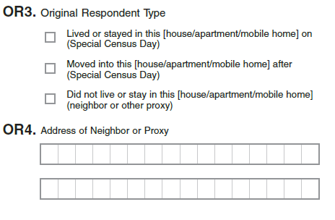
If the Lived or stayed in this [house/apartment/mobile home] on (Special Census Day) or Moved into this [house/apartment/mobile home after (Special Census Day) boxes are marked, the QC clerks contacts a respondent at the address shown on the address label. The information in OR1, Original Respondent’s Name, and OR2, Original Respondent Telephone Number contain information about the original respondent the Field Representative contacted.
If the Did not live or stay in this [house/apartment/mobile home](neighbor or other proxy) box is marked with X in item OR3, the QC clerks contact a neighbor or proxy that provided the information for the address shown in the label. In this case, the QC clerks may need to remind the neighbor or proxy that he or she is asking about the address in the label and not about their own address, which is the address in OR4 Address of neighbor or proxy.

Record of Contact
The QC clerks have up to three contact attempts on different days and different times to contact the respondent by telephone. The Record of Contact is completed after the QC clerks finish with the telephone call.
For each contact attempt, the QC clerks enter in the Record of Contact the following information:
- Interview type – the QC clerks always mark X the Telephone box,
- Month, Day, Hour, Minutes – the QC clerks enter the month, day, hour, and minutes when the telephone Reinterview was attempted. The clerks also mark X the a.m. or p.m. as appropriate, and
- Outcome – the QC clerks enter the interview outcome:
- NV – Not used by the QC clerk
- NC – Used if the QC clerk made a phone call and did not make contact
- RE – Used when the respondent refused to complete the reinterview
- CI – Used when the QC clerk conducted the reinterview
- OT – Used when for other reasons, such an invalid telephone number.
The QC clerks only log three attempts in the Reinterview Record of Contact section. If the QC clerk is unable to complete the telephone reinterview after three contact attempts, the Special Census Supervisor or Field Manager reassigns the SC-RQ, Special Census Reinterview Questionnaire to a QC FS so a personal interview can be conducted by a RI FR.
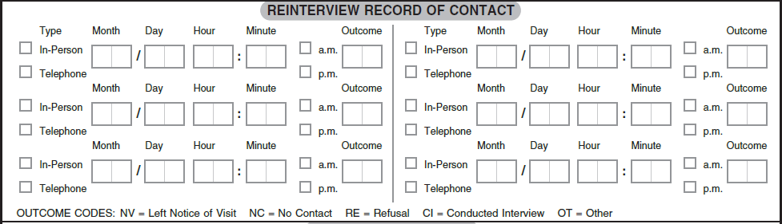
Introduction Section and Contacting the Original Respondent
Questions 1through 6 are the introductory questions for the reinterview. These questions determine who the clerk is talking to, who lives at the address shown on the label, whether the unit was vacant or not a housing unit on the Special Census Date, and the population count if the housing unit is occupied.
The QC clerk:
- Contacts the original respondent by using the information in Items OR1 or OR2, to verify the housing unit status and population. Clerks must know if they are talking with a resident or a proxy.
- Introduces himself or herself to the respondent using the introduction in Question 1.
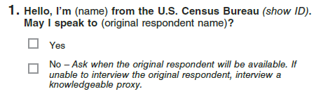
- Asks Question 2 exactly as worded.
- If the respondent responds No or Don’t Know, follows instructions in Form SC-50.1, SCO Office Job Aids to conduct a full interview using the SC-Q, Special Census Questionnaire.
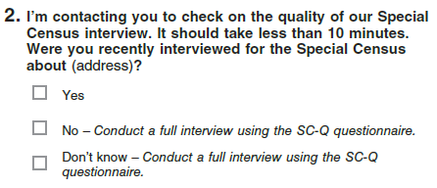
Asks Question 3 exactly as worded.
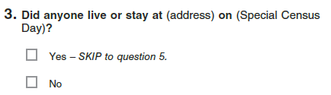
This question asks if anyone was living or staying at the Address printed on the label on the Special Census Day. If the QC clerk is talking to an original proxy respondent, the QC clerk must remind the respondent that he or she is asking for the information related to the address on the label.
If the respondent answers Yes, follow the skip pattern and continue with Question 5.
If the respondent answers No, continue to Question 4.
Asks Question 4 exactly as worded.
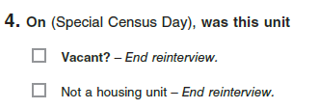
Asks Question 5 exactly as worded.
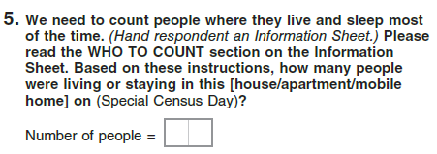
This question asks for the number of people that were living or staying at the address shown on the label. If the address is for the original respondent, then the QC clerk is asking the respondent about their own home. If the address is for a proxy, then the QC clerk must remind the proxy respondent that he or she is providing information for the housing unit shown on the SC-RQ, Special Census Reinterview Questionnaire label and not his or her own housing unit.
The QC clerk writes the number of people living at the address on the Special Census Day.
Asks question 6 exactly as worded.
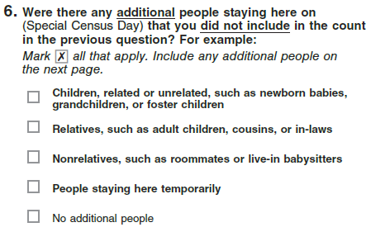
This question asks whether there were additional people not included in Question 5 that need to be included in the count. The QC clerk marks the appropriate box.
Asks Question 7 exactly as worded.
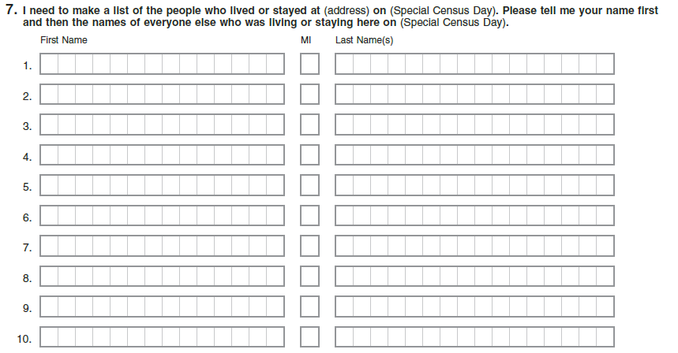
The QC clerk collects the household roster for the address shown on the label. The respondent provides the names of the people living at the housing unit on the Special Census Day.
Form SC-RQ, Special Census Reinterview Questionnaire has space for collecting 10 names. If there are more than 10 persons living at the housing unit, the QC clerk uses another blank Form SC-RQ, Special Census Reinterview Questionnaire and continues adding the names of the people living at the housing unit. The QC clerk numbers each Form SC-RQ, Special Census Reinterview Questionnaire in the upper right corner.
Refer to the figure below on where to place the number of forms.
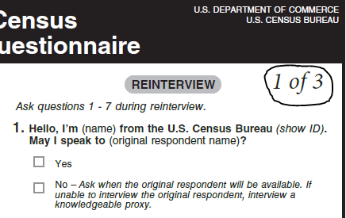

Completing Form SC-RQ, Special Census Reinterview Questionnaire
After the QC clerk completes a telephone reinterview, he or she thanks the respondent for their time responding to the questionnaire. We always want to leave a good impression with our respondents.
The QC clerk completes Form SC-RQ, Special Census Reinterview Questionnaire by:
- Completing the Reinterview Record of Contact section
- Signing his or her name in the Certification section
- Entering his or her Employee ID in the Certification section
- Entering the Month, Day, and Year in the Certification section under their signature
- Adding the FSA Number in the Field Supervisor area of the Certification section
Use a paper clip or a binder clip, when there are multiple Form SC-RQ, Special Census Reinterview Questionnaires from a large household, to keep all Form-RQ, Special Census Questionnaire(s)together before checking them in to MOJO.
Form SC-RQ, Special Census Reinterview Questionnaire, must be checked in to MOJO after the reinterview is complete. Do not check in any Form SC-Q, Special Census Questionnaire completed during QC until after Reinterview Office Matching is complete. If Form SC-Q, Special Census Questionnaire, is used during Reinterview, then the office staff must print the associated HU Full-RI label from MOJO and affix it to Form SC-Q, Special Census Questionnaire, used during Reinterview. The HU Full-RI label includes a different form type value in the barcode ID to ensure it is different from Form SC-Q, Special Census Questionnaire, completed during production. After checking in Form SC-RQ, Special Census Reinterview Questionnaire, the next step is to complete the matching of the SC-RQ, Special Census Reinterview Questionnaire to the SC-Q, Special Census Questionnaire.
If the QC clerk is unable to complete the telephone reinterview within three telephone attempts, the SC-RQ, Special Census Reinterview Questionnaire must be reassigned to a QC FS for reassignment to a RI FR.

Matching the SC-RQ, Special Census Reinterview Questionnaire with the Corresponding SC-Q, Special Census Questionnaire
After the reinterview is completed, in the office or returned from the field, and Form SC-RQ, Special Census Reinterview Questionnaire, has been checked into MOJO, the QC clerks conduct an office review of Form SC-RQ, Special Census Reinterview Questionnaire, to determine if all needed information was collected and also match the completed Form SC-RQ, Special Census Reinterview Questionnaire, with its corresponding Form SC-Q, Special Census Questionnaire, completed by the production Field Representative. The QC clerks locate the original Form SC-Q, Special Census Questionnaire, in a secured temporary bin to match it with its corresponding Form SC-RQ, Special Census Reinterview Questionnaire. The clerks review the Case ID on both questionnaires to ensure the Case IDs match.
After the Form SC-Q, Special Census Questionnaire, and Form SC-RQ, Special Census Reinterview Questionnaire, are matched, the QC clerk conducts a matching review. The QC clerk conducting the matching review cannot be the same clerk that completed Form SC-RQ, Special Census Reinterview Questionnaire. Refer to Topic 6 for more information on the matching review.
When reviewing a case, keep in mind that names in the roster may not match for many reasons. Differences in spellings, or in the form names take, in the original interview and the reinterview can occur. Refer to the Reinterview Matching Names Job Aid section of the SC 50.1 SCO Job Aid for help in matching.

Reinterview Check In, Reinterview Office Review, Matching Review and Entering Reinterview Status

Overview
Form SC-RQ, Special Census Reinterview Questionnaires, are checked in to MOJO prior to Reinterview Office Review and Matching Review. Do not check in any Form SC-Q, Special Census Questionnaire, completed during Reinterview until the after Reinterview Office Matching is complete.
After checking in completed Form SC-RQ, Special Census Reinterview Questionnaires, to MOJO, clerks perform an office review on Form SC-RQ, Special Census Reinterview Questionnaire, to determine if all the needed information was collected.
If the information was collected appropriately, the clerks match Form SC-RQ, Special Census Reinterview Questionnaire, with its corresponding Form SC-Q, Special Census Questionnaire, to determine if the Field Representative followed the Special Census procedures.
If the information from Form SC-RQ, Special Census Reinterview Questionnaire, and Form SC-Q, Special Census Questionnaire, match, the clerks mark X in the Pass box in the Clerk Office Review – Initial in the Reinterview Status section of Form SC-RQ, Special Census Reinterview Questionnaire. If the clerk finds one or more mismatches between Form SC-RQ, Special Census Reinterview Questionnaire and Form SC-Q, Special Census Questionnaire the clerks mark X in the Defer to Supervisor box and provides the case to the supervisor to decide on a final reinterview status.

SC-RQ, Special Census Reinterview Questionnaire Check In
Reinterview work is checked in to MOJO after reinterviews are completed by QC clerks or by RI FRs. Ensure Form SC-RQ, Special Census Reinterview Questionnaire, is checked in with the appropriate QC clerk or RI FR who completed the interview. Do not check in any Form SC-Q, Special Census Questionnaire, completed during Reinterview until the after Reinterview Office Matching is complete.
Refer to the SC-445, User Guide for the MOJO, for the steps to check in Form SC-RQ, Special Census Reinterview Questionnaires, to MOJO.

Reinterview Office Review
The QC clerks perform a review of the completed SC-RQ, Special Census Reinterview Questionnaire. The clerks ensure all questions are answered appropriately. The QC clerks attempt to fix any missing information in the office before conducting the matching review. Refer to Section 5, Reinterview Office Review of Form SC-1131, Office Checklist for Reviewing Materials for instructions on completing the reinterview office review. After the Reinterview Office Review is complete, the QC clerks conduct the Reinterview Office Matching.

Reinterview Office Matching
The QC clerks compare the original Form SC-Q, Special Census Questionnaire to Form SC-RQ, Special Census Reinterview Questionnaire to determine if the questionnaires match.
During the Reinterview Office Matching the QC clerks:
- Determine if the respondent of the reinterview was previously contacted by a Field Representative
- Determine whether the housing unit status of the SC-RQ, Special Census Questionnaire, matches the housing unit status of the SC-Q, Special Census Reinterview Questionnaire
- Check, if the housing unit was occupied on the Special Census Date, that the number of people that lived or stayed at the housing unit on the Special Census Date collected in Form SC-Q, Special Census Questionnaire, matches the number of people collected in Form SC-RQ, Special Census Reinterview Questionnaire
- Check, if the housing unit was occupied on the Special Census Date, that the people listed in the SC-Q, Special Census Questionnaire, and the people listed in the SC-RQ, Special Census Reinterview Questionnaire match at least 75% of the names listed.
Refer to Section 6, Reinterview Office Matching of Form SC-1131, Office Checklist for Reviewing Materials, for instructions on completing the reinterview office matching. Also refer to Form SC-50.1, SCO Job Aids.

Supervisor Review Matching Final Reinterview Status
All cases coded Defer to the Supervisor are reviewed by the Special Census Supervisor or the Field Manager in the SCO. It is the responsibility of the supervisor or Field Manager to assign a final reinterview status to the cases deferred to him or her by the QC clerks.
The Special Census Supervisor or Field Manager checks the Field Representative’s work against the reinterview completed for the same housing unit. The Special Census Supervisor or Field Manager determines if the Field Representative followed Special Census procedures and ensures data was not falsified.
To determine a final reinterview status on these cases, the Special Census Supervisor or Field Manager:
- Reviews other work completed by the same Field Representative
- Places additional work in supplemental reinterview
- Speaks to the Field Representative or Field Supervisor to resolve discrepancies between the original interview and reinterview questionnaire.
Based on the review of the case, the Special Census Supervisor assigns a final reinterview status and makes any necessary corrections to the questionnaires.
The supervisor assigns a final reinterview status of:
- Pass – after further research, the Special Census Supervisor determines that the Field Representative followed procedures and discrepancies were not due to Field Representative error. For example, a respondent might have forgotten a Field Representative visited the household to complete a questionnaire.
- Soft Fail/honest mistake – the Special Census Supervisor receives a reasonable explanation from the Field Supervisor or Field Representative related to the discrepancies found between the questionnaires. For example, the Field Representative accidentally went to the wrong housing unit to complete a questionnaire.
- Hard Fail/intentional falsification or deviation from procedures – after further research the Field Representative has a pattern of not following procedures after feedback was provided to correct the patterns; or was found falsifying some or all the data in the questionnaire.
- Non-Interview – after all allowed contact attempts, the Reinterview Field Representative could not complete a reinterview or was unable to collect enough data for the reinterview to complete matching.
The Special Census Supervisor selects the appropriate Final Reinterview Status on Form SC-RQ, Special Census Questionnaire, and documents the steps taken to investigate the case in the Notes section of Form SC-RQ, Special Census Reinterview Questionnaire.

Final Reinterview Status
The Special Census Supervisor or Field Manager takes further actions depending on the outcome of the case. After the Special Census Supervisor or Field Manager decides on final Reinterview Status, the QC clerks update MOJO with the Reinterview Status from Form SC-RQ, Special Census Reinterview Questionnaire.
The final reinterview status must be entered in MOJO for every reinterview case. If a final reinterview status has not been entered in MOJO at the time the corresponding SC-Q, Special Census Questionnaire, is being boxed at the end of the operation, then an error is displayed to remind the clerk that a final reinterview status must be entered for the questionnaire before it can be added to a box. In MOJO, table SC-342C(RI), RI Questionnaires Not Checked In, can be used to monitor reinterview progress at the AA level by tracking reinterview questionnaires that have not been checked into the SCO.

Pass
If the Special Census Supervisor or Field Manager can resolve the discrepancies between the original interview and the reinterview, the Special Census Supervisor or Field Manager assigns a final reinterview status of Pass. No further action is required for cases passed by the supervisor.

Soft Fail
The soft fail final reinterview status is used for mistakes made by the Field Representative. Experience show that mistakes will occur early in the operation. For example, a Field Representative might have entered the wrong unit status for the housing unit he or she enumerated.
After further research, if the Special Census Supervisor or Field Manager decides the discrepancy was an honest mistake, then the Special Census Supervisor or Field Manager assigns a final reinterview status of Soft Fail.
The Special Census Supervisor or Field Manager refers to Table SC-342S(RI) RI Status in MOJO to monitor the status of RI for Field Representatives that have multiple soft fails. If the Field Representative has two or more soft fails on the same error, this can be an indication that the Field Representative is intentionally or knowingly not following procedures. The Field Supervisor or Field Manager provides appropriate feedback on the errors committed by the Field Representative.
Cases coded as soft fail require that the Special Census Supervisor or Field Manager informs the Field Supervisor about the Field Representative’s mistake. The Special Census Supervisor or Field Manager prepares Form SC-225, INFO-COMM, to inform the Field Supervisor of the mistake. The Field Supervisor provides feedback to the Field Representative, so the mistake is not repeated.
After further research, if the Special Census Supervisor or Field Manager determines that a Field Representative is intentionally or knowingly not following procedures, this situation could be grounds to hard fail the Field Representative. The Special Census supervisor or Field Manager closely reviews previous work by this Field Representative and determines if re-training, other corrective action, or administrative action is necessary.

Hard Fail
A hard fail occurs when a Field Representative is intentionally or knowingly not following procedures or is found to have falsified part or all the data on a questionnaire. These cases require careful attention from the supervisor. A Field Representative found to be falsifying data or intentionally not following procedures can be grounds to remove the Field Representative from federal work.
The Special Census Supervisor or Field Manager must be certain that a Field Representative is intentionally not following procedures or falsifying data before assigning a hard fail final reinterview status.
The Special Census Supervisor or Field Manager must have information that supports a Field Representative has intentionally not followed procedures or has falsified data. If the Special Census Supervisor or Field Manager believes appropriate information to support a hard fail is available and decides the outcome should be hard fail, then he or she:
- Informs the RO manager that a hard fail final reinterview status should be assigned to the Field Representative.
- Shows or explains the reason(s) for the hard fail.
- Completes Form SC-282, Documentation of Conduct and/or Performance Problems and Form SC-283, Documentation of Termination for Conduct and/or Performance Problems, if the RO agrees to hard fail the Field Representative.
It is the responsibility of the Special Census Supervisor or Field Manager to gather all the appropriate information that supports the Field Representative was found falsifying data or intentionally not following procedures. This supporting information is used to complete Form SC-282, Documentation of Conduct and/or Performance Problems and SC-283, Documentation of Termination for Conduct and/or Performance Problems to remove the Field Representative from federal work. Refer to Chapter 7 for more information about removing staff from federal work.
Only after Form SC-282, Documentation of Conduct and/or Performance Problems and Form SC-283, Documentation of Termination for Conduct and/or Performance Problems are completed and signed, the Special Census Supervisor or Field Manager assigns a final reinterview status of Hard Fail.
When a hard fail final reinterview status is assigned to a Field Representative, all previous eligible completed work done by that Field Representative is automatically selected for hard fail Supplemental Reinterview to check if other work was completed according to procedures, and all their remaining work must be reassigned. The Special Census Supervisor or Field Manager instructs the clerk to:
- Print Form SC-RQ, Special Census Reinterview Questionnaire, from MOJO
- Locate, in the SCO storage area, all completed Forms SC-Q, Special Census Questionnaires, completed by the hard fail Field Representative
- Transcribe the original respondent information from Form SC-Q, Special Census Questionnaire, onto Form SC-RQ, Special Census Reinterview Questionnaire. Refer to Preparing Form SC-RQ, Special Census Reinterview Questionnaire in Chapter 13, Topic 3
The Special Census Supervisor or Field Manager ensures these questionnaires are checked out in MOJO.
Refer to the SC-445, User Guide for the MOJO for the steps to place Form SC-Q, Special Census Questionnaires in supplemental hard fail reinterview. In addition, any work that is currently assigned to this Field Representative must be reassigned to another Field Representative in the FSA.

Non-Interview
If after all allowed contact attempts, the Reinterview Field Representative could not complete a reinterview or was unable to collect enough data for the reinterview to do a matching, a final reinterview status of Non-interview is assigned.
These are cases where the Field Representative could not complete a reinterview questionnaire for the housing unit. The Reinterview Field Representative who conducted the reinterview enters RI NI in the Notes section on the back of Form SC-RQ, Special Census Reinterview Questionnaire, to indicate he or she could not complete the reinterview.
The Field Supervisor or Field Manager must ensure the Reinterview Field Representative made all attempts to complete the reinterview by checking the Reinterview Record of Contact section on the back for Form SC-RQ, Special Census Reinterview Questionnaire. If the Field Supervisor or Field Manager is satisfied that the Reinterview Field Representative made every effort to complete Form SC-RQ, Special Census Reinterview Questionnaire, then a final reinterview status of Non-interview. The original Form SC-Q, Special Census Questionnaire, is placed back to the storage bin.
The Special Census Supervisor or Field Manager monitors the RI NI received in the office. The RI NI code should be used as a last resort and it is expected that clerks and Reinterview Field Representatives complete most if not all Form SC-RQ, Special Census Reinterview Questionnaire.

Entering the Final Reinterview Status on Form SC-RQ, Special Census Reinterview Questionnaire
The Special Census Supervisor or Field Manager enters the final reinterview status on Form SC-RQ, Special Census Reinterview Questionnaire, after reviewing the results of the office matching review. The Special Census Supervisor or Field Manager enters in the Notes section on the back of Form SC-RQ, Special Census Reinterview Questionnaire, a brief explanation of the final reinterview status assigned. This note must include the Special Census Supervisor or Field Manager initials and date. The Special Census Supervisor or Field Manager marks X the appropriate box in the Reinterview Status section on the back of Form SC-RQ, Special Census Reinterview Questionnaire, to record the final reinterview status. See the following image for an example of this section completed.
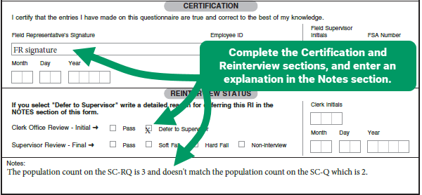
Managing Cases where the Respondent was not Contacted by the Field Representative
The clerks automatically defer to the Special Census Supervisor or Field Manager any Form SC-RQ, Special Census Reinterview Questionnaire where the respondent answered that he or she was not contacted by a Field Representative (answered No or Don’t Know for Question 2). These SC-RQ, Special Census Reinterview Questionnaire(s), must have Form SC-Q, Special Census Questionnaire completed for the housing unit.
In this situation the Special Census Supervisor or Field Manager determines if a questionnaire was already completed for the housing unit. Sometimes respondents forget Census Bureau staff contacted them.
If Form SC-Q, Special Census Questionnaire was previously completed for this housing unit, clerks compare both Forms SC-Q, Special Census Questionnaire, completed by the Field Representative with the one completed by the QC clerk or Reinterview Field Representative to determine if the information matches between both questionnaires.
If Form SC-Q, Special Census Questionnaire, completed by the production FR and Form SC-Q, Special Census Questionnaire, completed by the QC clerk or RI FR match, the clerk:
- Passes the SC-RQ, Special Census Reinterview Questionnaire, by marking X in the Clerk Office Review – Initial Pass box in the Reinterview Status section.
- Prints the appropriate HU Full RI label and affixes to the SC-Q, Special Census Questionnaire, completed during RI
- Checks in Form SC-Q, Special Census Questionnaire, completed by the QC clerk or RI FR. DO NOT mark the REP box on Form SC-Q, Special Census Questionnaire, completed by the QC clerk or RI FR.
- Place Form SC-Q, Special Census Questionnaire, completed by the QC clerk or RI FR in the appropriate storage bin.
- Return Form SC-Q, Special Census Questionnaire, completed by the production FR to the appropriate storage bin box.
- Check in Form SC-RQ, Special Census Reinterview Questionnaire, and enter the RI Final Outcome in MOJO.
- Place Form SC-RQ, Special Census Reinterview Questionnaire, in the appropriate storage bin box.
If Form SC-Q, Special Census Questionnaire, completed by the QC clerk or Reinterview Field Representative does not match Form SC-Q, Special Census Questionnaire completed by the Field Representative, the Special Census Supervisor or Field Manager determines which version of the SC-Q, Special Census Questionnaire to accept. Refer to Form SC-1131, Office Checklist for Reviewing Materials and Section 6 – Reinterview Office Matching, for detailed procedures.
The Special Census Supervisor or Field Manager determines if this is a case of falsification or intentionally not following procedures by the Field Supervisor or Field Representative. The Special Census Supervisor or Field Manager researches the reasons why these questionnaires do not match and takes appropriate action.

Update MOJO with the Reinterview Status
After check-in, Office Review, and Matching Review are complete, clerks enter the final Reinterview Status upon check in to MOJO.
Refer to the SC-445, User Guide for the MOJO, for the steps to enter the Reinterview Status from Form SC-RQ, Special Census Reinterview Questionnaires, into MOJO.
After entering the Reinterview Status, place Form SC-RQ, Special Census Reinterview Questionnaire in the appropriate storage bin for the FSA. Place any original Form SC-Q, Special Census Questionnaire(s), back in the appropriate storage bins.

Additional Questionnaire Reviews
The Special Census Supervisor or Field Manager can send additional work to the field to be reviewed. For example, the Special Census Supervisor can send to supplemental reinterview cases with a population of 1 if the volume seems too high for the AA. The Special Census Supervisor or Field Manager monitors and reviews the SC-341, HU Status by AA report to determine if additional Form SC-Q, Special Census Questionnaires need to be sent to supplemental reinterview.

Reviewing the SC-341, HU Status by AA Report
The SC-341, HU Status by AA report must be reviewed daily. This report shows the status of Form SC-Q, Special Census Questionnaires checked in to MOJO. A complete explanation of each column of the report is included in Chapter 17.
The Special Census Supervisor or Field Manager uses this report to put Form SC-Q, Special Census Questionnaires, into supplemental reinterview if anything appears out of the ordinary, such as a high percentage or POP 1.

Sending Other Questionnaires for Supplemental Reinterview
The Special Census Supervisor or Field Manager may consider sending to supplemental reinterview other Form SC-Q, Special Census Questionnaires, completed by the Field Representative that may need more information to determine a final reinterview status. For example, multiple soft fails could be an indication that a Field Representative could be falsifying information or intentionally not following procedures. In this instance, consider selecting some questionnaires for supplemental reinterview to determine a final reinterview status for the FR.

Using Management Reports

Management Reports

Overview
Field operations in the Special Census (SC) are short in duration and fast paced. It is extremely important to anticipate problems and resolve issues that may occur in the field as soon as possible. The SC management reports will help the Special Census Supervisor (SCS) detect issues and take appropriate action to resolve these issues. This chapter will explain in detail the management reports used during the SC operation.

Using Management Reports
No Title 13 or PII is shown in the sample reports in this document.
Several reports and tables are generated through MOJO to help manage SC field operations. The SCS must review the reports daily to monitor the timeliness of the operation, productivity, quality, and cost.
The SCS must assess field operations on the facts shown on management reports and not on verbal reports from Field Supervisors (FSs) or Field Representatives (FRs).

Available Reports
This section lists the production and reinterview (RI) reports and tables available in MOJO to monitor field operations.

Production Reports/Tables
Employee Functions
- SC-1019 Employee Listing by SCID and FSA
Assignment Directory
- SC-336 HU Assignment Directory
- SC-325 GQ Assignment Directory
- SC-326 TL Assignment Directory
Observations
- SC-958 Observation Summary
- SC-994 Observations Outstanding
Track Registers
- SC-342A AAs Not Checked In
Track Questionnaires
- SC-342C HU Questionnaires Not Checked In
Track GQs/TLs
- SC-342B GQs/TLs Not Checked In
Ship to NPC
- SC-972 Box Contents
Print or View Reports/Tables
- SC-301 Checked In HU Questionnaires
- SC-302 AA Completion Status
- SC-328B Count Comparison by Block
- SC-331 GQ Progress
- SC-333A HU Progress by AA
- SC-332 TL Progress
- SC-341 HU Status by AA
- SC-300 Self-Response/Dangerous Address Report

Reinterview Reports/Tables
Employee Functions
- SC-1019(RI) Employee Listing by SCID
Track Questionnaires
- SC-342C(RI) Reinterview Questionnaires Not Checked In
Print or View Reports
- SC-342S(RI) Reinterview Status
- SC-345(RI) Reinterview Questionnaire List
- SC-343 GQ RI Report
- SC-344 GQ RI Status Report

Production Reports/Tables

SC-1019, Employee Listing
The SC-1019, Employee Listing, provides useful employee information. This report shows the employees by name, title, and spoken languages. This report also includes the employee’s address and contact phone numbers.

Report Contents
The SC-1019, Employee Listing, contains the following information:
- Employee ID
- FSA (the FSA to which the employee is assigned)
- Employee Name (Last Name, First Name, Middle Initial)
- Employee Type
- FR
- FS
- Language(s) (display all languages the employee speaks)
- Address (Address Number, Street Name)
- Phone Number(s)

Report Uses
This report is useful to identify staff with special language skills that the SCO can use to complete a questionnaire in a specific language. It can also be used to locate or communicate with field staff as necessary.

SC-336 HU Assignment Directory
The SC-336, HU Assignment Directory, shows housing unit assignment information for each AA by FSA. It is used to keep track of which FS or FR currently is assigned the case.

Report Contents
The SC-336, HU Assignment Directory, contains the following information:
- SCO
- Date Assigned (date the AA was assigned)
- AA (6-digit AA number)
- Employee Name (Last Name, First Name, Middle Initial)
- Employee ID
- HUs (number of housing units expected in the AA)
- State (2-digit state code/2-character state abbreviation)
- County (3 county code/county name)
- FS

Report Uses
This report is useful to keep track of which FS or FR currently is assigned the case. Once the FS decides what FR to assign the case to, the FS will cross out their name and put in the FR name. The directory goes back to SCO for clerk to update MOJO with FR name.

SC-325 GQ Assignment Directory
The SC-325, GQ Assignment Directory, shows what FS or FR is assigned the GQ. It shows the GQ assignment information for each AA.

Report Contents
The SC-325, GQ Assignment Directory, contains the following information:
- SCO
- Date Assigned (date the AA was assigned)
- AA (6-digit AA number)
- Case ID
- GQ Name
- GQ Address
- Employee Name (Last Name, First Name, Middle Initial)
- Employee ID
- GQs (number of GQs expected in the AA)
- State (2-digit state code/ 2-character state abbreviation)
- County (3 county code/ county name)
- FS

Report Uses
This report is useful to keep track of which FS or FR currently is assigned the GQ case.

SC-326 TL Assignment Directory
The SC-326, TL Assignment Directory, shows what FS or FR is assigned the TL. It shows the TL assignment information for each AA.

Report Contents
The SC-325, TL Assignment Directory, contains the following information:
- SCO
- Date Assigned (date the AA was assigned)
- AA (6-digit AA number)
- Case ID
- TL Name
- TL Address
- Employee Name (Last Name, First Name, Middle Initial)
- Employee ID
- TLs (number of TLs expected in the block)
- State (2-digit state code/ 2-character state abbreviation)
- County (3 county code/ county name)
- FS

Report Uses
This report is useful to keep track of which FS or FR currently is assigned the TL case.

SC-958 Observation Summary
The SC-958, Observation Summary, shows all active employees that have observation data entered in MOJO.

Report Contents
The SC-958, Observation Summary, contains the following information:
- SCID
- FSA
- Employee Name (Last Name, First Name)
- Employee ID
- Case types (lists the various types of cases such as HU,GQ)
- Observation Status (header)
- Observation (contains the following):
- First Observation Date
- First Observation Recommendation (continue assigning work, additional observation, consult manager)
- First Observation observer Employee ID
- Additional Observation Date
- Additional Observation Recommendation (continue assigning work, additional observation, consult manager)
- Additional Observation observer Employee ID

Report Uses
This report is useful to keep track of which employee has had an observation and the status of the observation.

SC-994 Observations Outstanding
The SC-994, Observations Outstanding, shows active employees who have no record of having an observation entered into MOJO OR have had a first observation keyed but required a second observation that has not yet been keyed.

Report Contents
The SC-994, Observations Outstanding, contains the following information:
- SCID
- FSA
- Employee Name (Last Name, First Name)
- Employee ID
- Case types (lists the various types of cases such as HU,GQ)
- Observation Report Uses
This report is useful to keep track of which employees have no record of a first observation or if needed, a second observation.

SC-342A, AAs Not Checked In
Generate the SC-342A, AAs Not Checked In, daily to determine which address registers have not been checked into MOJO.

Report Contents
The report contains the following fields of information:
- AA
- Employee (last name, first name, middle initial, Employee ID)
- Date Assigned (date the AA was assigned)

Report Uses
This report can be used at the end of operations to determine staff with AAs that have not been checked-in to MOJO. It can also be used in combination with the SC-301 and/or SC-333A, HU Progress by AA, to determine FRs that might be having difficulties completing an AA. Refer to the SC-302, AA Completion Status, and SC-333A, HU Progress by AA, Report Uses sections to manage FRs not meeting completion schedules.

SC-342C, HU Questionnaires Not Checked In
Generate the SC-342C, Questionnaires Not Checked In, daily to monitor HU progress at the AA level by tracking questionnaires that have not been checked into the SCO.

Report Contents
The SC-342C, HU Questionnaires Not Checked In, contains the following information:
- AA
- Case ID (case ID from the address list page in the register)
- Block (block number associated with the AA and housing unit)
- Address List Page Line Number
- Employee (last name, first name, middle initial, Employee ID)
- Date Assigned (date the AA was assigned)

Report Uses
The SC-342C, HU Questionnaires Not Checked In, can be used in combination with the SC-342A, AAs Not Checked In, to identify questionnaires that are in the field. Use this report to monitor the questionnaires checked into MOJO.

SC-342B, GQ/TL Questionnaires Not Checked In
Generate the SC-342B, GQ/TL Questionnaires Not Checked In, daily to monitor GQ and TL progress at the AA level by tracking questionnaires that have not been checked into the SCO.

Report Contents
The SC-342B, GQ/TL Questionnaires Not Checked In, contains the following information:
- AA
- Case ID
- Block (block number associated with the AA and GQ/TL)
- Address List Page Line Number
- Employee (last name, first name, middle initial, Employee ID)
- Date Assigned (date the AA was assigned)
- GQ/TL case was an add

Report Uses
The SC-342B, GQ/TL Questionnaires Not Checked In, can be used in combination with the SC-342A, AAs Not Checked In, to identify questionnaires that are in the field. Use this report to monitor the questionnaires checked into MOJO.

SC-972 Box Contents
The SC-972, Box Contents, is a PDF that is generated from the “All Packing Lists” button from the Box List screen. The PDF of the Box Contents Report contains a list of materials that shows each barcode ID that has been checked in and scanned into a box along with the form type of each document.

Report Contents
The SC-972, Box Contents, contains the following information:
- SCID
- Box ID (refers to the number of boxes created)
- Box Tracking Number
- Total Number of Forms Count
- Barcode for each form
- Form type field

Report Uses
The SC-972, Box Contents, is printed and included in the box when shipping materials back to NPC.

SC-301 Checked In HU Questionnaires
The SC-301, Checked In HU Questionnaires, shows each questionnaire checked in from the selected geography.

Report Contents
The SC-301, Checked In HU Questionnaires, contains the following information:
- AA
- Case ID
- Employee name
- Housing Unit Population = 1
- Housing Unit Population = 99
- Housing Unit Population = 00 (Vacant)
- Status of Delete (Outcomes of Unable to Locate, Nonresidential, Duplicate, Demolished, Uninhabitable, Empty Mobile Home Site)
- Interview outcome code Close Out
- Interview outcome code Replacement
- Interview outcome code Refusal

Report Uses
The SC-301, Checked In HU Questionnaires, [content pending at time of publication].

SC-302, AA Completion Status
The SC-302, AA Completion Status, is designed to show the completion status of Assignment Areas (AA). The report shows the initial workload and the number of questionnaires checked in.

Report Contents
The SC-302, AA Completion Status, contains the following information:
- AA
- Initial workload (count of known addresses)
- Number of lines used on Form SC-921, Add Page
- Initial Workload Checked In (count of initial addresses that have been checked in)
- Total Adds
- Adds Checked In (count of questionnaires checked in from added addresses checked in for the AA)
- % Checked In (initial workload checked in plus actual adds checked in divided by the sum of the initial workload + total adds times 100)

Report Uses
This report shows the status of work checked in to the SCO. The SCS can quickly determine the completion status of AAs in the field.
Depending on Regional Office guidance on completed progress goals, a good rule to follow to determine if operations are on track to finish on time is to divide the schedule of operations into four portions.
For example, if a SC is scheduled to take four weeks to complete, the completion targets should be as follow:
- 25% or more work needs to be completed by the end of the first week,
- 50% or more work needs to be completed by the end of the second week,
- 75% or more work needs to be completed by the end of the third week, and
- 100% needs to be completed on or before the end of the fourth week.
The SCS can compare the completion targets against the work checked-in percentage column to determine if the field worked is being completed on time.

SC-328B Count Comparison by Block
SC-328B Count Comparison by Block is used to identify where housing unit and population counts for SC are 10% above/below the 2020 housing unit and pop counts and determine why they are different.

Report Contents
The SC-328B, Count Comparison by Block, contains the following information:
- AA
- Tract
- Block
- 2020 Population (coming from the input file)
- 2020 Housing Units (coming from the input file)
- SC Population (sum of total pop count from each SC-Q, item C)
- SC Housing Units (sum of total HUs in the block plus any adds)
- % change POP (from 2020)
- % change HU (from 2020)
- a column that puts an indicator for blocks above the threshold
- a column that puts an indicator for a split block
- # Adds (# of HUs added/keyed into MOJO, does not include added HUs that have since been deleted)
- # Deletes (# of HUs with the status of delete, status of delete includes outcome of: Unable to locate, nonresidential, group quarters, delete, duplicate, demolished, uninhabitable, empty mobile home site, out of scope)
- Remarks (column header only for user to write in column)
The SC-328B report will be require some work by the office if there are any suffix blocks in the SC geography. If the 2020 population was one complete block and the Special Census split the block, comparisons need to be made. The report will show split blocks, as evidenced by the 2.1 and 2.2 block rows below in Table 1 to adjust for that possibility. The block 2 row is if the block wasn’t split. The total 2020 population and HU counts will appear in both split block rows therefore the % change will likely be over the threshold. The RO will need to add up the split block rows to get a total to see if the % change is over the threshold.

Table 1. Example of the SC-328B Count Comparison by Block report.
AA | Tract | Block | 2020 Pop Count | 2020 HU Count | SC Pop Count | SC HU Count | % Change Pop | Pop Threshold | % Change HUs | HU Threshold | # of Adds | # of Deletes | Remarks
1 | 1 | 1 | 10 | 5 | 8 | 6 | 20.00% | X | -20.00% | X | 1 | 0
1 | 1 | 2.1 | 100 | 20 | 75 | 15 | 25% | X | 25% | X | 0 | 0 | Split block
1 | 1 | 2.2 | 100 | 20 | 25 | 5 | 75% | X | 75% | X | 0 | 0 | Split block
1 | 1 | 2 | 100 | 20 | 100 | 20 | 0.00% |  | 0.00% |  | 0 | 0 | Merging split SC blocks to compare to 2020 block

SC-331 GQ Progress by AA
The SC-331, GQ Progress by AA, shows progress of the GQ enumeration. It should be generated daily at the FSA level

Report Contents
The SC-331, GQ Progress by AA, contains the following information:
- AA
- Initial GQ workload
- GQ Cases Complete (Number of GQ cases complete from the initial workload only)
- GQ Cases Remaining (Number of GQ cases remaining from the initial workload only)
- % Initial Workload Complete
- Added GQ Workload
- Number of GQ Adds Complete
- Number of GQ Adds Remaining
- % of GQ Adds Workload Complete

Report Uses
This report shows the progress of each GQ, including statuses of response acquired, noninterview and delete.

SC-333A, HU Progress by AA
The SC-333A, HU Progress by AAAA, is generated daily at the FSA level. This report shows progress for the HU enumeration.

Report Contents
The SC-333A, HU Progress Report by AA, contains the following information:
- AA
- Initial workload - Number of housing units (HUs) in the initial workload for the AA, not including any adds.
- Cases Complete (Number of cases complete from the initial workload only)
- Cases Remaining (Number of cases remaining from the initial workload only)
- % Initial Workload Complete - Percentage of the initial workload cases done
- Adds (The number of added housing units checked in for the AA. Erroneous adds are removed from the count)
- Employee Name/ID/Cases Complete/Add – employee is the person who the AA is assigned to

Report Uses
This report is used in combination with the SC-302, AA Completion Status, to identify FRs that may be falling behind in completing work or may need additional work.
The SCS compares the progress goals against the percent of initial work complete. If the percent of initial work complete indicates progress goals are not being met, the SCS discusses with to the FS to determine the reason the reason(s) why progress goals are not being met.
The SCS may consider administrative action such as providing counseling to the FR to meet progress goals.
When Cases Remaining column shows zero, this indicates that all initial cases within the AA are complete. In this case, the FS assigns additional work to the FR if there are still outstanding AAs to complete.

SC-332 TL Progress by AA
The SC-332, TL Progress by AA, shows progress of the TL enumeration. It should be generated daily at the FSA level

Report Contents
The SC-332, TL Progress by AA, contains the following information:
- AA
- Initial TL workload
- TL Cases Complete (Number of TL cases complete from the initial workload only)
- TL Cases Remaining (Number of TL cases remaining from the initial workload only)
- % Initial Workload Complete
- Added TL Workload
- Number of TL Adds Complete
- Number of TL Adds Remaining
- % of TL Adds Workload Complete

Report Uses
This report shows the progress of each TL, including statuses of response acquired, noninterview and delete.

SC-341, HU Status by AA
The SC-341, HU Status by AA, is generated daily to monitor housing unit completion progress at the AA level.

Report Contents
The SC-341, HU Status by AA, contains the following information:
- AA (the 6-digit AA number)
- Initial Workload (number of initial housing units in the workload; does not include added housing units)
- # Adds (number of added housing units for the AA)
- Initial Housing Units Checked In (number of initial housing units checked in for the AA; does not include added housing units)
- Total Housing Units Checked In (sum of the initial housing units checked in plus the added housing units checked in)
- All HUs in Assignment Area Complete (shows when the initial housing units plus all added housing units have been checked in)
- Place X in this column when the address register has been checked in from Production
- Housing Unit Population = 1 (number of questionnaires checked in for the AA with a POP count of 1)
- % Housing Unit Population – 1 (number of questionnaires checked in for the AA with a POP count of 1 expressed as a % of the total questionnaires checked in for the AA)
- Vacant (number of questionnaires checked in for the AA with a POP count of 00)
- % Vacant (number of questionnaires checked in for the AA with a POP count of 00 expressed as a % of the total questionnaires checked in for the AA)
- Delete (number of questionnaires checked in for the AA with a Status of Delete)
- % Delete (number of questionnaires checked in for the AA with a Status of Delete expressed as a % of the total questionnaires checked in for the AA)
- Close Out (number of questionnaires checked in for the AA with an Outcome of Closeout, refers to item E box CO for instances when the questionnaire couldn’t be completed)
- % Close Out (number of questionnaires checked in for the AA with an Outcome of Closeout expressed as a % of the total questionnaire checked in for the AA)
- Replacement (number of questionnaires checked in for the AA with an Interview Outcome of REP)
- % Replacement (number of questionnaires checked in for the AA with an Interview Outcome of REP expressed as a % of the total questionnaire checked in for the AA)

Report Uses
This is an all-inclusive report that summarizes information about HU progress and check-in results. The following are suggested columns to review during operations:
- Housing Unit Population = 1 – Review this column regularly to determine if there are many questionnaires checked in as having a population of 1.
Past Census Bureau experience shows that many questionnaires with POP 1 might indicate that a field staff may be not following procedures.

SC-957, Added and Deleted Addresses and Erroneous Adds
This is a screen in MOJO, rather than a report. The screen will show the questionnaires checked in for added housing units and for housing units that were deleted from the address list. The screen will also display a list of all housing units added to the address list that were subsequently deleted. These units are known as Erroneous Adds.

Screen Uses
The screen is designed to help the Special Census Supervisor reconcile Added and Deleted addresses. It is particularly helpful for verifying changes when a housing unit is coded in the wrong block.
It is expected that erroneous adds do not occur often or at all in the SC. Housing unit appearing on this screen can be an indication that an FR is not following procedures. If housing units appear, ask the FS to provide immediate feedback to the FR, especially if the FR appears multiple times, to ensure he or she knows the proper procedure to add housing unit to the address list.

SC-300 Self-Response Received and Dangerous Address Report
The SC-300, Self-Response Received and Dangerous Address Report, shows every address that self-responded, is a dangerous address or a cease interview, along with geographic information.

Report Contents
The SC-300, Self-Response Received and Dangerous Address Report, contains the following information:
- AA
- Tract
- Block
- Case ID
- Line Number
- Address
- Address#||space||Street Name
- Unit Designation
- Place(City)||, space||State Abbrev||space||ZIP Code
- Location Desc (if Address# or Street Name blank)
- a reason column to indicate self-response / Cease Interview / Proceed with Caution

Report Uses
The office clerks use this report to indicate on the address list page that self-responding and cease interview cases must not be interviewed and proceed with caution cases are marked accordingly.

Reinterview Reports

SC-1019(RI), Employee Listing By SCID
The SC-1019(RI), Employee Listing By SCID, provides useful employee information. It is the same as production the version, but only showing RI employees. This report lists each employee and provides their employee ID, FSA code, employee type, language(s) spoken, address, and telephone number(s). This report also includes the employee’s address and contact phone numbers.

Report Contents
The SC-1019(RI), Employee Listing, contains the following information:
- Employee ID
- FSA (the FSA to which the employee is assigned)
- Employee Name (Last Name, First Name, Middle Initial)
- Employee Type
- Clerks
- RI FR
- FS
- Language(s) (display all languages the employee speaks
- Address (Address Number, Street Name)
- Phone Number(s) (allow up to 4 phone numbers)

Report Uses
This report is useful to identify staff with special language skills that the SCO can use to complete a RI questionnaire in a specific language. It can also be used to locate contact information for field staff as necessary.

SC-342C, RI Questionnaires Not Checked In
The SC-342C(RI), RI Questionnaires Not Checked In, is the reinterview version of the SC-342C, HU Questionnaires Not Checked In. Generate the SC-342C(RI), RI Questionnaires Not Checked In, daily to monitor reinterview progress at the AA level by tracking reinterview questionnaires that have not been checked into the SCO.

Report Contents
The SC-342C(RI), RI Questionnaires Not Checked In, contains the following information:
- AA
- Case ID (case ID from the address list page in the register)
- Block (block number associated with the AA and housing unit)

Report Uses
Use this report to identify questionnaires that are in the field. It is important that the RI questionnaires are completed as soon as possible so the matching case in the SCO can be worked. Monitor this report daily to identify questionnaires that are taking more than three days to complete.

SC-342S(RI), Reinterview Status
This SC-342S(RI), Reinterview Status, shows the status of reinterview field operations and the final RI status for the production FR.

Report Contents
The SC-342S(RI), Reinterview Status, contains the following information:
- Production Employee (Last Name, First Name, Middle Initial of the production employee)
- Total Prod (number of questionnaires completed by the FR; this is the number of questionnaires checked in from the field )
- Total RI (number of questionnaires in RI; includes randomly selected RI questionnaires, mandatory selected questionnaires, supplemental questionnaires, and/or hard fail supplemental questionnaires)
- % Prod in RI (number of questionnaires in RI presented as a percent of the total number of questionnaires in production)
- Rand (number of randomly selected questionnaires for RI)
- Supp (number of questionnaires selected for supplemental RI)
- Mandatory (number of questionnaires selected for mandatory RI)
- Hard Fail (number of questionnaires sent to RI for each FR that falsified data on a questionnaire or intentionally did not follow procedures)
- Checked In without a RI status (number of RI questionnaires checked in to MOJO without a RI status entered)
- Checked In with a RI status (number of RI questionnaires checked in to MOJO with a RI status entered)
- Pass (number of questionnaires for the Production FR that passes the office matching review)
- % Pass (number of questionnaires for the Production FR that passed the office matching review represented as a percent of the total RI questionnaires checked in)
- Soft Fail (number of questionnaires the Production FR was assigned a soft fail because of the office matching)
- % Soft Fail (number of questionnaires the Production FR was assigned a soft fail because of the office matching represented as a percent of the total RI questionnaires checked in.
- Hard Fail (number of questionnaires the Production FR was assigned a hard fail because of the office matching review)
- % Hard Fail (number of questionnaires the Production FR was assigned a hard fail because of the office matching review represented as a percent of the total RI questionnaires checked in)
- Non interview (number of questionnaires the Production FR was assigned a Non interview because of the office matching review)
- % Non-interview (number of questionnaires the Production FR was assigned a Non interview because of the office matching review represented as a percent of the total RI questionnaires checked in)

Report Uses
This report summarizes information about reinterview progress, check-in results, and office matching review outcomes. The following are suggested columns to review during operations:
% Prod in RI – The percentage shown in this column will be around 5%, if only random cases are selected for a Field Representative. Cases selected for supplemental reinterview (regular and hard fail) will increase the percentage shown in this column.
The Special Census Supervisor should make sure that he or she is selecting supplemental reinterviews only when necessary. Adding additional cases to reinterview will have an impact in the cost of the operation.
Ckd In – These columns show the number of reinterviews checked-in to MOJO either with or without a RI status entered. The Special Census Supervisor should ensure this number is close or equal to the number shown in the Total RI column.
Soft Fail – Monitor this column for each Field Representative. Field Representatives that have multiple soft fails for the same error can be an indication of intentionally not following procedures and be grounds for coding a case for this Field Representative as a hard fail. There are some suggested actions the Special Census Supervisor can take if a Field Representative has multiple soft fails:
Investigate the reasons for the soft fails. If the soft fails are for different errors, make sure the Field Supervisor is providing feedback to this Field Representative, so the Field Representative does not repeat the errors again.
Consider sending to supplemental reinterview other questionnaires with the same results as one that was coded as soft fail to verify this Field Representative is following procedures. If there is a pattern that the Field Representative is committing the same errors, this might be an indication of intentionally not following procedures. Talk to the Field Supervisor and make sure he or she provided feedback to the Field Representative to correct the errors. If the Special Census Supervisor has supporting information that this Field Representative is intentionally not following procedures, consider hard failing the Field Representative.
Hard Fail – If there is a case hard failed for the Field Representative, make sure all other completed work for this Field Representative is sent out to supplemental hard fail reinterview.
Non-Interview – It is expected that the majority of reinterviews are completed either in the office or in the field. The Field Supervisor is the only person allowed to assign a non-interview outcome for reinterviews that could not be completed in the field. This number should be as close to zero as possible. The Special Census Supervisor should talk to the QC Field Representative conducting the reinterviews to ensure he or she is doing everything possible to complete the reinterviews in the field.

SC- 345(RI), Reinterview Questionnaire List
This SC-345 (RI), Reinterview Questionnaire List, shows the names of Field Representatives selected for reinterview and the office matching review outcome (final RI status) for the reinterview case.

Report Contents
The SC-425(RI), Reinterview Questionnaire List, contains the following information:
- case ID (case ID associated with the production and RI questionnaire. It will be the same number for both.)
- RI Employee (Last Name, First Name, Middle initial of the clerk/FR who was assigned the case for RI)
- RI Type (type of RI: random, supplemental, mandatory, hard fail supplemental)
- Selection Date/Time (date/time when production questionnaire was selected for RI)
- Date RI was assigned to RI employee
- Date when RI questionnaire with Checked In with a RI status completed

Report Uses
The Special Census Supervisor should monitor the Selection Date/Time column, to check that reinterview cases are being assigned to staff. This column can also be used to check if cases are taking too long to complete based on when the case was assigned.

SC-343 GQ Reinterview Report
The SC-343, GQ Reinterview Report, shows the final RI status for the GQ case at the GQ level.

Report Contents
The SC-343, GQ Reinterview Report, contains the following information:
- Case ID (Case ID associated with the GQ)
- RI Employee (Last Name, First Name, Middle initial of the clerk who was assigned the case for RI)
- GQ Employee (Last Name, First Name, Middle initial of the FR who completed the GQ)
- RI Result (pass, soft fail, hard fail, non-interview)

Report Uses
This report summarizes information about the GQ reinterview progress and the result of the reinterview.

SC-344 GQ RI Status
The SC-344, GQ RI Status, shows the final RI status for the GQ case for the GQ Field Representative.

Report Contents
The SC-344, GQ RI Status, contains the following information:
- GQ Employee (Last Name, First Name, Middle initial of the FR who completed the GQ)
- Total GQ Prod (to make consistent with the HU version)
- GQ workload eligible for RI
- Pass (number of GQs for the GQ FR that passed reinterview)
- % Pass (number of GQs for the GQ FR that passed reinterview represented as a percent of the total GQ workload eligible for RI)
- Soft Fail (number of GQs for the GQ FR that soft failed reinterview)
- % soft fail (number of GQs for the GQ FR that soft failed reinterview represented as a percent of the total GQ workload eligible for RI)
- Hard Fail (number of GQs for the GQ FR that hard failed reinterview)
- % hard fail (number of GQs for the GQ FR that hard failed reinterview represented as a percent of the total GQ workload eligible for RI)
- Non interview (number of GQs for the GQ FR that were non-interview reinterview)
- % non-interview (number of GQs for the GQ FR that were non-interview reinterview represented as a percent of the total GQ workload eligible for RI)

Report Uses
This report summarizes information about the GQ reinterview progress for the GQ Field Representative.

Table Functionality

Filtering Tables
There are three methods to search by attributes in most tables.
- Filters above the table for specific data attributes. These filters may allow the user to select one or more value for that attribute. The selections you make filter the results table appropriately.
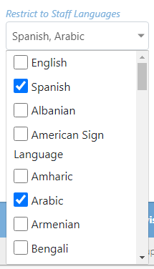
- Many tables include search boxes about the table for specific data attributes. These allow the user to search on a string value for that attribute and will filter the results table appropriately.
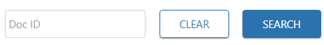
- Most columns in the tables are filterable by text. The user can simply type a character string in the column filter box (under the column name) and that column will be filtered by that character value.
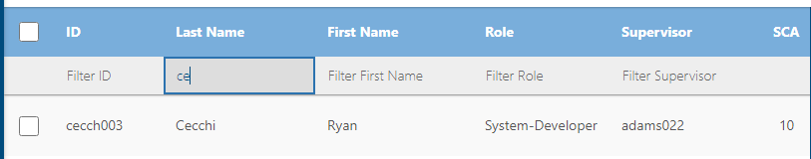

Sorting Tables
The tables can also be sorted by a single column by clicking the column name. The user can sort by ascending or descending order and the column name box will indicate which sort is currently being applied by an arrow.
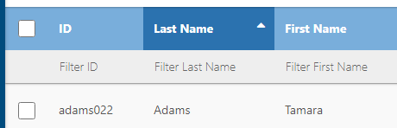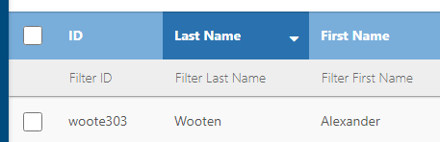

Map-View
Many of the tables also have a map component. Depending on which screen the user is on, the map may plot staff, cases, and/or geographic boundaries. The user can view either the table of results, map of results, or both at the same time.
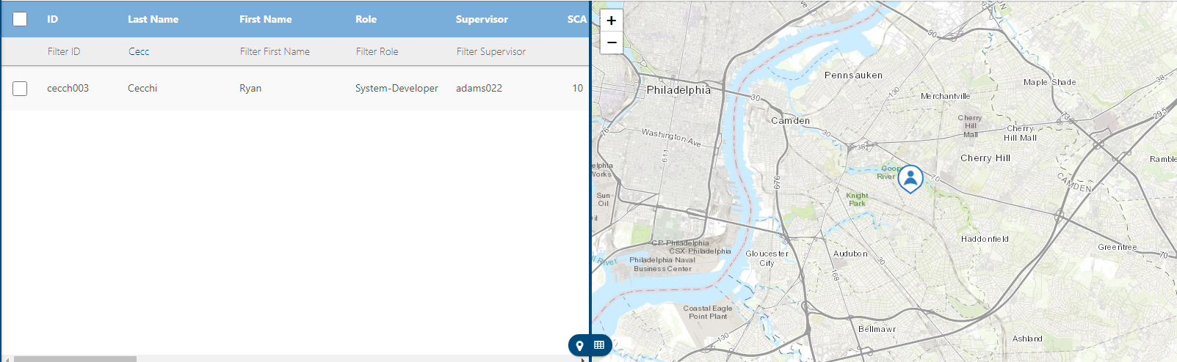
- To view only the table of results, select the table icon on the slider bar 
- To view only the map of results, select the map icon on the slider bar 

Exporting Tables
For added flexibility, tables can be downloaded as a .csv file. To download/export a table:
- Click Download on the table.
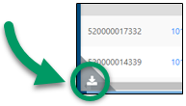
- The file downloads to the browser’s Downloads folder.
- The file should open automatically in whatever program is set as the default .csv file reader. Microsoft Excel is the suggested program to view the exported files.

This page intentionally left blank

Closing Out the Special Census

Activities Prior to Closing the Special Census Office

Overview
After the Special Census Office (SCO) has completed all field work, including quality assurance (QA) activities, and checked in all the questionnaires, the Special Census Supervisor (SCS) can start the activities for closing the operation and the SCO. These activities include:
- Ensuring all enumeration materials are collected from field staff, such as badges, bags, manuals, etc.
- Resolving missing cases and ensuring that all cases are checked in to MOJO

Collecting Field Enumeration Materials from Field Staff
Field Supervisors (FSs) collect the following materials from their Field Representatives (FRs) and return them to the SCO at the end of the FRs job with the Special Census (SC).
- Census Carrying bags
- Unused forms such as blank Special Census Questionnaires (SC-Qs), unused INFO – COMMs, etc.
- Office supplies such as pens, pencils, etc., if available
- Census Bureau-issued ID badges from every FR
- Enumeration reference materials such as manuals, job aids, etc.
The SCS collects from the FSs their enumeration materials, supplies, and their Census Bureau-issues ID badges. It is important to collect from the FSs Form SC-20, Field Supervisor’s Management Record, as this contains Personally Identifiable Information (PII) information.

Resolving Missing Cases
Ensure that all cases are checked in to MOJO. The SCS monitors that status of work by referring to various reports and tables to determine if there are any:
- Assignment Areas (AAs) Not Checked In (SC-342A)
- Housing Unit (HU) Questionnaires Not Checked In (SC-342C)
- Reinterview (RI) Cases Not Checked In (SC-342C(RI))
- Group Quarters (GQ) and Transitory Location (TL) Questionnaires Not Checked In (SC-342B)
These table should show that all items listed above are checked in at the end of the SC. The SCS needs to resolve any cases still in the field that may be showing as not checked in at the end of the operation. If the report or table shows a case that has not been checked in, the SCS follows up with the FR or FS that was assigned this case to check on the status of the case. In some cases, resolving a missing case may include sending the assignment out to the field and completing the assignment again.
If the SCS determines the case is lost that contains Title 13 or PII information, he or she must report the incident to the Census Service Center, within one hour, at 1-877-343-2010, then select option #1 for Cyber Security, Physical Security, and PII Breach Incident Reporting. The SCS must also call the Regional Office (RO) for further guidance. Provide the police report number if the materials were stolen. Obtain a case number from the Census Service Center operator.

Statement of Expenditures for the Governmental Unit
The Statement of Expenditures, for the governmental unit, is a summary of all expenditures that are charged against the government unit’s account.

Final Census Results
Do not make a commitment regarding a date for the release of the final census results. Headquarters staff prepares the final counts letter for the U.S. Census Bureau Director to sign after all data is collected and processed. A sample of this letter is in Appendix E.

Packing and Shipping Materials to NPC and the RO

Overview
The Regional Office (RO) informs the SCS when to ship materials out of the SCO. The RO provides guidance as to which shipping company to use and the delivery terms for shipment.
All Census Bureau materials are shipped out of the SCO. The SCS will:
Determine material disposition (communicated via a memo) See Appendix G for an example of the memo.
Ship materials to the RO or National Processing Center (NPC) based on the materials dispositions.

Materials Dispositions
All materials used for the SC need to be boxed and shipped to either the NPC or RO. The SCS uses the memo as a guide as to where materials need to be shipped. See Appendix G for an example of the memo.

Materials that Need to be Shipped to NPC
The SCO ships to NPC all completed enumeration materials. These include the following scanned items:
- Address registers, including the map envelope with the maps
- SC-Q, Special Census Questionnaire, with their corresponding SC-CQ, Special Census Continuation Questionnaire, if applicable
- SC-RQ, Special Census Reinterview Questionnaire
- SC-116, Special Census Group Quarters Control RecordSC-Q-GE, Special Census Individual Census Questionnaire (used for GQ)
- SC-Q-TL, Special Census Transitory Units Questionnaire, with their corresponding SC-CQ-TL, Special Census Transitory Units Continuation Questionnaire, if applicable
This item, while not scanned from MOJO, does get sent to NPC in the same box.
- SC-1222, Special Census Observation Checklist
- SC-116(CP), Special Census Group Quarters Control Record Continuation Page
        - The SCO will put the SC-1222 checklists and the SC-116(CP) pages into an envelope.
        - The office will mark the outside of the envelope indicating that observation forms and continuation pages are inside.
        - The envelope is then put into the same box as the barcoded forms and shipped to NPC.
Do not include office supplies in the boxes of Address Registers and questionnaires being sent to NPC.

Materials that Need to be Shipped to the RO
The SCO ships to the RO all other materials used in the SC such as:
- Unused reference materials such as manuals, training guides, job aids, etc. These are recycled for other SCs in the area the RO covers
- Unused enumeration materials such as blank questionnaires, INFO-COMMs, Notice of Visit pads, etc.
- Office supplies such as pens, pencils, pencil sharpeners, etc.
The SCO needs to also send back to the RO all forms or materials that contain Title 13 and or PII information. This includes:
- Employee folders
- The materials in the Title 13/PII locked destroy bin
- All completed SC-20, Field Supervisor Management Record
- All completed BC-27, Pay and Work Record
- Administrative forms that contain PII information
- SC-117, Special Census Transitory Location Control Record
- SC-693.2, Special Census Transitory Location Listing Sheet
Refer to the memo that will be sent at the conclusion of the operation for a comprehensive list of the items that need to be shipped and where the items need to be shipped.

Packing and Shipping Materials to the RO
Clerks will sort materials in the SCO prior to shipping the materials to the RO. The SCS also needs to ensure that Title 13 and/or PII materials are properly handled when placing the materials into the boxes for shipping to the RO.

Packing Unused Materials to the RO
Materials to be shipped to the RO need to be boxed in the same boxes that the materials came into the SCO. Make sure to save the boxes that arrive from NPC. Materials need to be sorted by type, for example, clerks will sort:
- Manuals and training guides by type such as FR materials, FS materials, etc.
- Enumeration materials by type such as unused Notice of Visit pads, unused Confidentiality Notices, etc.
- Forms by type such as unused Forms SC-Q, Special Census Questionnaires, and Form SC-CQ, Special Census Continuation Questionnaires, and unused INFO-COMMS; etc.
- Office supplies by type such as pens, pencils, erasers, pencil sharpeners, etc.
When boxing these materials be sure to keep the type of materials separate whenever possible.

Packing Title 13 or PII Materials to Send to the RO
The Title 13 and PII materials need to be packed by type. The clerks pack the administrative materials separate from the used enumeration materials.
When packing Title 13/PII materials, they must be securely double wrapped in opaque paper and taped, so the materials do not show through the wrapping.
The outer wrapping must specify that the package or envelope is for delivery only to a specific recipient, preferably an individual where possible. The outer wrapping should be opaque and NOT indicate that the package or envelope inside it contains controlled unclassified information (CUI).
The inner wrapping must be opaque, tamper-evident, and be labeled as follows:
CUI//SP-CENS
Disclosure Prohibited--Title 13 U.S.C.
To be opened by addressee only.
The CUI marking CUI//SP-CENS must be distinguishable from other information in the label.
To prevent loss when the outer wrapping/packaging is damaged, the inner wrapping also must be addressed to a specific recipient, preferably to an individual wherever possible.
The clerks also write on the outside wrap the following:
This package contains Title 13 and/or PII information. The release of which to unauthorized persons is prohibited by law.
The Title 13/PII materials that were temporarily placed in the secured destroy bin must also be double wrapped in opaque paper, taped, and sent to the RO at the end of the SC. In addition to the statement about Title 13/PII confidentiality, the clerks will write that these materials are from the secured destroy bin. A sample note could be Title 13/PII materials to be destroyed.

Shipping Materials to the RO
Once the items are packed and the boxes sealed in preparation for shipping, call the RO for instructions on shipping the materials to the RO. The RO provides guidance as to which shipping carrier to use (e.g., FEDEX, UPS), and which service to use for the shipment (two-day, ground, etc.).
The RO has contracts with shipping companies and will provide the SCS with the shipping company labels and the RO account number for the shipping company. The SCS completes the shipping labels and contact the shipping company for picking up the boxes.

Packing and Shipping Materials to NPC
The packing and shipping of enumeration materials for NPC start when all field operations are over. The materials shipped to NPC all contain Title 13 data and must be double wrapped with opaque paper and taped before placing them in the box.
When packing Title 13/PII materials, they must be securely double wrapped in opaque paper and taped, so the materials do not show through the wrapping.
The outer wrapping must specify that the package or envelope is for delivery only to a specific recipient, preferably an individual where possible. The outer wrapping should be opaque and NOT indicate that the package or envelope inside it contains controlled unclassified information (CUI).
The inner wrapping must be opaque, tamper-evident, and be labeled as follows:
CUI//SP-CENS
Disclosure Prohibited--Title 13 U.S.C.
To be opened by addressee only.
The CUI marking CUI//SP-CENS must be distinguishable from other information in the label.
To prevent loss when the outer wrapping/packaging is damaged, the inner wrapping also must be addressed to a specific recipient, preferably to an individual wherever possible.
The clerks also write on the outside wrap the following:
This package contains Title 13 and/or PII information. The release of which to unauthorized persons is prohibited by law.
All completed questionnaires must be scanned and placed in a box before any Address Registers. After all the questionnaires are scanned and placed in a box, then the clerk scans and places the address registers into a different box.

Packing SC-Q, Special Census Questionnaires
The questionnaires must be packed by AA. The clerks sort the questionnaires by AA, if not already done so. The clerks place as many whole AAs as will comfortably fit face up in the box, trying not to split AAs between boxes.
If Form SC-Q, Special Census Questionnaire, has one or more Form SC-CQ, Special Census Continuation Questionnaire, the clerk must scan the associated Form SC-CQ, Special Census Questionnaire, into the box before he or she can scan or key another questionnaire. DO NOT place continuation questionnaires inside the parent questionnaire.
In instances where a Spanish version of Form SC-Q, Special Census Questionnaire, was used, DO NOT scan the corresponding English version into a box. The corresponding English version must be sent to the RO to be destroyed.
As a reminder, the SCO ships the following to NPC:
- Address registers, including the map envelope with the maps
- SC-Q, Special Census Questionnaire, with their corresponding SC-CQ, Special Census Continuation Questionnaire, if applicable
- SC-RQ, Special Census Reinterview Questionnaire
- SC-116, Special Census Group Quarters Control Record
- SC-Q-GE, Special Census Individual Census Questionnaire (used for GQ)
- SC-Q-TL, Special Census Transitory Units Questionnaire, with their corresponding SC-CQ-TL, Special Census Transitory Units Continuation Questionnaire, if applicable
This item, while not scanned from MOJO, does get sent to NPC in the same box.
- SC-1222, Special Census Observation Checklist
- SC-116(CP), Special Census Group Quarters Control Record Continuation Page
        - The SCO will put the SC-1222 checklists and the SC-116(CP) pages into an envelope.
        - The office will mark the outside of the envelope indicating that observation forms and continuation pages are inside.
        - The envelope is then put into the same box as the barcoded forms and shipped to NPC.
The number of questionnaires added to a box must equal the number of questionnaires that were checked in. The SCS must resolve these discrepancies. Questionnaires may be stuck together or may have been misplaced in the SCO. When found, scan the questionnaire into the appropriate box and re-scan the address register into MOJO.
If an open box will no longer be used to ship materials to be send to NPC, then the clerk must delete the box in MOJO. Only an empty box can be deleted. If materials have been scanned into a box, then the materials must be removed before the box can be deleted. Refer to the SC-445, User Guide for the MOJO, for instructions for scanning and packing questionnaires.

Packing Address Registers
The Address Registers can be scanned into a box after all Forms SC-Q, Special Census Questionnaire, and Forms SC-CQ, Special Census Continuation Questionnaires, have been scanned into a box.
Refer to the SC-445, User Guide for the MOJO, for instructions for boxing Address Registers.
If, after all materials have been scanned into a box, the SCS determines that any materials are lost, the SCS must report this incident to the Census Service Center at 1-877-343-2010, within one hour, then select option #1 for Cyber Security, Physical Security, and PII Breach Incident Reporting. He or she needs to also contact the RO for further guidance. The SCS may need to go out to the field to collect the information for this questionnaire.

Shipping Materials to NPC
The SCS must ensure that all Title 13/PII materials being shipped to the RO or NPC have been packed double wrapped in opaque paper and taped prior to placing the materials in the box. Refer to the instructions provided above on how to ship Title 13/PII materials.
Once the items are packed in preparation for shipping, the SCS calls the RO for the instructions to ship materials to NPC. The RO provides guidance as to which carrier and service to use for the shipment (2-day, ground, etc.).
The RO has contracts with shipping companies and provides the SCS with the shipping company labels and the RO account number for the shipping company.
The SCS is responsible for completing the shipment of materials to NPC. The SCS:
- Ensures the materials in the boxes are properly wrapped.
- Prepares the shipping labels and obtain a shipment tracking number for each box through the current RO shipping vendor.
Before closing a box of materials being sent to NPC, the shipment tracking information must be entered in MOJO. Refer to the SC-445, User Guide for the MOJO, for instructions to enter the shipment tracking information.
Print the shipping document and include it with the shipping document and vendor label placed inside the box.
Pay careful attention of the placement of these shipping documents. Make sure this document is used with its corresponding box.
Once all boxes are ready to be shipped out:
- Seal them securely with shipping tape.
- Place the shipping document and vendor shipping label inside the box.
- Call the shipping vendor to pick up the materials.

Shipping Notices
Inform the RO when the materials are picked up by the shipping vendor and shipped out of the RO. Inform the RO how many boxes are being shipped to the RO and to NPC.

Closing the Special Census Office

Special Census Supervisor Responsibilities
The SCS ensures that the SCO is clean, and ALL Census Bureau equipment/materials/supplies are removed from the premises. The SCS will make sure that:
- All employees are separated on or before the closing date.
- All personnel and payroll forms and cost reports are completed and forwarded to the RO.
- All completed administrative documents and files are packaged and sent to the RO or to another place the RO designates they be sent.
- All final reports are submitted to the RO.
- All keys to the locked SCO are turned over to the RO SC Program Coordinator or to the landlord or his or her representative.
- No census materials are left behind.

